How can SEO get your website's message heard?

When a potential customer uses a search engine to look for a product or service that you offer, how many pages do you think they look through to find what they want? Most people searching online don't look further than page one on Google, Yahoo or Bing. If your potential customer doesn't see you on page one or two, do you think they will keep searching? Or will they click on a competitor's site? These basic questions help illustrate the value of SEO.
search engine optimization (SEO): n. is the process of affecting the visibility of a website or a web page in a search engine's "natural" or un-paid ("organic") search results.
As an online marketing strategy, SEO considers how search engines work, what people search for, the actual search terms or keywords typed into search engines and which search engines are preferred by their targeted audience. Optimizing a website may involve editing its content, HTML and associated coding to both increase its relevance to specific keywords and to remove barriers to the indexing activities of search engines.

What does a solid SEO strategy involve?
Search engine optimization isn't just about content; it's a complex process that involves many different steps and strategies.
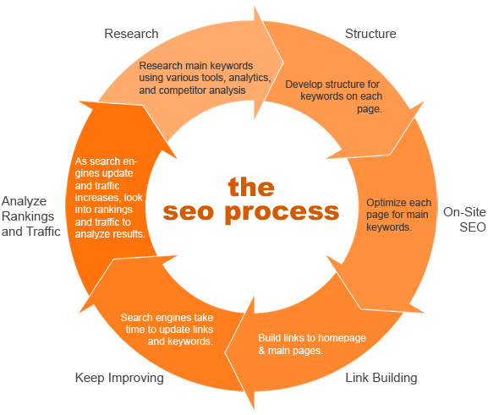
Image via moz.com
Along with page optimization, SEO also involves:
- Site Monitoring
- Keyword Research
- Competitive Analysis
- Link Analysis and Acquisition
- Page Management
- SERP Rank Tracking
- and more
Monitoring all of these also requires the use of specific software and online tools to ensure the optimization process is contributing to sales and revenue. In a nutshell, it's complicated.

