History Page/ Link

Evergreen has a deep and rich history in evocative and successful MPA faculty. From the early years with Dan Evans, Russ Lindman and Guy Adams to current faculty, much valued research and published works have emerged from Evergreen faculty and alumni into the Public Administration field.

Below are three featured faulty members of the past. Make sure to watch the MPA faculty video to learn more about today’s amazing teaching team.

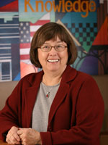
Camilla Stivers
Evergreen MPA Faculty 1987-1996
Current Board member of ASPA Publications, Public Administration Review Board

Camilla is the author of numerous peer reviewed articles as well as recognized book titles such as, Gender Images in Public Administration; Democracy, Bureaucracy and the Study of Administration; Bureau Men and Settlement Women; Governance in Dark Times as well as, Government is Us, with co- author and current MPA faculty, Cheryl Simrell King.

Camilla is recognized as a female pioneer in the field of Public Administration and has been known to make cameo appearances at the college.

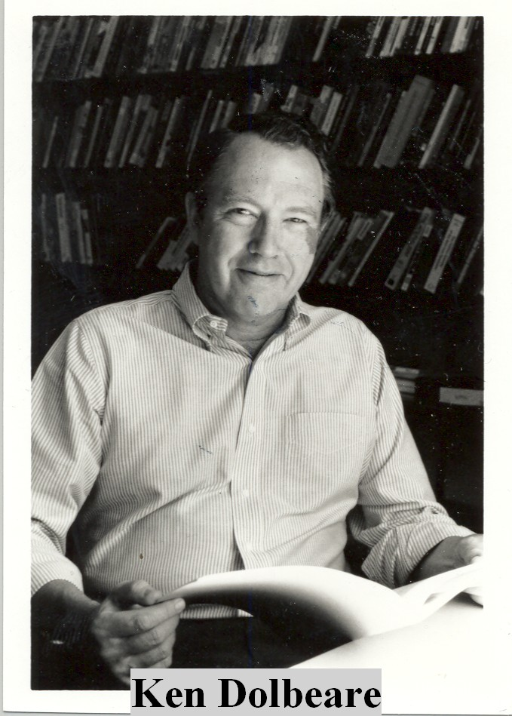
Photo Services Archives

Ken Dolbeare
Evergreen MPA Faculty 1981-1997
Currently writing and working alongside his wife in their business.

Ken authored over 13 books including the popular, American Political Thought, now in its 6th edition, with co-author, Michael S. Cummings. He recently co- authored, USA 2012: After the Middle Class Revolution, with his wife, Janette Kay Hubbell.
Ken is respected across the region and the nation as an influential political analyst.

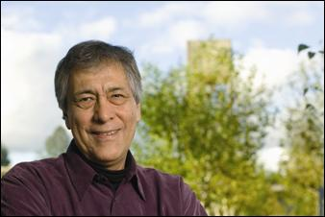
Alan Parker
Evergreen MPA faculty 1997-2013
Co-creator of the Tribal Governance concentration
Currently co-chair of the committee on indigenous nation relationships of the National Congress of American Indians, he is coordinating treaty negotiations to establish a United League of Indigenous Nations.
Alan practiced law in Washington, DC. He directed research on tribal governments for the American Indian Policy Review Commission and was the first Native American to serve as Chief Counsel to the US Senate Committee on Indian Affairs.
During his service in the US Senate he was instrumental in securing passage of the Indian Child Welfare Act, the Indian Religious Freedom Act, the Native American Graves Protection and Repatriation Act, the Tribal Self-governance Act, the American Indian Development Finance Corporation Act and numerous tribal land and water claims settlements. He also served as President of the American Indian National Bank from 1982 through 1987 and later organized the first "Native American think tank", the National Indian Policy Center at George Washington University. On May 21, 2000 Washington State Governor Gary Locke appointed Professor Parker as the first Native American attorney to serve on the Washington State Gambling Commission.

