WEB PAGE PROFILE FEATURES

**Alumni Profile for Home Page**

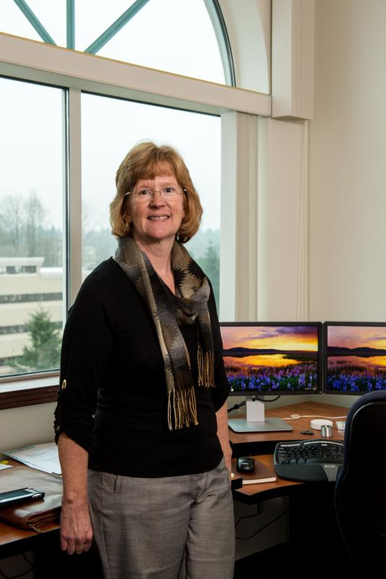

**Susan Lucas**

**MPA class of 2013, Public/Non- Profit Concentration**

Current Employer: Health Care Authority

Current Position: Chief Operating Officer

“The program is very convenient, with the evening/weekend schedule. Teachers and advisors are flexible in how work is done, making the program possible for a busy manager. The program’s cost is reasonable when compared to other similar programs available. The program has a very high value – the contacts I made are helping me in my job daily and the lessons learned are very applicable to my career. When I started the program I thought I was most interested in public policy development. As I went through the classes I realized my skills and interest lies in public administration. My skills and abilities relate to implementing public policy, managing employee groups and helping organizations adapt to organizational change and meet challenges.”

**Alumni Profile for Policy Page**



**Matthew Lemon**

**MPA Class of 2013, Public Policy Concentration**

Current Employer: Washington State Institute for Public Policy (WSIPP)

Current Position: Research Associate

Prior to Matt’s enrollment in the Evergreen MPA program, his work experience was entirely in the private sector. His first job in the public sector was an internship at WSIPP in early 2012. WSIPP offered Matt a full-time job as a research assistant and he has since worked his way up to research associate.

“Remember that the Evergreen MPA program is a unique opportunity and that you will get as much out of the program as you put into it. Don’t be afraid to embrace new challenges or experiences. Take electives in areas outside of your intended concentration. Take advantage of internship opportunities or investigate a topic through an independent contract. This is a chance to explore - get out there and see what you can find.”

**Student Profile for Public/Non-Profit page**



**Nikki Wegner**

**MPA Class of 2014, Public/ Non-Profit Concentration**

Current Employment: Instructor of Vocational classes for people who experience Intellectual Disabilities at Highline Community College

“I chose the Evergreen program while working abroad after reviewing many different programs. I loved the diverse and challenging field of Non-profits, so Non-profit Management was my natural focus. I communicated with other leaders in my field who were TESC Alumni and they raved about the program. I flew in from Korea and sat in on Doreen Swetkis’s class (which had a legislative guest speaker) where I fell in love with the class structure, campus and the welcoming faculty. Also, I was impressed with the cost (half the price of UW!) and needed to be able to work throughout my program. There were no other schools which offered the class structure I was seeking with such a high quality, nationally recognized program.”

**Student Profile for Tribal Governance Page**

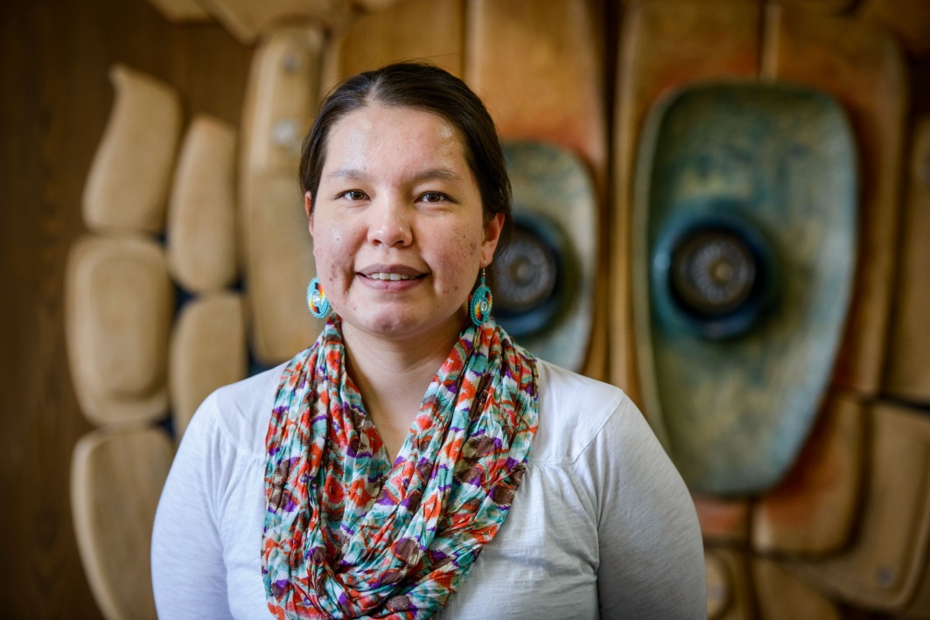

**Lexie Tom**

**MPA Class of 2014, Tribal Governance Concentration**

Current Employment: Curriculum Development at Northwest Indian College

“I chose the Evergreen MPA program because it is the only program in the Pacific Northwest area that offers the Tribal Government Concentration. I am a Lummi tribal member who is pursuing an education for the betterment of my community. A master’s degree in tribal government fit the needs of my community. A great take-away from the Evergreen MPA program is learning various strategies tribes are using in sovereignty issues and improving infrastructure. I also believe the training we are receiving in research design is invaluable.”