**Rivers of Knowledge in Native Programming at Evergreen State College**

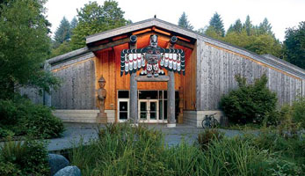

Please visit our updated webpage to view the breath of Native Programs offered through Evergreen. People can enter undergraduate programs, find community and receive a Master’s degree in Tribal Governance all with Evergreen’s on and off campus programming. Visit the following website to find out more information, to participate, or to learn how to apply today!

<http://www.evergreen.edu/nativeprograms>

**Native Cases Project Summer Workshop**

In August 2013 Evergreen’s Enduring Legacies Native Cases Project hosted its 8th annual Summer Workshop at Little Creek Resort Hotel. Linda Moon Stumpff and Barbara Leigh Smith led the workshop. The workshop’s purpose is to introduce faculty and other potential users to the Enduring Legacies resources and to demonstrate how cases can be used. “We want people to come away with the ability to go home and use the cases right away,” said Stumpff. The Native cases are now used at more than 90 colleges and universities across the United States and are an important component of many Evergreen programs.

The 2013 workshop attracted an unusually rich mix of people: faculty from Evergreen, Grays Harbor College, Peninsula College and South Puget Sound Community College, three teachers from Port Townsend High School, key Native educators at OSPI and the Kent School District, and two state legislators—Senator Karen Fraser and Representative John McCoy.

“It was amazing,” said one participant, “to have two of the leaders in the state legislature who sit on the Hood Canal sub-committees there when we discussed the case about Skokomish Fishing Practices and the issue of rising dissolved oxygen levels in Hood Canal. It was a rich discussion of biology, engineering, geology, public policy, native culture and intercultural communication. “

Many of the participants noted that the extensive interactivity of the workshop with extensive small group deliberation and problem solving was wonderful, providing lots of opportunities to get to know one another and explore different perspectives.

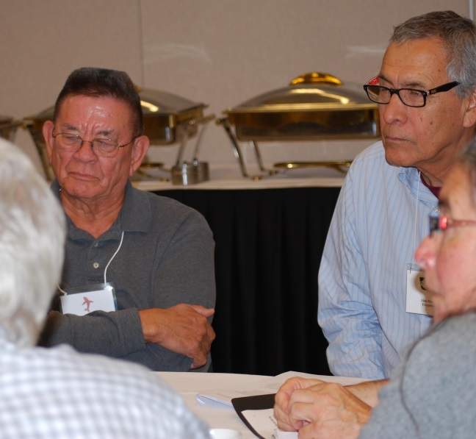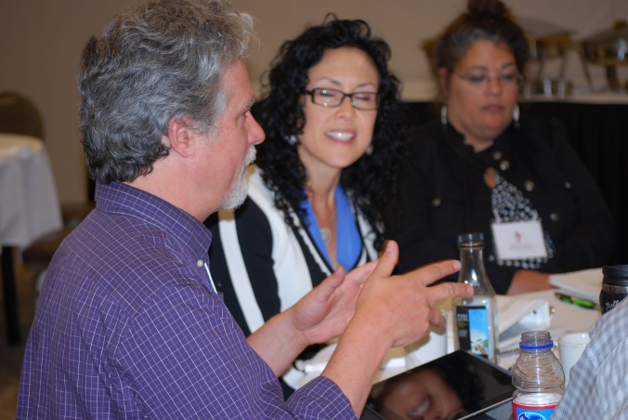

Participants discuss cases in small groups. (Left, Rep. John McCoy, Alan Parker and Norma Alicia Pino; right Bruce Hattendorf, Maria Pena, and Theresa Lockrem)

Cases discussed focused on many different issues--- climate change and intergovernmental negotiations , two spirit people, bullying and discrimination in schools, Indian identity and funding in the arts, the impact of mining in Alaska, Indian mascots, domestic violence, salmon restoration and the culvert case, and the Quileute and Twilight. Many of the cases in the collection focus on contemporary issues in the Pacific Northwest.

The 2013 workshop was supported by a grant from the Squaxin Island Tribe. Depending on available funding, the next two workshops will be in summer 2014 with one focusing on writing cases and the other on teaching with cases. We are pleased to report that the Nisqually Tribe is funding the writing workshop.

Visit the Native Cases website at [www.nativecases.evergreen.edu](http://www.nativecases.evergreen.edu) to access the Native cases and teaching notes and to find information about other resources and future workshops.

**Native Decolonization in the Pacific Rim Program Traveling to New Zealand**

Zoltan Grossman

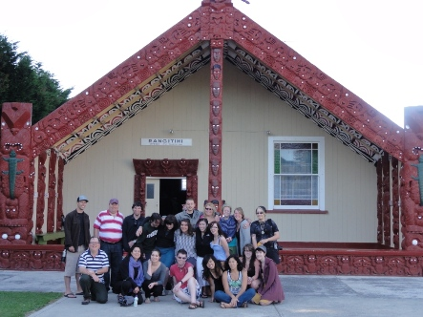

*Native Decolonization class at Taheke Marae in Rotorua NZ 2011.*

“*Our communities, cultures, languages and social practices – all may be spaces of marginalization, but they have also become spaces of resistance and hop*e.” -- Maori scholar Linda Tuhiwai Smith  
   
The Native Decolonization in the Pacific Rim program on the Olympia campus in 2014-15 will focus on Pacific Northwest Native nations and Maori in Aotearoa (New Zealand), including a Study Abroad component for undergraduates in New Zealand (or elsewhere in the Pacific Rim) in February-April 2015. The three-quarter program will be taught by Native Programs faculty Kristina Ackley, Lara Evans, and Zoltan Grossman; Ackley and Grossman took the class to Aotearoa in 2011.  
   
By concentrating on a larger region, students will have an opportunity to broaden Indigenous studies beyond the Lower 48 states, and explore and compare common processes of Native decolonization in different settler colonial societies. We will be studying decolonization through cultural revitalization and sovereign jurisdiction of First Nations. In order to examine the central role of Indigenous peoples in the region's cultural and environmental survival, we will use the lenses of geography, history, art and literature.  
   
In fall quarter, we will stress the complexities and intricacies of colonization and decolonization in Native nations of Washington and B.C. Students will gain skills to prepare for travel, and respectful interactions with Indigenous communities. We will expand the focus to appreciate Indigenous experiences in other areas of the Pacific Rim, emphasizing common concerns such as climate change, tourism, and cultural domination. For up to seven weeks in winter/spring quarters, most of us will travel to Aotearoa, where we will learn through participatory community projects how the Maori have been engaged in revitalizing their language, art, land, and politics, and their still unfolding, changing relationships with the Pakeha (non-Maori) people and society, while other students work with Indigenous communities elsewhere in the Pacific Rim.  
   
For more information, see the report on the 2011 Study Abroad to New Zealand at <http://academic.evergreen.edu/g/grossmaz/NZ.pdf>   and the 2014-15 program description at <http://www.evergreen.edu/catalog/2014-15/programs/nativedecolonizationinthepacificrimfromthenorthwesttonewzealand-10764>  Interested students (and Tribes wishing to fund their students) should contact ackelyk@evergreen.edu and grossmaz@evergreen.edu

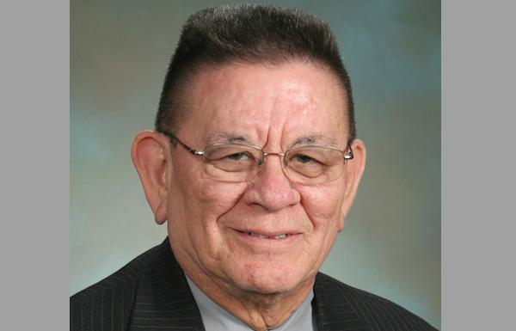

**John McCoy Feature**

JOHN R. McCoy, Democrat, represents the 38th Legislative District, which includes the Tulalip, Marysville and Everett communities of Snohomish County. John is Co-Chair of the National Conference of State Legislators Environment Committee and is an active member of the Environmental Management Roundtable, the Labor and Economic Development Committee, and the Communications, Financial Services & Interstate Commerce Committee for the National Conference of State Legislatures.

In the Washington State Legislature, John is Chair of Community Development and Housing and Tribal Affairs committee, Vice-Chair of the Environment Committee and sits on the House Education Committee. John has worked on expanding broadband across the state to get folks connected. He has also pushed to expand Washington’s renewable energy portfolio and create incentives for alternative energy, like biomass and solar. John continues to work on making Washington greener and run more efficiently.

John served in the United States Air Force for 20 years, retiring in 1981 with extensive training in computer operations and programming. He worked as a computer technician in the White House from 1982 to 1985. John went on to management in the private sector to continue his career in computer programming and operations. In 1994 he returned to Tulalip to help bring the community into the digital world and build what is now the Quil Ceda Village Business. In 2000 John became General Manager of the Quil Ceda Village Business Park where he retired August 2010.

He is encouraging Native youth to become active and aware in community building, education and leadership. Evergreen is honored to have John as a current member of the adjunct faculty in the Master of Public Administration, Tribal Governance program.

John and his wife, Jeannie McCoy, make their home in Tulalip. They have three daughters, nine grandchildren, and one great-grandson.