**Longhouse Education and Cultural Center**

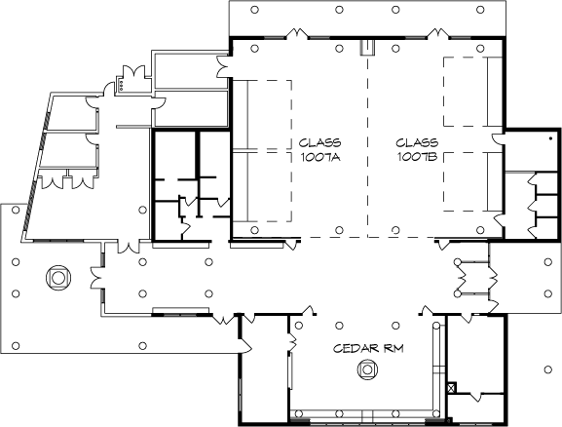

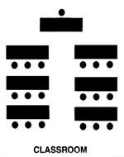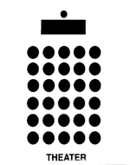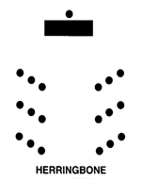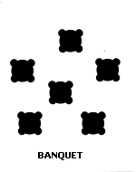

|  |  |  |  |  |
| --- | --- | --- | --- | --- |
|  | **Theater** | **Classroom** | **Herringbone** | **Banquet (6' rounds)** |
| 1007 A | 150 (4) | 96 (4) | N/A | N/A |
| 1007 A w/bleachers | 220 (5) | N/A | 220 (5) | N/A |
| 1007 AB | 300 (5) | 192 (5) | 290 (5) | 180 (5) |
| 1007 AB w/bleachers | 440 (6) | N/A | 440 (6) | N/A |
| Cedar Room | N/A | N/A | N/A | 50 (2) |