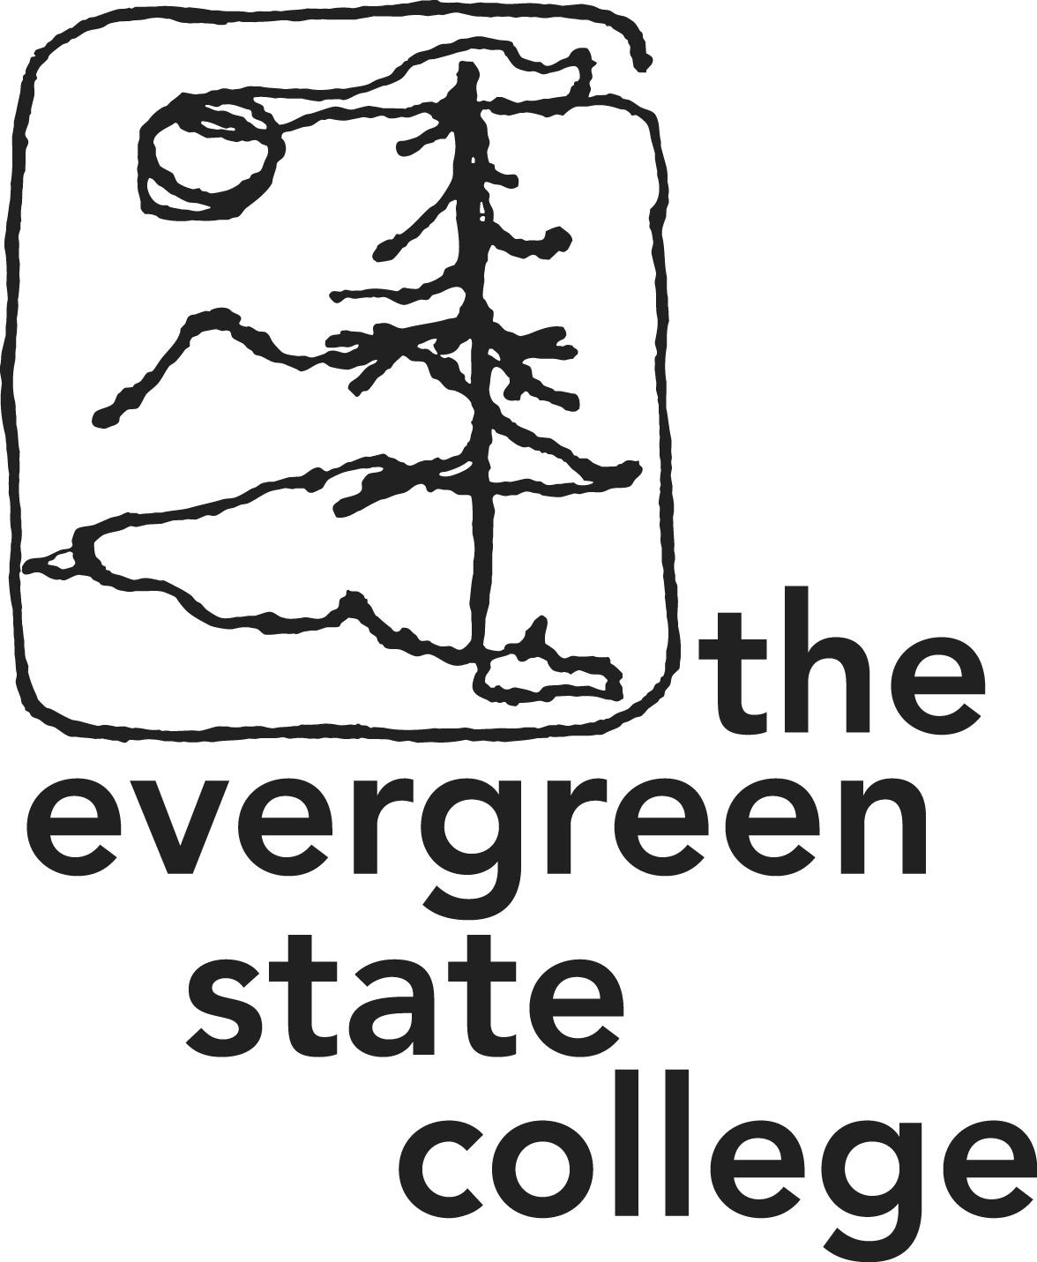

Masters of Public Administration and Rivers of Knowledge

Marketing and Communications Plan

Introduction:

The Evergreen State College Master’s of Public Administration graduate program, including the Tribal Governance program and the associated River’s of knowledge programs, seeks to expand and promote its current marketing and communications strategy. By using content marketing (the process of others sharing a desired message and pertinent information), the MPA program can deliver a unified message to various audiences anywhere and in the medium that best suits their needs.

This outline or brief seeks to convey how the college could renew the program in several key areas: outreach and recruitment, ongoing communications though (social media, website, newsletters and publications as well as interactive accessibility). The plan touches on follow- up and outreach to alumni.

This plan focuses on:

1. Objective
2. Plan outline
3. Actual methods for marketing

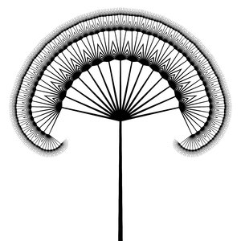 **be the change**

Objective:

The Master of Public Administration program (MPA) needs to identify itself as a unique, affordable, competitive/ successful and professional educational option. Much of this is stated in the current website but is buried in text. Cooperative dialog, directed by the 2012 MPA survey, and an agreement on the “face” of the MPA program’s message and identity is an essential first step. The ubiquity of smart devices will allow for rapid sharing of information and compelling content. To convey this message, the marketing strategy needs to utilize touch points and place focus on:

*Increased awareness of program success

*Increased awareness of the program financial value, mission, and unique character

*Increased use of interactive media to engage past, present and future students and the PA community at large/ web based marketing priority

Project/ Program plan:

*Define identity and message (idea formation in conjunction with both MPA faculty as well as the overall Evergreen college marketing design)

*Identify stakeholders and audiences

*Create meaningful and comprehensive plan (design and pilot/ revisions with the assistance of the Evergreen marketing team)

*Implement plan with the Evergreen Marketing team

*Assess and revisit

Methods:

The Evergreen State College, MPA program will use traditional and innovative methods for engaging audiences. The overall effect should be one that both promotes the program as well as produces an honest representation of the college’s MPA offerings.

|  |  |  |  |  |
| --- | --- | --- | --- | --- |
| **Social media** | **Website** | **News/ media** | **Advertising and promotion** | **Publications** |
| Twitter | MPA/Rivers | Awards | KAOS | Newsletter |
| Facebook  *Under con-sideration*  Google +/ no | Storyboards with up-worthy notations | Faculty, alumni and stakeholder publications and professional affiliations | The Olympian | Brochures  Unify and consolidate brochures for MPA and Rivers//Evergreen photos and marketing |
| Instagram/  no | Connected to youtube and linkedin | KAOS | NPR | Use web blog base newsletter |
| Linked In/Yes | Virtual tours with faculty and program elements |  | Special logo/ brand |  |
| Youtube/Yes |  |  | WA Capitol |  |
| Tumbler/no |  |  | On Campus |  |
| Hashtag/no |  |  | Volunteer causes |  |

Conclusion:

By using the survey and past/present contacts, the MPA administrative team can use tools to design and sculpt a well-defined message on the identity and significance they would like to focus their marketing and communications plan towards.

A strong and comprehensive plan that is inclusive of both past, present and future students will convey the ongoing support and value that the MPA program provides in lifelong learning. The current culture of social media and information sharing behooves the college in its ability to reach a broad audience.

The plan will try to tighten the amount of material produced and create a tight package of brochures for the MPA program as well as a linier suggestion for the Rivers of Knowledge programs. These new brochures, and the web designs, will use professional Evergreen photos and follow the Evergreen State College marketing guidelines to help create a unified look throughout the college.

The plan should focus on various audience needs as well as MPA promotion. This exciting opportunity opens the world to all that the MPA program has to offer in learning, professional advancement and in the love of community and humanity.





OLD PLAN ATTACHED:

**Marketing Plan**

**Budget**

**Calendar**

**Methods**

Direct Mail

Web Presence

Magazine/Newspaper Ads/Articles

Site Visits

Conferences

Press Releases

Alumni Relations

**Contact Lists**

Prospects

Tribal Managers

Government-Tribal Liaisons

Newsletters

Tribal Alumni

Regional Indian Organizations

**Community Monitoring**

Subscription to all regional tribal newsletters

Regular site visitations

Place ads in National magazines:

Winds of Change Annual College Guide

American Indain Graduate Sp & F

Indian Country Today Education magazine

Conference flyers:

ATNI

NCAI

NIEA

AFN

Contribute articles to tribal newletters featuring local students

Develop Evergreen MPA/Rez-based Alumni Association and newsletter

Quarterly contacts with Tribal Education Departments, Human Resource Departments, Tribal General Managers

Develop list of Tribal liaisons for agencies municipalities, governments

Make sure Tribal Governance track web presence is updated periodically

Visit each of these tribes at least once per year

Contact various government agencies to present info re: MPA Tribal Governance track

Washington Indian Education Organization