Take out Nikki, Matt (already featured in concentrations) and Shaz (no new info…not recent).

Rodney Gervais, Blackfeet, MPA ’14, Leader in Indian Civil Rights

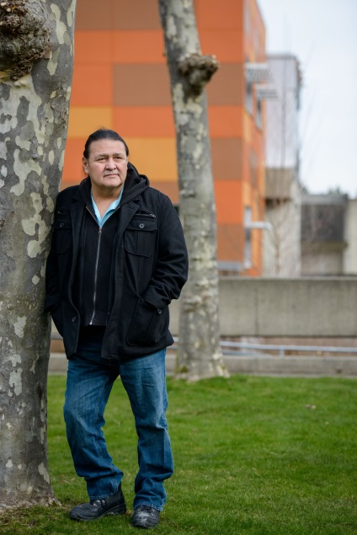

Rodney has worked for the Blackfeet tribe for 27 years and has served as a Tribal Chair person. His efforts have focused on issues around Indian civil rights to reorganizing the Blackfeet governance system.

During his two years completing his MPA degree in Tribal Governance, Rodney made the journey from Montana to Olympia with near perfect attendance. Rodney’s expansive service to his people and his never ending quest to grow and learn and serve has made Rodney a memorable and influential member of his academic and tribal communities.

Lexie Tom, Lummi, MPA ’14, Tribal Administration with the Lummi Tribe

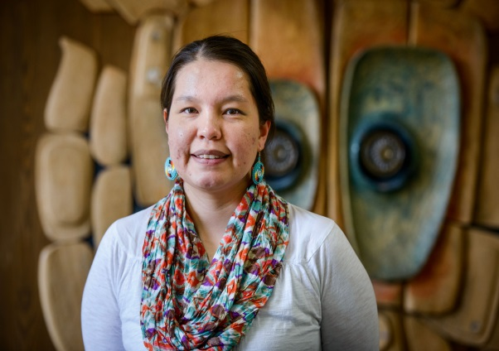

Lexie was the 2014 graduate speaker for the Evergreen campus commencement. Her commitment to her community has shown through her work and her continuing education in MPA, Tribal Governance.

Like many of our students, Lexie has a full time position. Lexie works with Curriculum Development at Northwest Indian College. The flexible schedule and unique Tribal Governance concentration allowed Lexie to continue on her path for her community and career. “I chose the Evergreen MPA program because it is the only program in the Pacific Northwest area that offers the tribal government concentration. I am a Lummi tribal member who is pursuing an education for the betterment of my community. An MPA degree in tribal governance fit the needs of my community”. Lexie reiterated that the learning experience is best defined and created by each student, “When I first applied to Evergreen the statement that really stuck out to me was by Joseph DeLaCruz about self-determination: “No right is more sacred to a nation, to a people, than the right to freely determine its social, economic, political and cultural future without external interference.” This is so important for Tribal Nations today to understand. This statement speaks to the true meaning of self-determination. And it speaks to my experience here in the Evergreen MPA program. In classes we talk about what self-determination really means, and it’s different for each tribe. This curriculum was not designed to always give every answer we are seeking. As students it’s our responsibility to dig deep and find answers that suit our own tribes for ourselves”.

Dominic (DJ) Crisostomo, MPA ’13, Pre-College Coordinator, UW- Tacoma: Student Transition Programs

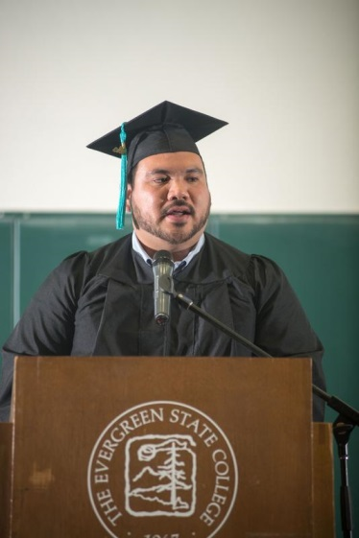

DJ served as the voice of his 2013 MPA cohort. His volunteer work with underprivileged youth, through innovative and creative programming has given rise to a nonprofit program still in existence in Tacoma. He has taken his passion into the workplace where he continues to serve.

DJ’s ability to listen carefully to those around him and offer balanced insight has helped to craft his leadership style. “The Evergreen MPA program helped me develop ways to observe, implement, and assess all that I do both professionally and personally.  Also the cohort (faculty and students included) I was a part of formed a sense of community that was extremely vital to my success as a scholar and individual.  In relation to my current job, it is critical that I perform and evaluate my performance daily.  Most importantly, when doing the work I do for local youth, it makes it all the more worthwhile when I have a strong sense of community to back me up.  In a collegiate setting, I learned how to appreciate and reciprocate that support because with the Evergreen MPA program I was inundated with it”.

Susan Lucas, MPA ’13, Chief Operating Officer, Washington State Health Care Authority

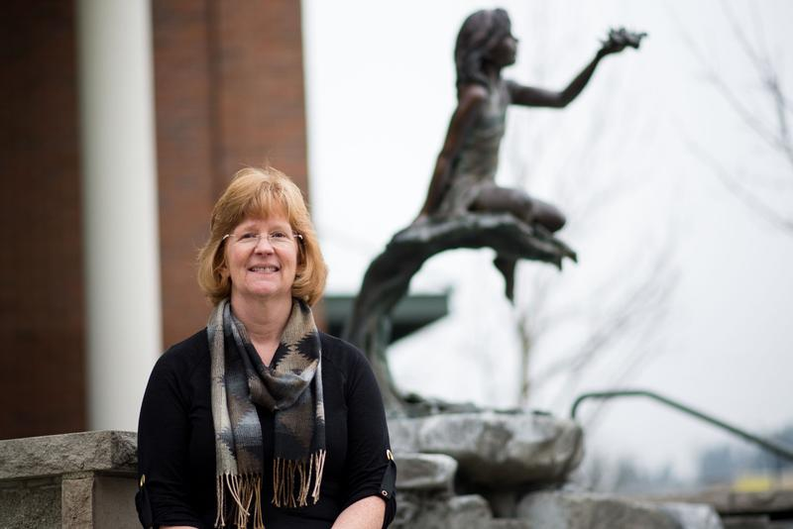

Susan entered the MPA program at Evergreen with a vast bank of professional knowledge. Since graduating, she has gone on to publish a paper on public administration and she took a position with the Washington State Health Care Authority, as the Chief Operating Officer. Susan chose the program because, “The program was convenient for my schedule and its location was close to work and home.  Graduates and reviewers of the program gave it very high ratings.  A review of the classes offered and subjects taught indicated it would be very applicable to my work as a public administrator. The program is very convenient, with the evening/weekend schedule.  Teachers and advisors are flexible in how work is done, making the program possible for a busy manager.  The program’s cost is reasonable when compared to other similar programs available.  The program has a very high value – the contacts I made are helping me in my job daily and the lessons learned are very applicable to my career”.

Susan also valued how the program helped her to hone in on her professional interest and skills, “When I started the program I thought I was most interested in public policy development.  As I went through the classes I realized my skills and interest lies in public administration.  My skills and abilities relate to implementing public policy, managing employee groups and helping organizations adapt to organizational change and meet challenges. It is a great experience you will always treasure”.

### Kendra Aguilar, Luiseno- MPA ‘12, pursuing PHD in Indigenous Studies

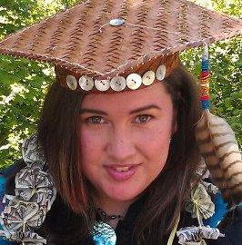

Kendra is part of the first ever cohort of U.S. Tribal students to pursue their Doctorate in Indigenous Development and Advancement (IDA) through Te Whare Wananga O Awanuiarangi, an Indigenous-Maori University based in New Zealand. The cohort is led by Alan Parker, Evergreen’s Co-founding faculty of the Tribal MPA program. While studying she has continued to work as an Independent Consultant on community building projects involving local nonprofits, Tribes, and City & County agencies. She is also the Co-Founder of a Native organization, One Totem.

Kendra started her academic career with the Evergreen Reservation Based Community Determined program. After building a foundation for a Native nonprofit with a fellow RBCDP student, Kendra knew she could benefit herself and her community from the top-rated Evergreen MPA program.  Although some would have thought it more prudent to choose the Nonprofit concentration, the opportunity to learn from and along-side faculty and students with similar cultural values and a foundation of understanding of the complex history and current issues impacting Tribes and other Indigenous peoples made it the natural choice. It is the first MPA program to work directly with local Tribes to develop a curriculum suited for building a career in Tribal Governance or in serving Native communities. “I had witnessed what other graduates of the Tribal cohort had done to benefit their peoples and was compelled to honor the sacrifices of my own ancestors by becoming a part of that legacy. However, the greatest contribution this program has made to me, in my career serving Native communities, is the knowledge that together we can apply standard as well as our own traditional values and ways of knowing & learning to create a clear and proven pathway for Native student success”.

### Alicia LeDuc- MPA ‘11, Entering Law School at Willamette

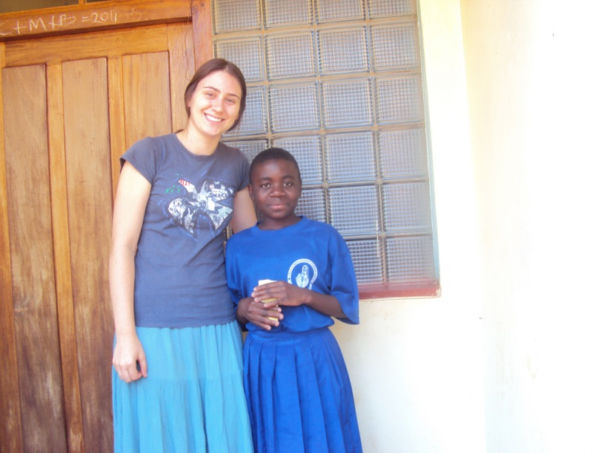

Alicia embodies the spirit of both Evergreen and the MPA program.  She is inquisitive, focused on social justice and motivated to do everything she can to grow and learn in a vast capacity.  From volunteering in Tanzania (see photo above), working with Washington State, to entering law school, Alicia is being the change! Alicia’s career interest have generally focused on international economic and social development where she has been active in a number of realms, including HIV/AIDS activism, Social Responsible Investing and microfinance/access to capital issues, homelessness issues, community development, environmentalism/conservation, clean energy, education, religious freedom, criminal justice/prison issues, and more recently medical cannabis patient rights and rural economic development.

Alicia came to Evergreen for a few reasons. She knew she wanted to work in a capacity that influenced the way the world works, making the dual Public and Nonprofit Administration concentration attractive.  Evergreen’s lack of a GRE requirement, coupled with the philosophy regarding grades and evaluations, was also attractive to Alicia. The lack of a GRE requirement allows applicants to apply at Evergreen to start in the coming year, rather than having to wait an additional admissions cycle after taking the GRE and gives students a leg up on starting their careers. “My greatest takeaway from the MPA program has been the training and skill building I received regarding conducting and analyzing social research. I applied those skills firsthand in my capstone work in Tanzania, and have been able to carry the knowledge with me in my current work as a research analyst with the Department of Commerce and volunteer work I do in the community. Understanding how to develop research; acquire, analyze and vet data; and harness that analysis and information to achieve goals or understand situations has been invaluable, on multiple occasions setting me apart from my peers in the field in a lucrative way. MPA connections have been directly responsible for my last 3 internship/employment positions and in part my admission to law school on a full-ride scholarship, not to mention a tremendous resource as a professional sounding board and volunteer pool to call on for community engagement”.

### Daniel O’Neill and Breezie O'Neill- MPA ’10, 2012-13 Peace Corps Volunteers, currently serving as Senior Public Health Consultant with the Department of Health and Assistant Director of International Programs and Development at Saint Martin’s University

##### Daniel and Breezie O Neill with Wall Art

**Danny** has worked in state and federal government for the past 7 years where he currently serves as a Senior Public Health Consultant and the Department of Health. Before working for the Department of Health Danny served, with his wife Breezie, as a Peace Corps Volunteer in Belize working with a Mayan school on their food security program. Danny is driven by a desire to serve others. This dedication to public service specifically relates to an MPA from Evergreen, which imparts a deontological ethic towards serving others. Danny decided to abandon a much more lucrative career in law because of this passion, and that has carried over greatly to his desire to serve the developing world. During their time in the Peace Corps, Danny and Breezie spent time living with destitute families that opened their homes, sharing their stories and their lives. “When they had nothing to eat, they would feed us. When they had nowhere to sleep, we got their beds. It was awe inspiring and humbling beyond words”.

“The most valuable resource I got from MPA was project management. The MPA specifically taught me important management techniques for project planning and mapping, working with difficult stakeholders, and negotiating appropriate terms for group projects. It also taught me to be a bit more open-minded, not always assume I had the right answer right away, and to spend more time listening than talking (not easy for a former Pre-Law student from a stuffy private school). This has advanced me personally and professionally more than I ever imagined, especially working in the development field. Challenge yourself to understand the opinions of others. As it turns out, life is a group project. To anyone looking into the program, come check out some classes, visit with the students, and see if you can prepare for the work-life-school balance. The MPA is a respected program and will open many doors to you personally and professionally. Studying PA in a state capital is an invaluable resource”.

**Breezie** has lived, worked, and studied around the world while specializing in nonprofit management and Southeast Asian studies. Her career and community life has centered around nonprofits. After serving in the Peace Corps in Belize as a Business and Organizational Development Volunteer, she worked for Girl Scouts of Western Washington as a Community Development Manager. Currently, Breezie is the Assistant Director of International Programs and Development at Saint Martin’s University.

“I decided to pursue an MPA degree from Evergreen because I needed to learn how to manage nonprofit organizations in an increasingly globalized world. Evergreen's interdisciplinary style helped me develop a wide range of skills that I need to work effectively with organizations that tackle complex systematic issues. I've known for a very long time that the Peace Corps was for me. I also knew that an MPA degree from Evergreen would help me be a more effective volunteer. The MPA taught me the importance of collaborative work. In the Peace Corps your work isn't sustainable if you are doing it on your own. We must work WITH our local organization not FOR our local organization. The MPA program showed me the value of learning from my peers and helped me practice communicating to people with diverse backgrounds and skills. I'm also utilizing my skills in project management, nonprofit management, social entrepreneurship, and sustainable decision-making. A lot of times people approach me about the MPA or Peace Corps and say, "I wish I could do something like that." I always tell them "YOU CAN”! My advice is to try and then decide. Your time in the MPA program is an amazing opportunity to experiment with new ideas and career options. Take classes you might not be sure about, do internships, volunteer. Learn about topics you’ve never considered. If you are thinking about answering the call to service either in the states or abroad know that it will be the most rewarding work you will ever do”.