**Plan for Marketing**

**Implementation and Continuity**

***mpa…be the change***

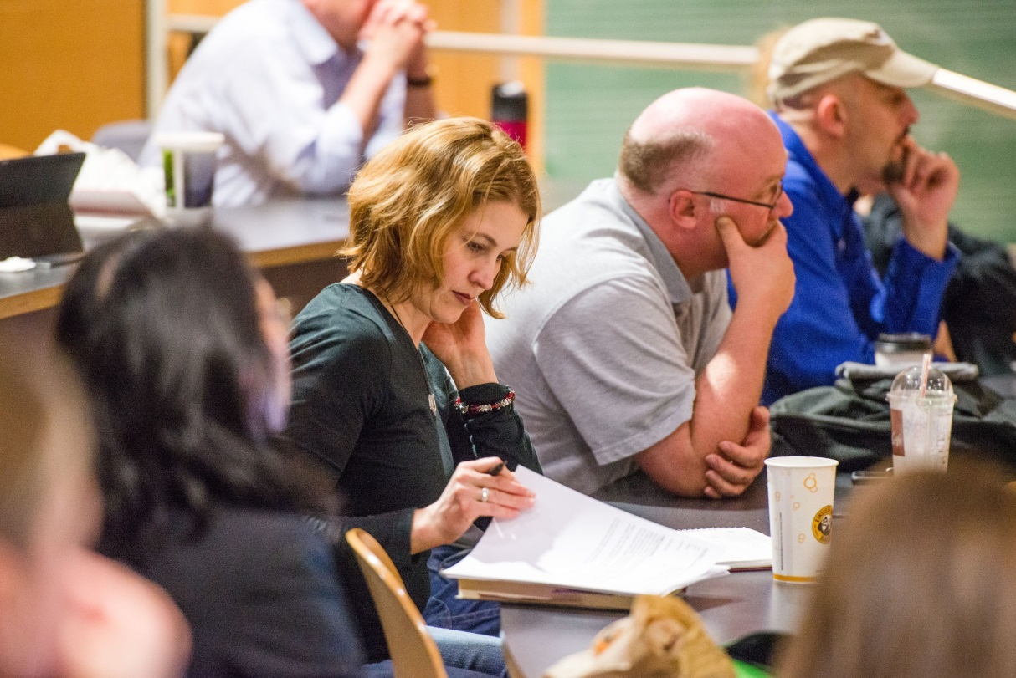



Table of Contents

Introduction……………………………………………………………………………. 3

Photography……………………………………………………………………4

Project Scheduling…………………………………………………………. 4

Website…………………………………………………………………………………… 4

Blog/ Tribal Newsletter……………………………………………………………. 5

Community Corner…………………………………………………………………… 6

Brochures………………………………………………………………………………… 6

Bookmark………………………………………………………………………………… 7

Banners…………………………………………………………………………………… 7

Posters……………………………………………………………………………………. 7

Ads………………………………………………………………………………………….. 7

Public Service Announcement………………………………………………….7

Social Media…………………………………………………………………………… 8

Appendices- Documents of Interest………………………………………… 9

Appendix A- MES Social Media Plan……………………………………….. 10

Appendix B- Keep the MPA Website Current on the Web………..11

Appendix C- MPA Marketing Notes………………………………………….. 12

Appendix D- Tag line and Term Renaming……………………………….. 14

Appendix E- 2013 Marketing Plan……………………………………………. 16

Appendix F- McGuire Report…………………………………………………… 25

**Introduction**

The 2013-14 academic year introduced a part time, non- continuing contract position in marketing the MPA program. This includes all concentrations of the MPA program as well as the Reservation Based Community Determined (RBCD) undergraduate program. The primary concerns were to upgrade the website and to create a Tribal Newsletter as well as update posters, brochures and banners. In the process, the program would receive new campus produced photographs and a potential, annual system for additional photography.

**Objectives**: The Master of Public Administration program (MPA) needs to identify itself as a unique, affordable, competitive/ successful and professional educational option. Much of this is stated in the current website but is buried in text. Cooperative dialog, directed by the 2012 MPA survey, and an agreement on the “face” of the MPA program’s message and identity is an essential first step. The ubiquity of smart devices will allow for rapid sharing of information and compelling content. To convey this message, the marketing strategy needs to utilize touch points and place focus on:

* Increased awareness of program success
* Increased awareness of the program financial value, mission, and unique character
* Increased use of interactive media to engage past, present and future students and the PA community at large/ web based marketing priority

Branding has been determined to fall under the branch of the Evergreen College in an attempt to remain a unified package (See Appendix F). Therefore, all major projects are designed and finalized by the overall marketing department. New logos, terms, content and images are still the responsibility of MPA staff and faculty (See Appendix D).

The main contacts are MPA Director Cheryl Simrell- King ([kingcs@evergreen.edu](mailto:kingcs@evergreen.edu) , 867-5541), Randee Gibbons ([gibbonsr@evergreen.edu](mailto:gibbonsr@evergreen.edu) , 867-6554); General Concentrations Assistant Director, Puanani Nihoa ([nihoap@evergreen.edu](mailto:nihoap@evergreen.edu) , 867-6202); Tribal Governance Concentration Assistant Director and Janet Hays ([haysj@evergreen.edu](mailto:haysj@evergreen.edu) , 867- 5939); Office and Administrative. Permanent Faculty are: Doreen Swetkis ([swetkisd@evergreen.edu](mailto:swetkisd@evergreen.edu) , 867-5320), Larry Geri ([GeriL@evergreen.edu](mailto:GeriL@evergreen.edu) , 867-6616), Amy Gould ([goulda@evergreen.edu](mailto:goulda@evergreen.edu) , 867-6135), and Michael Lane (new hire, contact information [lanem@evergreen.edu](mailto:lanem@evergreen.edu)). Cindy Marchand-Cecil ([marchanc@evergreen.edu](mailto:marchanc@evergreen.edu) , 867-6286) will be your direct contact for all RBCD business.

The following report serves to guide a person through the current marketing plan and help them to continue current services as well as prepare for further projects.

**Photography**

The key to successful marketing in this era is to provide captivating images with brief, direct content. This places intense value on quality photography. In line with the recent McGuire Report (See Appendix F), the MPA Program needs to brand itself within the greater college’s appeal and look/feel. A sure way to do this is to use the same photographer that the college uses for all photos in brochures, posters, banners and prominent web pages. Shauna Bittle ([bittles@evergreen.edu](mailto:bittles@evergreen.edu), 867-6280) is the current contact at photoland for setting up work sessions. There is a page on photoland’s website where you can request a photo session. It is advised to CALL Shauna prior to requesting an order. You will need a date, a time, and a theme for your photos (candid/ work environment, profile photos, classroom action, etc.). You will also need a campus contact number and name for the photo session so that Shauna can call them, if needed. It is highly recommended that a calendar is created of potential events or highlights of the MPA Program/ RBCD year and submitted to Shauna every fall or each quarter so that she can see where possible photo shoots may occur. This will require contacting both faculty and staff for both programs.

**Project Scheduling**

One of the greatest challenges of the marketing position is scheduling with other departments for meetings and work orders. Because it is recommended that all outputs be in line with the Evergreen brand, almost all printed material will come out of the marketing department located on the 4th floor of the Library. Todd Sprague ([spraguet@evergreen.edu](mailto:spraguet@evergreen.edu) , 867- 6042) is the contact, though a project manager is expected to be hired soon. NEW HIRE: Nani Paape ([paapen@evergreen.edu](mailto:paapen@evergreen.edu), 867-6066). Title, “Publications and Content Manager”, Nani will be the main contact and liaison between the MPA marketing staff and Alyssa Parker ([parka@evergreen.edu](mailto:parka@evergreen.edu) , 867-6038) and Judy Nunez-Pinedo([NunezJ@evergreen.edu](mailto:NunezJ@evergreen.edu) , 867-6037); graphic artists. It is recommended that anything that is able to be produced in-house is done so. This will include items done in publisher (such as the Tribal Newsletter and some ads). All content and images are the responsibility of the MPA Program to provide. Marketing does the layout and design.

**Website**

Work scheduled for the website should be done with Susan Bustetter ([bustetts@evergreen.edu](mailto:bustetts@evergreen.edu) 867-6626); website manager. However, most work should be done in-house through CMS. A username and log in, through Susan, will be required to begin editing <http://www.evergreen.edu/webresources/training.htm>. The new website was completed under the MPA marketing, staff contract. It is very important to work closely with staff in how to structure the information to keep the site current but uncluttered. The home page should remain simple and open. Use the blog news feed to put in any important/timely information. Another option is to use links to other pages where it makes sense to add the information. The home page must remain clear and easy to read. New images can replace current ones but the content and space used should not change. A usability study was conducted to help construct the current home page into its user friendly form. The Left Navigation has also been condensed and limited to include only the most important items. Most additional information can be found in the MPA News Hub blog and within links to more in depth pages. This method is used understanding that brevity is best and that those who want more information will find it.

**Alumni and Student Profiles**

The profiles are an exceptionally important part of painting a successful face of who the MPA program serves. The profiles show professional success, diversity, and a love for the Evergreen MPA program. They should stay relevant. Adding, changing and featuring new people will be essential. The profile /MPA web page requires more effort and content than the MPA News Hub/ Alumni blog page. Faculty has been very helpful in providing leads for featured persons.

Social media has been intentionally limited on our site to include facebook, LinkedIn (through Evergreen) and YouTube*.

*Currently, we do not have any videos to share. However, a project that did not come to fruition was to create an introductory video of faculty and students that could be posted to the site.

**Blog/Tribal Newsletter**

The blog, MPA News Hub, was created by the MPA marketing staff to serve as a clearing house of current and pertinent information. The monitor of the site will need to update the log in information for the account with their own username and password. It is currently hendrixl and Jabwar02. It has five tabs: Home (current news), Alumni (jobs and profile info), Faculty (current and historic blurbs), Publications (for faculty and student writing) and the Tribal Newsletter (MPA, RBCD and all Native programming info).

All of the tabs get edited with current information but the home page is the only one that dates and archives them. This is important because this is where the most important and time sensitive information is placed.

All new information on alumni job placements is included in the profile list. Keep it short and put the new information at the top.

Faculty bios need updated as they volunteer new information. Feel free to add more stories about past professors or stories about MPA Faculty.

The publications could really be developed to contain links to faculty books and publications. Keep track of anything a student writes as that is REALLY cool and exciting to see.

The Tribal Newsletter is maintained by gathering information from the campus Native Programs (<http://www.evergreen.edu/nativeprograms/> 867- 6286), RBCD, MPA Tribal Governance and Native Cases (Barbara Smith- [SmithB@evergreen.edu](mailto:SmithB@evergreen.edu) ). An e-mail every three months for a call for content usually gives more than enough information to work with.

**Tribal Newsletter Hard Copy**

The most pertinent information from the current Newsletter information is copied into a publisher template. The template is found in the O drive/MPA/Marketing under Tribal Newsletter Template. Articles will need updated but try to leave the format the same (RBCD likes to see a student profile in there). This newsletter takes minutes to create and can be printed at the copy shop for distribution (Start with about 200). It can also be e-mailed out to MPA All via Janet Hays. The Newsletter is slotted to be created at the start of each quarter, skipping summer.

**Community Corner**

This site was created to make a space for students and the community to discuss, in a live forum setting, projects that could be of mutual benefit. Creating capstone projects, internship opportunities and individual study contracts is the overall goal. However, current structures require a registration and sign in to participate. This is often a large barrier to participation and the current site remains largely unvisited. The monitor of the site will need to update the log in information for the account. This is a project that could be a focus for change in the future.

**Brochures**

Brochures are the most important tangible output for MPA marketing. Like the website, they need to have a careful balance of tempting images and packed yet brief content. A clear message is essential. *Convenient, Affordable, Dynamic, Unique, Success;* these are the messages we want to convey. This information with photos will tell the story that leads people to apply. Brochures should be updated every other year at the least. Date the brochure somewhere for easy filing.

MPA General- Covers all concentrations, last updated in August of 2014

MPA Tribal Governance- Specific to that concentration, last updated in August 2014

RBCD- Covers Evergreen and other sites (work with Cindy), last updated August 2014

**Bookmark**

This item is used by all MPA concentrations and is a great take away for events. The idea is that it is both beautiful and useful as a bookmark but that the website and basic program information goes with the person too. This is a new marketing item. It shouldn’t need updated very often but should be ordered at high amount to keep them on hand.

**Banners**

In an effort to have the program appear more professional at recruitment events, two table banners were created for the MPA program. One is for the overall program and one is specifically for the Tribal Governance concentration. A floor banner was also requested by RBCD. Each one was created in May of 2014. These shouldn’t need replaced unless the content/ data changes.

**Posters**

Posters should be made by the marketing department. However, in a tight spot, posters can be quickly created in publisher and printed in color on the 2nd floor of Lab 1.

The posters follow the banner model and give a flashy photo with brief information. These can be used at off campus events, recruitment fairs and on the Tri board that RBCD and MPA Tribal Governance take to some events. Each party should have at least a few hundred per year of their poster.

**Ads**

Because these items are intended for other publications and they are program specific, it seems that they can be produced in-house. The ads are currently complete and housed as both pdfs and publisher files on the O drive/ MPA/Marketing under MPA RBCD Ads. A list of publications and a schedule of times to submit/ pay for running them is available but should be updated. This list and schedule will need to be done with staff and faculty.

**Public Service Announcement**

An audio PSA was created with KAOS. It is played intermittently. Bi-annual contact with Quentin Mahoney ([kaostu@evergreen.edu](mailto:kaostu@evergreen.edu) , 867-6898); at KAOS is recommended to continue to get air time on the announcement. The clip could be added to the blog or website in some capacity if it isn’t getting played enough. The clip is also saved on the O drive/ MPA/Marketing/ KAOS PSA.

**Social Media**

By choice, the MPA website is limited in its social media connections to LinkedIn (through the Evergreen Campus/ University link- in process of connection/ RJ Burt [burtr@evergreen.edu](mailto:burtr@evergreen.edu) , 867-6568) facebook (needs icon loaded and connected to our website/ webteam will complete) and YouTube (at this time still needs put on the website). YouTube is hoped to one day house an introductory video as well as produced, short videos of capstone presentations, student projects and video pertinent to the field. This is a project that can easily be expanded and developed by MPA Marketing. Contacting faculty and creating a filming time will be the greatest challenge to creating an introductory video. It may work better to choose one faculty to interview and add some film of a different faculty teaching to round it off. The video should be under two minutes and even shorter for student presentation samples. The website team can help to upload the film when you are finished as you tube is not currently on the MPA Site.

**Facebook**

Facebook does have active MPA and RBCD sites. These sites are monitored by the assistant director or program directors. Some sites are created and monitored by students. The official facebook connections to the MPA website are under [hendrixl@evergreen.edu](mailto:hendrixl@evergreen.edu) password, MPA014. Someone should update the e-mail and add themselves as an administrator. Cheryl is also an administrator. A person should stay dedicated to monitoring the content and quality of posts on a daily basis. (See appendix A- MES social media plan)

Appendices

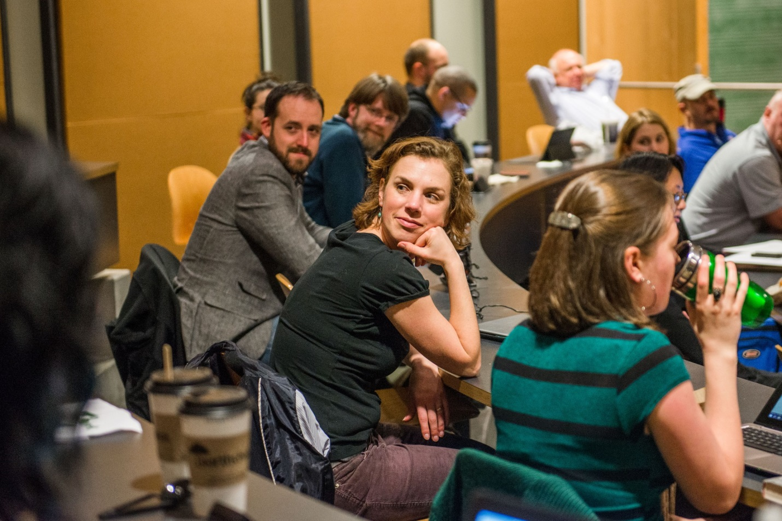

**Appendix A- MES Social Media Plan**

**Facebook**

* almost everything!
* posts at least every-other day
* lots of photos
* interactive posts (questions)
* links to blog posts that are longer
* create photo albums for big events
* announcements of events, conferences, etc
* create event pages (Rachel Carson, TEDx)

**Twitter**

* short with links to more info (maybe blog or website)
* try to tweet or at least re-tweet daily
* okay to repost similar content with different copy
* similar/same content as Facebook

**LinkedIn**

* Post about career-related things (interview tips, job postings)
* Invite alumni to join
* Gail’s visits to other schools
* post a few times a month

**Blog**

* longer than Facebook posts: full stories, lots of good “content”
* include most of what will be in newsletter before it is published
* post every 3-4 days, at least once a week
* try to include at least one photo in each blog, even if it’s just of the author
* lots of guest blogs

**Newsletter**

* updates & announcements
* letter from director
* recent graduates
* a few stories that will be similar/identical from blog
* scholarships & awards
* event save-the-dates and summaries afterward
* quarterly (draft due to Gail week 8)

How to get likes & followers: Introduce all MES communications at each orientation and send an email with links for new students. “Like” or “favorite” other organization’s pages, posts and tweets to get our name out there (similar audiences). Keep a careful balance to keep current followers interested but not bombarded with posts (to not lose any). Occasionally ask followers to share the page with their friends (especially when we’re near a landmark number of followers).

**Appendix B- Keep the MPA Website Current on the Web**

To find out who is linking to our site, and to see if the information is correct, search in google with this:

link:http://www.evergreen.edu/mpa

more info here: <https://support.google.com/webmasters/answer/55281?hl=en>

**Google Analytics**

Work with Elaine and the web team to set up a system to monitor the new web page and analyze page use and information gathering.

**Appendix C- MPA Marketing Notes**

Notes so far:

Items in order of process priorities

BIG picture- Graduate program recognition and marketing priorities/ this is a pilot for big picture marketing…update marketing plan as developments happen

*clarification from provost on marketing funds from the overall budget and comment of faith to build internal recognition of graduate and tribal programs on campus

Linier connection from undergrad and res-based programs to the MPA/ Tribal Concentration Done

Create a communication tool for all the programs to coordinate calendar and work dates.

Re-brand and re-market as a singular package. NEW LOGO Limit the various types of posters and brochures to a collection of few, most important (Mit style). Check on “be the change” royalties/ Alyssa creates logo

*Next Brochure due in September… so August! Make sure it has the application form or a rip out send in postcard/ postage paid for tribal/ IN Progress

Set up a training with Susan for CMS. Make sure all new documents are mobile ready! First change to web/ photos/ profile (Susan). Shawna is billable for photography to Marketing. Create a system for obtaining, finding and using photos

*photo shoots with Shawna billed to marketing Done

*use of archival photos Filing- in progress

*use of student photos/ with photo credits DONE

Create an MPA marketing folder from archives/ Shawna photoland one is in need of upgrades/ IN PROGRESS with phototland

Work with Cheryl on the content of web to eliminate any unnecessary or underutilized information. Start with the bare bones of info and then add to it! DONE

Work with David Farro to create a one to two minute video with Doreen/ Amy and Cheryl expressing their views on the program/ faculty perspectives! Requires a You tube platform to be added to our site/ ON CAMPUS/ not David

Additional social media tools to consider: Linked In/ RJ BURT

Link website to NASPAA/ with their logo and look for websites we are connected to that may need updated Done

Connect to the Elaine/ google analytics for our website to monitor how it is visited and used.

Create a portable mix and match of materials for recruitment board/ all graduate programs/ concentrations/ Banners instead

Redesign the MPA policy, public and non-profit newsletter to be in blog form, available on the web and facebook/ same for tribal but determine a number for printing and distribution- Use Emma for mass e-mails in blog story or newsletter dispersion/ tribal

*Requires a second system of obtaining regular stories on events, news and student and alumni stories/ profiles DONE/ systems still needed

Create a jingle for grad programs/ NPR, KEXP and KAOS DONE

Plan for usability studies and potential card sort to assess website and brochure collection- contact Sandy Keiser for info Done

**Appendix D- Tag line and Term Replacement**

Tag Line and replacement term for “general/PNAPP”

Tag line- be the change

"We equip change agents to make our world work better." Ryhs Roth

Suggestions from Amy Gould:

Troy University held a student competition. Anywho, here are some thoughts........

Tag line options:

1) MPA: Toward a shared vision.

2) "Change is the law of life. And those who look only to the past or present are certain to miss the future".--- JFK

3) "Hope is a waking dream". --- Aristotle

4) "What we achieve inwardly will change our outer reality". --- Plutarch

5) "In a gentle way, you can shake the world".--- Gandhi

6) "Enthusiasm moves the world". --- Balfour

From Doreen, Thich Nhat Hanh said: “Be the peace we wish to see in the world”

Suggestions from Laura Hendrix:

*\*Note: some of these, from me, will be awful but it is pure quick brainstorming that each of us could do or we can put it out to a survey. Also feel free to change, alter or combine any of these.*

Extracting the best of you for the rest of us (teehee)

Where learning leaders come to play

Expanding horizons and options

Growing citizenship and equity/ or Planting the seeds of leadership and equity

Helping to write a better story in democracy

Utopia Recognized

Using our hearts, minds and hands for positive change

Seizing opportunities for an equitable tomorrow

Catalytic conversions for democracy

Dynamic by nature

Realizing Positive Transitions

Practicing Mindful Leadership

Analyzing the power of change

A place to practice who you want to be

Mastering the art of applied thought

Creating cohorts who care (a nod to my crew)

Tomorrow’s Sunshine

Replacement Term for “General/ PNAPP”

Comprehensive, Encompassing, Dual Plan?? (This one is hard!!)

**Appendix E- 2013 Marketing Plan**



Masters of Public Administration and Rivers of Knowledge

Marketing and Communications Plan

Introduction:

The Evergreen State College Master’s of Public Administration graduate program, including the Tribal Governance program and the associated River’s of knowledge programs, seeks to expand and promote its current marketing and communications strategy. By using content marketing (the process of others sharing a desired message and pertinent information), the MPA program can deliver a unified message to various audiences anywhere and in the medium that best suits their needs.

This outline or brief seeks to convey how the college could renew the program in several key areas: outreach and recruitment, ongoing communications though (social media, website, newsletters and publications as well as interactive accessibility). The plan touches on follow- up and outreach to alumni.

This plan focuses on:

1. Objective
2. Plan outline
3. Actual methods for marketing

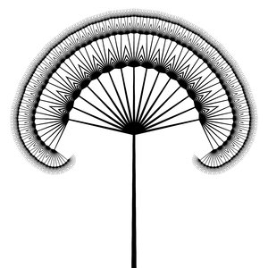 **be the change**

Objective:

The Master of Public Administration program (MPA) needs to identify itself as a unique, affordable, competitive/ successful and professional educational option. Much of this is stated in the current website but is buried in text. Cooperative dialog, directed by the 2012 MPA survey, and an agreement on the “face” of the MPA program’s message and identity is an essential first step. The ubiquity of smart devices will allow for rapid sharing of information and compelling content. To convey this message, the marketing strategy needs to utilize touch points and place focus on:

*Increased awareness of program success

*Increased awareness of the program financial value, mission, and unique character

*Increased use of interactive media to engage past, present and future students and the PA community at large/ web based marketing priority

Project/ Program plan:

*Define identity and message (idea formation in conjunction with both MPA faculty as well as the overall Evergreen college marketing design)

*Identify stakeholders and audiences

*Create meaningful and comprehensive plan (design and pilot/ revisions with the assistance of the Evergreen marketing team)

*Implement plan with the Evergreen Marketing team

*Assess and revisit

Methods:

The Evergreen State College, MPA program will use traditional and innovative methods for engaging audiences. The overall effect should be one that both promotes the program as well as produces an honest representation of the college’s MPA offerings.

|  |  |  |  |  |
| --- | --- | --- | --- | --- |
| **Social media** | **Website** | **News/ media** | **Advertising and promotion** | **Publications** |
| Twitter | MPA/Rivers | Awards | KAOS | Newsletter |
| Facebook  *Under con-sideration*  Google +/ no | Storyboards with up-worthy notations | Faculty, alumni and stakeholder publications and professional affiliations | The Olympian | Brochures  Unify and consolidate brochures for MPA and Rivers//Evergreen photos and marketing |
| Instagram/  no | Connected to youtube and linkedin | KAOS | NPR | Use web blog base newsletter |
| Linked In/Yes | Virtual tours with faculty and program elements |  | Special logo/ brand |  |
| Youtube/Yes |  |  | WA Capitol |  |
| Tumbler/no |  |  | On Campus |  |
| Hashtag/no |  |  | Volunteer causes |  |

Conclusion:

By using the survey and past/present contacts, the MPA administrative team can use tools to design and sculpt a well-defined message on the identity and significance they would like to focus their marketing and communications plan towards.

A strong and comprehensive plan that is inclusive of both past, present and future students will convey the ongoing support and value that the MPA program provides in lifelong learning. The current culture of social media and information sharing behooves the college in its ability to reach a broad audience.

The plan will try to tighten the amount of material produced and create a tight package of brochures for the MPA program as well as a linier suggestion for the Rivers of Knowledge programs. These new brochures, and the web designs, will use professional Evergreen photos and follow the Evergreen State College marketing guidelines to help create a unified look throughout the college.

The plan should focus on various audience needs as well as MPA promotion. This exciting opportunity opens the world to all that the MPA program has to offer in learning, professional advancement and in the love of community and humanity.





OLD PLAN ATTACHED:

**Marketing Plan**

**Budget**

**Calendar**

**Methods**

Direct Mail

Web Presence

Magazine/Newspaper Ads/Articles

Site Visits

Conferences

Press Releases

Alumni Relations

**Contact Lists**

Prospects

Tribal Managers

Government-Tribal Liaisons

Newsletters

Tribal Alumni

Regional Indian Organizations

**Community Monitoring**

Subscription to all regional tribal newsletters

Regular site visitations

Place ads in National magazines:

Winds of Change Annual College Guide

American Indain Graduate Sp & F

Indian Country Today Education magazine

Conference flyers:

ATNI

NCAI

NIEA

AFN

Contribute articles to tribal newletters featuring local students

Develop Evergreen MPA/Rez-based Alumni Association and newsletter

Quarterly contacts with Tribal Education Departments, Human Resource Departments, Tribal General Managers

Develop list of Tribal liaisons for agencies municipalities, governments

Make sure Tribal Governance track web presence is updated periodically

Visit each of these tribes at least once per year

Contact various government agencies to present info re: MPA Tribal Governance track

Washington Indian Education Organization