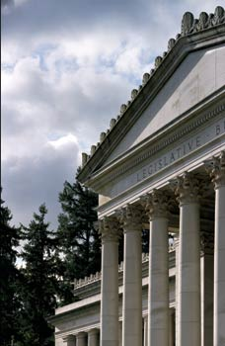

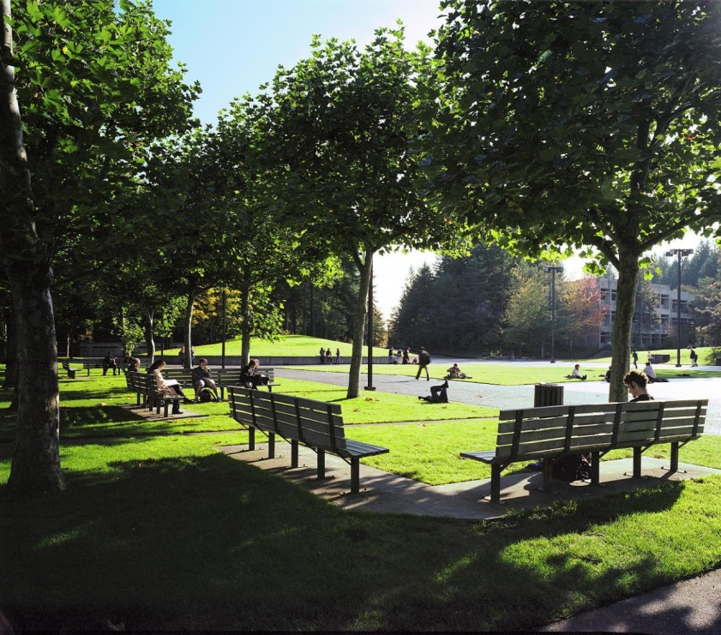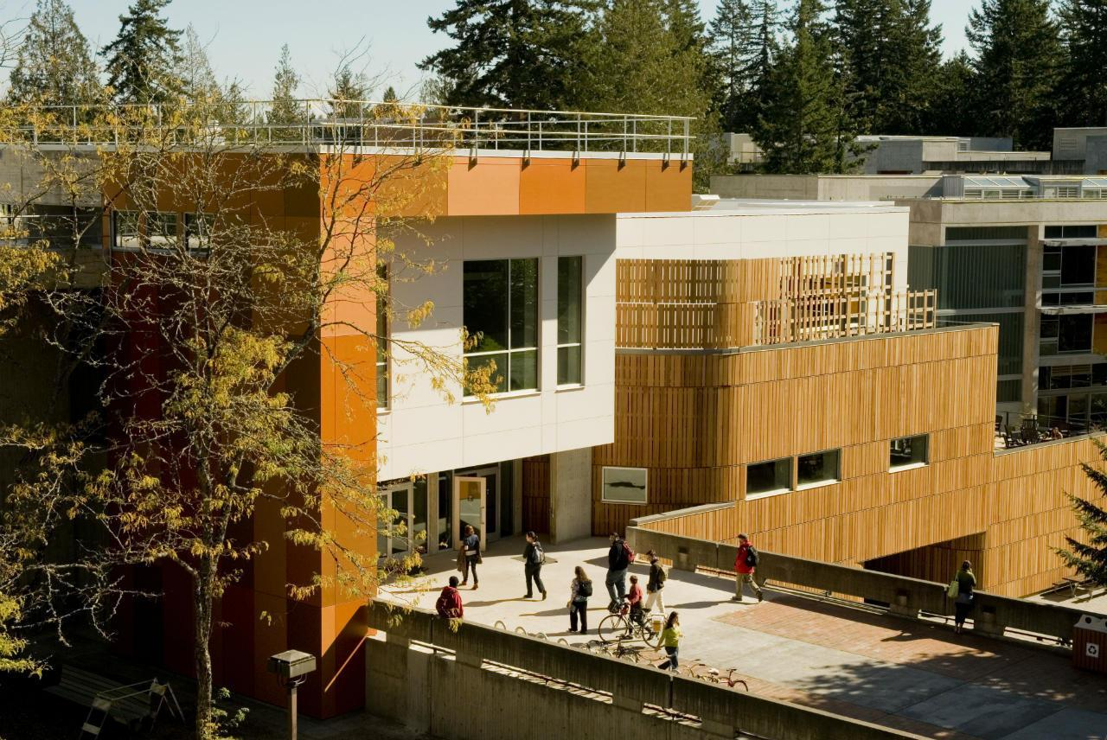

Evergreen MPA in Olympia Washington

Advanced degrees in Public Policy and Public/ Non-profit Administration offer strong skills in leadership, analysis and critical thinking.

* Evergreen offers one of the Nation’s best values in quality and affordable Master in Public Administration degrees with low-cost tuition, no required GRE, and opportunities for financial aid
* Effective, multidisciplined faculty and small class sizes add to the uniquely specialized education at Evergreen
* Convenient schedule for families, full-time workers and distance travelers
* Quality education that collaborates with Tribes, local, regional, state and federal agencies as well as non-profit and private organizations

Visit www.evergreen.edu/mpa