**Marketing Items/ note new logo to have mpa (lower case, no periods) and “… be the change” underneath** Red text are notes

* 1 MPA General Bookmark
* 3 Banners (1) MPA/table, (1) MPA Tribal/table, (1) RBCD/floor
* 3 posters/ MPA, MPA Tribal, RBCD (maybe the same design as the banner)?
* 4 Ads/ Laura did these on Publisher but may need updated to fit the college “look”
* 3 Brochures MPA, MPA Tribal, RBCD

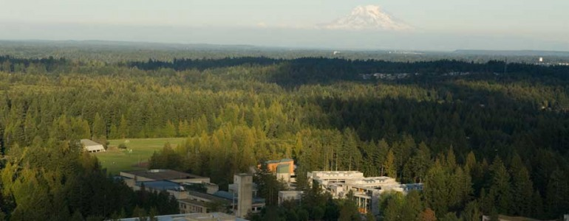

**Bookmark** *(bring example from Lewis and Clark)*

*Front*: The Evergreen State College

Master of Public Administration

* Policy
* Public/Non-profit
* Tribal Governance

Beautiful photo of campus

Back**:** [**www.evergreen.edu/mpa**](http://www.evergreen.edu/mpa) **(large up the side)**

MPA

The Evergreen State College

2711 Evergreen Parkway NW

Olympia, WA 98505

360. 867.6225 (with logo)?

MPA Tribal Banner



MPA Tribal Governance Concentration

Welcome to the Nation’s only MPA Tribal Governance Concentration. This degree offers professional credentials that reflect in-depth specialization and leadership in Indian Country.

* **Affordable**, low-cost tuition, no required GRE, and opportunities for financial aid
* **Convenient** schedule for families, full-time workers and distance travelers
* **Dynamic**, effective, multidisciplined faculty and small class sizes add to the uniquely specialized education at Evergreen
* **Quality** education that collaborates with local, regional, state and federal agencies as well as Tribes and affiliated leaders in Indian Country
* **Evergreen’s MPA program** also has concentrations in Public Policy and Public/ Non-profit Administration

Visit [www.evergreen.edu/mpa](http://www.evergreen.edu/mpa)/tribal/

MPA General Banner

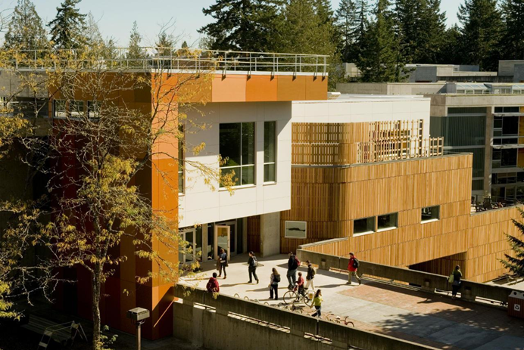

Evergreen MPA in Olympia Washington

Advanced degrees in Public Policy and Public/ Non-profit Administration and Tribal Governance offer strong skills in leadership, analysis and critical thinking.

* Evergreen offers one of the Nation’s **best values** in quality and **affordable** Master in Public Administration degrees with low-cost tuition, no required GRE, and opportunities for financial aid
* **Effective**, multidisciplined faculty and small class sizes add to the uniquely specialized education at Evergreen
* **Convenient** schedule for families, full-time workers and distance travelers
* **Nationally recognized**, quality education that collaborates with Tribes, local, regional, state and federal agencies as well as non-profit and private organizations
* Graduates **making a difference** in their communities

Visit www.evergreen.edu/mpa

RBCD Banner

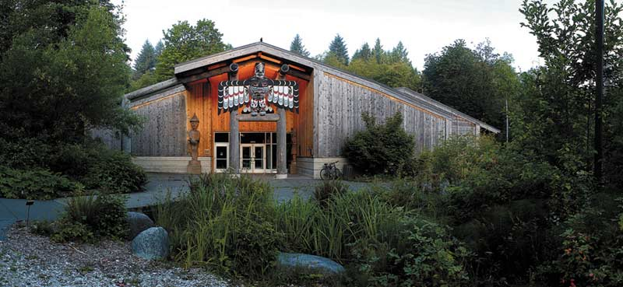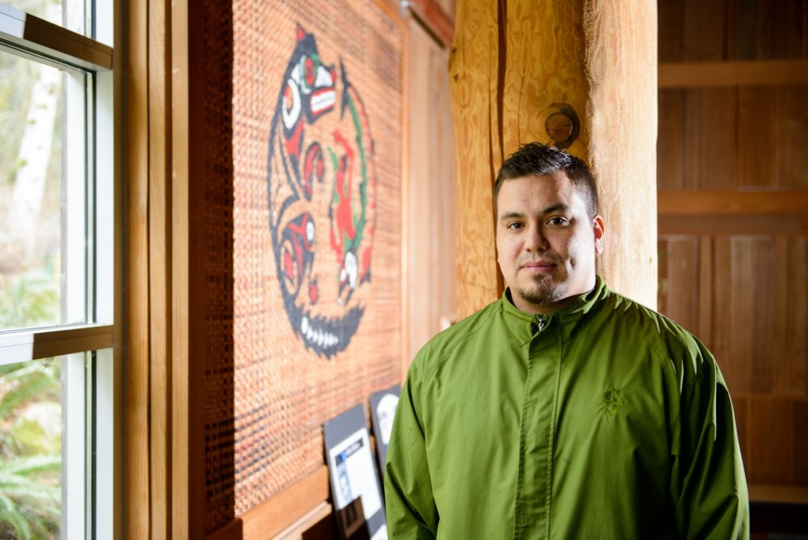

Reservation Based Community Determined Learning

*Liberation Through Education*

This unique program works closely with local Tribes and Evergreen, Grays Harbor, and Peninsula Colleges to offer on- site college level courses that prepare students to further their education with a BA or obtain an AA. The program offers a great gateway into higher education.

* **Affordable** for Tribal community members, employees or community members with strong ties to Tribal communities
* **Convenient** schedule with classes meeting at local Tribe sites as well as on campuses
* **High quality education** with indigenous knowledge, personal authority and close community, faculty and mentorship support
* New site developments out of state

Visit [www.evergreen.edu/tribal/home](http://www.evergreen.edu/tribal/home)

**Ads**

On file in Publisher

**mpa Brochure** Large Trifold/ ***Keep all green highlighted headings lower case for continuity and flow***

*Cover*: Long Green Sidebar with “mpa (large, lower case, top row) master in public administration (smaller font, lower case) be the change (smaller yet, lower case, last row)”. Bottom of bar, Evergreen logo with [www.evergreen.edu/mpa](http://www.evergreen.edu/mpa) underneath- similar to the MiT smaller size brochure. Use photo updates.

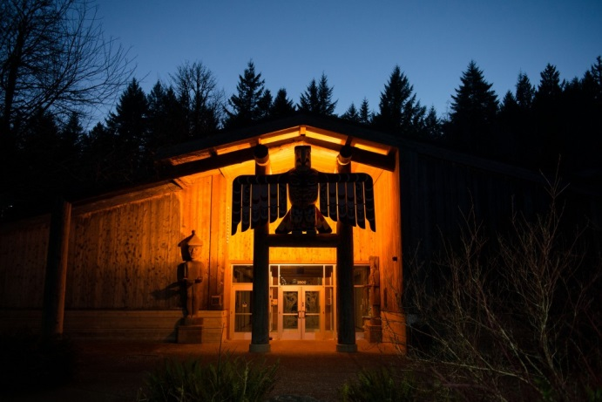



*Inside page 1:* Keep question format/ why get an mpa degree?/ add photos

Public Administration is (all in a bar)….

A set of practices that promote the public’s best interest in policies and procedures that define civil society throughout local, regional, state, federal tribal, international and non-profit, community based and private organizations.

*New headings:* value of mpa at evergreen, affordable, life- friendly schedule

value of mpa at evergreen

* Highly useable degree from a nationally recognized institution
* Acquire many practical skills for today’s workplace
* Emphasis on socially just public service, applicable to every field
* Small teaching teams with dedicated faculty and cohort/seminar models allowing for deep understanding of material
* Offers three concentrations: Policy, Public/Non-Profit & the nation’s only Tribal Governance concentration
* Uniquely located in the State’s Capitol for maximum exposure to government and supporting organizations in action
* Long lists of successfully placed alumni

affordable

* Evergreen graduate tuition runs nearly 1/3 to half the cost of comparable MPA programs
* Financial aid is widely available
* Course schedules allow for students to work full or part time jobs while they attend
* Does not require the GRE for admission

life- friendly schedule

* Program accommodates for busy family and work schedules with once a week evening and 1 to 2 weekend classes for Policy and Public/Non- Profit cohorts and 5 intensive weekend programs for the Tribal Governance concentration per quarter
* Format enables students to commute from all over the area
* Degree can be completed in 2 years (full time) or 3 or more years
* Students can qualify to take electives and statistics prior to admission

*Inside Page 2:* Keep question format/ what will you learn here?/

mpa curriculum- bar

The MPA degree consists of 60 credits. All students complete 36 credits in core coursework with the remaining 24 credits determined by their concentration of choice.

*Move up “concentrations “ bar

Band of three photos with headings of concentrations and place current information bubbles below corresponding photo***\*NOTE Tribal Governance has an error and should say* Tribal Governance meets five sessions each quarter. Each session meets Fridays, Saturdays and Sundays).**

  

Tribal Public/ Non-Profit Public Policy

Governance

Core Programs are team taught by faculty with different specializations within public administration. Cohorts typically move through the core classes together in a two year period. Each class is 6 credits and lasts a full quarter (Fall through Spring) for a total of 36 credits. The remaining course requirements are determined by the concentration each student chooses.

First Year Core is designed to give students the foundations of public administration. Students acquire the knowledge, skills and abilities to lead others and to manage within organizations in public, non-profit, tribal and private sectors.

Second Year Core prepares students in practical analytical skills and research techniques. Their experience is showcased in a required capstone or applied demonstration project involving organizations within the region.

Elective Courses allow students to tailor their degree to their particular interests. Individual study, internships and other approved graduate program courses can build onto the rich offerings in leadership, management, policy, ethics, human resources and more offered through the degree.

*Page 3 inside:* Keep question format/ how to apply/

This page can stay the same minus the application deadline

*Page 4 outside fold:* Keep question format/ what are people saying about us?



**Matt Lemon MPA 2013**

**Current Research Associate with Washington State Institute for Public Policy**

“…I have a much better grasp of the various methodologies, methods, and approaches that people use when thinking about public policy. This has been a tremendous boon in my professional work, as it has allowed me to more effectively understand and work with a variety of stakeholders that represent multiple perspectives. “

**Kendra Aguilar MPA-2012 Pursuing PHD in Indigenous Studies**

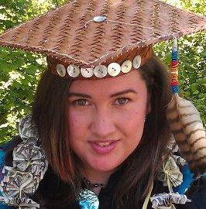

“I’ve taken with me several great things from this program. It gave me the tools I need to succeed in any public service related field as well as a lifelong network of friends and colleagues who will continue to work together towards building a brighter future for our peoples. However, the greatest contribution this program has made to me in my career serving Native communities, is the knowledge that together we can apply standard as well as our own traditional values and ways of knowing & learning to create a clear and proven pathway for Native student success. “

**Kendra is a graduate of both the Evergreen Reservation Based Community Determined Program, the MPA Tribal Governance Concentration and is part of the first ever cohort of U.S. Tribal students to pursue their Doctorate in Indigenous Development and Advancement (IDA) through Te Whare Wananga O Awanuiarangi, an Indigenous-Maori University based in New Zealand.**

Make different font /green/ statement: Washington Monthly ranks Evergreen among the top master’s colleges in the nation. This distinctive rating asks “what are colleges doing for the country?” and ranks Evergreen 29th in the nation among master degree colleges for 2012-2013 Academic Year.

Delete most quotes keep Steve Salmi and Nicole Peters/ keep Alum/employer bar but delete Alum quote at bottom and delete second quote from bottom on employers/ add to alum “It has helped me work with the Port Gamble S’Kallam Tribe by providing the educational qualifications I need for employment.”

*Page 5 back:* Keep Question format/ How do our graduates contribute?

Take out first bar and just put the paragraph under.

Add Susan Lucas and Rodney Gervais with quotes to the back page

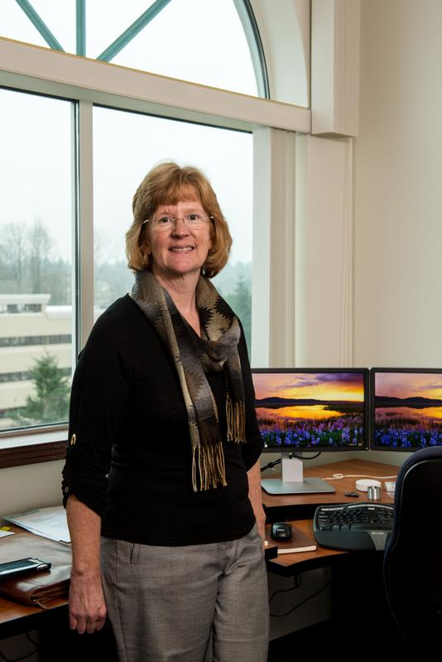

**Susan Lucas MPA 2013**

**Current Chief Operating Officer of Heath Care Authority**

“When I started the program I thought I was most interested in public policy development. As I went through the classes I realized my skills and interest lies in public administration. My skills and abilities relate to implementing public policy, managing employee groups and helping organizations adapt to organizational change and meet challenges.”

**Our Students**

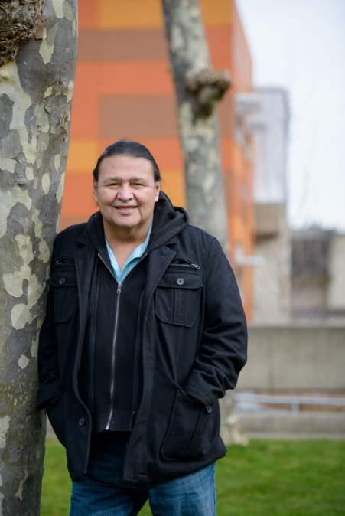

Rodney Gervais, Blackfeet, Tribal MPA expected 2014

*Rodney has worked for the Blackfeet tribe for 27 years and has served as a Tribal Chair person. He has received two A.A. degrees from Blackfeet community college, one in human services and general studies. Rodney got his bachelor degree from the University of Montana, in political science and a minor in native studies and is currently attending the MPA Tribal Governance Concentration at Evergreen State College in Olympia Washington, where he will graduate in 2014.*

Delete most long lists of specifics and keep bold headers

Keep final bar with updated mpa logo

**TG Brochure/ fits the look, colors and style of the MPA program brochure/ *should be the largest size trifold that accommodates a mail in card***

**mpa**

**Tribal Governance Concentration**

**New logo with**

[**www.evergreen.edu/mpa/tribal/**](http://www.evergreen.edu/mpa/tribal/)

**cover photos(page 1)**

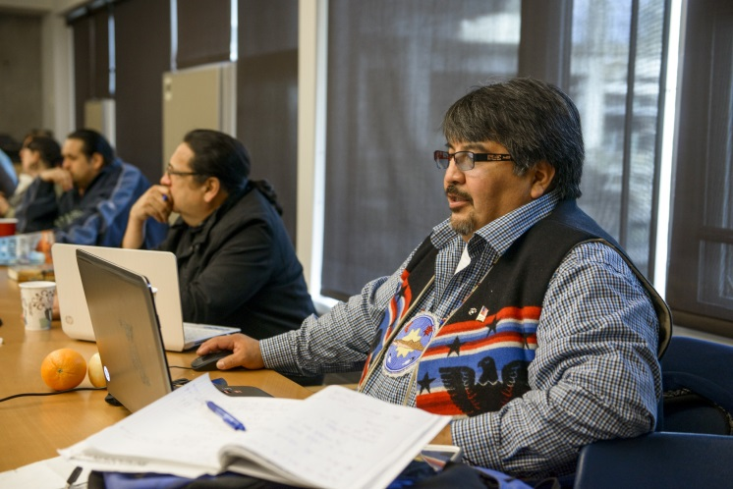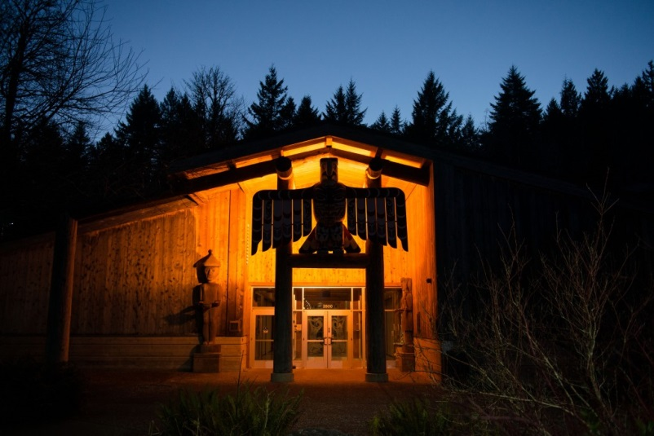 

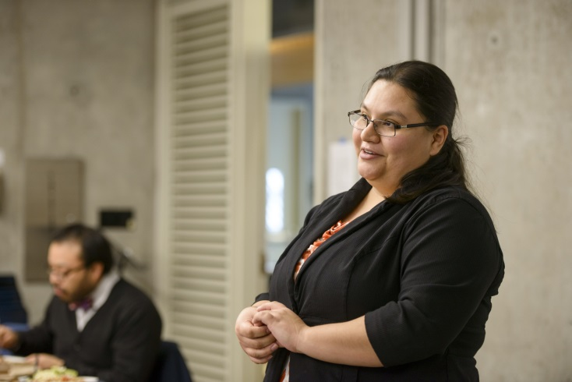

**Inside pg. 2**

**Preparing Native Leaders**

This concentration was created for present and future leaders who wish to actively engage in shaping Tribal public policy and administration. The concentration offers many opportunities for learning, research, professional development and public engagement. No other college or university in the United States offers an advanced degree or preofessional credentials that reflect in depth specialization in contemporary Tribal governance.

* Focuses on critical issues specific to roles and responsibilities of Tribal government leaders and their staff and provides them with the knowledge and skills needed to work sussessfully in Indian Country
* Informs those working with governemental or other organizations in a lianson role with Tribal governments
* Offers an innovative and highly participatory curriculum that focuses on in class work, cohort style learning, and written evaluations rather than grades
* Reflects diversity of topics addressed by tribes including health, housing,education, youth, wealfare, land use, law enforcement, human resources, transportation, fiscal policy, sustainability and economic development

**Collaborating with Local Tribes**

A survey of Tribal governemnt leaders and staff in the Northwest revealed a high level of interest in graduate studies that would equip Tribal members for the increasingly complex work in administration of Tribal governments. Tribal leaders approached Evergreen’s MPA program with their vision and a concentration was formed that not only taught the core principals of public administration but that also combined the cultural and specialized knowledge needed to work in Tribal governance and public and non-profit agencies working with Tribes. The result of the added concentration has produced many capable leaders who are giving back to their Tribes and communities.

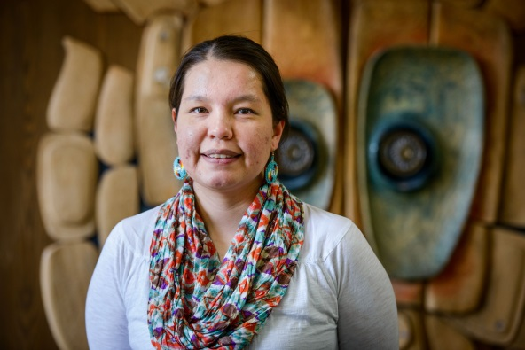

**Lexie Tom, Lummi, MPA 2014 with quote**

I chose the Evergreen MPA program because it is the only program in the Pacific Northwest area that offers the tribal government concentration. I am a Lummi tribal member who is pursuing an education for the betterment of my community. A master’s degree in tribal government fit the needs of my community.

Center pg. 3



**Designed for Your Schedule**

The Evergreen Tribal Governance MPA Concentration is organized so that students who live a significant distance away from campus can attend. Courses are taught in an intensive format, meeting **five sessions each quarter (three sessions for core course and two sessions for the concentration course). Each session is 20 hours long and meets Fridays, Saturdays and Sundays.** Students taking a full load of coursework (eight credits per quarter, fall-spring, with some summer work) can finish the degree in two years.

***Insert credit information here (from MPA general brochure)***

**Admission Requirements and Financial Aid**

The Evergreen MPA Tribal Governance Concentration admits students every other year. New cohorts begin in even years.

Admission requirements are:

* A bachelor’s degree from an accredited institution of higher education (students may be accepted pending completion of the degree). NO GRE required.
* A minimum grade point average of 3.0 for the last 90 quarter credits (or equivalent) of work toward a Bachelor of Arts or Bachelor of Science degree. There is some room for this rule and interested students should contact the college to inquire about applying.
* Evidence of writing, analytical and general communication skills of high quality and at a level appropriate for graduate study.
* Statistics (4 credit ), completed within the past three years, is a prerequisite to the MPA program.

**Financial Aid**

Many students are eligible for some form of financial aid. The college offers a number of scholarships, fellowships and tuition waivers. Most students will also qualify for student loans. Additionally, many students of the Tribal Governance Concentration have been able to obtain assistance through educational benefits offered by their Tribes.

Back cover/ center pg 6

**Our Graduates**

Graduates of the MPA Tribal Governance Concentration emerge as strong advocates and leaders both within their tribes as well as with the agencies, and non-profit organizations where they work. Several graduates have gone on to pursue their PHDs, many in Indigenous Studies.



**Kendra Aguilar MPA 2012- Tribal Governance, currently pursuing her PHD in Indigenous Studies**



**Dawn Lewis, Chehalis, MPA 2014 with Quote (back cover)**

The biggest take-away for me was the Analytical Techniques I & II comprehensive research bringing together our current and past work as teams and individuals. The amount of critical thinking and statistical data was conformed with law and ethics. I have been able to apply those learning techniques as an Executive board member, manager, and now an Associate Director of a Tribal Coalition.

***"No right is more sacred to a nation, to a people, than the right to freely determine its social, economic, political and cultural future without external interference. The fullest expression of this right occurs when a nation freely governs itself. We call the exercise of this right Self-determination. The practice of this right is Self-government."***

**— Joseph Burton DeLaCruz (1937-2000), President of the Quinault Indian Nation (1970-1994)**

***Pages 4 and 5 is a rip- out/informational mailer back to the MPA Tribal***

***Pg. 4 mailing info. (can we do postage paid? Or is it standard to do a place stamp here)***

**The Evergreen MPA Tribal Governance Concentration**

**2700 Evergreen Parkway NW**

**Olympia WA 98506**

***Pg. 5 Request for more information***

***Request for more Information : MPA Tribal Governance Concentration***

**Please contact me for more information about your program:**

**Name:**

**Mailing Address:**

**Street or POBox City State Zip**

**Phone:**

**( ) -**

**E-mail:**

**Visit** [**www.evergreen.edu/mpa/tribal/**](http://www.evergreen.edu/mpa/tribal/) **for more information**

**RBCD Brochure**

**Cover photos**

**Reservation Based Community Learning**

**RBCD- Liberation through Education**

**www.evergreen.edu/tribal**

**Evergreen and RBCD logos**

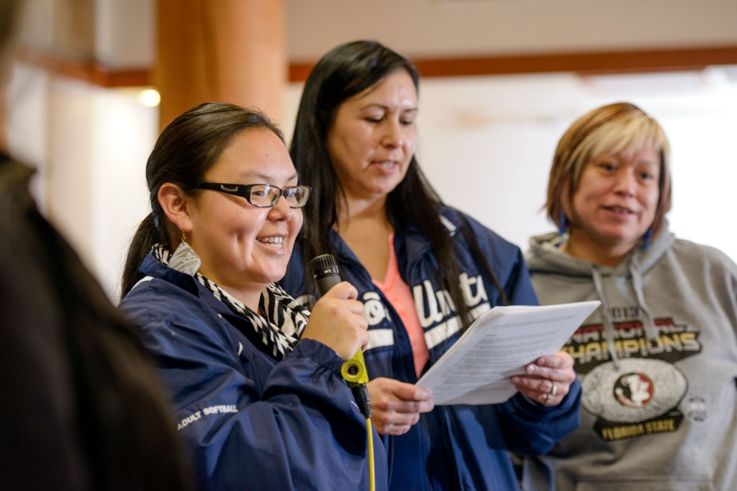

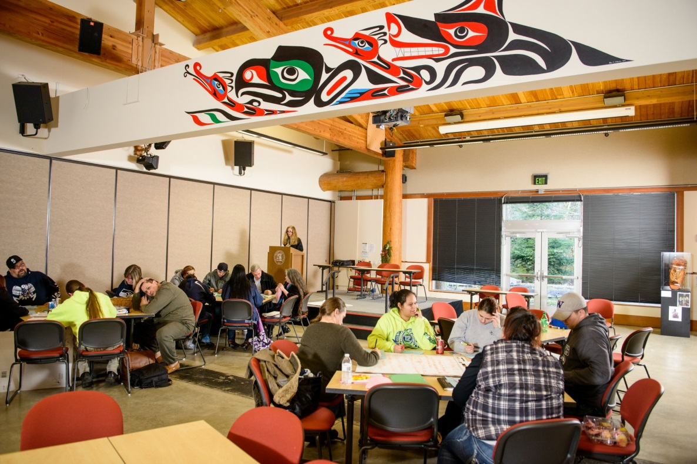

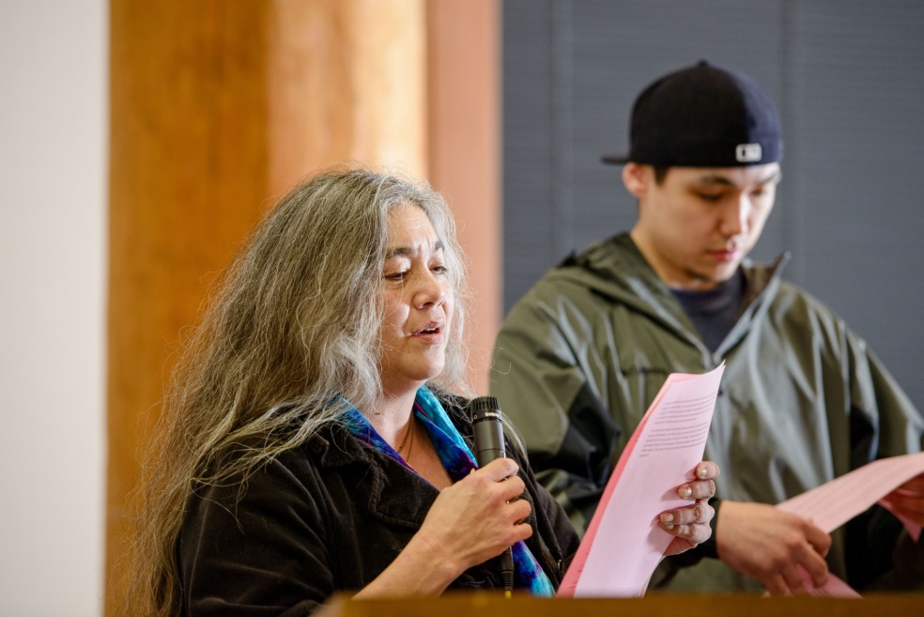

**Inside/pg2**

**Reservation Based Community Determined Learning**

**We help Native leaders emerge**

**RBCD** programs are offered to obtain a BA or an AA. The Grays Harbor and Peninsula Colleges work alongside Evergreen to offer on-line courses that bridge current students to obtain an AA and connect future/ continuing students to earning a BA. These uniquely Native curriculums transfer to continuing colleges and the Evergreen Campus BA. The RBCD Evergreen program has been serving Tribal communities for over 20 years. It serves upper division students who have 90 college credits or an AA degree. Several students go on not only to graduate with their BA but go on to earn a Masters in Evergreen’s MPA Tribal Governance Concentration.

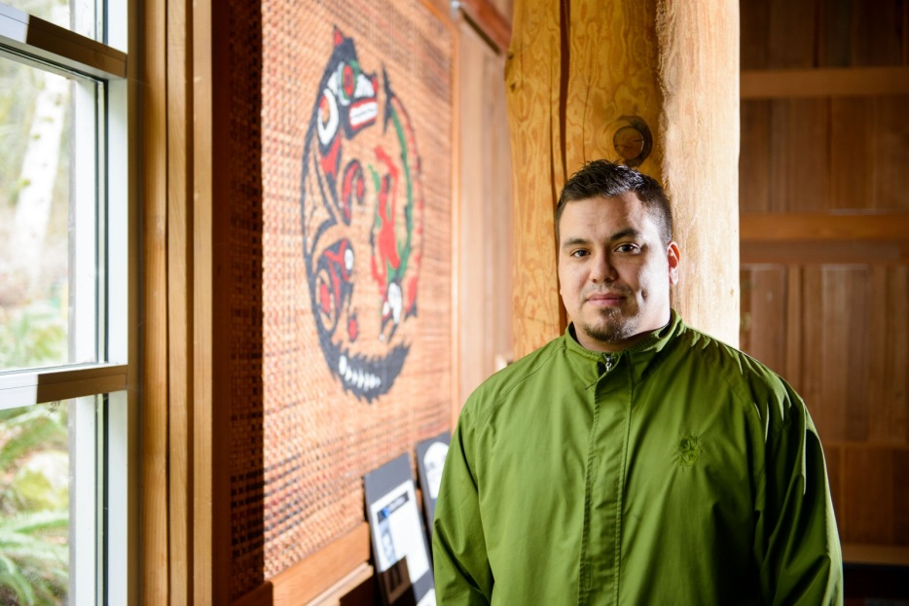

**Ricky Johnson, S’Klallam, RBCD 2014 with Quote**

*“…My friends encouraged and supported me all the way down the mountain and I made it!  That is also what the RBCD program was for me, exciting, new, vast, and fun.  I made the leap into the program and although I had bumps, bruises and was sore even after that first run through the quarter, I succeeded because I had tremendous support from all the faculty at the RBCD Program.  They wouldn’t let me start at the bunny hill.  They weren’t going to accept anything but the best from me.  I have and continue to be pushed and pushed and pushed some more to excel in everything I do.  This program prepares you for your future, whether that is going to work or continuing your education this program is the step I am so glad I took.”*



**Kendra Aguilar RBCD Graduate, MPA 2012- Tribal Governance, currently pursuing her PHD in Indigenous Studies**

**PG. 3/ inside center**

**Courses are conveniently located on reservation sites, local campuses and at the Evergreen campus Longhouse.**

The bridge programs meet ten weeks for fall, winter and spring quarters. Students work on-line and meet at reservation sites as well as four Saturdays, each quarter, at the Evergreen campus Longhouse. Students of the Evergreen campus, earning their BA, also meet for ten weeks each quarter at reservation sites on Monday and Thursday as well as four Saturdays, each quarter, at the Evergreen campus Longhouse. The program philosophy has a focus on

* Personal Authority: challenges students to be personally accountable for their attendance, engagement, learning and to declare the nature of their own work.
* Indigenous Knowledge: honors the founding principals of the program: involves community keepers of cultural and traditional knowledge and includes the indigenous perspective.
* Academics: give breadth within the liberal arts through reading, writing, research, critical thinking, analysis and other scholarly pursuits that complement personal authority and community knowledge.



**Contact us today to see which program would best suit your needs.**

PG. 6/ Back center

**Contact us:**

**The Evergreen State College**

**RBCD Program, Lab 1, Room 1023**

**2700 Evergreen Parkway NW**

**Olympia, WA 98505**

**360.867.6286**

**www.evergreen.edu/tribal**



**Pages 4 and 5 is a rip- out/informational mailer back to the MPA Tribal**

**Pg. 4 mailing info. (can we do postage paid? Or is it standard to do a place stamp here)**

**The Evergreen Reservation Based Community Determined Program**

**2700 Evergreen Parkway NW**

**Olympia WA 98506**

***Pg. 5 Request for more information***

***Request for more Information: Reservation Based Community Determined Programs***

**Please contact me for more information about your program at:**

* **Evergreen Campus**
* **Grays Harbor College**
* **Peninsula College**

**Name:**

**Mailing Address:**

**Street or POBox City State Zip**

**Phone:**

**( ) -**

**E-mail:**

**Visit** [**www.evergreen.edu/mpa/tribal/**](http://www.evergreen.edu/mpa/tribal/) **for more information**