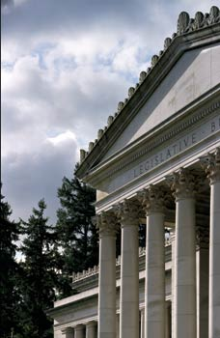****

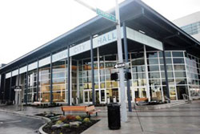

# MASTER OF PUBLIC ADMINISTRATION (MPA)

***2012/13 Program Review***

***“Be the Change”***

*Prepared by MPA Staff and Faculty*

**TABLE OF CONTENTS**

Introduction…………………………………………………………………………….……3

It's Our Program ……………………………………………………………………………3

It’s Our Presence…………………………………………………………………………...6

It’s Our People………………………………………………………………………….….13

It’s Our Design and Processes……………………………………………………...……18

It’s Our Future…………………………………………………………...…………………20

Addendum: Charts and Graphs of Importance…………………………………………24

**APPENDICES**

Appendix I - Core Competencies of the MPA program

The key knowledge, skills and abilities (KSAs)……………………………………….2

Appendix II- Faculty CV’s………………………………………………….....…………5

Appendix III - Long-Term Faculty Staffing/Rotation plan)……………………………21

Appendix IV - Full Alumni Survey Data………………………………………………..22

Appendix V - Full Employer Survey Data………………………………………..……78

Appendix VI - Student Data...................................................................................89

Appendix VII – Content Sufficiency of the MPA and Comparisons ……………….103

Appendix VIII - Annual Reports………………………………………………………………………...…….….132

**INTRODUCTION**

We, faculty and staff of the MPA program, undertook this assessment for a series of reasons. First, we were asked to do so by our Provost. In addition, we are in the habit of undertaking a serious review of the program every five years or so -- it was time. Along with our regular five-year reviews, we also review the program yearly.

It is in this context that we undertook this program review. In doing so, we reviewed all program material from 2002 (annual reports, annual student surveys, and other documents), when the program was redesigned. We conducted an alumni and employer survey, and accessed other alumni survey data collected by the college. We reviewed other MPA programs to see how our curriculum compares. The faculty and staff engaged in a year-long strategic analysis/planning process, handily assisted by Faith Trimble (CEO, The Athena Group and The Evergreen State College MPA Alumna).

What the MPA program encompasses is the question we are attempting to answer in this review. What follows is a concise, but thorough, answer to this question. Supporting documentation is found in the appendices.

**IT’S OUR PROGRAM**

**A Brief History** The MPA program at Evergreen was founded in 1980. From 2000-2001, responding to a drop in enrollment, we engaged in a re-design process, which included the last stages of work envisioning and designing a MPA Tribal Governance component. In the Fall of 2002, we rolled out our reformulated program which included three concentrations (Public and Nonprofit Administration, Public Policy, and Tribal Governance). It also included a brand new cohort - the Tribal Governance cohort. We remain the only MPA program in the United States that offers both a concentration in Tribal Governance and a cohort designed for people who work with Tribes and in Tribal governments.

In the Fall of 2008, we tinkered with the program again, slightly increasing the number of Core hours toward the degree, and decreasing elective hours. This change reflected our deep commitment to the work taught in Core courses (the work all MPA program students do, regardless of concentration) and to the centrality of Core to our program.

Each of the concentrations total 60 credit hours, with 36 credits in Core coursework and the balance in a mix of electives and requirements.

**Core Sequence (all 6 credit hours)**

|  |  |  |  |
| --- | --- | --- | --- |
|  | **Fall** | **Winter** | **Spring** |
| **First Year** | The Context of Public Administration | Doing Democratic Public Administration | Policy, Finance & Budgeting for Public Administration |
| **Second Year** | Analytical Techniques for Public Administration I | Analytical Techniques for Public Administration II | Capstone |

In the Public/Nonprofit Administration (PNA) concentration students design their choice of electives to emphasize a certain area and/or they sample various electives to discover new interests or possible career paths. The nonprofit component is integrated into the Core curriculum. Students work with faculty to create their own individual pathway and nonprofit electives are offered. The amount of Core coursework of this concentration sits firmly within the range of foundational topics outlined by NASPAA.

|  |  |
| --- | --- |
| **Degree Requirements for**  **Public Policy (PP) Concentration** | |
| 1st and 2nd Year Core  (including Capstone) | 36 credits |
| Foundations of Public Policy | 4 credits |
| Advanced Research Methods | 4 credits |
| Electives | 16 credits |
| Total Credits | 60 credits |

|  |  |
| --- | --- |
| **Degree Requirements for Public and Non-profit Administration (PNA) Concentration** | |
| 1st and 2nd Year Core (including Capstone) | 36 credits |
| Electives | 24 credits |
| Total Credits | 60 credits |

The Public Policy Concentration (PP) requires the two years of Core plus two specialized policy concentration courses, leaving students 16 elective credits from which to develop a policy pathway. We regularly offer policy arena electives.

In the Tribal Governance Concentration (TG), the two years of Core coursework mirrors the general track[1]: titles and coverage of topics are the same, with 75% uniform curriculum with the general. The unique 25% portion of the Tribal governance core curriculum situates the Core curriculum in Tribal contexts, addressing the administrative challenges of Tribal governments and their partners, and uses administrative problem-solving curriculum in a Tribal context. TG Concentration students take 20 credits of Concentration coursework and 4 credits of electives. This concentration is the most structured concentration in the MPA Program.

|  |  |
| --- | --- |
| **Degree Requirements for**  **Tribal Governance (TG) Concentration** | |
| 1st and 2nd Year Core (including Capstone) | 36 credits |
| Tribal Concentration Courses | 20 credits |
| Electives | 4 credits |
| Total Credits | 60 credits |

**High Performance Organization** The MPA program is in a very strong position, on a number of measures (tracked over time; see Appendices). Demand for our program exceeds our student carrying capacity; we've expanded, yearly, since 2002 and could continue to grow, should that be a strategic choice (in Fall 2014, we plan to grow the first year General cohort by 10 students). Our reputation in the community is strong; employers appreciate our interns/students/alumni and say that The Evergreen State College MPAs bring strong critical thinking, communication, and analytical skills and abilities to the workplace. The majority of our alumni are employed in the field and are satisfied with their employment. The majority of our students (and alumni) are satisfied with the program and recommend it to others; many believe the MPA program is a transformational experience. Our faculty and staff are active in their academic disciplines, publishing books/articles, representing the program at conferences, and serving as journal reviewers, editors and in other ways. In addition, our faculty and staff (and students) are active in community-based work. As such, we do much to positively promote the college, and the MPA program, in our communities.

**Challenges** Times are tough, locally and nationally, for higher education. Tuitions are rising, student debt is increasing, and students are more intensely considering the value of their education dollars. Competition is increasing. The national trend in higher education is toward more distance-learning methods and against the high-touch type of education we do at Evergreen. Internally, the college struggles with what to do with the graduate programs and our work is shaped by these struggles. We have had a difficult time with faculty stability in the program, due to retirements and faculty leaving the program. In particular, we have had a difficult time building a stable group of faculty and staff to work with the Tribal Governance cohort. This has led to concerns about the health and sustainability of the Tribal Governance concentration and cohort, in particular. In short, our question is how to remain innovative, flexible, strong, and stable in an ever-changing environment—i.e. to maintain a dynamic equilibrium.

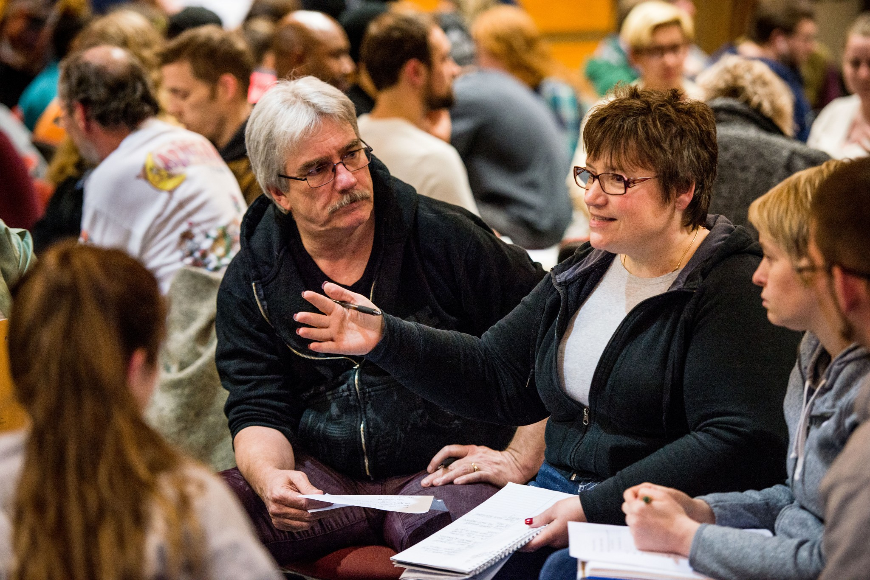

**IT’S OUR PRESENCE**

Our assessment results tell us we are doing very well, in myriad ways.

**Our Market/Niche** Our MPA program is considered medium-sized with regard to the number of students we serve, but small with regard to the number of continuing, full-time faculty (NASPAA). We serve a regional niche among other Washington State schools who offer the MPA degree. We are the only MPA program south of Tacoma down to Vancouver, Washington. We are the only (and the first) MPA in the country with a concentration in Tribal Governance.

We've grown from a program that in the first 20 years annually served 50-60 students to a program that annually serves 120-140 students, as can be seen in Figure 2. We have consistently met, and exceeded, our annual target FTE for the last six years, as can be seen in Figure 1.



**Cost-Effective and Program Demand** The program is mostly cost effective for the college -- we are a good return on the college's investment. There is high demand for the program and evidence indicates that we could continue to have more admission discretion to enhance the quality of each cohort at its current level, and/or increase the size of the program.

**MPA Mission**

### Our students, faculty and staff create learning communities to explore and implement socially just, democratic public service.

**We**:

* think critically and creatively;
* communicate effectively;
* work collaboratively;
* embrace diversity;
* value fairness and equity;
* advocate powerfully on behalf of the public; and
* imagine new possibilities and accomplish positive change in our workplaces and in our communities.

**Place Matters** Situated in Olympia, we are located in the hub of Washington state policy discussions and action. Regionally, we maintain connections with Tribes and Tribal communities both on reservations and in urban settings.

The program is one of a few MPA programs in the country with a social equity/justice mission. We are deeply committed to democratic and socially just public service, always cognizant of the effects of inequality and inequity in the framing and delivery of public service(s). We work toward mitigating these effects both in the classroom and in public service. We believe that in order to live this commitment, as our missions states, our graduates need to think critically and creatively, be imaginative and analytical, collaborate and communicate effectively, embrace diversity, value fairness and equity and advocate powerfully on behalf of the public in order to accomplish positive, transformational change in our communities. The entirety of the program curriculum is designed to meet these ends.

**Reputation** We have a strong reputation in our communities and many community leaders serve as adjunct faculty. In the 2013-2014 academic year, a State Representative/Tribal Leader, a State Senator, a Mayor, and many local, state, nonprofit and Tribal organizational leaders serve as adjunct faculty in the program. In addition, our alumni, students, faculty and staff serve their communities through volunteer and pro bono work, making significant contributions to the college's town/gown relationships.



**Quotes from MPA Alumni**

* **Nicole Peters**,**MPA 2010.** **Social Entrepreneur, Nature Nurtures Farm:**

“It's great to have a dream, but without acquiring the knowledge, skills, and abilities to achieve that vision I would still be dreaming. My experience in the MPA program added concrete skills to my passion and drive, and so far it's been a winning combination.”

* **Zach Powers, MPA 2012 -- Director of Marketing and Communications, The Grand Cinema:**

“My Evergreen MPA equipped me with a tool belt of knowledge and perspective that I utilize every day working at an arts non-profit. The practical but rigorous curriculum - which includes real-world case studies, budget exercises, and candid dialogue on subjects like diversity and ethics – is designed to not only empower graduates to advance through the public and non-profit sector, but also to be catalysts for positive change while doing so.”

* **Survey Respondent:** "I think Evergreen's unique collaborative and community learning structure is amazing and offers something that is difficult to get at any other school. The faculty and programming were responsive to student interests, yet varied enough to meet the needs of students with different professional and personal goals while the class sizes were small enough for individual support and attention. I absolutely loved the cohort model as well and gained lifelong friends and professional contacts as a result."
* **Survey Respondent:** "Lit the fuse on my public sector and related career."
* **Survey Respondent:** "I am better educated and have a grasp of how government impacts my daily life. I feel as if I have increased my self esteem and feel worthy of moving forward toward some desired life goals."
* **Survey Respondent:** "The program gave me the ability to think "360 degrees" instead of addressing public policy through only the familiar"

**Survey Respondent:** "Evergreen's MPA pushed me to consider different ways we conceive of what is public, the different ways we have to work to manage that physical, social and psychological space, and how to engage others in it."

"**Survey Respondent:** The MPA Program was the best educational experience I've ever had."

**Student and Alumni Feedback** Students and alumni believe we provide value for the money, are mostly happy with the program and over 50% percent graduate within two years (our work to develop a 2-year program has paid off), with the majority graduating within three years. Our students are diverse, in a multitude of ways (race, ethnicity, sex, see Appendix VI). And, the majority of our alumni are employed, in public service, and believe the program has positively contributed to their employment. Alumni serve their communities in many ways, through their employment and through their volunteer work/active citizenship. Our alumni take seriously the program's quest to bring about positive change they wish to see in the world.

The program has been well administered over the last 10+ years. We conduct annual student surveys and work to address any program weaknesses. In other words, we measure our performance and use the data to improve program performance.

Students, alumni and employers are generally satisfied, if not pleased, with the MPA program. The majority of alumni respondents in a recent survey indicated they are very satisfied (48%) or satisfied (44%) with how the program has served their ends. Ninety two percent of alumni respondents recommend the program to others. \**See addendum, illustration1, 2 &3*

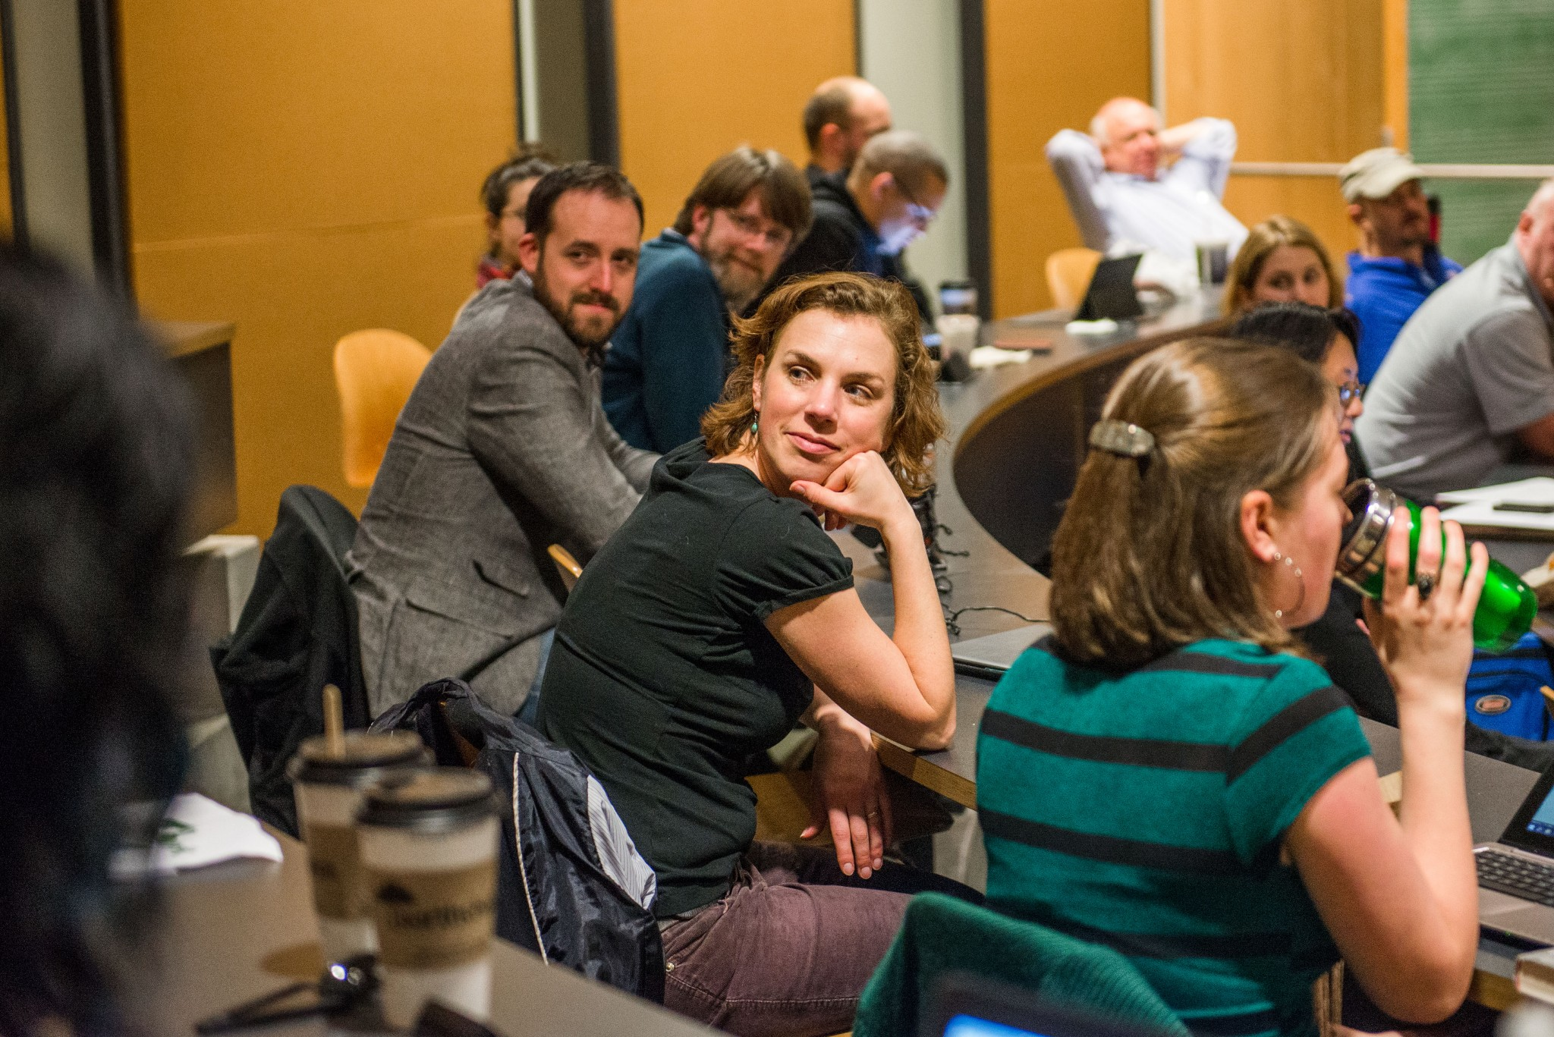

**Quotes from MPA Employers (and alumni)**

* **Ken Conte, MPA 1982 -- Director - Office of Program Research/Washington State House of Representatives**

"Having worked with Evergreen MPA students for nearly thirty years, I am increasingly impressed with how well prepared they are to enter into the work environment as productive members of our team. They are critical thinkers who dig deep, ask the right questions, and apply practical sense in their analytical work and every day work environment."

* **Steve Salmi, MPA 1995 -- Research Services Program Manager, Washington State Department of Commerce**

“Eight of our 12-person staff are Evergreen grads; five have MPA degrees. Why? Because our experience has been that Evergreen produces graduates with strong writing, problem-solving and inter-personal skills. Evergreen’s interdisciplinary focus is also a big plus because we need researchers who possess the confidence to tackle policy issues outside of their core areas of expertise. We have found Greeners to be particularly good at managing projects in fluid and politically challenging environments where a strong sense of public service is a must."

* **Alicia Seegers Martinelli, MPA 2005 -- Chief Administrative Officer, Washington State Transportation Improvement Board**

"As a full-time professional who decided to return to school and pursue my MPA, I found Evergreen’s program gave me both flexibility to do my day job and academic rigor to ensure I got more than just a diploma at the end of my studies."

"Evergreen’s MPA professors bring “real-world” experience as well as academic achievements into the classroom, teaching in a theoretical yet practical manner. Their connection with leaders in state government and local nonprofit organizations allowed me to engage in high-level global and policy discussions, and also become connected with local challenges and solutions."

* **Faith Trimble, MPA 1993 -- CEO, FLT Consulting/The Athena Group**

"In the business of management consulting, I need creative, dependable, critical thinkers who are great communicators and listeners. That is why half my staff are TESC MPA graduates. They know how to lead and follow, learn and grow, and have a natural curiosity to understand and improve systems. The MPA program is one of the greatest assets in our community!"

* **Jenny Greenlee, MPA 2005 -- Director, Finance and Performance Evaluation Division, Children's Administration, Washington State Department of Social and Health Services**
* "I use lessons learned in the MPA program every day. The program taught me to pull back, look at the big picture, examine the framing of the issue, and work collaboratively with a variety of stakeholders to find solutions. Without my degree, I would not have had access to my current career. I was able to start state service as intern because I was an MPA student and having a masters allowed me to be considered for high level budget and policy jobs through out state government. Throughout my career I have created internship opportunities and hired MPA grads because I believe they have the skills necessary to succeed and produce quality work."



**Employer Feedback** Even though the sample is small, all of the employers who responded to our survey are satisfied with the program and 92% of those employer respondents recommend the program. *See addendum, illustration 4& 5

**Student Satisfaction** We’ve collected student satisfaction data on an annual basis, starting with 2005. As can be seen in figure 3, while there have been some yearly effects and excepting those effects (e.g., 2006 &2011), the data are fairly consistent- satisfaction ranges from 82%-94%. Ratings of quality of instruction are high. The program meets the learning goals of over 80% of our students. Students are likely to recommend the program to others.

**Figure 3**

**Student Satisfaction Indicators**

|  |  |  |  |  |  |  |  |  |  |  |
| --- | --- | --- | --- | --- | --- | --- | --- | --- | --- | --- |
|  | **2003** | **2005** | **2006** | **2007** | **2008** | **2009** | **2010** | **2011** | **2012** | **2013** |
| **Satisfaction with program**  (combined very satisfied and satisfied) | **52%** | **89%** | **57%** | **94%**  (42% very, 52% satisfied) | **86%**  (36% very satisfied; 50% satisfied) | **87%**  27% very satisfied; 60% satisfied) | **84%**  (40% very satisfied;  44% satisfied) | **78%**  (35% very satisfied;  43% satisfied) | **82%**  (42% very satisfied;  40% satisfied) | **91%**  (61% very satisfied;  30% satisfied |
| **Recommend**  **the**  **Program?** | **73%** | **72%**  Strongly/generally  27% possibly | **55%**  Strongly/generally  27% possibly | **89%**  Strongly/ generally  7% possibly | **84%**  Strongly/ generally  15% possibly | **83%**  Strongly/  generally 14% possibly | **80%**  Strongly/  generally 16% possibly | **77%**  Strongly/generally 15% possibly | **88%**  Strongly /generally 10% possibly | **80%**  Strongly /generally 12% possibly |
| **Quality of Instruction**  (combined very satisfied and satisfied) |  | **94%** | **72%** | **95%** | **90%**  (50% very 41% somewhat) | **81%**  (43% very 38% somewhat) | **90%**  (46% very 44% satisfied) | **82%**  (42% very  40% satisfied) | **93%**  (57% very  36% satisfied) | **94%**  (62% very  31% satisfied) |
| **Program Meets Learning Goals**  (combined great and moderate) extent) |  |  |  |  | **87%**  (46% great 41% moderate) | **89%**  (43% great extent; 49% moderate extent) | **86%**  (46% great extent; 40% moderate extent) | **80%**  (37% great extent; 43% moderate extent) | **88%**  (59% great extent; 29% moderate extent) | **84%**  (53% great extent; 31% moderate extent) |

*not measured in 2004

We have also collected annual data from students measuring our performance in mission-specific areas. As can be seen in Illustration 5, we are doing well with room for improvement in some categories.

**Figure 4**

**Extent MPA Program Enhances Student Capabilities in Mission-Specific Areas**

|  |  |  |  |  |  |  |  |
| --- | --- | --- | --- | --- | --- | --- | --- |
|  | **2007\*** | **2008\*** | **2009\*** | **2010\*** | **2011\*** | **2012\*** | **2013** |
| **Think Critically** | 95% | 90% | 91% | 92% | 91% | 96% | 94% |
| **Think Creatively** | 87% | 81% | 79% | 75% | 78% | 93% | 93% |
| **Communicate Effectively** | 90% | 85% | 82% | 91% | 84% | 91% | 82% |
| **Work Collaboratively** | 90% | 87% | 80% | 89% | 88% | 89% | 76% |
| **Embrace Diversity** | 74% | 73% | 74% | 73% | 78% | 74% | 73% |
| **Value Fairness & Equity** | 80% | 74% | 78% | 78% | 86% | 77% | 85% |
| **Advocate on Behalf of Public** | 85% | 86% | 78% | 81% | 84% | 82% | 85% |
| **Imagine New Possibilities** | 81% | 84% | 79% | 81% | 80% | 89% | 88% |
| **Accomplish Positive Change** | 80% | 88% | 74% | 75% | 81% | 90% | 84% |

*(* % responding “great” or “moderate” extent)*

**Comparing our Core Curriculum with Peer Schools** While the MPA program is not accredited by the National Association of Schools of Public Administration (NAASPA); we are Associate Members and abide by their standards and policies. Each year we evaluate the pros and cons of becoming accredited and every year, thus far, we have determined the resource expenditure to be prohibitively beyond our reach. As is demonstrated by the scope and depth of our curriculum, our offerings do match well with national norms for similar programs nationwide.

Within the diverse range of curricular emphases within U.S. Public Administration coursework, all of the concentrations at Evergreen can be described as having a strong foundation of the basic traditional core curriculum for MPA programs, as compared with other NASPAA affiliated, peer MPA programs. In the twelve programs sampled for this comparison, the range of credit devoted to basic core MPA knowledge ranged from 38% to 65%. (See Appendix VII for more details). For all our concentrations, 53% of the curriculum is in Core coursework.

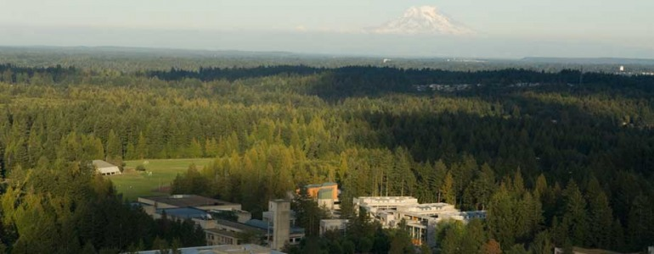

**IT’S OUR PEOPLE**

**Where alumni are employed**

* **Washington State departments and offices including:** Agriculture, Attorney General, Auditor's Office, Commerce, Corrections, Early Learning, Ecology, Employment Security, Financial Management, Health, Health Care Authority, Information Services, Labor and Industries, Licensing, Natural Resources, Puget Sound Partnership, Revenue, Social and Health Services, Superintendent of Public Instruction, Transportation, Veterans' Affairs
* **Washington State Legislature**
* **City governments, including:** Olympia, Seattle, Tacoma, Lacey, etc)
* **County governments, including:** Thurston, King, Pierce, Lewis, Mason, etc)
* **Other governmental organizations including:**Joint Base Lewis McChord, Lacey Fire District, Minority and Justice Commission,Pierce Conservation District, Tacoma Housing Authority, Tacoma/Pierce County Health Commission on Children and Youth, Thurston Conservation District, Washington State Institute for Public Policy
* **Washington non-profit organizations including:** Aberdeen School Board, Association of Washington Cities, Bellevue Community College, Casey Family Programs, Centralia College, Choice Regional Health Network, Community Youth Services, Evergreen State College, Family Support Center, Girl Scouts of America, Gonzaga University, Group Health, Grays Harbor College, GRuB (Garden Raised Urban Bounty), Hands On Children's Museum, Intercity Transit, KBTC Public Television, Loaves and Fishes, National Audubon Society, Nature Nurtures Farm, Oasis Youth Center, SafePlace, Seattle Children’s Hospital, South Puget Sound Community College, Tacoma Art Museum, Tacoma Visitors Bureau, Thurston County Food Bank, Timberland Regional Library, University of Washington, Virginia Mason Medical Center, Whatcom Volunteer Center, YMCA (Olympia, Pierce County, Seattle)
* **Tribes in Washington State including:** Chehalis, Cowlitz, Lummi, Puyallup, Quinault, Muckleshoot, Nisqually, Skokomish, Squaxin Island, Suquamish, Swinomish, Yakama and others.
* **Other organizations that work in Indian Country, including:** South Puget Intertribal Planning Agency (SPIPA), Northwest Indian Fisheries Commission, National Indian Child Welfare Association, Seattle Indian Health Board
* **National Universities and Colleges:** As both Faculty and pursuing PHDs
* **Private Consulting:** The Athena Group.
* **Out of state non-profit and government organizations, including:** Beaverton School District, Equality New Mexico, Heart of Florida United Way, Idaho Department of Health and Welfare, Oregon Department of Revenue, Portland State University, South Carolina Department of Health Services, Univ. of Wisconsin, Madison, University of California, Santa Cruz, University Of Idaho, Wisconsin Department of Agriculture
* **Federal government departments and organizations, including:** Defense, Federal Emergency Management Agency, Fish and Wildlife Service, Health and Human Services, House of Representatives, Interior, Internal Revenue Service, Peace Corps,Personnel Management, State Department, Transportation, NASA
* **U.S. House of Representatives**

Our strength is our people - our alumni, students, faculty, staff, advisory board members (which is in the process of reinstitution) and community partners. Because of this, achieving stability and sustainability around staffing, both faculty and staff, is one of our most serious challenges.

**Our Students** We have terrific students representing a plethora of public service sectors, organizations and intentions. Our students represent the best of what we do, and they serve us well in our communities.

**Our Faculty and Staff** Our faculty and staff team do much more than teach and administer the program. We work in a shared leadership team, with the MPA Program Director serving as a leader among equals. Unlike our undergraduate colleagues at the college whose only governance activities are college-wide, we do both college and MPA governance. The faculty and staff make policy decisions about the program, implement these decisions, measure and report on our effectiveness, and perform many basic administrative activities including admissions, financial aid awards and tracking, planning and implementing graduation ceremonies, advising students, building internships and other like opportunities, organizational capacity building, and sponsoring student and alumni group activities.

In addition to teaching and program administration, faculty and staff also represent the program in our communities doing community-based volunteer, pro-bono, or consulting work. We also support our academic and practice-based disciplines through writing, publishing, conference attendance, and serving in editorial roles on journals and with publishers. We also take leadership positions in professional organizations.

**Sampling of Adjunct Faculty**

* **Stephen Buxbaum** - MPA Alumnus & Mayor, City of Olympia
* **Russ Lidman** - Professor Emeritus, Seattle University
* **Marc Baldwin** - Office of Financial Management
* **Helena Meyer Knapp** - TESC Faculty Emeritus
* **Representative John McCoy** - Washington State Legislature
* **Senator Karen Frase**r - Washington State Legislature
* **Grace O'Connor** – Washington State Supreme Court
* **Kris Tucker** – ED, Washington State Arts Alliance
* **Pam Peters** – TGMPA Alumna & South Puget Intertribal Planning Agency
* **Jan Ward Olmstead** – TGMPA Alumna & American Indian Health Commission
* **Michael Mucha** – CEO, Metropolitan Sewerage District, Madison, WI
* **Larisa Benson** – The Athena Group, Former Gov Gregoire's GMAP Specialist
* **Jenny Serpa** – TGMPA Alumna & Grants/Research Consultant
* **Emily Lardner** – TESC Washington Center for Improving the Quality of Undergraduate Education
* **Ryan Warner** – MPA Alumnus and WA Department of Transportation
* **Kathe Taylor** – Department of Early Learning/OSPI
* **Marla Elliott** – TESC Faculty
* **Steve Marshall** – Research Consultant
* **Karen Champagnie Alman** - Wenatchee Valley College
* **Larry Dzieza** – Office of Administrative Hearings
* **Russ Lehman** – Consultant
* **Faith Trimble** – CEO, The Athena Group

As such, the role of faculty in the MPA program is significantly different from the role of faculty in the undergraduate curriculum. We have to work together outside of the classroom to administer the program. We teach with a limited set of faculty (choice of teaching partners is restricted). We are always refreshing our faculty base because of attrition and rotations. Unfortunately, since remodeling the program, we have yet to achieve faculty staffing stability with the program.

Rotations into the undergraduate curriculum, leaves, fellowships, and sabbaticals are vital for MPA faculty. In redesigning our curriculum, an unintended consequence emerged: full-time faculty in the MPA program need to have specific disciplinary training in the areas of public administration, urban studies, management, political science and/or economics, tribal governance or indigenous studies, among other sub-fields. Consequently, because few faculty in the undergraduate curriculum are trained in these areas coupled with their reluctance to engage in evening and weekend teaching, it is difficult to find faculty to rotate into the MPA program to periodically replace MPA faculty absences.

With an insufficient number of continuing faculty, we rely too heavily on adjuncts to teach both our Core curriculum and electives. In addition, if we were to choose to pursue NASPAA accreditation, we would likely not pass the minimum requirements for number of full-time faculty affiliated/assigned to the program. In other words, we need to hire several new faculty members.

We are fortunate that we have excellent adjunct faculty and that we can rely on them to help us fill some big gaps. These topnotch, highly experienced individuals bring extensive practitioner experiences to the classroom and we plan to continue to have electives taught by adjuncts. Nevertheless, any stable and sustainable MPA program must have a sufficient number of long-term permanent and continuing faculty to offer the consistency and stability needed in a program such as ours. In addition, it takes continuing faculty with an eye toward the future to do the kind of strategic work needed to ensure we are mission driven and perform as such, and to know when to make needed changes in the mission and curriculum.

**The MPA Director** It has always been an important value that the MPA Director have a teaching role and presence in the classroom. However, with the growth of student FTE and concomitant responsibilities for adequate oversight, the Director’s 50% teaching and 50% administrative position has become problematic. The ability to assume full teaching duties on a faculty team and fully tend to the administrative needs of the entire MPA program, with two student cohorts, is compromised. In an effort to make this position more effective, stable and sustainable, in AY2013-2014, the Director will teach at the 40% level and devote 60% of the position to administration. This is only the beginning of an effort to find the correct balance -- we can't imagine that a 10% shift of duties will make much of a difference. The position is not sustainable. We expect more will need to be done and look to this assessment process to guide us in this.

The growth of the program has a significant effect on staff and faculty. These effects are being seen particularly in the Director and Assistant Director positions. The 50/50 Director load model is a hold- over from the early years of the MPA when Directors, perhaps, supervised one staff member, there was just one cohort and the total number of students was roughly half of now.

Another way in which the position is not sustainable is the rotational nature of the position. The position reflects a core Evergreen value: faculty members rotate in and out of administrative positions so we don't create an administrative class and faculty members are always close to teaching. The job appointment is for three years and we aren't sure if that is too long or too short. The unintended, or collateral, consequences of a rotational administrative position is that staff members, particularly if they stay in their positions for a number of years (which is often worth encouraging) have to contend with rotating bosses and have to weather the effects of how different people approach the position differently. Is the rotation the best model for the contemporary MPA - what do we lose if we give it up - what do we gain? These are questions about which we hope to receive guidance from this review.

**The Assistant Directors** There are two MPA Assistant Directors (AD); one is assigned to the Tribal Governance concentration and the other supporting the Public/Nonprofit Administration and Public Policy concentrations. These positions are designed to be the first stop for addressing student needs and do the bulk of the hands-on administrative work of the program. This includes helping students track progress through program; program tracking (conditionals, graduation, etc.); recruiting and retention; providing information on internships, scholarships and financial aid; market and promote the program (newsletters, catalog, brochures); course enrollment management; cohort enrollment management; relationships with external and internal stakeholders; and event planning management and support.

Each of the Assistant Director positions have different challenges. We've yet to achieve staffing stability in the Tribal Governance AD position, and we've been hiring into this position for the past 12 years (four "permanent" people have filled this position and four at an interim level). In addition, because of the turn- over in this position, a good 40% of the job description has not been achieved for the past 4-5 years.

The Public/Nonprofit Administration and Public Policy Concentrations AD is stretched particularly thin. Not only has this position had to take the lead on most administrative duties (e.g., updating brochures, Web maintenance, orientations, graduations, financial aid) as the Tribal Governance AD was in upheaval (usually leadership for these duties are shared), the administrative work to support the two concentrations has increased, along with the size of our student body.

The serious question on the table now is how to re-structure the duties of the Assistant Director's accordingly.

**Exploratory Marketing and Administrative Support Position** In the Fall of 2013, an MPA alumnus was hired at half time for a year contract to explore the functionality of having another staff position added to assist the Director and Assistant Directors, from both cohorts, to assist in marketing and communications, and with administrative support duties. The position is being analyzed for its effectiveness not only for the MPA program, but for all the Graduate programs at Evergreen in general.

**The Advisory Board** Like most schools with successful graduate programs in public administration, we have had an advisory board to help develop and conceptualize program ideas. The Board is comprised of individuals from across a wide variety of state agencies, nonprofits, and Tribal communities. The Board has been inactive since 2009. It is being reprised in AY2013-2014.

**Student-Faculty Ratios & the Budget** College-wide, student-faculty ratios are set by the Faculty Collective Bargaining Agreement (CBA). The CBA is mostly silent and confused about appropriate faculty/student ratios in the MPA program. That said, the general student-faculty ratio set by the CBA for the program is 1-15. Most electives and course required for the Public Policy concentration run with this ratio or, if the faculty are open to it, with a slightly higher count of students. Depending on the year and on the offerings, sometimes electives are under-enrolled.

Core courses for the Public/Nonprofit Administration and Public Policy cohorts run with student-faculty ratios of, on average, about 18-1. Tribal Governance Core and concentration courses run with student-faculty ratios of, on average, 10/12-1.

The program has three major budget lines: 1) overall program administration (mostly staffing costs and overall program administration costs including advertisement, office support, support for events, etc.); 2) curricular and other support for the Public/Nonprofit and Public Policy concentrations; and, 3) curricular and other support for the Tribal Governance concentration. The Tribal Governance Concentration has been funded, from its inception, at a higher level than the other concentrations to account for the specifics of this concentration (guest speakers who need travel assistance, attendance by faculty/staff at national conferences and events, particular advertisement, etc.). This funding level is the result of founding agreements.

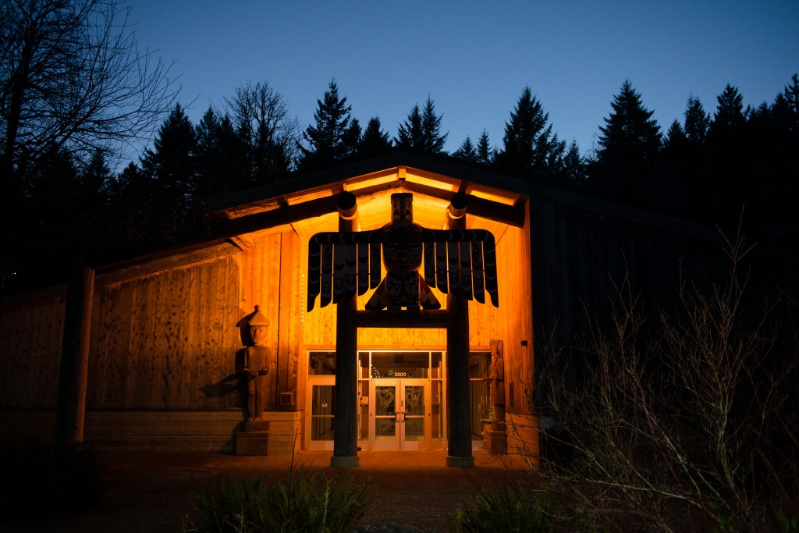

**IT’S OUR DESIGN AND PROCESSES**

Like our people, the MPA program is distinguished because of the design of our program, how we administer the program and the fact that we have been measuring annual performance for over 10 years and tweaking the program to respond to performance needs.

In 2012, the MPA faculty/staff approved a Core Competencies document (See Appendix I) that both reflects what we do in our curriculum and shapes/structures learning goals and outcomes for all Concentrations. We continue to work on fully implementing this policy.

In short,with a large percentage of coursework devoted to traditional core coursework, all of our concentration offerings meet national norms through placing significant emphasis on traditional Core MPA coursework (as defined by NASPAA and peer programs).

Another strength of our program is the cohort model. Currently, we have three cohorts in operation each year. The Tribal governance cohort (generally 20-25 students - the Tribal Governance concentration runs one year at a time) and the First year and Second year of the Public/Nonprofit Administration/Public Policy cohort (we admit between 55-60 in the first year and retain between 45-50 in the second year). In addition, there are a handful of students on a longer-to-program-completion plan (3 or 4 years).

Students and alumni consistently tell us that the cohort model is a precious and important part of their MPA. They work with the same group of students through their Core work (for the Tribal governance cohort, through most of their coursework). They form life-long relationships, provide networking opportunities for each other, and support each other through their programs. They deal with cohort problems together.

Another important (and unique) part of the MPA is that the Core curriculum is team taught, by an inter/multi-disciplinary team, and often by the same faculty for the entire year (one faculty position may be rotational and filled by a practitioner, to provide the practitioner perspective). Working with the same team, over the course of a year, enriches the experiences for both students and faculty.

Finally, as for the rest of Evergreen, seminar is a key learning component in the MPA program. Seminar is the time set aside (usually every class session) for students to have a discussion, together (with faculty, preferably, playing a minimal role), centered on the readings or class activities. When seminar goes well, students and alumni cite it as one of the most important parts of the teaching/learning environment.

The program has always encouraged students to engage in internships as they study. Remaining academically stable in a dynamic and ever-changing policy and administrative problem-solving environment implies a close relationship by the MPA program with many governmental and non-governmental entities. Recently, we've had much more activity around internships than we have in the past: organizations are contacting us at a higher rate than in the past and more of our students are in need of, or desire, internships. This activity has also increased the administrative load of the Assistant Directors.

**Agile Planning/Innovation - Achieving Stability & Dynamic Equilibrium** Putting together the curriculum described above, while assuring integration of the key theory and practices in the field and integrating current public policy issues, is a challenge. As already indicated, the current curriculum planning processes annually seeks input about program satisfaction from students both informally and through written surveys. At a series of faculty/staff meetings, faculty and staff collaboratively assess this information and attempt to balance demand with what has been offered in the past. This process allows opportunities for proactive and reactive agile course planning and delivery. The faculty has begun discussions on how to weave our Core Competencies into the expectations section of each our classes. We will also add these into our Student Handbook and to the MPA website. This will strengthen and highlight anticipated outcomes associated with each of our classes.

**Dependency/Independency on other College Departments** While we receive assistance from college departments that do this work for the undergraduate functions of the college (e.g., Admissions, Financial Aid, Marketing), in the end, we perform the majority of the work of these fringe administrative functions for our program. This puts us in a unique position of being dependent on some college units for the inputs into our processes, but independent to do the work itself. This dependent/independent relationship poses many challenges in administrating our program. Our preference would be to perform our administrative functions ourselves. This is particularly the case with admissions. This, however, begs the question of job duties for staff in the MPA program, whether we have capacity to bring in new duties and whether job descriptions are right sized and appropriate for the positions.

**Growing Research Organizations Affiliated with our Program** Prior to organizational changes, the MPA Program was affiliated with the Northwest Indian Applied Research Institute which brought value to the MPA program and created opportunities for faculty and staff. Even then, we were in need of more institute-like arrangements to support faculty and students in their research and outreach work. As of January, 2014, the MPA program has partnered with the Center for Sustainable Infrastructure. This is a start-up research center, currently in the process of being built by the founder, Rhys Roth. Amy Gould, a faculty member with the program, is involved in conversations around starting a Non-Profit research institute affiliated with MPA Program.

Our Provost is very clear about entrepreneurial activity: we welcome it and every new venture must be 100% self-sustaining.

**IT’S OUR FUTURE**

What does success in the future look like for the MPA program? It is critical that students continue to perceive value for their education dollars coupled with our alumni/employers affirming that value in the post-graduate years. The program needs to meet the demand for quality education. Our graduation rates needs to remain at 90%+ of enrolled students. We need to be able to attract and enroll a broad diversity of students, while demonstrating good return on investment to TESC. We need to maximize our advantage of being in the state’s capital, the heart of the Washington State’s policy development environment.

In order to be successful there is an ongoing need for agility, stability, and sustainability while delivering a quality program. As such, the following areas require special attention in the near and intermediate future.

**The Cohort/Curricular Structure** The existing cohort structure only weakly provides for the type of rich discussions between the cohorts (Tribal Governance and General) that the faculty and students desire. There's a tension between the cohorts that gets played out between and within faculty and students. Cross-cohort rumors and talk indicate discrimination, on both the faculty and students' parts, and moving in all directions. Several years of instability in faculty/staff staffing in the Tribal Governance cohort has led to a less-than-well feeling amongst the Tribal cohort. This needs to be fixed and we are hoping for guidance from this assessment.

Many students have expressed a need for a non-profit concentration within the program. This includes more defined electives and targeted internships created from MPA program partnerships with various not-for-profit agencies in the region. In addition, a faculty team is working on examining the potential of starting a local/regional government concentration in the program. It seems the opportunities are there to expand and grow. But, can we?

**"Permanent Whitewater"** To develop this metaphor provided by faculty member Larry Geri (attributed to Peter Vaill - http://ww4.ccl.org/connected/enews/articles/0803vaill.htm), one can kayak or raft in calm waters and one can kayak in whitewater. The best kayaking/rafting experience includes both, with sufficient time in between to rest and prepare. The best experience includes the time and opportunity to predict or expect your next occurrence of whitewater. And, permanent whitewater can be very costly, often in the loss of people and equipment.

This metaphor aptly describes the situation of the MPA program over the past 10 years. We've been in perpetual whitewater, all the while performing at a high level. The last 10 years have felt like fundamental turmoil, always one step away from melt down. While we may have reacted well, according to our performance measures, permanent whitewater takes a toll. It may well be that the fundamental improvement needed -- faculty and staff stability -- may be related to this toll.

**Inside/outside Relationships to Rest of College** Student support should be fully accessible, culturally appropriate, and geared towards adult students who are professionals. Students in the Tribal Governance cohort have often struggled with weekend housing and childcare, and having access to Enrollment Services offices – especially financial aid, Food Services, and the Bookstore and the Library. Ensuring that these offices are open at least during the lunch hour on weekends would enable students to utilize these much-needed resources during the limited times they are on campus. Placing an emphasis on weekend classes in the Building Services department would eliminate issues with classroom lockouts, and heating. In addition, increased coordination with Media Services on the weekends would streamline class time when media problems arise. Evergreen could work to enhance student life, from having more opportunities to connect with campus cultural activities by building the graduate community support and recognition while lessening a feeling of isolation that often occurs with weekend-only students.

In addition, more scholarships and financial aid should be made available to students, and Evergreen Foundation scholarship accounts must be replenished regularly. To enhance student life, students would benefit from having more opportunities to connect with campus cultural activities to build community and lessen a feeling of isolation that often occurs with weekend-only students.

An important part of our improvements is the new Online Application process for all three graduate programs. This has moved us away from the online paper submission process and put us on par with our competing graduate programs nationwide. There are a number of implementation problems with the system, not the least of which is that CollegeNet (online application) and our (What do we call Banner) Banner don’t “talk” to each other.

The college lacks a fully coordinated computerized student application monitoring and tracking system. This deficit significantly adds more time and work to the duties of all graduate programs assistant directors. We will continue to lobby the college to investigate and purchase this service for everyone.

There is a long history of efforts to co-locate and a share resource with the other two Evergreen graduate programs. In 2010 another opportunity arose when the Labor Center was relocated off campus making space available for both the MPA and MES programs to move closer to the MIT program offices. The effort unfortunately failed. We tried again to co-locate in the summer of 2012 and these efforts also failed. Since these programs share many common support needs it would be efficacious to continue to seek ways to co-locate the graduate programs and include a shared and dedicated supporting administrative staff.

Our MPA general website is undergoing close review and update this year, along with the college’s main website. We continue to extend our marketing and promotion into social media outlets involving closer coordination with our alumni database.

**Faculty and Staff** We need to continue efforts to stabilize the faculty staffing and rotation system. Our goal is to be able to staff the Core classes each year with continuing faculty. For a host of reasons we may not wish to, however we need the capacity to do so. While a rich offering of electives taught by adjuncts will always be desired and important, we need to reduce our dependence on them for teaching our most critical subject areas. Comments in our surveys also indicate that this would also help with student satisfaction. Adequate faculty and a good rotation plan provides stable faculty student advising, coherent opportunities for the faculty to stay current on topical policy issues and research through sabbatical opportunities, and sets the stage for rational and non-disruptive succession planning for MPA faculty periodically to assume the Director’s duties.

The work load and responsibilities of both the Directors and the Assistant Directors require attention, for all the reasons mentioned previously.

**Relationships/working with other Indian Education Offerings on Campus** The college provides academic services to address a range of needs of Native American students—on-campus undergraduates, reservation based, native arts, as well as our Tribal graduate students. A new Native American Planning Unit, as well as efforts to add a fourth masters program in Native American Arts, are under development. These open the door to creative approaches and links with our Tribal Governance students in our MPA program. Consequently, we need to support and work with these initiatives. Positive partnerships with all people and units working on Indian education at Evergreen are needed.

**Partnership Development** Because of the success of our students’ performance in internships, agencies in a number of sectors have approached us to establish more structured partnerships that can provide them with a reliable pool of interns, while offering our students critical internship opportunities. A few of these include the Washington State Institute for Public Policy, Thurston Co. Public Health & Social Services, Mason County Facilities, Parks & Trails Department, the Department of Fish and Wildlife, the Department of Natural Resources, the Department of Commerce, Washington Non-Profits, the City of Olympia, and a host of other Washington State agencies. We need to develop these further into active partnerships, paying particular attention to links to our areas of concentration. And, we need to sufficiently analyze the effects of these new partnerships with regard to administrative costs - who is managing these partnerships from year to year?



**The Faculty Collective Bargaining Agreement (CBA)** The existing union contract, as spelled out in the CBA, fails to address the unique situation in Evergreen’s graduate programs. These programs have highly specific course content to deliver that is often established by national accreditation institutions. This hampers the ability of faculty to rotate throughout the college to meet union contract stipulations concerning the number of teaching partners within a specified period and working with college freshmen. The contract is also silent on many other aspects of the duties and obligations of graduate faculty and directors. Consequently, for the past several years, the directors of all three graduate programs have been working with both the administration and union representatives to update the contract. This work needs to continue.

**Advisory Board** We will renew and restart a functioning MPA Advisory Board this year. The existing members are local active professionals in the field and are consequently very busy. For the past several years, we have had no meetings of the Board due to a significant number of last minute cancellations. We also have a need to diversify membership as it was with the original Advisor Board. There are currently no Native American board members.

**Budget and Finance** Though the program is currently adequately funded, there is a need to enhance the financial resources of the program for student conferences, contests and incidentals. There has been very little interest in the past and currently to grow and support the Student Union, who traditionally helped to create scholarships for fellow students to attend conferences and etc. Additionally, scholarships and financial aid should be made available to students, and Evergreen Foundation scholarship accounts must be replenished regularly.

**Do we want to grow? If so, where do we want to grow?** An increasing number of applicants over the past several years indicate an opportunity to grow the size of the program. Growth would bring in more dollars and serve more students. However, this would also require additional resources in staff, faculty, and space. In addition, there is a valid case as to whether new resources instead should be focused on providing the unmet needs of the program at its current size before physically expanding. These include initiatives to stabilize the number of faculty, firming up a host of staff/college support/college, strengthening our student advising/mentoring approaches, and stable/reliable internships to strengthen ties to MPA student employers and the community. The questions are one of quantity versus quality; could either approach pay for itself; and can both be accomplished simultaneously? Central to answering this is discussions about the very definition of ‘quality’ at any desired size and the challenges inherent in providing it. We are currently growing as a pilot for the 2014-2015 year. The general cohort will accept an additional 10 students into the combined Public/non-profit and Public Policy concentrations.

In addition to the pilot, the MPA program is exploring the addition of new concentrations, such as Local Government and Non-Profit, as well as the addition of certificates.

**ADDENDUM**

**CHARTS AND GRAPHS OF IMPORTANCE**

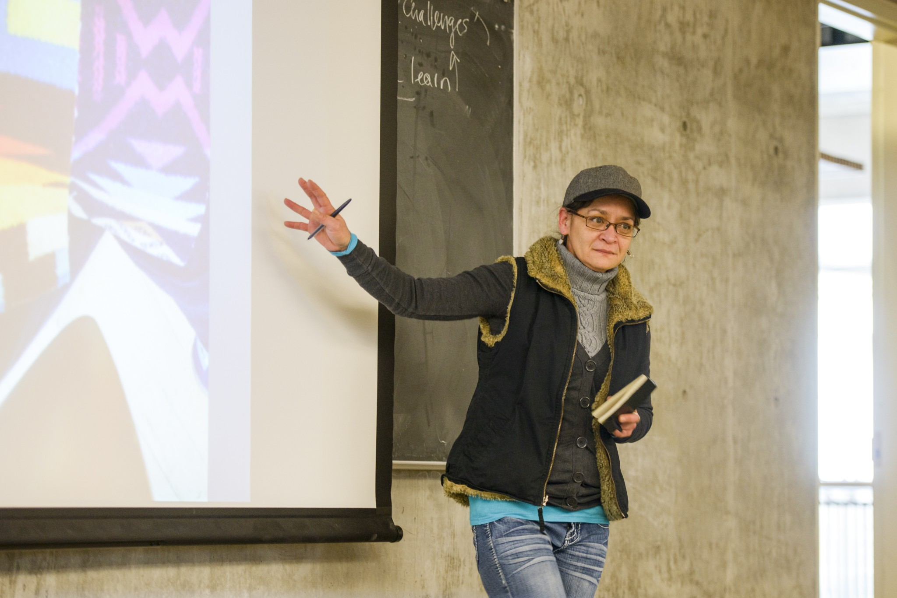

Illustration 1

Alumni Survey Respondents

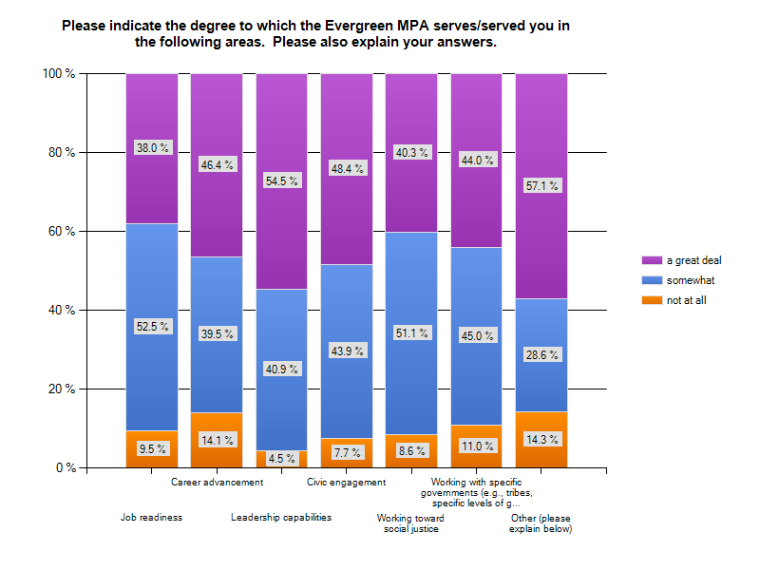

Illustration 2

Alumni Survey Respondents

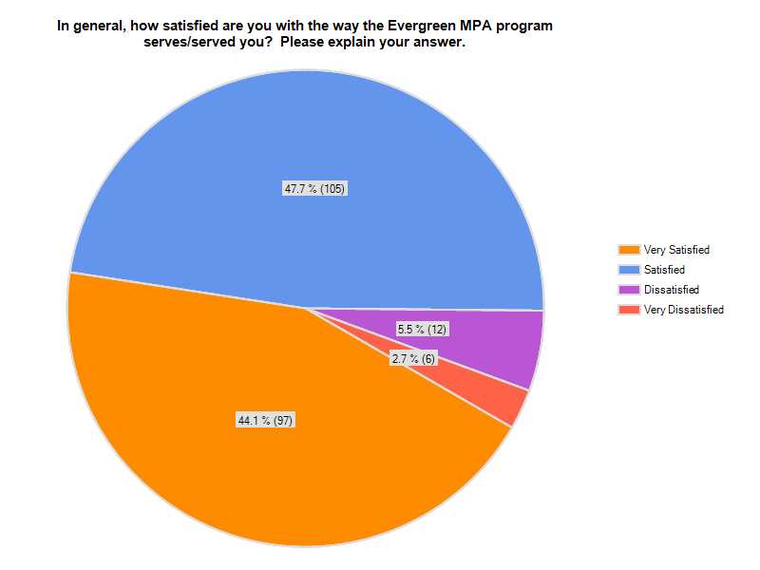

Illustration 3

Alumni Survey Respondents

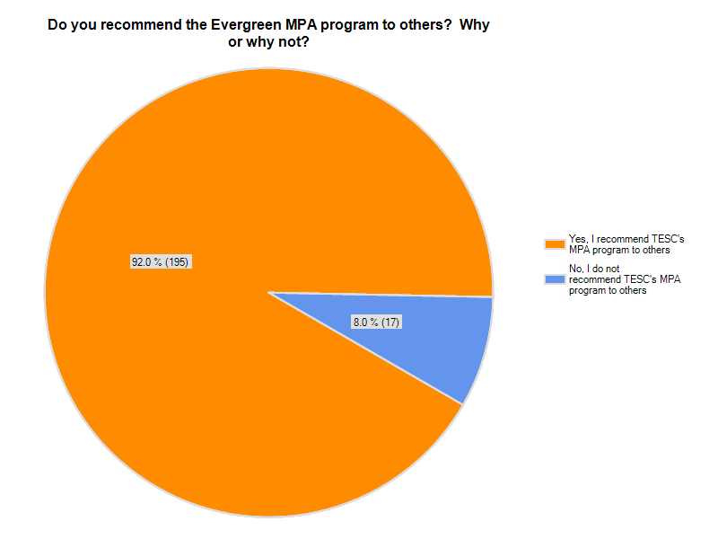

Illustration 4

Employer Survey Respondents



Illustration 5

Employer Survey Respondents



1. We are currently looking for a new name for the “General” track/cohort