***Illustration 1: Alumni- Survey Respondent***

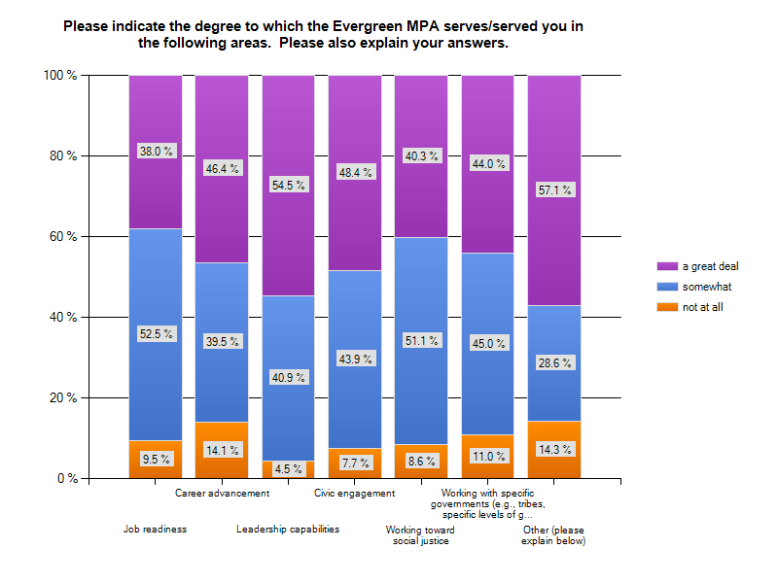

***Illustration 2 and 3: Alumni- Survey Respondents***

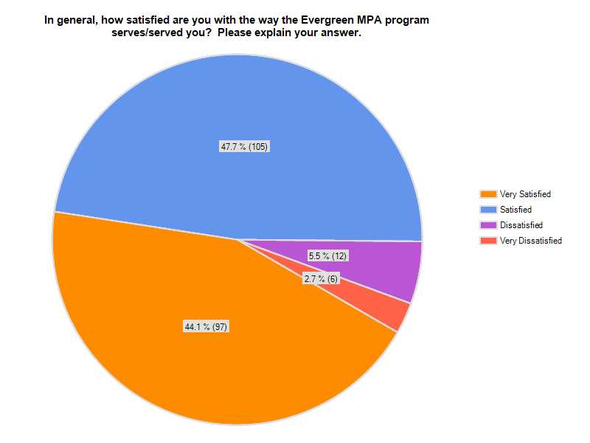Illustration 2

Illustration 3

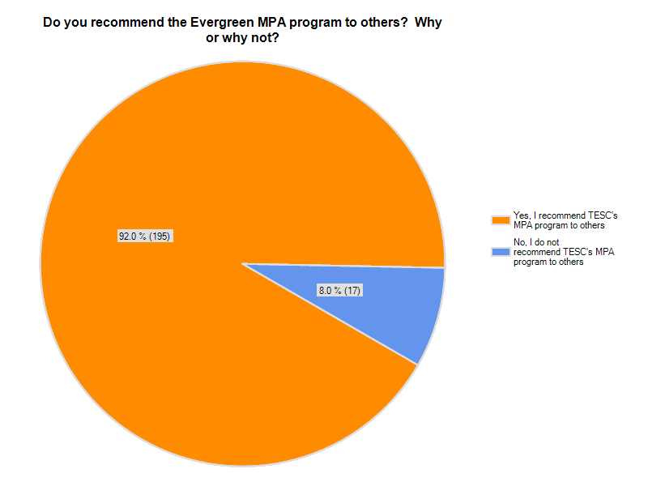

***Illustration 4 and 5: Employer- Survey Respondents***

Illustration 4



Illustration 5