It's our Program

We, faculty and staff of the MPA program, undertook this assessment for a series of reasons. We were asked to do so by our Provost. In addition, we are in the habit of undertaking a serious review of the program every five years or so -- it was time. Along with our regular five year reviews, we also review the program yearly.

A Brief History. The MPA program at Evergreen was founded in 1980. From 2000-2001, responding to a drop in enrollment, we engaged in a re-design process, which included the last stages of work envisioning and designing a MPA Tribal component. In the Fall of 2002, we rolled out our reformulated program which included three concentrations (Public and Nonprofit Administration, Public Policy, and Tribal Governance). It also included a brand new cohort - the Tribal cohort. We remain the only MPA program in the United States that offers both a concentration in Tribal Governance and a cohort designed for people who work with tribes and in tribal governments.

In the Fall of 2008, we tinkered with the program again, slightly increasing the number of Core hours toward the degree, and decreasing elective hours. This change reflected our deep commitment to the work taught in Core courses (the work all MPA program students do, regardless of concentration) and to the centrality of Core to our program.

High Performance Organization. The MPA program is in a very strong position, on a number of measures (tracked over time; see Appendices). Demand for our program exceeds our student carrying capacity; we've expanded, yearly, since 2002 and could continue to grow, should that be our strategic mission. Our reputation in the community is strong; employers appreciate our interns/students/alumni and say that TESC MPA people, in particular, bring strong critical thinking, communication, and analytical skills and abilities to the workplace. The majority of our alumni are employed in the field and are satisfied with their employment. The majority of our students (and alumni) are satisfied with the program and recommend it to others; many believe the MPA program is a transformational event. Our faculty and staff are active in their academic disciplines, publishing books/articles, representing the program at conferences, and serving as journal reviewers, editors and in other ways. In addition, our faculty and staff (and students) are active in community-based work. As such, we do much to positively promote the college, and the MPA program, in our communities.

Challenges. This said, the times are not without their challenges. Times are tough, locally and nationally, for higher education. The national trend in higher education is toward more distance-learning methods and against the high touch type of education we do at Evergreen. Our MPA program is always at risk of competition. Internally, the college struggles with what to do with the graduate programs and our work is shaped by these struggles. We've had a particularly difficult time with faculty stability in the program, due to retirements and faculty leaving the program. In particular, we've had a difficult time building a stable group of faculty and staff who work with the tribal cohort. This has led to concerns about the health and sustainability of the tribal concentration and cohort, in particular.

This Program Review. It is in this context that we undertook this review. In doing so, we reviewed all program material (annual reports, annual student surveys, other documents - See Appendices for specific documents) from 2002, when the program was radically reformulated. We conducted an alumni and employer survey, and accessed other alumni survey data collected by the college. We reviewed other MPA programs to see how our curriculum compares with others. The faculty and staff undertook a year-long strategic analysis/planning process, handily assisted by Faith Trimble (CEO, The Athena Group and TESC MPA Alumna).

What follows is an abbreviated presentation of our findings; details can be found in various appendices.
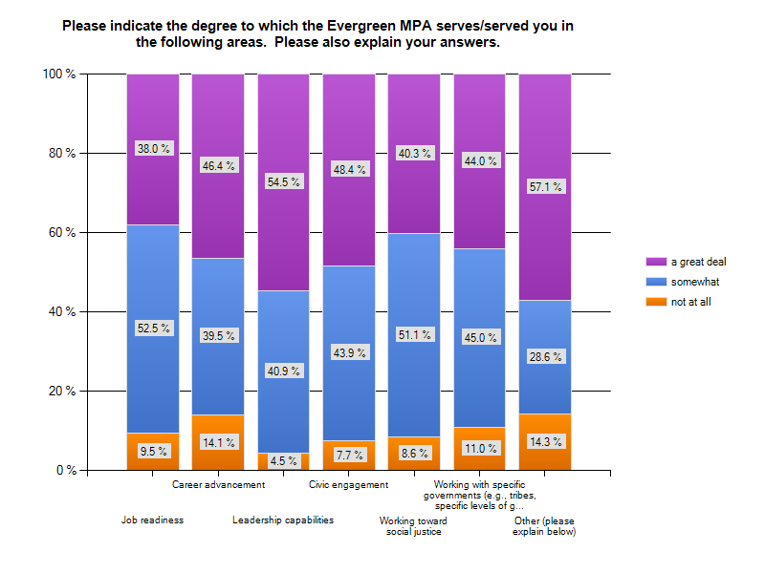
It's our Presence

Our assessment results tell us we are doing very well, in myriad ways.

Student and Alumni Feedback. Students and alumni believe we provide value for the money, are mostly happy with the program and a high percent graduate within 2 years (or work to develop a 2 year program has paid off). Our students are diverse, in a multitude of ways (race, ethnicity, sex, ideologies). And, the majority of our alumni are employed, in public service and believe the program has positively contributed to their employment. Alumni serve their communities in many ways, through their employment and through their volunteer work/active citizenship. Our alumni take seriously the program's tag-line, from Mahatma Gandhi: "You must be the change you wish to see in the world."

The program has been well administered over the last 10+ years. We conduct annual student surveys and work to address any program weaknesses. In other words, we measure our performance and use the data to improve program performance.

Cost-Effective and Program Demand. The program is mostly cost effective for the college -- we are a good return on the college's investment. There is high demand for the program and evidence that we could continue to have some admission discretion and also grow the program (if this is a route we decide to take).

Reputation. We have a strong reputation in our communities; community leaders serve as adjunct faculty. In the 2013-2014 academic year, a State Representative/Tribal Leader, a State Senator, a Mayor, and many local, state, nonprofit and tribal organizational leaders will serve as adjunct faculty in the program. In addition, our alumni, students, faculty and staff serve their communities through volunteer and pro bono work, making significant contributions to the college's town/gown relationships.

Our Market/NIche. Our MPA program is considered a medium-sized program. We serve a regional niche among other Washington State schools who offer the MPA degree. We are the only MPA program south of Tacoma down to the Washington/Oregon boarder. Situated in the State Capitol, we are located in the hub of Washington state policy discussions and action. This gives our MPA program the ability to focus on real world practical policy and administrative issues while we teach the comprehensive range of administrative theory and history of public administration.

Comparing our Core Curriculum with Peer Schools. While the MPA program is not accredited by the National Association of Schools of Public Administration (NAASPA), we are associate members and abide by their standards and policies. Each year we evaluate the pros and cons of becoming accredited, and every year thus far, we have determined the cost to be prohibitively beyond our reach. As is demonstrated by the scope and depth of our curriculum, our offerings do match well with national norms for similar programs nationwide.

Within the diverse range of curricular emphasis within U.S. Public Administration coursework, all of the concentrations at Evergreen can be described as having a strong foundation of the basic traditional core curriculum for MPA programs, as compared with other NASPAA affiliated, peer MPA programs. In the twelve programs sampled, the range of credit devoted to basic core MPA knowledge ranged from 38% to 65%. For all our concentrations, 60% of the curriculum is in Core coursework.

The MPA program consists of three concentrations, each totaling 60 credit hours, with 32 credits in Core coursework and the balance in a mix of electives and requirements.

CORE SEQUENCE
(all 6 credit hours)
 | Fall | Winter | Spring
First Year | The Context of Public Administration | Doing Democratic Public Administration | Policy, Finance & Budgeting for Public Administration
Second Year | Analytical Techniques for Public Administration I | Analytical Techniques for Public Administration II | Capstone
Degree Requirements for
Public Policy Concentration
1st and 2nd Year Core  (including Capstone) | 36 credits
Foundations of Public Policy | 4 credits
Advanced Research Methods | 4 credits
Electives | 16 credits
Total Credits | 60 credits

Degree Requirements for Public and Non-profit Administration Concentration
1st and 2nd Year Core  (including Capstone) | 36 credits
Electives | 24 credits
Total Credits | 60 credits

In the Public and Nonprofit Administration Concentration (PNA) students design their choice of electives to emphasize a certain area and/or they sample various electives to discover new interests or possible career paths. The nonprofit component is integrated into the Core curriculum. Students work with faculty to create their own individual pathway and nonprofit electives are offered. The amount of Core coursework of this concentration sits firmly within the range of foundational topics outlined by NASPAA.

The Public Policy Concentration (PP) requires the two years of Core plus two specialized policy concentration courses, leaving students with a significant amount of elective credit (16 units) from which to develop a pathway.

In the Tribal Governance Concentration (TG), the two years of Core coursework mirrors the general track: titles and coverage of topics are the same, with the intent of 75% uniform curriculum with the General. The unique 25% portion of the tribal core curriculum situates the Core curriculum in tribal contexts, addressing the administrative challenges of tribal governments and their partners and use administrative problem-solving curriculum in a tribal context (see Appendix # for more on Tribal Governance Concentration).
Degree Requirements for
Tribal Governance Concentration
1st and 2nd Year Core  (including Capstone) | 36 credits
Tribal Governance Concentration Courses | 20 credits
Electives | 4 credits
Total Credits | 60 credits

In 2012, the MPA faculty/staff approved a Core Competencies document (see Appendix #) that both reflects what we do in our curriculum and shapes/structures learning goals and outcomes for all Concentrations. We continue to work on fully implementing this policy.

In short, with a large percentage of coursework devoted to traditional core coursework, all of our concentration offerings meet national norms through placing significant emphasis on traditional Core MPA coursework (as defined by NASPAA and peer programs).

Longitudinal Performance Indicators
Student Satisfaction

 | 2003 | 2005  All cohorts | 2006  All cohorts | 2007  All cohorts | 2008  All cohorts | 2009  All cohorts | 2010  All cohorts | 2011  All  cohorts | 2012  All cohorts
Satisfaction with program  (combined very satisfied and satisfied) | 52% | 89% | 57% | 94%  (42% very satisfied; 52% satisfied) | 86%  (36% very satisfied; 51% satisfied) | 87%  27% very satisfied; 60% satisfied) | 84%  (40% very satisfied;44% satisfied) | 78%  (35% very satisfied;43% satisfied) | 82%  (47% very satisfied;40% satisfied)
Recommend  the Program? | 73% | 72%  strongly or generally;  27% possibly | 55%  strongly or generally;  27% possibly | 89%  strongly or generally;  7% possibly | 84%  strongly or generally;  15% possibly | 83%  Strongly or generally; 14% possibly | 80%  Strongly or generally; 16% possibly | 77%  Strongly or generally; 15% possibly | 88%  Strongly or generally; 10% possibly
Quality of Instruction  (combined very satisfied and satisfied) |  | 94% | 72% | 95% | 90%  (50% very satisfied, 41% somewhat) | 81%  (43% very satisfied; 38% somewhat) | 90%  (46% very satisfied; 44% satisfied) | 82%  (42% very satisfied;40% satisfied) | 93%  (57% very satisfied;36% satisfied)
Program Meets Learning Goals  (combined great and moderate) extent) |  |  |  |  | 87%  (46% great extent; 41% moderate extent) | 89%  (43% great extent; 49% moderate extent) | 86%  (46% great extent; 40% moderate extent) | 80%  (37% great extent; 43% moderate extent) | 88%  (59% great extent; 29% moderate extent)

Longitudinal Performance Indicators
Extent MPA Program Enhances Student Capabilities in Mission-Specific Areas
 | 2007* | 2008* | 2009* | 2010* | 2011* | 2012*
Think Critically | 95% | 90% | 91% | 92% | 91% | 96%
Think Creatively | 87% | 81% | 79% | 75% | 78% | 93%
Communicate Effectively | 90% | 85% | 82% | 91% | 84% | 91%
Work Collaboratively | 90% | 87% | 80% | 89% | 88% | 89%
Embrace Diversity | 74% | 73% | 74% | 73% | 78% | 74%
Value Fairness & Equity | 80% | 74% | 78% | 78% | 86% | 77%
Advocate on Behalf of Public | 85% | 86% | 78% | 81% | 84% | 82%
Imagine New Possibilities | 81% | 84% | 79% | 81% | 80% | 89%
Accomplish Positive Change | 80% | 88% | 74% | 75% | 81% | 90%

* % responding “great” or “moderate” extent

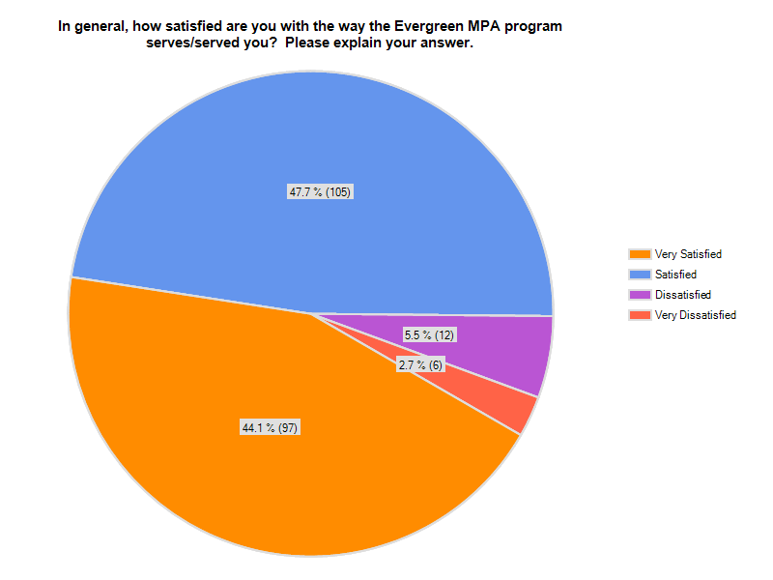
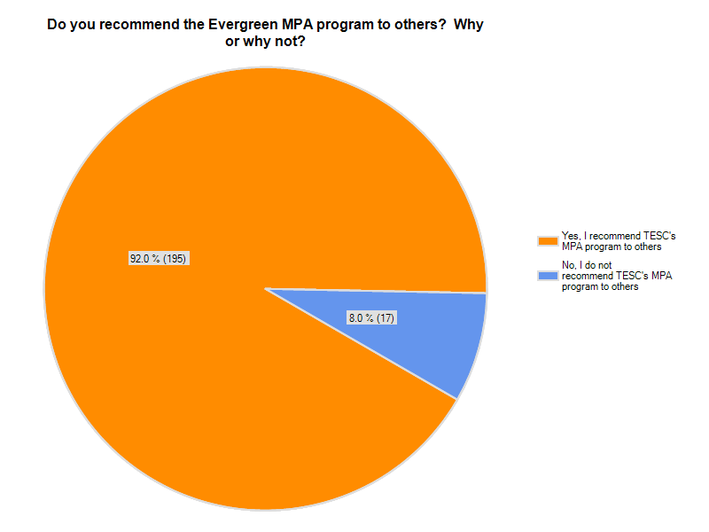
≈
It's our People

Our strength is our people - our alumni, students, faculty, staff, advisory board members and community partners.

Achieving stability and sustainability around staffing, both faculty and staff, is one of our most serious challenges.

Our Students and Alumni. We have terrific students and alumni, representing a plethora of public service sectors, organizations and intentions. Our students and alumni are the best part of what we do, and they serve us well in our communities.

Our Faculty and Staff. Our faculty and staff team do much more than teach and administer the program. We work in a shared leadership team, with the MPA Program Director serving as a leader among equals. Unlike our undergraduate colleagues at the college whose only governance activities are college-wide, we do both college and MPA governance: we make policy decisions about the program, implement these decisions, measure and report on our performance and perform many basic administrative activities (admissions, financial aid awards and tracking, planning and implementing graduation ceremonies, advising students, sponsoring student and alumni groups and activities, etc.).

In addition to teaching and program administration, faculty and staff also represent the program in our communities: doing community-based volunteer, pro-bono, or consulting work; and, supporting our disciplines through writing, publishing, conference attendance, serving in editorial roles on journals and with publishers, etc.

Faculty Roles. As such, the faculty role in the MPA program is significantly different from the faculty role in the undergraduate curriculum. We have to work together outside of the classroom to administer the program. We teach with a limited set of faculty (choice of teaching partners is restricted). We are always refreshing our faculty base because of attrition and rotations, and we have yet, since we remodeled the program, achieved staffing stability with regard to total faculty in the program. We rely heavily on adjuncts to teach both our Core curriculum and electives.

In redesigning our curriculum, an unintended consequence has emerged: full-time faculty need to have specific competencies in the areas of public administration, urban studies, management, political science and/or economics, among other sub-fields. While MPA faculty regularly rotate out into the undergrad curriculum, or take a leave from the program for sabbaticals and fellowships, it has become much more difficult (than before the redesign) for undergraduate faculty to rotate into the MPA program. Our base of potential faculty is, therefore, reduced.

Our adjunct faculty are well situated, and include Legislators, Tribal leaders, heads of departments, Mayors, police and fire, veterans, and military spouses among others.

Overuse of adjuncts, benefits and costs.

Advisory Board.

Need for Faculty Staffing Stability and Sustainability. A stable and sustainable program has both stability in continuing faculty, and sufficient numbers (see Appendix # for long-term faculty staffing/rotation plan), and a strong core of adjunct faculty bringing their practitioner experiences to the classroom.

Need to Right-Size Director Position. In addition, while we have made strides in right-sizing the Director position (rotational faculty position), we need to do more to make this position stable and sustainable.

Need for Stability and Sustainability in Assistant Director, Tribal Concentration. We've also suffered the challenge of stability and sustainability in the Assistant Director position which supports the tribal cohort and concentration.

Need to Right-Size Assistant Director, PNA and PP Concentrations. (Text)

Need for Stable and Sustainable Program Quality, and Measurable Quality Indicators. (Text)

It's our Structures(Design), and Processes

Like our people, the MPA program is distinguished because of the design of our program, how we administer the program and the fact that we've been measuring annual performance for over 10 years and tweaking the program to respond to performance needs. We are an agile, flexible and innovative organization. This doesn't mean we don't have challenges...student performance data consistently tell us...

Agile Planning/Innovation - Achieving Dynamic Equilibrium & Stability in Motion

-cohorts
-concentrations
-agile course planning (proactive and reactive)
-partnerships
-support mechanisms - e.g., internship process put in place AY 12-13

Dependency/Independency on other College Departments. While we get receive assistance from college departments that do this work for the undergraduate functions of the college (e.g., Admissions, Financial Aid, Marketing), in the end, we perform the majority of the work of these fringe administrative functions for our program. This puts us in a unique position of being dependent on some college units for the inputs into our processes, but independent to do the work itself. This dependent/independent relationships pose many challenges in administrating our program. Our preference would be to perform most, if not all, of our administrative functions ourselves.

Do we want to grow?

It's our Future

- inside/outside relationships to rest of college
- rotation situations (Director/faculty) - inside/outside
- staffing
- succession planning
- maintain rotation - rotation plan
- refresh faculty
- relationships/working with other Indian Education offerings on campus
- partnership development; continuing to develop active partnerships (concentrations, internships)
- "where do we want to grow?"
- CBA
- student advising/mentoring
- NASPPA? It's always a question.

