Executive Summary

Our Applicants

Data Source: Randee & Puanani files on applicant pool?

Our Students

Data Source: Annual Student Survey Parts I General Questions & IV Demographics

N=35

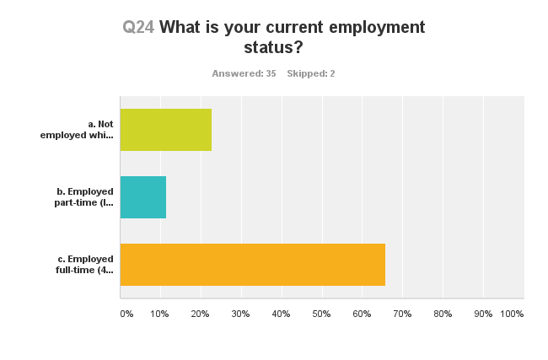

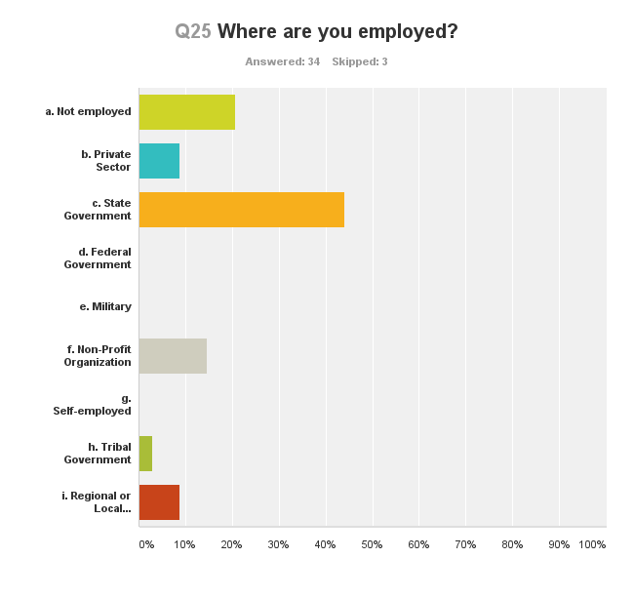



Male 20%

Female 74%

Other 6%

LGBTQ 5%

Disability 23%

Latina/o 4%

Black 4%

Native American 14%

Pacific Islander 4%

More than one racial identification 14%

White 64%

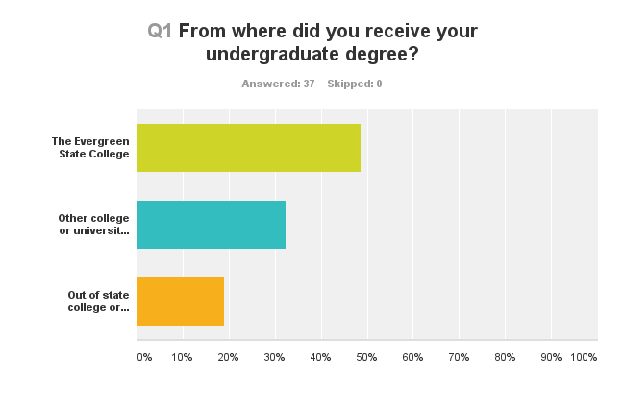

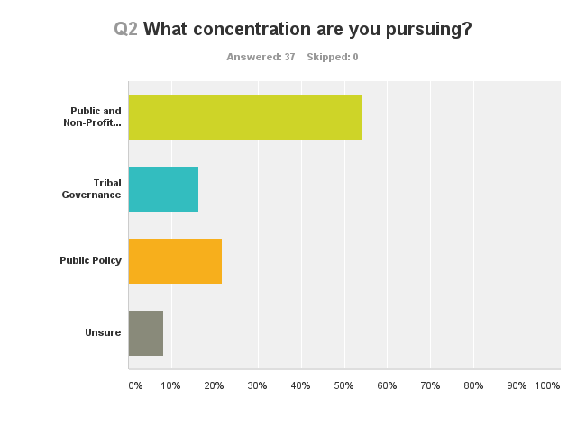

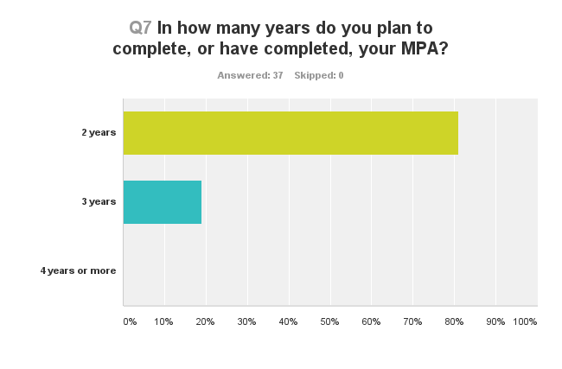

Our Mission

**To what extent have your experiences in the MPA program at Evergreen enhanced your capabilities in the following mission areas:**

|  | Great | Moderate | Some | Little or No |
| --- | --- | --- | --- | --- |
| a. Think critically | 57% | 34% | 9% | 0% |
| b. Think creatively | 40% | 34% | 23% | 3% |
| c. Communicate effectively | 40% | 40% | 20% | 0% |
| d. Work collaboratively | 43% | 43% | 11% | 3% |
| e. Embrace diversity | 34% | 31% | 20% | 14% |
| f. Value fairness & equity | 37% | 40% | 17% | 6% |
| g. Advocate on behalf of the public | 37% | 49% | 9% | 6% |
| h. Imagine new possibilities | 46% | 43% | 6% | 6% |
| i. Accomplish positive change | 43% | 40% | 11% | 6% |

Data Source: Annual Student Survey Part II

Our Learning Communities

Data Source: Part II Question 9 (a-g) and Question 13 b, f, g of Annual Student Survey

Our Program Performance

Data Source: Part III of Annual Student Survey (except for Q13 b,f,g)

Our Service

Data Source: service plans submitted to the MPA Director by faculty

What is Next for MPA?

**Our Service**

Each member of the faculty of the MPA Program at the Evergreen State College, in addition to teaching duties, performs institutional and programmatic governance roles, and makes contributions in scholarship and/or public service. These activities take the form of conference presentations, scholarly publications, peer reviewers and editorial board members for journals and publishers, service and leadership to nonprofit organizations, service on citizen boards and active in community groups. Each academic year, MPA Program faculty are asked to submit a public service plan to the MPA Director for publication in the MPA Program Annual Report. In 2015-16, Evergreen’s MPA faculty continue to make meaningful contributions to both the scholarly field of public administration and to the community.

**Larry Geri, Ph.D.**

Evergreen Institutional Governance and MPA Program Governance:

* Representative to Council of Faculty Representatives during 2016-2017 academic year;
* Member of President Bridges' Budget and Resource Advisory Committee during 2016- 17;
* Chaired the MPA Hiring Committee, which resulting in the successful hiring of three new full time faculty to the MPA Program;
* Assisted the MPA Admissions Committee by reviewing over 30 applicant files.

Public/Community Service and Scholarship:

* Board President for Child Care Action Council Board of Trustees for 2016-17;
* Providing research assistance to local ad-hoc group of faculty/staff from TESC, St. Martin's Univ., and SPSCC performing survey research on local issues;
* Writing an article on Aviation and the Paris Agreement for publication submission summer 2016;
* Beginning a research project on the climate change impacts of travel and travel sustainability.

**Amy Gould, Ph.D.**

Evergreen Institutional Governance and MPA Program Governance:

* Member of Emergency Response Plan Work Group;
* Member of the Sustainability Council;
* Served on MPA Admissions Committee, reviewing over 130 applicant files.

Public/Community Service and Scholarship:

* Served a second term serving on ASPA's Evergreen Chapter Board of Directors, including being the event chair for the 2016 ASPA National Conference;
* Panel organizer/moderator for ASPA National Conference: "Innovations within Tribal Organizations." Panelists included Linda Moon Stumpff (TESC), Jean Dennison (UW);
* Paper co-submitted for another panel at ASPA National Conference: "Multi-State Agreements vs. Compacts: Fiscal Options States Should Know." Co-presenter is current 3rd year MPA student Kathy Hoffman;
* Continued work on an article under consideration with *Administrative Theory & Praxis:* "A Question for the Ongoing Feminist Revolution: Can Critical Feminisms Be Relevant in Women Centered U.S. Nonprofits & International NGOs?"
* Continue to develop research plans for second book: *Leave the Leaves Alone: Crucial Decisions Public Servants Never Made*.

**Cheryl Simrell King, Ph.D.**

Evergreen Institutional Governance and MPA Program Governance:

* Convened panel for Return to Evergreen;
* Reviewer of faculty grant applications;
* Member of Student Conduct Review Board;
* Member of the MPA Hiring Committee, which resulting in the successful hiring of three new full time faculty to the MPA Program;
* Faculty Advisor to ICMA Evergreen Chapter;
* Provided consistent social media support throughout the academic year;
* Assisted the MPA Admissions Committee by reviewing over 20 applicant files.

Public/Community Service and Scholarship:

* Served as Board Secretary for the PARC Foundation of Thurston County (Parks, Arts, Recreation and Culture);
* Working on two invited book chapters: social class & public administration, and participatory research & community building;
* Working on one invited book review essay for *Public Administration Review* on public lands and the national parks;
* Board of Editors or peer reviewer for the following journals/review, on average, one article a month: *Public Administration Review, American Review of Public Administration, Administration and Society, Administrative Theory and Praxis, State and Local Government*;
* Served as external reviewer for tenure and promotion for two national colleagues;
* Presented work on lessons public administrators can learn from new social movements at ASPA National Conference;
* Co-authored paper (with Director of Evergreen’s Center for Sustainable Infrastructure) on sustainable infrastructure and presented paper at ASPA National Conference.

**Michael Lane, J.D.**

Evergreen Institutional Governance/MPA Program Governance:

* Member of Evergreen’s Human Subjects Review Board.

Community Governance and Scholarly Endeavors:

* Participated in Indigenous Peoples Climate Justice Symposium;
* Worked on planning Walk for Leonard Peltier Clemency.

**Doreen Swetkis, Ph.D.**

Evergreen Institutional Governance/MPA Program Governance:

* Served first year as Director of Evergreen’s MPA Program;
* Served on MPA Admissions Committee, reviewing over 50 applicant files.

Public/Community Service and Scholarship:

* In the role of MPA Director attended NASPAA Annual Conference, ASPA National Conference, and ARNOVA Conference;
* Volunteered for Evergreen Swim Club, a local nonprofit organization;
* Performing social network analysis of five years of MPA Program internship data. Submitted proposal to present research findings at 2016 NASPAA Conference;
* Peer reviewer for *Human Reproduction* and *Family and Consumer Sciences Research Journal*.

**What is Next for MPA?**

The MPA Program weathered some significant challenges in 2015-16: a full-time faculty member left, a new Director stepped in, and the Program’s two largest cohorts of students graduated. Institutional changes impacted the program as well, including the welcoming of a new College President, the exiting of the Provost, and the placement of an interim Provost. Accepting and weathering change are inherent to organizations

Two new faculty fall 2016; 1 new faculty fall 2017

CRM training and implementation

Launch of a Tacoma cohort 2018-20

Develop a more robust MPA adjunct faculty pool—be more deliberate in who’s teaching for us, what’s on the horizon in the field that needs to be approached in the classroom.