**How to send e-mails through Wordpress E-Newsletter**

1. Login to **sites.evergreen.edu** – you will use your Evergreen Login and password
2. Once you have logged in, go to the top left of the webpage and hover your mouse over “My Sites” and click on MPA NEWS 2017 – 2018 (now named Evergreen’s Master of Public Administration)).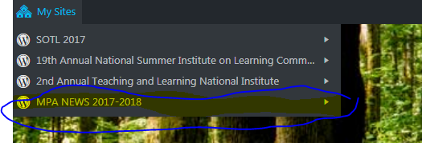
3. You will be navigated to the MPA News 2017-2018 (now named Evergreen’s Master of Public Administration) Dashboard. From here, look for ENewsletter on the left-hand column menu. Click on that to access the ENewsletter app. This is where you will send e-mails.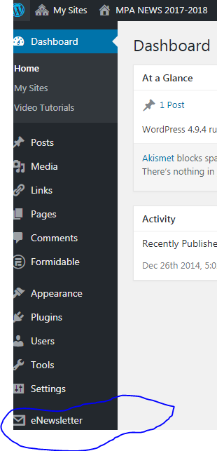
4. You are now on the Newsletters Dashboard. To send out a new e-mail, you will need to create a new “newsletter,” which is essentially a new e-mail. Click Create New Newsletter, under the Latest Newsletters box.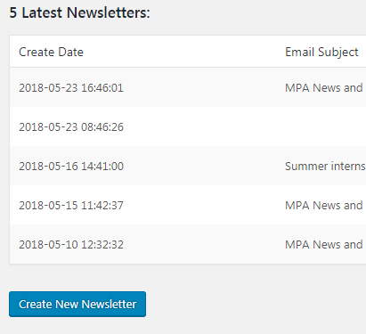
5. You will be navigated to a new page. You should be looking at a blank Evergreen Newsletter template. Your menu should look like this. You will first add the content to the ENewsletter. Click the **Content** button.

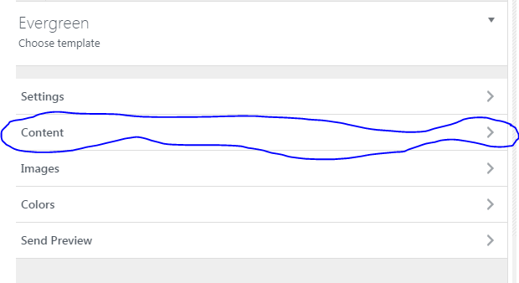

1. This is where you will add the Email Title (Title relevant to the e-mail content), and the E-mail content. You can format the content like you would in a normal e-mail. **Do not type anything in to the BRANDING HTML/Text box or Contact Info.** 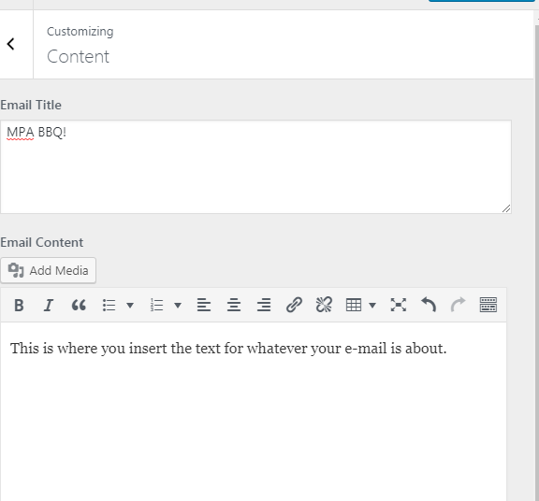

You will see a preview on the right side of the editing box:

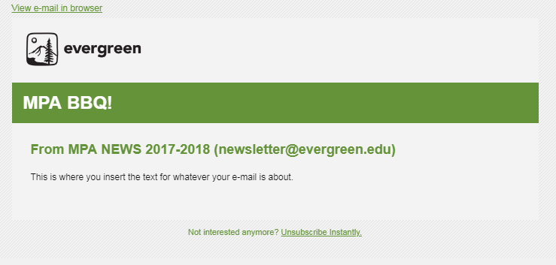

1. If you are happy with your content, press the Save Newsletter button in the **top left corner** and press the back arrow next to Customizing Content.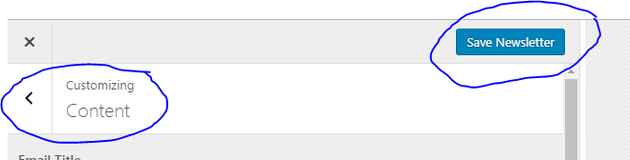
2. Now we need to create an E-mail Subject Line, and who the e-mail is from. You can do this by clicking the Settings button.

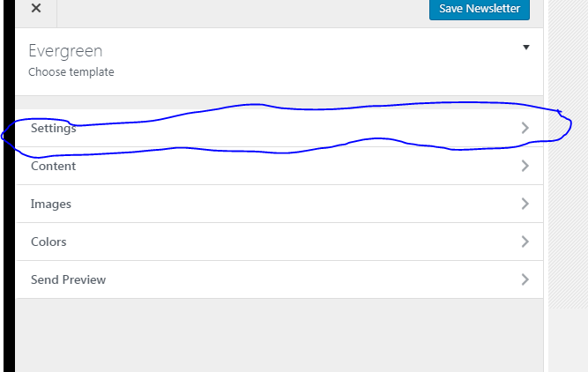

1. Insert your e-mail subject, from name, and from e-mail. **Don’t add text to the Bounce Email text box.** 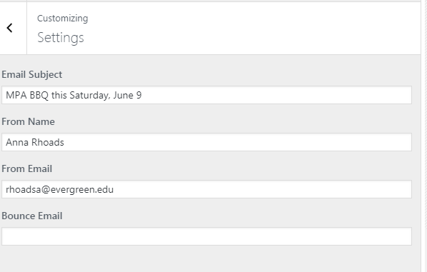
2. Now, we need to send a preview to make sure it looks good before we send it to our lists. Click the back arrow next to settings to go back to the main menu. From the main menu, press Send Preview. 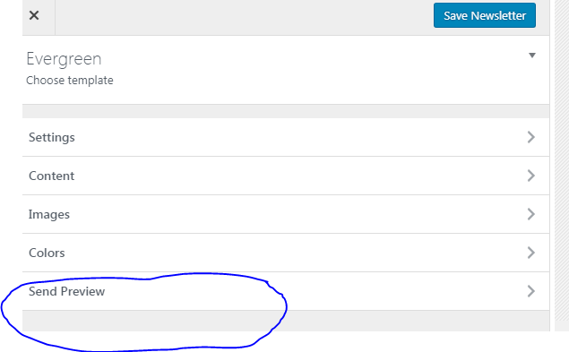
3. Type the e-mail you would like to send a preview e-mail to in the Send Preview to Email (Send First) text box. After you type the address in, press the Save Newsletter button, and then press Send Preview.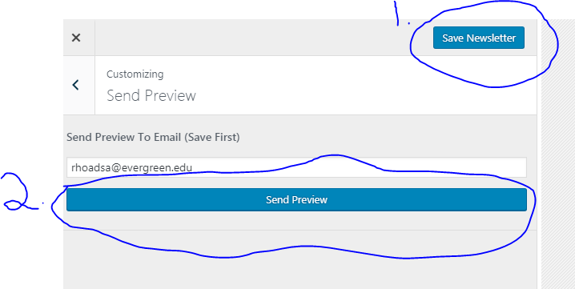
4. You should receive an e-mail momentarily. Review the preview e-mail. If you find any errors or typos, you can go back to the Content section and make the necessary edits. Ready to send the newsletter? Press the Save Newsletter button at the top left and then exit out of the newsletter editor. 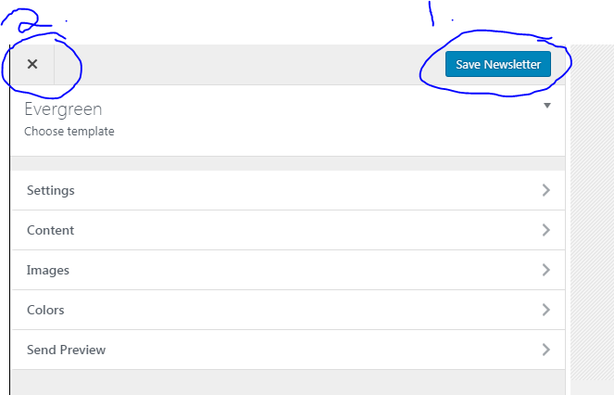
5. You will be brought back to the Newsletters Dashboard. On the far right, press the Send button for the newsletter you just created (look at the Create Date and E-mail subject if you aren’t sure). 
6. After you click send, it will take you to a page where you choose what member groups you can send this e-mail to. For this e-mail, I checked the three groups I wanted to send it to. Do not worry about the “WordPress User Roles.” Click “Send Newsletter Now”. It will take about 5 – 10 minutes to send the email depending on the number of groups you check. Do not exit from the webpage until all the e-mails have been sent.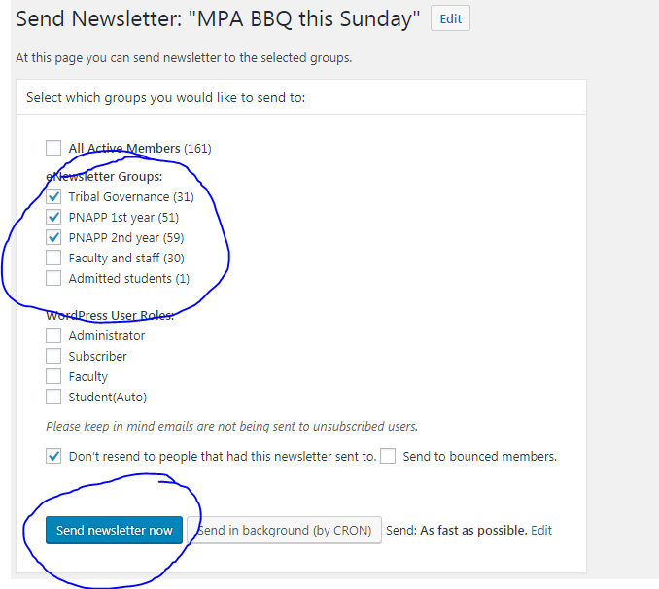

Hooray! You sent an e-mail through ENewsletters! Have any trouble? Contact Amy Greene [greenea@evergreen.edu](mailto:greenea@evergreen.edu) , Evergreen’s WordPress expert, and she can walk you through the process.