Graduation 2019 - Important links and info!

From Anna Rhoads (rhoadsa@evergreen.edu)
Hello,
It was lovely talking with you all yesterday about graduation! The hooding and commencement ceremony will be on Friday, June 14. The hooding ceremony will start mid-morning (we are still finalizing the start time) and the commencement ceremony will begin at 1 pm. The hooding ceremony will take place in the CRC (Evergreen's gym). Commencement takes place on Red Square, rain or shine. Both ceremonies are optional, but they are a great opportunity to celebrate this milestone with family and friends.
As promised, here are the web links I promised.
- Apply to graduate. You will need to apply by the end of next week. If you are unsure what quarter you should apply to graduate, please contact me and we can discuss what coursework you still need to complete. Remember, you need to complete 60 credits to graduate, and cannot exceed 76 credits. You can also read about credit requirements in the student handbook. You need at least 46 credits completed (including Capstone) to participate in the hooding and commencement ceremony.
- Complete the MPA Hooding Ceremony survey. Please complete this by May 16. This helps MPA staff with designing the program, ordering food, and other planning logistics.
- Nominate a class speaker by May 16. Please have one person from your cohort email me your class pick by that date.
- You can borrow regalia for FREE from the MPA office. Please email Jan Hays (haysj@evergreen.edu) if you are interested. We have limited quantities and sizes. You can also purchase regalia from the bookstore. Regalia is optional.
- I also recommend reading MPA's Graduation web page for additional information.
Here are some photos from the 2018 hooding ceremony to give you an idea of what to expect.

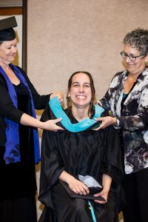
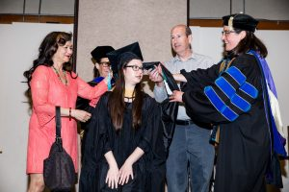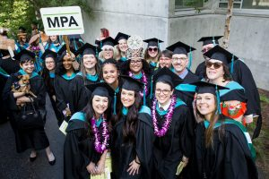
Please let me know if you have any questions.
Best,
Anna Rhoads, M.E.S. | Assistant Director, Master of Public Administration |Public & Nonprofit Administration and Public Policy concentrations (PNAPP) | rhoadsa@evergreen.edu |360-867-6554

