Helpful hints to run reports in Banner

**SPAIDEN**: *General contact info.*

*Type in A# or if not known type in the persons last name, comma and the first name. If the first name is not available you can use the “ % ” this is used as a wild card to search/**This search can be used for all Banner searches**

*Control (CTRL) Page (pg.) down:

These functions will allow the user to view the 8 tabs of information, see clip below

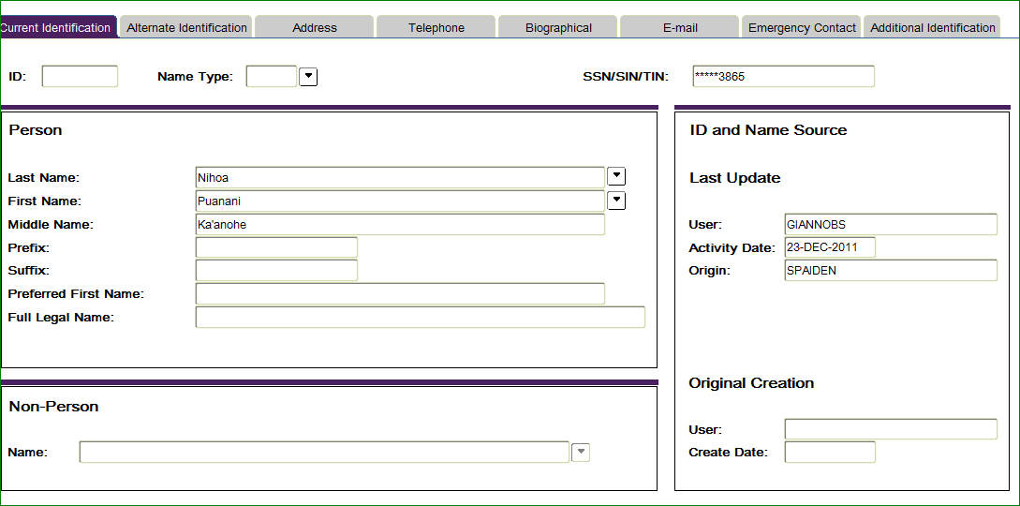

If a message comes up indicating the **information is confidential** don’t use it for any public sharing, do not contact as per request

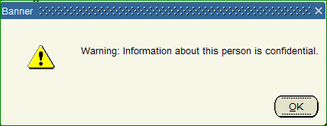

**SOAHOLD:**  *Displays any ‘Holds’ on accounts*

*Type in A# if known, otherwise type in last name, and “ % “ as wild card to search for student

*CTRL Pg. down: if there is a “31-DEC-2099” to: date in the middle column indicates there is an active code on the applicant

Look at the far right column in the ‘Origination Code: this will indicate where the ‘Hold’ came from and you will know what you need to inform the applicant

**SZRPGPR**: *Displays academic credits attempted & earned *NOTE: it’s a good idea to have the students A# ready before you go into SZRPGPR*

At the main Banner page type in ‘SZRPGPR’

CNTRL Page Down

At the ‘Printer’ location type in caps ‘EMAIL’

CNTRL Page Down

Tab over under Values type in the students A#

CNTRL Page Down

Alt F then press the ‘S’ key a report will be sent to you e-mail in less than a minute, if you do not receive an e-mail something went wrong along the way so you will have to go through the process again until you actually have data to review.

**SPACMNT:** *Notes, comments, adjustments to the students file can be found here*

Type in A# if known, otherwise use wild card process as explain above once found

CNTRL Page down

Use the scroll bar on the right side of the screen to view messages & notes

**SFRSLST**: *Class list/roster*

CNTRL Page Down

At the ‘Printer’ section type in caps “EMAIL”

CNTRL Page Down

Tab over & using downward arrow goto ‘02’ line under ‘Values’ type in the term ex. 201810=fall qtr. 2017; 201820=winter qtr.; 201830=spring qtr.; 201840=summer qtr.

Using the downward arrow key goto line ‘06’ type in the CRN #

Using the arrow key down continue going down until you reach line ’09’

Type “%”

Go down, be sure you have the “%” for lines ‘09’ thru line ‘13’

CNTRL Page Down

Alt F then S

A report will be sent to your e-mail