**Assistant Director (MPA PNAPP) Transition Document**

Hello!

Welcome to Evergreen and the MPA program. Here is a guide that you may find helpful as you transition into this role. You will learn quickly that you wear over a dozen different “hats” in this role and that every day will be different. I recommend finding and using your strengths to get adjusted in this role, taking on new challenges, and building relationships across campus every opportunity you can.

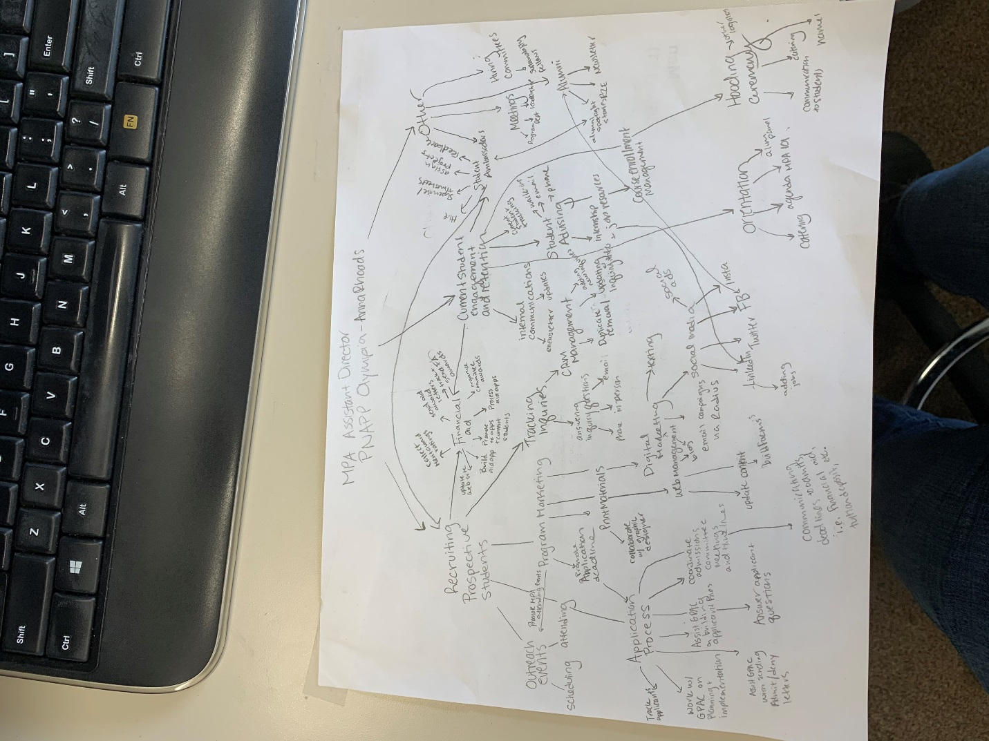

I’m including this visual I drew a few months ago to demonstrate the complexity and moving parts of this position. You need to be a successful program manager and have a system in place to help you stay organized with upcoming projects, events, goals, etc. When I first started in my role, I wasn’t given a training document and all pertinent files were deleted. I was left with nothing to go off and had to scramble to figure everything out during fall recruiting season (the busiest time of year in this position). I don’t want you to be in the same situation I was in.

What is nice about this position is that projects are cyclical. Here is a **VERY general idea** of what to expect each month:

September: New student onboarding, recruiting, update application for web, orientation

October: New students, recruiting, application opens

November: recruiting, application is open

December: recruiting, application is open

January: application open, busy with prospective students

February: application building, admissions committee work, answering applicant questions

March: applications, application building, admissions committee work, notifying applicants of status

April: applications, sponsored aid application closes, start building recruiting/outreach calendar

May: Tuition deposit due, new student onboarding, prep for hooding ceremony

June: new student onboarding, hooding ceremony (mid-June to early July is a great time to take a vacation!!!)

July: new student onboarding, recruiting, long-term projects, website updates, orientation

August: New, student onboarding, orientation, recruiting

Below I’ve done my best to summarize everything that this position is responsible for. I believe you’ll do a great job and make this position your own!

**STUDENTS**

***Prospective students***

* **Radius**: Request training from CRM Manager (currently Jo Bernier 2/12/2020) and Graduate Admissions Coordinator (currently Amanda Mobbs 2/12/2020) as soon as possible. Radius is our Customer Relationship Management (CRM) software we use to track and communicate with prospective students, applicants, and admitted students. Request training in:
  + **Listviews**
  + **Targets**
  + **Email Templates**
  + **Campaigns**
  + **Applications**
  + **Notes and Touches**
* **Communications with prospective students:** You will need to use Radius to communicate with prospective students. You can send individual emails, targeted emails to groups, and mass emails to all contacts. I highly recommend responding to prospective student emails within 48 hours.
* **Tracking inquiries and applicants:** Track communications through Radius using Notes & Touches. When you receive a new inquiry, add their contact information to Radius. You can also provide contact info of inquiry to MPA program assistant.

**Prospective Student Recruitment**

* **Information sessions:** The most success (inquiries -> applicants) I’ve had with outreach events has been hosting information sessions at one of the local Timberland Libraries. The Olympia one is ideal because it is walking distance from the Capitol campus and state agencies. There is also free parking. It is free to reserve the community room, you just need a library card. The reservation process is online. I recommend reserving the room on a Wednesday or Thursday from 5:00-7:00 p.m. and host the info session from 5:30 – 6:30 p.m. I would give a presentation (see Info Session folder for Power point), but you can do whatever format you are comfortable with. I also recommend bringing a student ambassador or alumni to help answer questions! Don’t forget to bring a sign-in sheet so you can follow up with attendees and add them to Radius.
* **Fairs and outreach events I recommend going to:**
  + ICSEW Professional Development Conference (August or September)
  + Evergreen Block Party (September)
  + Evergreen Mentoring Day (February)
  + UW Graduate Fair (October)
  + Evergreen Graduate Fair (October)
  + Central Washington University Graduate Fair (April)
  + Idealist Graduate Fair (October – recommend asking Marketing to pay for)
  + Saint Martin’s Graduate Fair (varies)
  + There are other ‘industry’ fairs as well to attend, but many are costly. I recommend partnering with the other graduate programs.
* **Agency Outreach:** This has been a struggle for me, but I recommend trying to build connections at various state agencies and asking to host lunch time information sessions. I recommend partnering with other grad programs and the evening weekend studies (EWS) program. You need to have an in-agency contact (like HR rep) to begin this process. So far, I’ve hosted lunch time info sessions at DSHS and DES. I have been trying to host info sessions at Ecology, but it is challenging to connect with them to set something up. Maybe you are coming from a state agency and already have great connections!
* **Class visits:** Before every quarter, I would look at the undergraduate course catalog and see if there are any classes offered that have similar themes, ideas, etc. to what we offer in the MPA program. If so, I email the professors and ask if I can give a five minute presentation about the MPA program. UG faculty that have been eager to work with me are Dariush Khaleghi (he also teaches in MPA), and Nancy Parkes. I bring brochures and other materials. Most EWS classes tend to be a good fit for MPA students. I usually went to two to three UG classes a quarter. This is also something you could ask student ambassadors to do.
* **Other:** I also recommend attending local networking events like Thurston County Young Professionals and the state’s Business Resource Groups. There used to be a nonprofit networking group, but I think that fizzled out. Keep your eyes out for relevant groups to attend.

***Admitted students***

* Communicate upcoming deadlines (sponsored-aid application deadline, tuition deposit deadline, orientation, stats requirement deadline, etc.) through email.
* Deferrals – new process, see form in O drive. Director approves deferrals.
* Orientation – you’ll need to give a one hour MPA 101 talk and plan orientation. You should begin this early May.

***Current students***

* **Adminweb/Banner:** When I first started, I used Banner. Banner is NOT easy and you don’t necessarily need to use it to perform this job. Adminweb is basically the web-based version of Banner and you can still pull a lot of reports and look up student information. I rely on Adminweb 99% of the time and recommend you go that route (unless you really want to learn Banner). I recommend asking another graduate program Assistant Director, MPA’s program assistant, someone in academic advising, or Amy Betz (Systems manager 2/12/2020) for training. When you request Adminweb, you need access to the Curriculum, Individual Study Contracts, and Manage Curriculum pages.
* **Answering questions:** You will receive walk-ins, calls, and emails from current students with questions. I recommend becoming an expert on MPA policy and practice. You can do this by reading the MPA student handbook. I kept an open-door policy with students and always did my best to answer all questions. If I didn’t know the answer, I did my best to find out the answer and get back to them as soon as possible. It took me about six months to become knowledgeable on the nuances of MPA program and campus policies, so just be willing to ask questions and ready to learn. This will help you help students!
* **Advising:** MPA faculty are responsible for academic and career advising, but you will be asked by students to assist with degree planning. There is a worksheet you can rely on to help you with this process (in student handbook and also on the O drive). As the curriculum changes, you’ll need to create a new degree planning worksheet to complement this exercise you’ll be helping students with.
* **Student Conduct:** Student issues arise. Remember, it is not YOUR job to handle student conduct. I do not recommend getting involved in student-faculty conflict. That goes to the Dean and/or the Director. I did my best to redirect students to the appropriate person to talk to regarding whatever issues they were having. That said, it is important to keep abreast of campus resources that can help students if they don’t feel comfortable talking to the Dean or Director.
* **Weekly MPA e-newsletters:** To reduce email fatigue, I would only send emails out to students once or twice a week. I started sending weekly e-newsletters to all students (including TG and TAC students) with program updates, college updates, and community events and opportunities. Please review sample newsletters in transition folder. You will send this through sites.evergreen.edu/e-newsletter program. See instruction sheet in transition folder. Request training from Amy Greene (as of 3/2/2020).
* **Eligibility for Capstone & Hooding Ceremony:** 
  + **Fall Quarter Week 9:** Email all students in 2nd year core that they have at least 40 credits completed by the end of Winter Quarter if they are to continue on to Capstone in Spring. That way, they have time to register for more credits in winter in case they are a bit short on credits.
  + Email only those students in ATPS II who will not have 40 credits by the end of Winter Quarter and let them know they will not be able to register for Capstone in Spring.
  + Similarly, students must complete a minimum of 46 credits in order to participate in the Hooding Ceremony. Therefore, students currently in 2nd year Core need to receive an email **from** an AD in Week 2-3 of Spring Quarter informing them that they will not be able to participate in the Hooding Ceremony because they will not have enough credits.
* **Leave of Absence/Withdrawal:** There are two scenarios with LOAs. If they take an official LOA, meaning they are taking a break from ALL coursework, then they need to complete the college’s LOA paperwork (on Registration webpage). If they decide to take a break from just core but want to complete electives, they do not fill out paperwork. You will need to follow up with all LOAs before they intend to return and make sure they are prepared to come back to class. See tracking spreadsheets for examples.
* **Director’s Approval to Graduate:** Refer to instructions in transition folder + hardcopy folder
* **Annual student survey:** This isn’t your job, butyou’ll need to help MPA staff send out the survey (via e-newsletter). You may also need to help create the survey as a webform on the website. You’ll need to request a Help Ticket through the web team to create a web form. I recommend a
* **Student Ambassadors**
  + I created MPA’s Current Student Ambassador Program two years ago. It is modeled after MES’s SA program. This is a great opportunity for students who are excited about the MPA program and natural networkers/communicators. I recommend only hiring up to three MPA students at a time. As of 2/12/2020, they are paid $13.50/hr and only work 1 – 5 hours a week. We are using work study funds to pay them.
  + See student ambassador file on O drive (O:\MPA\Student Ambassadors) to see job description, tasks, interview questions, etc. My philosophy with student employees is that they are students first, and they need to put schoolwork before SA work. I hope you will continue with this management philosophy!

**Communications**

* **Listserv management** – We manage our communications to current students through sites.evergreen.edu/e-newsletter. I recommend asking MPA program assistant for training on how to add/remove members (aka students).
* **Social media** – We have four social media accounts: Twitter, Facebook, LinkedIn, and Instagram. I’m assuming that you are an experienced social media user, but if you aren’t, I recommend taking a couple online courses in social media management. I do want to advocate that our social media is incredibly important and needs to be taken seriously. If you can take control over the accounts, come up with a strategy, and even do a social media audit, that would be amazing.
  + **Twitter**: Twitter is currently managed by Eric Trevan (as of 2/13/2020). I do my best to post official MPA news + outreach on Twitter, but this hasn’t been my priority.
  + **Facebook**: We have a lot of engagement on our official MPA Facebook page, so I put most of my attention onto this platform. I recommend posting at least 3 – 4x a week. I also share MPA related events (like info sessions) on Facebook through the events feature.
  + **LinkedIn**: We are currently using our LinkedIn page to share jobs and internships. We’ve grown our page significantly since I started and have a lot of engagement on this platform too. Dhara will post jobs on LinkedIn.
  + **Instagram**: The MPA student ambassadors are responsible for posting content on this platform. I provided them a set of guidelines and I check the Instagram regularly. I also will post on the Instagram occasionally. There is a lot of potential with Instagram, but I haven’t been able to devote a ton of time to it. Maybe you can?
* **Social Media Ads** – We’ve run paid ads on Facebook when our application opens (early October), a month before the priority deadline (Jan 1 – 31), and to promote the second round deadline (usually early March). You are going to want to work with the Assistant Director of Marketing (as of 2/13/2020 is Alexa Morris Ley). Alexa will set up the ads and everything, you just need to tell her when and what you want the ads to say. I recommend following up with her so you can see the results of the ads.
* **Program News blog** – My goal was to post one to two new blogs a month. Solicit the help from student ambassadors and faculty. I occasionally wrote spotlight stories on alumni and students when I had the time. You edit the Program News blog through the web editor.
* **Website** – I highly recommend becoming a web editor. The website is edited through Drupal (as of 2/12/2020). You’ll need to request web editor training through Elaine Nelson (as of 2/12/2020). This can be a long process to be approved and go through the website editor training. It is important that you have access to web editing if the program assistant is unable to make an edit due to absence, or if there is significant content that needs to be edited quickly.
* **Print materials** – it is up to the MPA staff to update and order brochures, envelopes, paper, stickers, and other materials. The ADs will let program assistant know when print materials are low, and then the program assistant will order more through Marketing. If a print material needs an update (logo update, content update, etc.), it is up to ADs to work with Marketing’s graphic designer. It would almost always be me who took the lead on this. To begin that process, you put in a ticket here: <https://www.evergreen.edu/marketing>

**Alumni**

* Will email you jobs

**FINANCIAL AID**

* **Sponsored-aid: Refer to sponsored-aid guide on Odrive**
* <https://www.evergreen.edu/mpa/costs>
  + **Merit award ratings:** Faculty are asked to rate their students quarterly. You can review their merit ratings on the o drive. When awarding the
* **College sponsored-aid:**

**Events**

* Hooding Ceremony
  + Communicate with graduating PNAPP students. Go to Capstone and share information about capstone
* Orientation

**Student Ambassadors**

I created MPA’s Current Student Ambassador Program two years ago. It is modeled after MES’s SA program. This is a great opportunity for students who are excited about the MPA program and natural networkers/communicators. I recommend only hiring up to three MPA students at a time. As of 2/12/2020, they are paid $13.50/hr and only work 1 – 5 hours a week. We are using work study funds to pay them.

See student ambassador file on O drive (O:\MPA\Student Ambassadors) to see job description, tasks, interview questions, etc. My philosophy with student employees is that they are students first, and they need to put schoolwork before SA work. I hope you will continue with this management philosophy!

**Campus involvement**

* Graduate Program Quarterly Meetings – Quarterly meeting
* Student and Academic Life Meetings – Quarterly meeting with the Student and Academic Life (SAL) department.
* Campus Leadership Meetings – I recommend going to represent MPA and so leadership knows who you are.
* Graduate Sustainability Fellowship hiring committee

**Other**

* Potlucks – Completely optional, but a few of us started a “Potluck club” in 2017. We invite staff and faculty in Lab 1 to join us. We typically take turns sending out invites. Touch base with Lucky or Puanani if you are interested in continuing this tradition. 