<DATE>

<FIRST NAME> <LAST NAME>

<ADDRESS>

<CITY>, <STATE> <ZIP>

Dear <FIRST NAME>,

Congratulations! I am pleased to offer you conditional admission to the Master of Public Administration (MPA) program at The Evergreen State College for Fall 2015. You will be part of a diverse, capable, and dedicated cohort of people selected to begin the program. We hope you will join us.

Please note that this offer of admission is dependent upon the following (deadlines needed):

* Successful completion of the program at EF International Language Schools at Level C-1 or higher, resulting in an IELTS score of 7.0 or higher
* Confirmation of sponsorship/proof of ability to pay for one year of full-time non-resident tuition and fees, preferably from a government or similar agency
* Proof of completion of an MPA-approved introductory statistics course with a grade of “C” (2.0 on a 4.0 scale) or higher -- see our MPA Statistics Prerequisite page for details: <http://www.evergreen.edu/mpa/statisticsprerequisite>
* A submitted Fall 2015 Evergreen MPA Application for Admission, completed between October 15, 2014 and February 2, 2015, via our online application form at this link: <http://www.evergreen.edu/mpa/application>
* Evidence of writing, analytical, and general communication skills of high quality as demonstrated by submission of the following:
  + A three-page statement of purpose which describes why you want to pursue a master’s degree in public administration, particularly at Evergreen. Please see our Apply page for complete details, at: <http://www.evergreen.edu/mpa/applicationcheck.htm>
  + Two letters of recommendation, submitted to Evergreen by the recommenders
* An interview with the MPA Director
* Successful completion of any academic work currently in progress

In addition, prior to graduation from the MPA program you are required to:

* complete a **one (1) quarter credit public or non-profit sector internship**. If you have professional experience of one year or more in public policy or public and nonprofit administration, you may apply for a waiver of this requirement **after** you begin the MPA program.

For more information about our program, check our website at: <http://www.evergreen.edu/mpa/>

The staff and faculty at Evergreen are here to make you feel welcome and to smooth your transition to the Evergreen MPA program. If you have any questions about the admissions process or the program, I encourage you to contact Randee Gibbons, the Assistant MPA Director, at [gibbonsr@evergreen.edu](mailto:gibbonsr@evergreen.edu).

**Once again, congratulations on your admission to the Master of Public Administration program!** We are looking forward to working with you.

Sincerely,

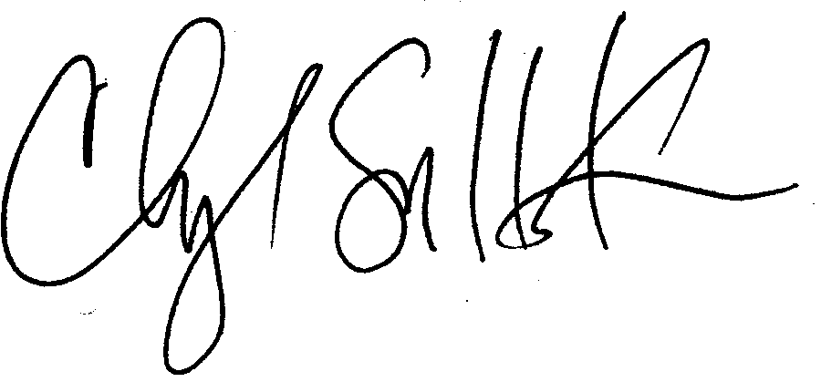

Cheryl Simrell King, PhD

Director, MPA Program & Member of the Faculty

The Evergreen State College