To: Salah Zayed N Alotaibi

From: Cheryl Simrell King, MPA Director

Date: June 9, 2015

Thank you for your application for Fall 2016 admission to the Evergreen State College Master of Public Administration program.

We have reviewed your file carefully, and we regret that we are unable to offer you admission for Fall 2016.

We appreciate your interest in Evergreen’s Master of Public Administration program and wish you great success in your future endeavors.

Sincerely,

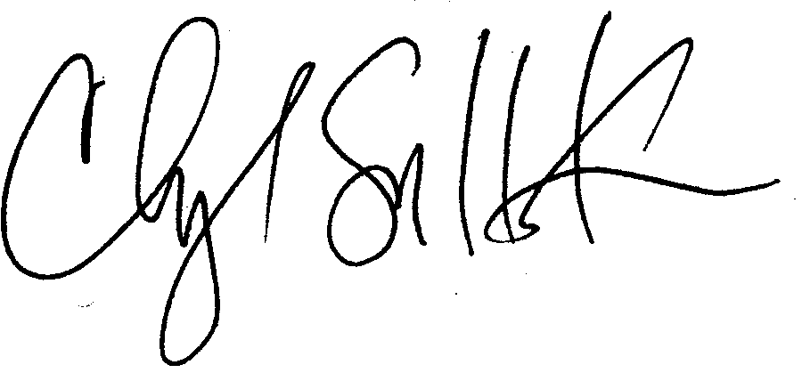

Cheryl Simrell King, PhD

Director, MPA Program & Member of the Faculty

The Evergreen State College