To: Hadeel Abdulrahman A Alsufyani

From: MPA Adminssions Committee

Date: November 3, 2014

Congratulations! I am pleased to offer you conditional admission to the Master of Public Administration (MPA) program at The Evergreen State College for Fall 2015. You will be part of a diverse, capable, and dedicated cohort of people selected to begin the program. We hope you will join us.

Please note that this offer of admission is dependent upon the following:

* **By July 1, 2015:** Successful completion of a minimum of Level C-1 at the EF International Language Schools
* **By July 1, 2015:** Proof of sponsorship/ability to pay for full-time non-resident cost of attendance, preferably from a government or similar agency
* A submitted Fall 2015 Evergreen MPA Application for Admission, **completed between October 15, 2014 and February 2, 2015**, via our online application form at this link: <http://www.evergreen.edu/mpa/application>
* **By July 1, 2015:** Evidence of writing, analytical, and general communication skills of high quality and at a level appropriate for graduate study, as demonstrated by submission of the following:
  + A three-page statement of purpose which describes why you want to pursue a master’s degree in public administration, particularly at Evergreen. Include information about your education, employment, public or community work and any other factors or experiences that have influenced you.
  + Two letters of recommendation, submitted to Evergreen by the recommenders
* **By September 15, 2015:** Proof of satisfactory completion of an MPA-approved college level introductory statistics course: if completed at Evergreen, full credit must be received; if completed at another college or university, a letter grade of “C” (2.0 on a 4.0 scale) or higher must be received. See our MPA Statistics Prerequisite page for complete details and a list of preapproved courses: <http://www.evergreen.edu/mpa/statisticsprerequisite>
* An interview with the MPA Director
* Successful completion of any academic work currently in progress

In addition, prior to graduation from the MPA program we require:

* Completion of a **one (1) credit public or non-profit sector internship for one (1) academic quarter**. If you have professional experience of one year or more in public policy or public and nonprofit administration, you may apply for a waiver of this requirement **after** you begin the MPA program.

For more information about our program, check our website at: <http://www.evergreen.edu/mpa/>

The staff and faculty at Evergreen are here to make you feel welcome and to smooth your transition to the Evergreen MPA program. If you have any questions about the admissions process or the program, I encourage you to contact Randee Gibbons, the Assistant MPA Director, at [gibbonsr@evergreen.edu](mailto:gibbonsr@evergreen.edu).

**Once again, congratulations on your admission to the Master of Public Administration program!** We are looking forward to working with you.

Sincerely,

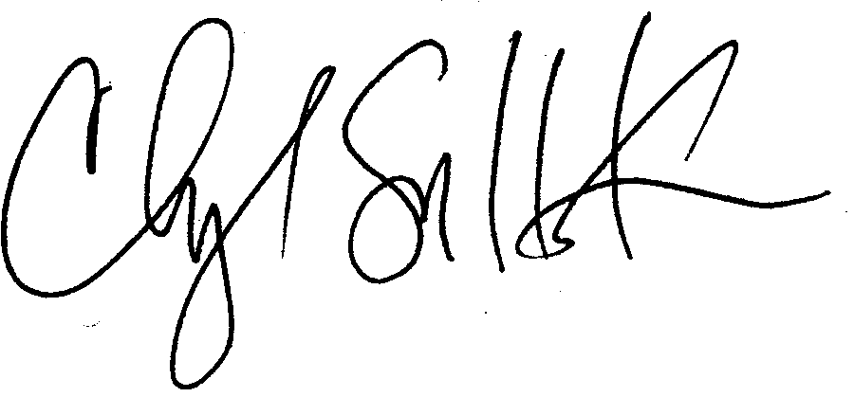

Cheryl Simrell King, PhD

Director, MPA Program & Member of the Faculty

The Evergreen State College