TRAINING FACILITY CHECKLIST
Name: Clive Stewart

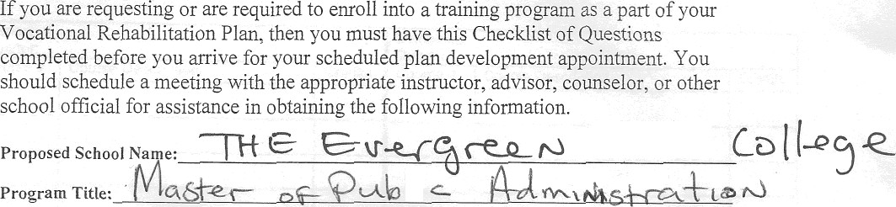

How many students graduated from the program in the last year?
—

How many of those graduates obtained jobs? (# or %)? How many obtained jobs in the field for which trained? Examples of Job Titles they were hired into.

What is a projected date training/schooling could be completed?

Remarks:

Costs:

Title/Phone # Date

