June 5, 2014

Grace J Thompson STUDENT ID: A00355151

1114 7th St

Las Vegas, NM 87701

Dear Grace,

Congratulations! I am pleased to inform you, upon recommendation of the MPA Admissions Committee, that you have been accepted into Evergreen’s Master of Public Administration program for Fall 2014. We select our entering cohorts with considerable care, and this year’s pool of applicants was more competitive than ever before. You are part of a diverse, capable, and dedicated cohort of people selected to begin the program this year.  We hope you will join us.

To accept this offer of admission and reserve your space in the Fall 2014 cohort, **the college must receive a non-refundable $100.00 tuition deposit by Monday, June 16, 2014**. The tuition deposit billing form is enclosed. Once you have paid your deposit, please activate your “My Evergreen” account to ensure that you receive emails from us.

If you \***cannot\*** accept our offer of admission, please email Randee Gibbons, Assistant MPA Director, as soon as possible at [gibbonsr@evergreen.edu](mailto:gibbonsr@evergreen.edu) so that we may inform students on our waiting list.

What follows is some important information about admission, financial aid and Fall quarter registration and course scheduling. If you have any questions, feel welcome to contact Randee, at [gibbonsr@evergreen.edu](mailto:gibbonsr@evergreen.edu).

Your admission to the MPA program requires **proof that you’ve been awarded a baccalaureate (bachelor’s) degree** before you begin MPA coursework in Fall 2014. Accordingly, the Evergreen Office of Admissions must receive an official transcript or other written confirmation from an official of the awarding institution indicating you have been awarded your bachelor’s degree **by September 15, 2014**. The Office of Admissions must receive an official transcript reflecting the awarding of the bachelor’s degree by November 1, 2014 in order for you to continue in the MPA Program beyond the Fall Quarter. *If you are awarded financial aid, your final transcript reflecting completion of the bachelor’s degree* ***must*** *be received by September 15, 2014 in order for any financial aid funds to be released for Fall Quarter.*

Your admission to the MPA program also requires that you **complete an MPA-approved 4 credit introductory statistics course** with a grade of “C” or better before you begin MPA coursework in Fall 2014. For a list of Evergreen and non-Evergreen courses that would satisfy the statistics requirement and other important information about the statistics prerequisite, go to the “statistics prerequisite guide” on the Admissions Requirements page of our website, at: <http://www.evergreen.edu/mpa/admissionsreq.htm>. After course completion, please submit an official transcript by **September 15, 2014** to Jan Hays, MPA Office Assistant, at: MPA Program; Lab 1, Room 3019; Evergreen State College; 2700 Evergreen Parkway NW; Olympia, WA 98505. *Your admission to the program will be withdrawn if we do not receive an official transcript documenting completion of the statistics prerequisite by September 15, 2014.*

In addition, we are requiring that you participate in a **one (1) quarter credit public or non-profit sector internship** *before you* ***\*graduate\**** from the MPA program. This internship is a requirement for students with limited professional experience (less than one year) in public policy or public and non profit administration. Please note that if you believe you have the requisite experience, you may petition this decision to the MPA Director **after** you begin the MPA program.

This offer of admission is dependent upon successful completion of any academic work currently in progress.

**Re: financial aid:** applications for federal student loan aid are still being accepted. To apply for federal student loans, your first step is to complete the federal student aid form, the “FAFSA”. For access to the FAFSA and for more financial aid information, go to the MPA Financial Aid page at: <http://www.evergreen.edu/mpa/finaid.htm>.

**Fall 2014 course registration is underway.** After we receive your tuition deposit, registration instructions and information about Fall courses will be emailed to your **Evergreen email address.**

**Re: Orientation/first meeting of first year Core**: The first year Core course begins with an intensive weekend meeting **on Friday, October 3 from 3-7pm and Saturday, October 4 from 9am-5pm**. This meeting is a mix of coursework and an orientation to the MPA program. **All new students are required to participate**: please reserve this date. More specific information will follow during the summer.

**Once again, congratulations on your admission to the Master of Public Administration program!** We hope you will accept this offer and look forward to working with you.

Sincerely,

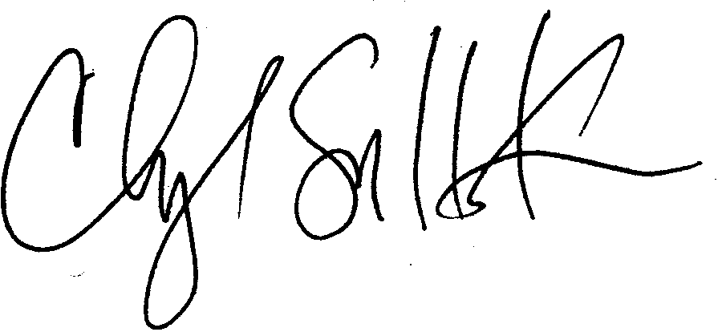

Cheryl Simrell King, PhD

Director, MPA Program & Member of the Faculty

The Evergreen State College