July 30, 2026

Kebba Manneh
C/O Dawda Kaira
PO Box 1866
Banjul, THE GAMBIA
West Africa

Dear Kebba,

Thank you for your application for Fall 2012 admission to the Evergreen State College Master of Public Administration program.

The MPA Admissions Committee has reviewed your file carefully. I regret to inform you that the Admissions Committee is unable to offer you admission to the MPA program. We had a strong pool of applicants and a competitive admissions process. We believe that applicants who were denied this year would have been competitive in earlier years.

We appreciate your interest in the Master of Public Administration program and wish you the best in your future endeavors.

Sincerely,

Sincerely,
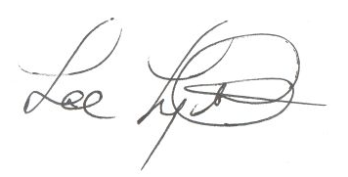
Lee Lyttle.
Director, MPA Program & Member of the Faculty
The Evergreen State College

