July 30, 2026

NAME STUDENT ID #
ADDRESS

Dear FIRST NAME,

Congratulations! I am pleased to inform you that you have been accepted into Evergreen’s Master of Public Administration program for Fall 2011. This year we had a record number of applicants and admissions was very competitive. You are part of a diverse, capable, and dedicated cohort of people who will begin the program this year.

What follows is some important information about financial aid and Fall quarter registration and course scheduling. If you have any questions, feel welcome to contact Randee Gibbons, Assistant MPA Director, at gibbonsr@evergreen.edu.

Fall quarter classes began on Monday, September 26, 2011, and Fall 2011 course registration is in progress. After you are formally admitted in our system, Randee will get you registered in first year Core and email further registration instructions and information about Fall courses.

If you wish to apply for financial aid, the first step is to complete the federal student aid form, the “FAFSA. The information generated by the FAFSA will help determine your eligibility for federal student loans and need-based MPA related scholarships. At this time in the aid awarding process, the MPA program only has limited funds available. After we access and review your financial aid info from the FAFSA, we will determine whether you are eligible for MPA related scholarships and other forms of “free money” assistance.

To contact the Financial Aid Office directly regarding loan eligibility and timelines, call 360-867-6205 or email finaid@evergreen.edu. For access to the FAFSA and for more financial aid information, go to the MPA Financial Aid page at: http://www.evergreen.edu/mpa/finaid.htm.

Once again, congratulations on your admission to the Master of Public Administration program! We look forward to working with you.

Sincerely,
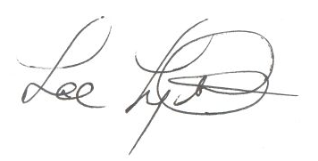
Lee Lyttle.
Director, MPA Program & Member of the Faculty
The Evergreen State College

