Sincerely,
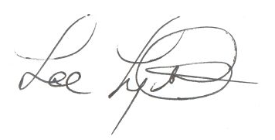
Lee Lyttle.
Director, MPA Program & Member of the Faculty
The Evergreen State College

