NAME NEW STUDENT ID: xxxxxxxx
ADDRESS
CITY STATE ZIP

Dear NAME,

I am pleased to inform you, upon recommendation of the MPA Admissions Committee, that you have been accepted into Evergreen’s Master of Public Administration program for Fall 2009.

Your admission to the MPA Program is PROVISIONAL based on the fact that your file does not contain an official transcript indicating you have been awarded a baccalaureate (bachelor’s) degree. The Evergreen Office of Admissions must receive written confirmation by September 15, 2009 from an official of the awarding institution indicating you have completed the requirements for your bachelor’s degree in order for you to enroll for the Fall Quarter. In addition, by November 1, 2009, the Office of Admissions must receive an official transcript reflecting the awarding of the bachelor’s degree in order for you to continue in the MPA Program beyond the Fall Quarter. If you are awarded financial aid, please note that your final transcript reflecting completion of the bachelor’s degree must be received by September 15, 2009 in order for any financial aid funds to be released for Fall Quarter.

Your admission to the MPA Program is also CONDITIONAL based the fact that the MPA Admissions Committee did not see evidence in your application that you have completed, within the last five years, a minimum of 4 quarter credit hours of introductory statistics in the social or behavioral sciences. Completion of this coursework is required before you can begin the first year of the MPA core sequence. Please submit an official transcript reflecting completion of an approved statistics course no later than September 15, 2009 to Jan Hays, MPA Office Assistant, at: MPA Program; Lab 1, Room 3019; Evergreen State College; 2700 Evergreen Parkway NW; Olympia, WA 98505. Your admission to the program will be withdrawn if we do not receive an official transcript documenting completion of the statistics prerequisite by September 15, 2009. For a list of Evergreen and non-Evergreen courses that would satisfy the statistics requirement and other important information about the statistics prerequisite, go to the MPA Course and Schedule Information page at http://www.evergreen.edu/mpa/courseinfo.htm and, under “Program Information,” click on the link that begins: “Prerequisite info for prospective MPA students…”.

In addition, upon review of your application materials, the MPA Admissions Committee did not see evidence that you have done full-time work, for a year or more, with significant responsibility in public/non-profit administration or in a public policy area. Therefore, we are requiring that you expand your experience base by participating in a public or non-profit sector internship. This internship is minimally one quarter credit hour and involves part-time work with an agency or organization for one quarter. This internship is a requirement for graduation from the MPA program and must be completed after Winter quarter of your first year and before graduation from the MPA program. If you believe you have the requisite experience, you may petition this decision to the MPA Program Director, after you begin the MPA program. Petitions will not be accepted until after the Fall 2009 quarter has begun.

This offer of admission is dependent upon successful completion of any academic work currently in progress.

The Faculty of the MPA program recently made the decision to change our curriculum. We will roll out these curriculum changes starting this Fall. Our basic structure and the total number of credits needed to complete the MPA program remains the same (60): what changes is the mix of credit hours. In the old model, each Core course was 4 credit hours and Capstone was offered in addition to Core. In the new model, each Core course is now 6 credit hours, as indicated below, and Capstone is combined with 2nd Year Core. We believe this new curriculum model better recognizes the primary importance of Core coursework as well as allowing us to meet student needs and make the adjustments needed in these critical economic times. In the new model, Core courses will continue to meet one night a week, from 6-10pm, with the addition of one weekend (for Fall of the 1st year Core) or a Saturday meeting (for other quarters of Core).

YEAR | FALL | WINTER | SPRING
1st Year Core | Context of Public Administration  (6 credits) | Doing Administration in a Democracy  (6 credits) | Policy, Finance and Budgeting for Public Administration.  (6 credits)
2nd Year Core | Analytical Techniques for Public Service I  (6 credits) | Analytical Techniques for Public Service II  (6 credits) | Capstone  (6 credits)

Public and Non-Profit Administration Concentration:

New model: 1ST & 2nd Year Core (36 credit hours) + 24 elective credit hours = 60 credit hours

(Old model: 1ST & 2nd Year Core + Capstone (30 credit hours) + 30 elective credit hours = 60 credit hours)

Public Policy Concentration:

New model: 1ST and 2nd Year Core (36 credit hours) + Required concentration coursework: Advanced Research Methods & Foundations of Public Policy (8 credit hours) + 16 elective credit hours = 60 credit hours

(Old model: 1ST & 2nd Year Core + Capstone (30 credit hours) + Advanced Research Methods & Foundations of Public Policy (8 credit hours) + 22 elective credit hours = 60 credit hours)

Your decision to accept our offer must take into consideration these changes to the curriculum. We know you applied to a program that was designed somewhat differently and will understand if the changes affect your decision. If you have any questions, feel welcome to contact Randee Gibbons, Assistant MPA Director, at gibbonsr@evergreen.edu.

It’s also important to note that while Fall quarter classes begin on Monday, September 28, 2009, we will be starting classes for first year MPA students a bit earlier. Your first year Core course begins with an intensive weekend plus an orientation to the MPA program, on the weekend of Friday, September 25 through Sunday, September 27: Friday from 5-9pm, Saturday and Sunday from 9am-4pm.

Please note that all new students are required to participate in this first weekend of class/orientation on September 25-27. We will send more detailed information about the September weekend and information about first year courses to all students who have confirmed their enrollment by sending in their tuition deposit.

If you wish to accept this offer of admission and reserve your space in the Fall 2009 cohort, the college must receive a non-refundable $100.00 deposit by August 28, 2009. The tuition deposit billing form is enclosed, or for faster service you may make a web payment via “My Evergreen”. To log in for the first time, go to my.evergreen.edu, click on "login help", click on "logging in for the first time", follow the instructions and then click on "web payment. After you pay your deposit, please email Randee Gibbons, Assistant MPA Director, so that she may send you detailed information about Fall course registration and Orientation, at: gibbonsr@evergreen.edu. If you cannot accept this offer of admission, we’d really appreciate it if you’d email Randee as soon as possible so that we may inform students on our waiting list.

Many students admitted to the MPA program are eligible for some form of financial aid. The MPA program has already awarded all 2009-10 non-loan aid (scholarships, tuition waivers, work study, etc.) Loans are still available, and the Evergreen Financial Aid Office administers the federal student loan program. To apply for a federal student loan, begin by completing the federal student aid form, the “FAFSA”, as soon as possible, which is accessible via the Graduate Student Financial Aid page: http://www.evergreen.edu/financialaid/graduate_finaid.htm. After completing the FAFSA you would contact the Evergreen Financial Aid Office re: loan eligibility and distribution, at 360-867-6205.

Congratulations on your admission to the Masters of Public Administration program. We select our entering cohorts with considerable care and admissions are quite competitive. You are part of a diverse, capable, and dedicated cohort of people selected to begin the MPA program this year. We hope you accept this offer and look forward to working with you.

If you have any questions, contact me at kingcs@evergreen.edu.

Sincerely,
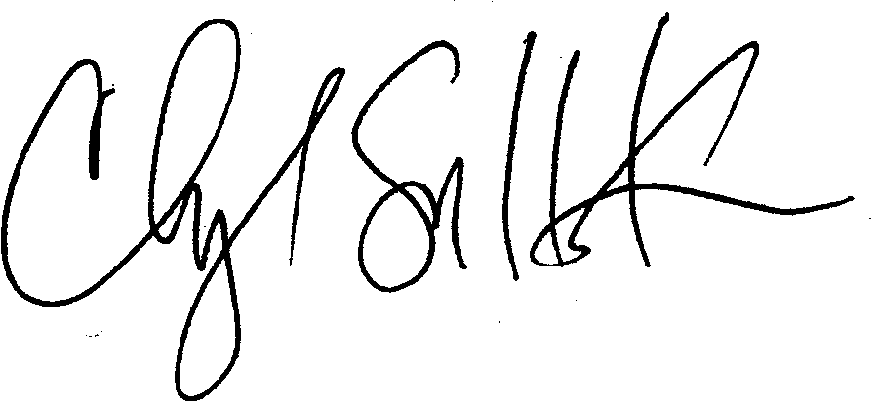
Cheryl Simrell King, Ph.D.
Director, MPA Program & Member of the Faculty
The Evergreen State College

