<LETTERHEAD>

July 30, 2026

NAME NEW STUDENT ID:
ADDRESS

Dear FIRST NAME

I am pleased to inform you, upon recommendation of the Graduate Admissions Committee, that you have been accepted into Evergreen’s Master of Public Administration Program for Fall 2008.

Your admission to the MPA Program is PROVISIONAL based on the fact that your file does not contain an official transcript indicating you have been awarded a baccalaureate (bachelor’s) degree. The Evergreen Office of Admissions must receive written confirmation by September 15, 2008 from an official of the awarding institution indicating you have completed the requirements for your bachelor’s degree in order for you to enroll for the Fall Quarter. In addition, by November 1, 2008, the Office of Admissions must receive an official transcript reflecting the awarding of the bachelor’s degree in order for you to continue in the MPA Program beyond the Fall Quarter. If you are awarded financial aid, please note that your final transcript reflecting completion of the bachelor’s degree must be received by September 15, 2008 in order for any financial aid funds to be released for Fall Quarter.

Your admission to the MPA Program is also CONDITIONAL based on the following:

- The Graduate Admissions Committee did not see evidence in your application that you have completed, within the last five years, 4 credits of introductory statistics in the social or behavioral sciences. Completion of this coursework is required before you can begin the first year of the MPA core sequence. Please see that Randee Gibbons, the Assistant MPA Director, receives an official transcript reflecting completion of this work no later than September 15, 2008. For a list of Evergreen and non-Evergreen courses that would satisfy the statistics requirement and other important information about the statistics prerequisite, go to the MPA Course and Schedule Information page at http://www.evergreen.edu/mpa/courseinfo.htm and, under “Program Information,” click on the link that begins: “For Fall 08 MPA Applicants: Prerequisite info…”:

- Upon review of your application materials, the MPA Admissions Committee did not see evidence that you have done full-time work, for a year or more, with significant responsibility in public/non-profit administration or in a public policy area. Therefore, we are requiring that you expand your experience base by participating in a public or non-profit sector internship. This internship is minimally one quarter credit hour and involves part-time work with an agency or organization for one quarter. This internship is a requirement for graduation from the MPA program. Additional information regarding internships will be available during the Fall quarter.

Congratulations, I hope you will be able to join us! This offer of admission is dependent upon successful completion of any academic work currently in progress. If you wish to accept this offer of admission, please inform the Office of Admissions in writing promptly. Enclosed is a billing form for your tuition deposit. This non-refundable $100.00 deposit reserves your space in the program. The college must receive payment within 30 days from the date of this letter in order to hold your space at the institution. If you cannot accept this offer of admission, please also notify us in writing immediately so that we can inform students on our waiting list.

This year, the Fall quarter will begin on Monday, September 29, 2008. An orientation to the Master of Public Administration Program will be held during the weekend of September 19-21 or September 26-28. The orientation schedule may include sessions on Friday evening, all day Saturday and all day Sunday. At this time please hold both of these weekends open: we expect to confirm our schedule by the end of May. Please note that all new students are required to participate in orientation. In the summer, we will send more detailed information about this orientation meeting and information about first year courses to all students who have confirmed their enrollment by sending in their tuition deposit. Please inform the Office of Admissions of any changes in your mailing address so we can get this information to you on time.

Many students admitted to the MPA program are eligible for some form of financial aid. This may include student loans, scholarships, tuition waivers, and other forms of assistance. The first step is to complete the federal student aid form, the “FAFSA”, as soon as possible. The second step is to complete the MPA Financial Aid Application for 2008-2009, which is due by May 1, 2008. For access to these forms and for more information, go to http://www.evergreen.edu/mpa/finaid.htm.

Again, congratulations on your admission to the Masters of Public Administration program. We select our entering class with considerable care and admissions are increasingly competitive. You are part of a diverse, capable, and dedicated cohort of people selected to begin the MPA program this year. We look forward to working with you.

If you have any questions, contact me at kingcs@evergreen.edu.

Sincerely,
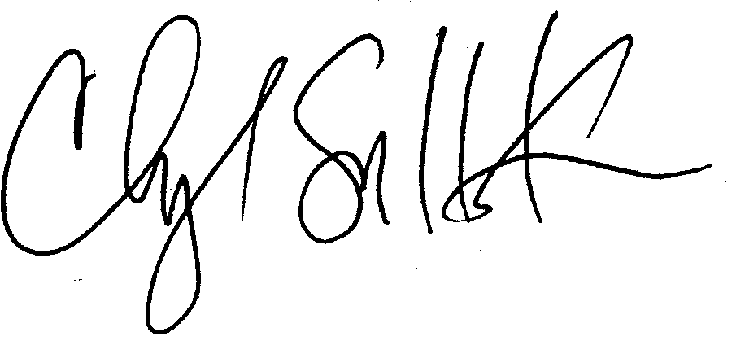
Cheryl Simrell King, Ph.D.
Director, MPA Program & Member of the Faculty
The Evergreen State College

