July 30, 2026

NAME NEW STUDENT ID: A
ADDRESS
ADDRESS

Dear NAME,

I am pleased to inform you, upon recommendation of the Graduate Admissions Committee, that you have been accepted into Evergreen’s Master of Public Administration Program for Fall 2008.

Your admission to the MPA Program is PROVISIONAL based on the fact that your file does not contain an official transcript indicating you have been awarded a baccalaureate (bachelor’s) degree. The Evergreen Office of Admissions must receive written confirmation by September 15, 2008 from an official of the awarding institution indicating you have completed the requirements for your bachelor’s degree in order for you to enroll for the Fall Quarter. In addition, by November 1, 2008, the Office of Admissions must receive an official transcript reflecting the awarding of the bachelor’s degree in order for you to continue in the MPA Program beyond the Fall Quarter. If you are awarded financial aid, please note that your final transcript reflecting completion of the bachelor’s degree must be received by September 15, 2008 in order for any financial aid funds to be released for Fall Quarter.

Your admission to the MPA Program is also CONDITIONAL based on the following:

- The Graduate Admissions Committee did not see evidence in your application that you have completed, within the last five years, 4 credits of introductory statistics in the social or behavioral sciences. Completion of this coursework is required before you can begin the first year of the MPA core sequence. Please see that Randee Gibbons, the Assistant MPA Director, receives an official transcript reflecting completion of this work no later than September 15, 2008. For a list of Evergreen and non-Evergreen courses that would satisfy the statistics requirement and other important information about the statistics prerequisite, go to the MPA Course and Schedule Information page at http://www.evergreen.edu/mpa/courseinfo.htm and, under “Program Information,” click on the link that begins: “For Fall 08 MPA Applicants: Prerequisite info…”:

- Upon review of your application materials, the MPA Admissions Committee did not see evidence that you have done full-time work, for a year or more, with significant responsibility in public/non-profit administration or in a public policy area. Therefore, we are requiring that you expand your experience base by participating in a public or non-profit sector internship. This internship is minimally one quarter credit hour and involves part-time work with an agency or organization for one quarter. This internship is a requirement for graduation from the MPA program.

This offer of admission is dependent upon successful completion of any academic work currently in progress. If you wish to accept this offer of admission and reserve your space in the Fall 2008 cohort, the college must receive a non-refundable $100.00 deposit within 30 days from the date of this letter. The tuition deposit billing form is enclosed. If you cannot accept this offer of admission, please notify us in writing immediately so that we can inform students on our waiting list.

This year, Fall quarter classes begin on Monday, September 29, 2008. However, we’ll be starting classes for first year MPA students a bit earlier. The first weekend of class and an orientation to the Master of Public Administration program will be held September 26-28. We expect sessions to be held on Friday evening and all day Saturday and Sunday.

Please note that all new students are required to participate in this first weekend of class/orientation. In the summer, we will send more detailed information about the September weekend meeting and information about first year courses to all students who have confirmed their enrollment by sending in their tuition deposit. Once you have paid your deposit, please activate your “My Evergreen” account to ensure you are receiving emails from us.

Many students admitted to the MPA program are eligible for some form of financial aid. This may include student loans, scholarships, tuition waivers, and other forms of assistance. In order to qualify for all forms of financial aid please complete the federal student aid form, the “FAFSA”, as soon as possible. The second step is to submit the 2008-09 MPA Financial Aid Application. Please note that limited funds are available to award MPA program scholarships, fellowships and tuition waivers after May 1, 2008. For access to these forms and for more information, go to http://www.evergreen.edu/mpa/finaid.htm.

Congratulations on your admission to the Masters of Public Administration program. We select our entering cohorts with considerable care and admissions are increasingly competitive. You are part of a diverse, capable, and dedicated cohort of people selected to begin the MPA program this year. We look forward to working with you.

If you have any questions, contact me at kingcs@evergreen.edu.

Sincerely,
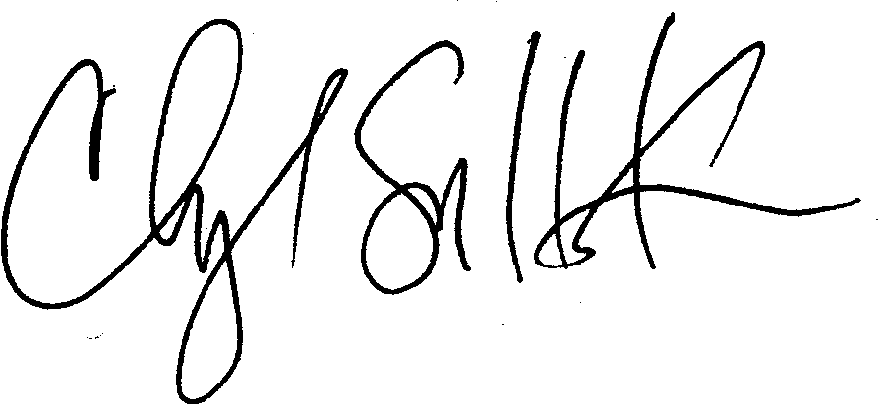
Cheryl Simrell King, Ph.D.
Director, MPA Program & Member of the Faculty
The Evergreen State College

