July 29, 2026

Julie Ann Meier NEW STUDENT ID: A00140611
PO Box 383
Olympia, WA 98507

Dear Julie,

We are pleased that you are joining us in Fall 2008 to begin the Master of Public Administration Program. This is an updated Admissions letter, to give you current information related to Fall 2008 admission.

First, our prerequisite requirements have changed. Your admission to the MPA Program is still CONDITIONAL; now there is only one prerequisite for the MPA program – statistics --- and we must receive evidence of statistics course completion before the Fall quarter of your first year of core coursework begins (no later than September 15, 2008.) Here are the details:

- The Graduate Admissions Committee did not see evidence in your application that you have completed, within the last five years, 4 credits of introductory statistics in the social or behavioral sciences. Completion of this coursework is required before you can begin the first year of the MPA core sequence. Please see that Randee Gibbons, the Assistant MPA Director, receives an official transcript reflecting completion of this work no later than September 15, 2008. For a list of Evergreen and non-Evergreen courses that would satisfy the statistics requirement and other important information about the statistics prerequisite, go to the MPA Course and Schedule Information page at http://www.evergreen.edu/mpa/courseinfo.htm and, under “Program Information,” click on the link that begins: “For Fall 08 MPA Applicants: Prerequisite info…”:

As stated in your previous admissions letter, you must complete an internship before you graduate from the MPA program, as follows:

- Upon review of your application materials, the MPA Admissions Committee did not see evidence that you have done full-time work, for a year or more, with significant responsibility in public/non-profit administration or in a public policy area. Therefore, we are requiring that you expand your experience base by participating in a public or non-profit sector internship. This internship is minimally one quarter credit hour and involves part-time work
with an agency or organization for one quarter. This internship is a requirement for graduation from the MPA program and must be completed after the Winter quarter of your first year in the program.

This year, Fall quarter classes begin on Monday, September 29, 2008. However, we’ll be starting classes for first year MPA students a bit earlier. The first weekend of class and an orientation to the Master of Public Administration Program will be held September 26-28. We expect sessions to be held on Friday evening and all day Saturday and Sunday.

Please note that all new students are required to participate in this first weekend of class/orientation. In the summer, we will send more detailed information about the September weekend meeting and information about first year courses to all students who have confirmed their enrollment by sending in their tuition deposit. Please activate your “My Evergreen” account to ensure you are receiving emails from us.

Many students admitted to the MPA program are eligible for some form of financial aid. This may include student loans, scholarships, tuition waivers, and other forms of assistance. The first step is to complete the federal student aid form, the “FAFSA”, as soon as possible. The second step is to complete the MPA Financial Aid Application for 2008-2009, which is due by May 1, 2008. For access to these forms and for more information, go to http://www.evergreen.edu/mpa/finaid.htm.

Once again, congratulations on your admission to the Masters of Public Administration program. We select our entering cohorts with considerable care and admissions are increasingly competitive. You are part of a diverse, capable, and dedicated cohort of people selected to begin the MPA program this year. We look forward to working with you.

If you have any questions, contact me at kingcs@evergreen.edu.

Sincerely,
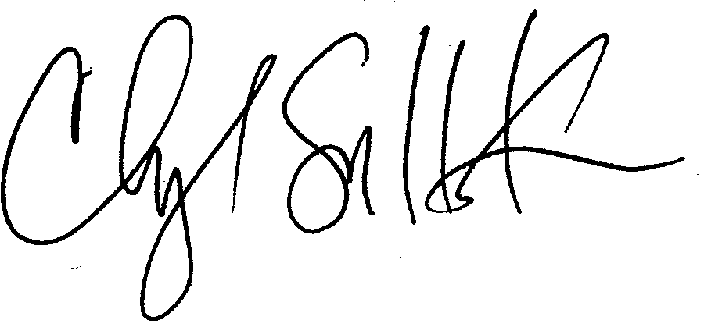
Cheryl Simrell King, Ph.D.
Director, MPA Program & Member of the Faculty, The Evergreen State College

