July 30, 2026

Julie Ann Meier NEW STUDENT ID: A00140611
PO Box 383
Olympia, WA 98507

Dear Julie,

I am pleased to inform you, upon recommendation of the MPA Admissions Committee, that you have been accepted into Evergreen’s Master of Public Administration Program for Fall 2008. Your admission to the MPA Program is CONDITIONAL based on the following:

- The Graduate Admissions Committee did not see evidence in your application that you have completed, within the last five years, 4 credits of introductory statistics in the social or behavioral sciences. Starting this fall, our statistics prerequisite requirement has changed: the statistics requirement must be completed before admitted students are permitted to begin the first year of the MPA program in Fall 2008. Please see that the Evergreen Office of Admissions receives an official transcript reflecting completion of this work no later than September 15, 2008.

- Upon review of your application materials, the MPA Admissions Committee did not see evidence that you have done full-time work, for a year or more, with significant responsibility in public/non-profit administration or in a public policy area. Therefore, we are requiring that you expand your experience base by participating in a public or non-profit sector internship. This internship is normally one quarter credit hour in addition to the 60 quarter credit hours required for the MPA program and involves part-time work with an agency or organization for one quarter. This internship is a requirement for graduation from the MPA program. Additional information regarding internships will be available at the orientation session.

This offer of admission is dependent upon successful completion of any academic work currently in progress. Enclosed is a billing form for your tuition deposit. This non-refundable $100.00 deposit reserves your space in the program. If you wish to accept this offer of admission, the college must receive payment within 30 days of the date of this letter in order to hold your space in the program. If you cannot accept this offer of admission, please notify us in writing immediately at the Office of Admissions so that we may inform students on our waiting list. If we don’t hear from you one way or the other within 30 days, we will automatically assign your space to a student on the waiting list.

This year, Fall classes start on Monday, September 29, 2008. An orientation to the Master of Public Administration Program will be held on Saturday September 27, 2008. All new students are required to participate in orientation. In the summer, we will send more specific information about this orientation meeting and information about the first year classes to all students who have confirmed their enrollment by sending in their tuition deposit. Please inform the Office of Admissions of any changes in your mailing address so we can get this information to you on time.

Again, congratulations on your admission to the Masters of Public Administration program. We select our entering class with considerable care and admissions are increasingly competitive. You are part of a diverse, capable, and dedicated cohort of people selected to begin the MPA program this year. We look forward to working with you.

If you have any questions, contact me at kingcs@evergreen.edu.

Sincerely,
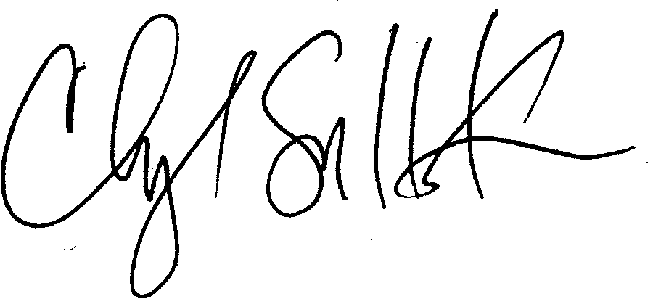
Cheryl Simrell King, Ph.D.
Director, MPA Program & Member of the Faculty
The Evergreen State College

