July 30, 2026

Ian Daniel Ward NEW STUDENT ID: A00136229
7887 Beardsley Ave NW
Gig Harbor, WA 98335

Dear Ian,

I am pleased to inform you, upon recommendation of the Graduate Admissions Committee, that you have been accepted into Evergreen’s Master of Public Administration Program for Fall 2008.

- Upon review of your application materials, the MPA Admissions Committee did not see evidence that you have done full-time work, for a year or more, with significant responsibility in public/non-profit administration or in a public policy area. Therefore, we are requiring that you expand your experience base by participating in a public or non-profit sector internship. This internship is minimally one quarter credit hour and involves part-time work with an agency or organization for one quarter. This internship is a requirement for graduation from the MPA program.

This offer of admission is dependent upon successful completion of any academic work currently in progress. If you wish to accept this offer of admission, please inform the Office of Admissions in writing promptly. Enclosed is a billing form for your tuition deposit. This non-refundable $100.00 deposit reserves your space in the program. The college must receive payment within 30 days from the date of this letter in order to hold your space at the institution. If you cannot accept this offer of admission, please also notify us in writing immediately so that we can inform students on our waiting list.

This year, Fall quarter classes begin on Monday, September 29, 2008. However, we’ll be starting classes for first year MPA students a bit earlier. The first weekend of class and an orientation to the Master of Public Administration Program will be held either September 19-21 or September 26-28. At this time please hold both of these weekends open: we expect to confirm our schedule by the end of May. Sessions will be held on Friday evening and all day Saturday and Sunday.

Please note that all new students are required to participate in this first weekend of class/orientation. In the summer, we will send more detailed information about the September weekend meeting and information about first year courses to all students who have confirmed their enrollment by sending in their tuition deposit. Once you have paid your deposit, please activate your “My Evergreen” account to ensure you are receiving emails from us.

Many students admitted to the MPA program are eligible for some form of financial aid. This may include student loans, scholarships, tuition waivers, and other forms of assistance. The first step is to complete the federal student aid form, the “FAFSA”, as soon as possible. The second step is to complete the MPA Financial Aid Application for 2008-2009, which is due by May 1, 2008. For access to these forms and for more information, go to http://www.evergreen.edu/mpa/finaid.htm.

Congratulations on your admission to the Masters of Public Administration program We select our entering cohorts with considerable care and admissions are increasingly competitive. You are part of a diverse, capable, and dedicated cohort of people selected to begin the MPA program this year. We look forward to working with you.

If you have any questions, contact me at kingcs@evergreen.edu.

Sincerely,
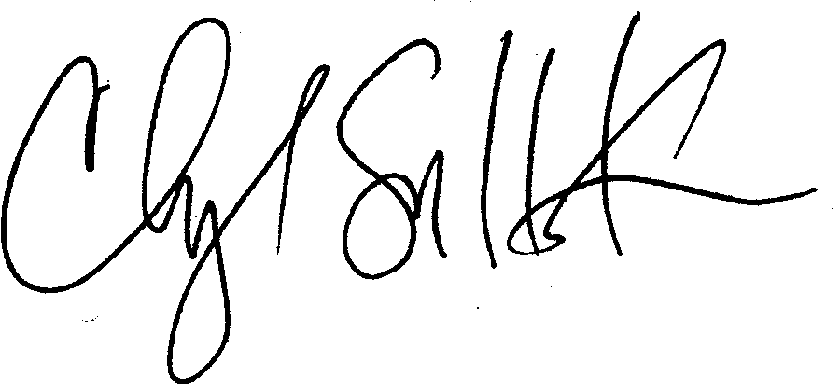
Cheryl Simrell King, Ph.D.
Director, MPA Program & Member of the Faculty
The Evergreen State College

