July 30, 2026

Rosetta Renee Brown NEW STUDENT ID: A08005797
8720 132nd St E
Puyallup, WA 98373

Dear Rosetta,

I am pleased to inform you, upon recommendation of the Graduate Admissions Committee, that you have been accepted into Evergreen’s Master of Public Administration Program for Fall 2008.

Your admission to the MPA Program is PROVISIONAL based on the fact that your file does not contain an official transcript indicating you have been awarded a baccalaureate (bachelor’s) degree. The Evergreen Office of Admissions must receive written confirmation by September 15, 2008 from an official of the awarding institution indicating you have completed the requirements for your bachelor’s degree in order for you to enroll for the Fall Quarter. In addition, by November 1, 2008, the Office of Admissions must receive an official transcript reflecting the awarding of the bachelor’s degree in order for you to continue in the MPA Program beyond the Fall Quarter. If you are awarded financial aid, please note that your final transcript reflecting completion of the bachelor’s degree must be received by September 15, 2008 in order for any financial aid funds to be released for Fall Quarter.

Your admission to the MPA Program is CONDITIONAL based on the following:

- Upon review of your application materials, the MPA Admissions Committee did not see evidence that you have done full-time work, for a year or more, with significant responsibility in public/non-profit administration or in a public policy area. Therefore, we are requiring that you expand your experience base by participating in a public or non-profit sector internship. This internship is minimally one quarter credit hour and involves part-time work with an agency or organization for one quarter. This internship is a requirement for graduation from the MPA program.

This offer of admission is dependent upon successful completion of any academic work currently in progress. If you wish to accept this offer of admission, please inform the Office of Admissions in writing promptly. Enclosed is a billing form for your tuition deposit. This non-refundable $100.00 deposit reserves your space in the program. The college must receive payment within 30 days from the date of this letter in order to hold your space at the institution. If you cannot accept this offer of admission, please also notify us in writing immediately so that we can inform students on our waiting list.

This year, Fall quarter classes begin on Monday, September 29, 2008. However, we’ll be starting classes for first year MPA students a bit earlier. The first weekend of class and an orientation to the Master of Public Administration Program will be held September 26-28 (Friday, 5-9pm; Sat/Sun, 8:30-4:30pm). Attendance is mandatory.

We will send more detailed information about the September weekend meeting and information about first year courses to all students who have confirmed their enrollment by sending in their tuition deposit. Once you have paid your deposit, please activate your “My Evergreen” account to ensure you are receiving emails from us. Then, contact Randee Gibbons, Assistant MPA Director, so she can help you with course registration, at gibbonsr@evergreen.edu.

Most students admitted to the MPA program are eligible for some form of financial aid. The MPA program has already awarded scholarships and tuition waivers for 2008-09. In order to apply for the federal student loan program, you will need to complete the federal student aid form, the “FAFSA.” For access to this form and for more information, go to http://www.evergreen.edu/mpa/finaid.htm or contact the Evergreen Financial Aid Office directly, at 360.867.6205.

Congratulations on your admission to the Masters of Public Administration program We select our entering cohorts with considerable care and admissions are increasingly competitive. You are part of a diverse, capable, and dedicated cohort of people selected to begin the MPA program this year. We look forward to working with you.

If you have any questions, contact me at kingcs@evergreen.edu.

Sincerely,
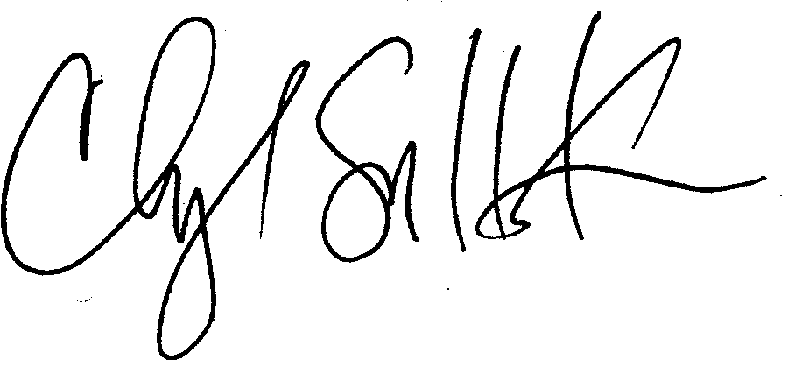
Cheryl Simrell King, Ph.D.
Director, MPA Program & Member of the Faculty
The Evergreen State College

