Professional Education and
Certification

electronic certification information

On-line User Manual

V1.1



User Manual Introduction

General
Roles/Users – an important concept
Reports – Report Viewer

How-To
Login
EDS Home
My Application List
OSPI eCert
Certification information
Occupation information
Test scores
fingerprints

User Manual Introduction
This manual is intended to assist users in navigating successfully, step-by-step through the Professional Education and Certification electronic certification information application. As well as context-specific help during your interaction with the application, this manual can be printed in its entirety as a desk reference manual.

These instructions are limited to the “how-to’s” and navigation of this application.

General Layout of User Manual
The manual has graphic and written instructions by Role (Example), Screen, Page or Tab pertaining to the process, User (if applicable), General Descriptions of the screen being used, a screen shot and Steps needed to correctly use the page. Special instructions are in italics. Example:

EDS Home All users will see this screen

This screen shows a list of options available for the user.
Steps:
- Click View my applications
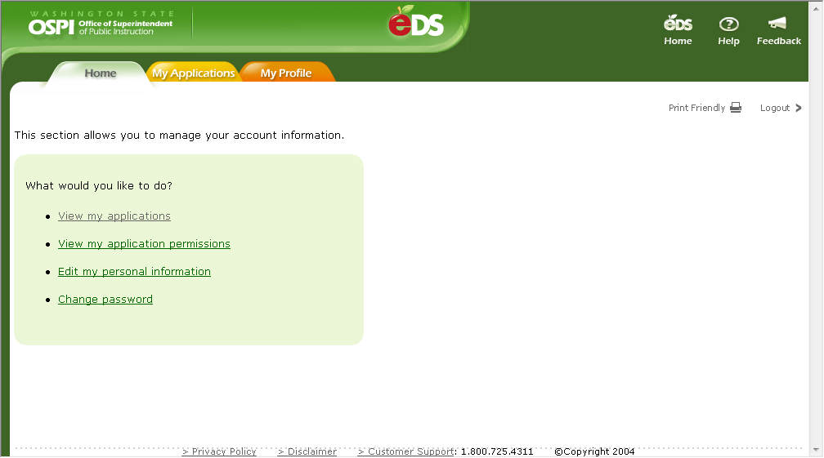

TECHNICAL ASSISTANCE
For login access, please contact your District Security Manager.

For technical help using the on-line system (can’t log on to the system, can’t access dropdown menus, etc.) contact OSPI customer support at CustomerSupport@ospi.wednet.edu or 1-800-725-4311.

This information is also available on the agency Web site at the following address: http//www.k12.wa.us/bulletinsmemos.

Roles– an important concept
ROLES: Directions are provided based on the role of the user, and will be noted if specific to that role: SCHOOL DISTRICT, ESD, OSPI. The options you view will be expanded or limited based on your role.

ALSO, depending on which security rights you are granted for your business role, additional options will be expanded/limited.

If no role or user type is indicated, screen or page interface and steps are the same for all roles/users

How-To

Login
This page is the entry point to the Electronic Data System (EDS) Applications at OSPI. The School Apportionment and Financial Services System is one application that is available to users within this portal.

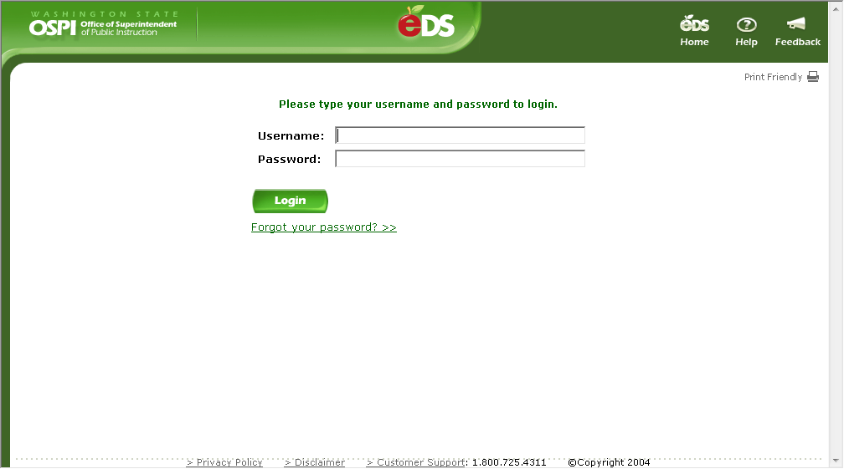

Steps:
- Enter your Username
- Enter your Password
- Click Login

EDS Home
This screen shows a list of options available for the user.

Steps:
- Click View my applications

My Application List
This screen shows a list of applications at OSPI that the user is has been provided access to.

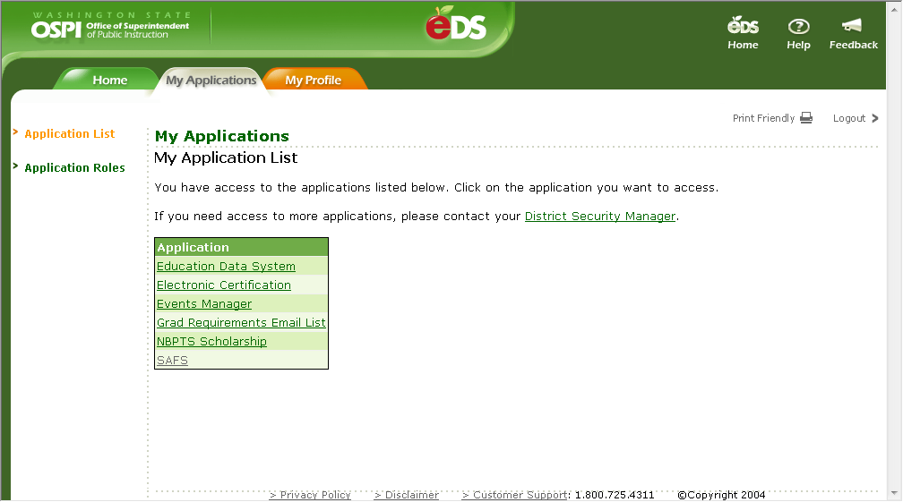

Steps:
- Click Electronic Certification

School district users do not need to review page 7 instructions.

Certification Home
The home screen confirms successful login by displaying the Electronic Certification home screen. This screen will display different menu options for different users, School District, ESD or OSPI.

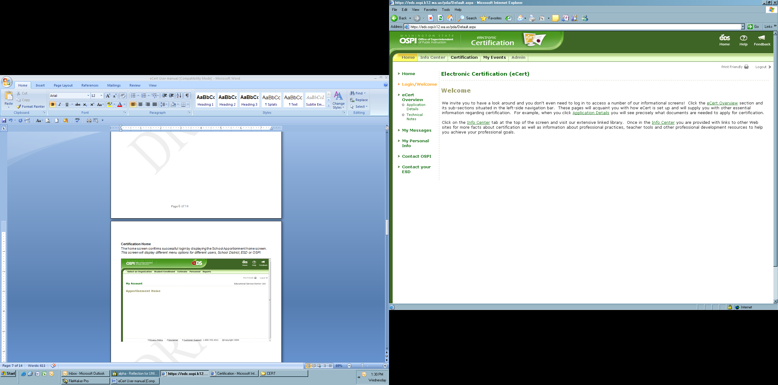

NOTE for ESD user: To access electronic certification information, select ‘Admin’ Tab.

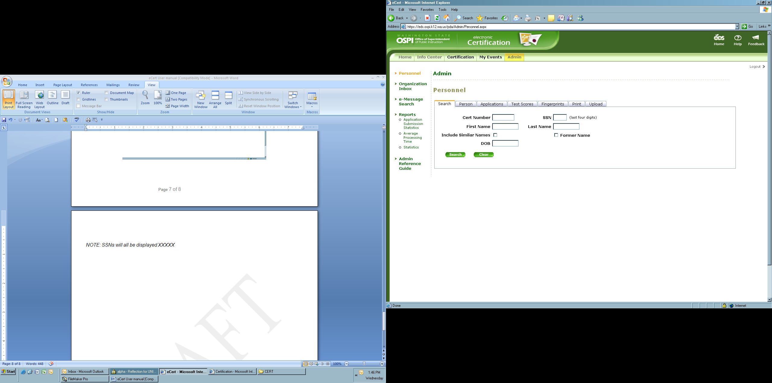

Search Tab function: The search tab can be used to search all other tabs (person, test scores, fingerprints, etc). If you enter an individual’s first and last name, it will search the other tabs using that criterion. If you enter a certificate number, you will only receive results where the certificate number is used in that record. Applications, Test Scores, and Fingerprints do not use a certificate number as part of the record.

NOTE: SSNs will all be displayed ***1234

NOTE FOR SCHOOL DISTRICT USER: School districts can also request information regarding certification and occupation for employees in their district or in a particular building using the district/school search.

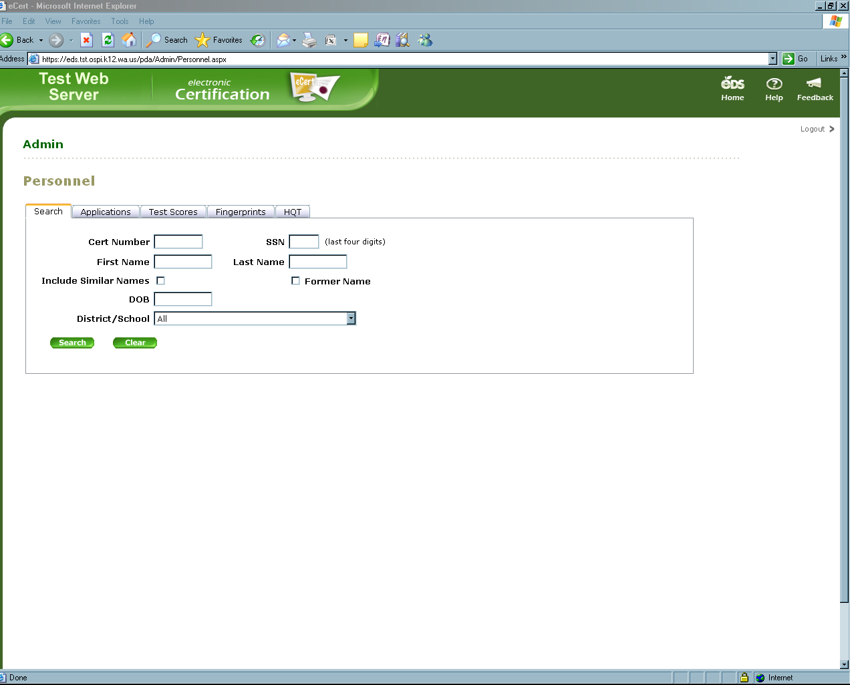
Once a search is initiated by name, certificate number, district or school, the results for certification information and assignment will display at the bottom of the search tab:

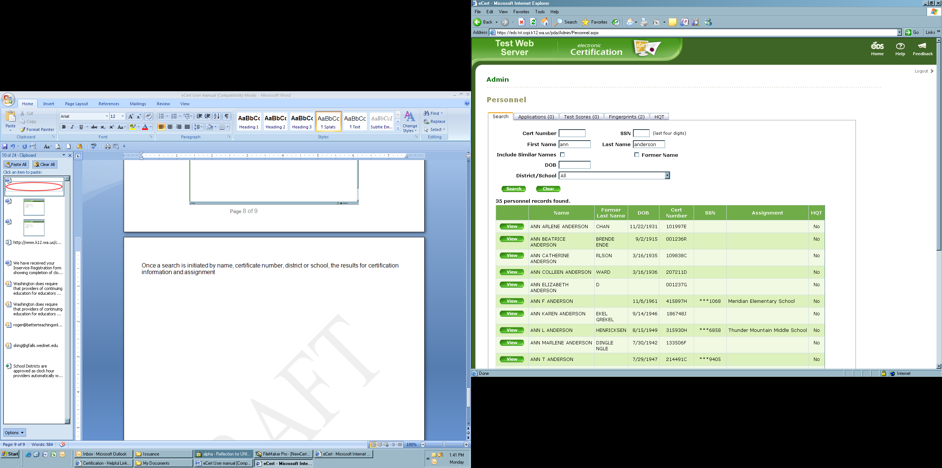

To view individual certificate information for a particular person, select ‘view’ next to their name.

NOTE: ESD users will be taken to the Person tab to view only certification information. School District users will be taken to the Occupation tab which shows certification and employment information (if employed).

Test Scores Tab: Once a name search has been initiated, the test scores tab and fingerprints tab will indicate the number of results found based on name. Selecting the test score tab or fingerprints tab will display the results found.

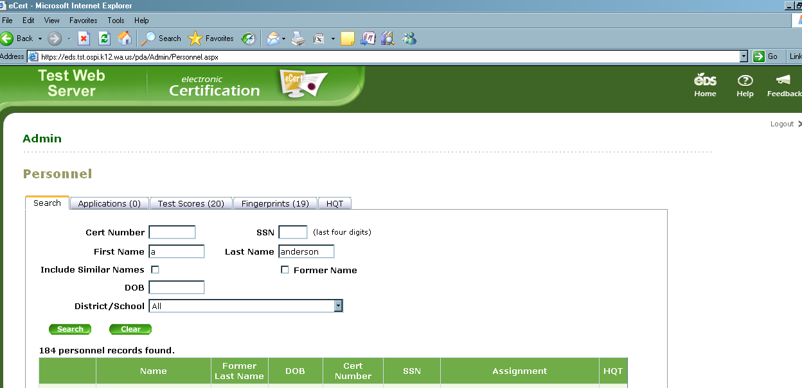

National Board Teacher Certificate Tab: This tab will show an individual’s name, DOB, NBCT certificate area and NBCT validity/expiration date.

Highly Qualified Teacher Tab: This information will show districts HQT data as it relates to certification endorsements for an individual in the core academic subject areas. More and more information will be shown as it becomes available.

