Higher Education Act
Title II

Institutional and Program Report
Card System (IPRC)

User Manual

February 2011

U.S. Department of Education
Office of Postsecondary Education



OMB Control No. 1840-0744 (expiration date: 09/30/2012)

Paperwork Burden Statement

This is a required data collection. Response is not voluntary. According to the Paperwork Reduction Act of 1995, no persons are required to respond to a collection of information unless such collection displays a valid OMB control number. The valid OMB control number for this information collection is 1840-0744 (expiration date 09/30/2012). The time required for institutions to complete this information collection is estimated to average 145.8 hours per response, including the time to review instructions, search existing data resources, gather the data needed, and complete and review the information collection. The time required for states to complete this information collection is estimated to average 600 hours per response, including the time to review instructions, search existing data resources, gather the data needed, and complete and review the information collection. If you have any comments concerning the accuracy of the time estimate(s) or suggestions for improving this form, please write to: U.S. Department of Education, Washington, DC 20202-4651. If you have comments or concerns regarding the status of your individual submission of this form, write directly to: Assistant Secretary, Office of Postsecondary Education, U.S. Department of Education, 1990 K Street, NW, Room 7115, Washington, DC 20006.

Contents

Part I. Introduction to Title II Reporting

A. Introduction 1
B. Reporting Requirements 2
C. Reporting Cycles 3
D. Key Definitions 4
E. General Information for IHE Reporting 5
F. Benefits to Using the IPRC System 5

Part II. Using the IPRC System for Title II Reporting

A. Logging In and Logging Out 6
B. System Security 12
C. System Features 13
D. Report Navigation 18

Part III. Completing the Title II Report

1.a. Admissions Requirements 22
1.b. Program Enrollment 24
1.c. Supervised Clinical Experience 27
1.d. Teachers Prepared 29
1.e. Program Completers 32
II. Annual Goals 34
II. Assurances 34
III. Pass Rates 36
IV Low-Performing 41
V. Use of Technology 43
VI. Teacher Training 45
VII. Contextual Information (Optional) 47
VIII. Certification 49

Printing Your Report 51
Updating User Account Information 52
Glossary 53
Contact Us 54

Appendix A Title II Tips for Reporting: Pass Rate Templates A-1

Tables

1. Types of responses by report section 2
2. Data collection year/cycle by report section 3

Figures

1. Login screen 6
2. Initial password change 8
3. Unlock Account 9
4. Unlock Account Security Questions 10
5. Forgot your username or password? Link 11
6. Log out 12
7. Time-out warning 12
8. Radio buttons and text boxes 14
9. Check boxes 15
10. Insert/edit/delete 16
11. Web address 17
12. Main menu 18
13. Change program 19
14. Instructions 20
15. Institution/program information 21
16. Section I.a Admissions requirements 22
17. Section I.a Admissions requirements 23
18. Section I.b Enrollment 26
19. Section I.c Supervised clinical experience 28
20. Section I.d Teachers Prepared 30
21. Section I.d Teachers Prepared 31
22. Section I.e Program completers 33
23. Section II Annual goals 35
24. Section III Assurances 35
25. Section III Pass rates 37
26. Assessment pass rates 39
27. Summary pass rates 40
28. Section IV Low-performing 42
29. Section V Use of technology 44
30. Section VI Teacher training 46
31. Contextual information (Optional) 48
32. Certification 50
33. Print menu 51
34. User account information 52
35. Glossary 53
36. Contact us 54

Part I: Introduction to Title II Reporting

- Introduction

Sections 205 through 208 of Title II of the Higher Education Act (HEA), as amended in 2008, (PL 110-315) call for accountability for programs that prepare teachers. Section 205 of Title II requires reports from each institution of higher education (IHE) that conducts a traditional teacher preparation program or an alternative route to state certification or licensure program and that enrolls students receiving federal assistance under HEA (e.g., Title IV). In addition, states must be able to report on alternative routes to teacher certification or licensure that are operated by entities that are not institutions of higher education. The law can be accessed at http://www2.ed.gov/policy/highered/leg/hea08/index.html.

A teacher preparation program is a state-approved course of study, the completion of which signifies that an enrollee has met all the state’s educational and/or training requirements for initial certification or licensure to teach in the state’s elementary, middle or secondary schools. A teacher preparation program may be either a traditional program or an alternative route to certification, as defined by the state. Also, it may be within or outside an institution of higher education. For the purposes of Title II reporting, all traditional teacher preparation programs at a single institution of higher education are considered to be a single program. Likewise, all alternative routes to initial teacher certification are considered to be a single program. The law requires institutions of higher education to submit timely and accurate reports or risk a fine of up to $27,500.

Teacher preparation programs, both traditional and alternative, report to their states, which report to the U.S. Department of Education. Since 2001, the Office of Postsecondary Education at the U.S. Department of Education has collected data from states on teacher preparation programs and their students, as well as states’ assessment and licensing of teacher candidates.

While annual Title II reporting is required by law, the mechanisms IHEs use to report are determined by the state. The Institutional and Program Report Card (IPRC) system is an online tool by which IHEs and other organizations with state-approved teacher preparation programs can meet the annual reporting requirements on teacher preparation, certification and licensing mandated by Title II. If a state chooses to use the IPRC system, all IHEs in the state must report to the state using this system. IHEs may need to develop their own internal systems or processes to collect the necessary information to enter into the IPRC system.

This manual provides an overview of Title II reporting for IHEs, including reporting requirements and cycles, key definitions and guidance on using the IPRC system. For purposes of this manual, all entities reporting to their state under Title II will be referred to as IHE(s). For technical assistance in using the IPRC, contact Westat at title2@westat.com or 877-684-8532. Additional technical assistance documents and information, such as frequently asked questions, can be found at https://title2.ed.gov/TA.asp. For purposes of this manual, all screenshots are informational and for display purposes only. Data shown in screenshots are examples only and do not necessarily represent correct data.
- Reporting Requirements

Section 205(a) of Title II requires each IHE to report annually on:

- Basic aspects of its teacher preparation program, such as admissions requirements; number of students enrolled by gender, ethnicity and race; information about supervised clinical experience; the number of students prepared by academic major and subject area; and the number of program completers;
- Goals for increasing the number of teachers trained in shortage areas and assurances about aspects of teacher training;
- How well groups of students perform on initial state licensing and certification assessments;
- Approval or accreditation of the teacher preparation program and whether the program is under a designation of “low-performing;” and
- Information about preparing teachers to use technology, to participate as a member of individualized education program teams and to teach students with disabilities or who are limited English proficient.

Table 1 highlights each section of the report card and whether a narrative or numeric response is required. A narrative response to a question may include checking yes or no, selecting from a list of possible responses or typing a response in a text box. A numeric response asks for you to type a number in a box or upload a data file. Sections may require only narrative responses, only numeric responses or both types of responses.

Table 1. Types of responses by report section
Report Section | Narrative | Numeric
Admissions requirements
Enrollment
Supervised clinical experience
Teachers prepared
Program completers
Annual goals
Assurances
Pass rates
Low-performing
Use of technology
Teacher training

- Reporting Cycles

The data elements required by Title II refer to different points in time. For example, admissions requirements are based on the most current information available, while enrollment is based on a specific academic year. Table 2 shows each report section and the corresponding data collection year/cycle for each reporting year.

Table 2. Data collection year/cycle by report section
Report section | Reporting year
Report section | 2011 | 2012 | 2013
Admission requirements | Most recent information | Most recent information | Most recent information
Enrollment | Academic year 2009-2010 | Academic year 2010-2011 | Academic year 2011-2012
Supervised clinical experience | Academic year 2009-2010 | Academic year 2010-2011 | Academic year 2011-2012
Teachers prepared | Academic year 2009-2010 | Academic year 2010-2011 | Academic year 2011-2012
Program completers | Academic year 2009-2010 | Academic year 2010-2011 | Academic year 2011-2012
 | Academic year 2008-2009 | Academic year 2009-2010 | Academic year 2010-2011
 | Academic year 2007-2008 | Academic year 2008-2009 | Academic year 2009-2010
Annual goals | Most recent academic year | Most recent academic year | Most recent academic year
Assurances | Most recent information | Most recent information | Most recent information
Pass rates–program completers | Academic year 2009-2010 | Academic year 2010-2011 | Academic year 2011-2012
Pass rates–program completers | Academic year 2008-2009 | Academic year 2009-2010 | Academic year 2010-2011
 | Academic year 2007-2008 | Academic year 2008-2009 | Academic year 2009-2010
Pass rates–all enrolled students who have completed nonclinical courses | Academic year 2009-2010 | Academic year 2010-2011 | Academic year 2011-2012
Pass rates–other enrolled students | Academic year 2009-2010 | Academic year 2010-2011 | Academic year 2011-2012
Low-performing | Most recent information | Most recent information | Most recent information
Use of technology | Most recent information | Most recent information | Most recent information
Teacher training | Most recent information | Most recent information | Most recent information

- Key Definitions

Below are some key definitions for Title II reporting. Additional definitions can be found in the IPRC system’s glossary.

Academic year: A period of 12 consecutive months, starting September 1 and ending August 31.

Alternative route to certification or licensure: A teacher preparation program that primarily serves candidates who are the teacher of record in a classroom while participating in the route. Alternative route teacher preparation programs are defined as such by the state.

Enrolled student: A student who has been admitted to a teacher preparation program, but who has not yet completed the program.

Initial certification: The first teaching certificate or license issued to an individual. The specific certificates or licenses classified as initial certification in each state are defined by the state.

Program completer: A person who has met all the requirements of a state-approved teacher preparation program. Program completers include all those who are documented as having met such requirements. Documentation may take the form of a degree, institutional certificate, program credential, transcript or other written proof of having met the program’s requirements. In applying this definition, the fact that an individual has or has not been recommended to the state for initial certification or licensure may not be used as a criterion for determining who is a program completer.

Teacher preparation program: A state-approved course of study, the completion of which signifies that an enrollee has met all the state’s educational and/or training requirements for initial certification or licensure to teach in the state’s elementary, middle or secondary schools. A teacher preparation program may be either a traditional program or an alternative route to certification, as defined by the state. Also, it may be within or outside an IHE. For the purpose of reporting, all traditional teacher preparation programs at a single IHE are considered to be a single program.

Traditional teacher preparation program: A teacher preparation program that primarily serves undergraduate students without prior teaching or work experience and leads at least to a bachelor’s degree.

- General Information for IHE Reporting

Please note the following general reminders about IHE Title II reporting.
- Your report is due on or before April 30.
- The focus of Title II reporting is on initial teacher certification or licensure. When gathering data and completing the report, do not include currently licensed teachers who are earning additional licenses or endorsements, or licenses for school staff other than classroom teachers (e.g., administrators, guidance counselors).
- IHEs must comply with all of the requirements outlined by their testing companies for the calculation of pass rates. IHEs may need to provide program participant information to the testing companies and work with the testing companies to verify pass rate data.
- The data reported in the IPRC system is at the aggregate level, not the individual level.
- States determine the classification of teacher preparation programs as traditional or alternative.
- IHEs with only traditional teacher preparation programs will submit one report for traditional programs. IHEs with only alternative routes will submit one report for alternative programs. IHEs with both traditional and alternative programs will submit two reports—one for the traditional routes and one for the alternative routes. The two reports are identical; the only distinction is the type of program reporting.
- IHEs are encouraged to use the text boxes throughout the report, and the optional contextual section, to provide additional information to describe the teacher preparation program and to provide context for the data being reported.

- Benefits to Using the IPRC System

Using the IPRC data entry system is not required by law; however, it has been designed to help IHEs, and ultimately states, with their data collection process. Benefits to using this system include:

- There is no cost to use this system.
- This system allows users to work on the report at their own pace by saving data electronically as they work.
- Data submitted using this system will be pre-populated into the state report.
- Narrative information entered in the previous year’s report will be pre-populated in the following year’s report. Narrative information includes text typed into text boxes, responses to yes/no questions and other non-numerical data.
- The IPRC contains automated internal edit check functions to help users identify missing or incomplete data.

Part II: Using the IPRC System for Title II Reporting

- Logging In and Logging Out

To log in to the on-line Title II Institutional and Program Report Card system (IPRC), follow these steps:

1. Go to this Website: https://title2.ed.gov/Title2IPRC/default.aspx. You may want to bookmark this Website or set it as a favorite for future reference.
2. Type the username and password given to you by Westat in the username and password fields. Alternatively, you may want to copy and paste the username and password given to you by Westat to ensure that they are entered correctly.
3. Click the box next to I have read and accept the terms and conditions of using this system and click on the Continue button. You can also tab to the Continue button and press Enter (see Figure 1). If you do not check this box, the system will not allow you to log in. A pop-up box will appear reminding you to accept the terms and conditions of using this system.

Figure 1. Login screen

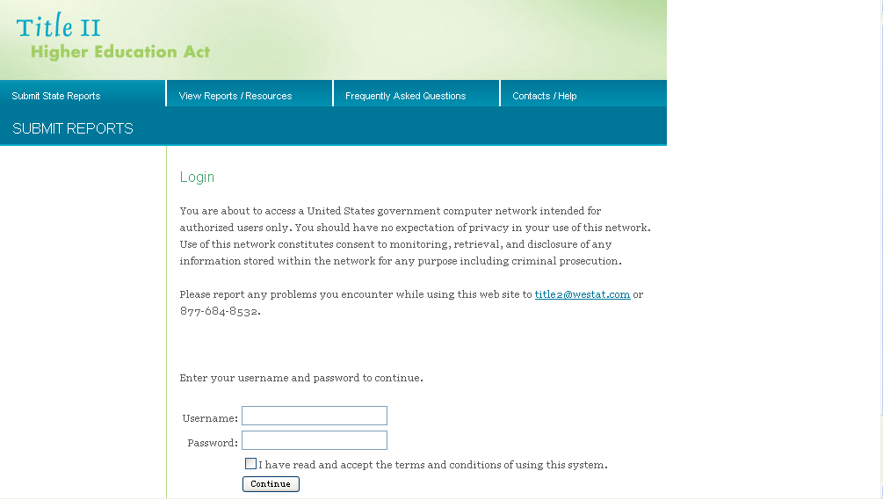

The first time you log into the IPRC, you will be prompted to change your password (see Figure 2). Your new password must meet the following requirements:

- Must be 8-15 characters in length;
- Cannot be one of your last 6 IPRC passwords;
- Cannot contain a symbol;
- Must contain at least one letter;
- Must contain at least one number;
- Must be changed at least every 90 days.

Some examples of a password that meets the requirements are:
- 123MainSt
- Elizabeth7
- October31
- eddd2796af
- 35flowers
- Sum14mer

Use care when creating a new password. The IPRC will not warn you that your new password may not meet the requirements. Entering a new password that does not meet the requirements (e.g., is 16 characters) will allow you to continue into the IPRC, but the new password will not work the next time you log in and may cause your account to be locked.

Usernames and passwords are case sensitive. Be sure that your Caps Lock is not on when you are logging in.

When logging in, if you receive a message saying “Your username is invalid,” this indicates that you have entered your username incorrectly. Be sure you are using your IPRC username and password. Additionally, be sure that you are using this website to log into the IPRC: https://title2.ed.gov/Title2IPRC/default.aspx. You can also access the IPRC from the Title II homepage (https://title2.ed.gov), by clicking on the Submit Reports tab and selecting the second item from the menu (Institutional and Program Report Card System).

IPRC accounts that are not used for more than 90 days are deactivated. Contact Westat (title2@westat.com) to reactivate your account.

Figure 2. Initial password change
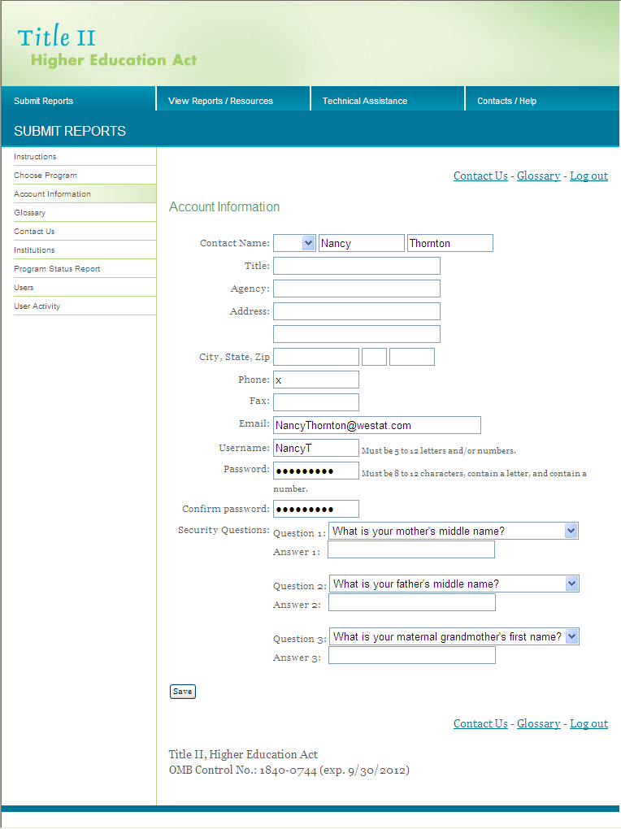

After you have changed your password, you will see drop down menus containing security questions that will allow you to access the IPRC in the event you get locked out of the system. You will be required to set up your security questions at the initial password change screen by selecting three different questions from the drop down menu in the Question 1, Question 2 and Question 3 boxes. After you have identified your questions, provide the answers in the Answer 1, Answer 2 and Answer 3 boxes. Be sure to keep track of your security questions and answers as you have provided in the system. If you need to use this feature in the future, you will be required to provide the answers exactly as you have provided in this section.

After you have successfully changed your password and setup your security questions and answers, click Save to proceed (see Section II Part C. System Features for help with the buttons).

During subsequent logins, if you enter an incorrect username and/or password, you will see a message stating, “The username/password supplied is incorrect. Please check it before trying again.” You may then re-enter the correct username and password to log in. If you enter an incorrect username and/or password three times, you will be locked out of your account. The incorrect logins do not necessarily happen consecutively. If you logged in incorrectly three times during the last 12 hours, your account will be locked. This feature is for security purposes; however, it means that you will not be able to access your account. In the event that you get locked out of your account, you will be able to unlock your account via your computer by answering the three security questions that you provided at your initial login. To begin this process, enter your email address in the box provided (see Figure 3), click Continue. You must ensure that you provide the email as it was listed in the IPRC account information. If you provide anything different from what is on file, the IPRC system will not be able to identify you, subsequently not allowing you to unlock your account.

Figure 3. Unlock Account

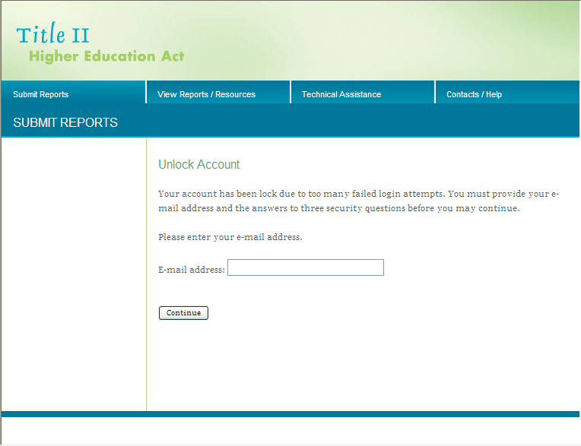

After entering in your email address, the next screen will prompt you to answer your three security questions (see Figure 4). Enter the correct answers to your security questions and click Continue. After answering your security questions, you will be directed to the account information page (Figure 2), where you will be required to change your password. Be sure to follow all of the security requirements when resetting your password. Enter the new password in the Password and Confirm Password boxes, then click Save. Your account has now been unlocked and you are ready to navigate the IPRC system.

Figure 4. Unlock Account Security Questions

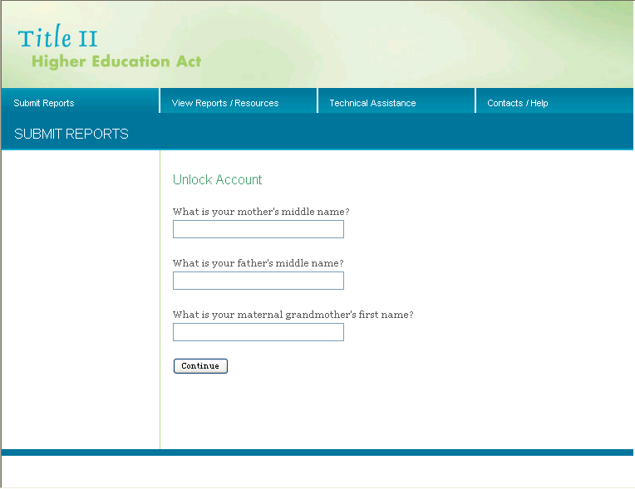.

If you do not remember your username and/or password, click on the “Forgot your Username or Password?” link (see Figure 5), and your login information will be sent to you via email.

Figure 5. Forgot your username or password? Link

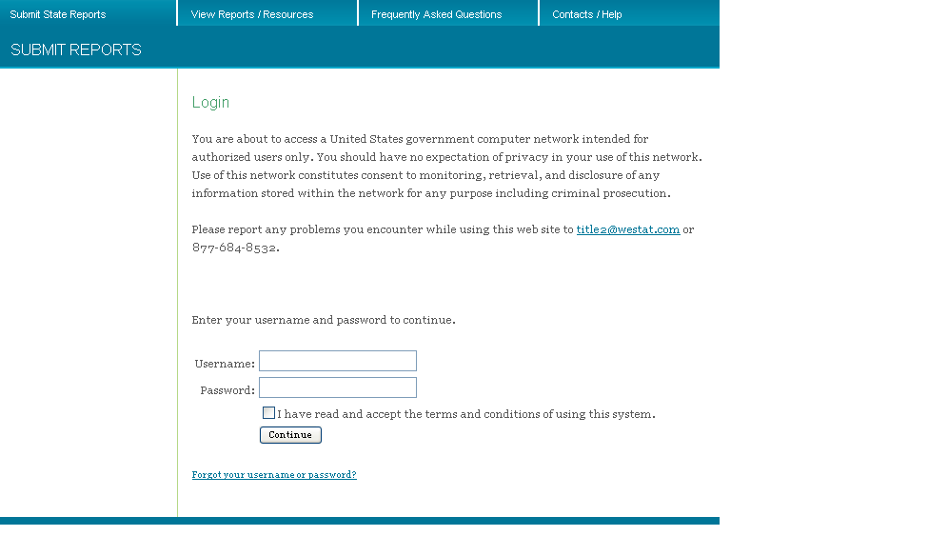

In the top right-hand corner and bottom right-hand corner of each page, you will see a link called Log out (see Figure 6). Click on this link when you want to log out of the system. This will return you to the Login Page.

Figure 6. Log out
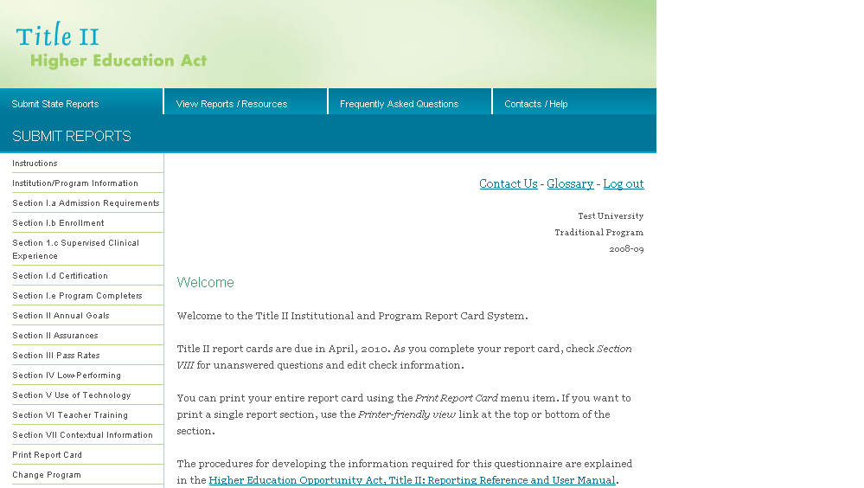

- System Security

For security purposes, only one username and password is distributed to each IHE or program. Data are stored on a secure database running on a secure operating system and are accessible only by use of a username and password; thus, you are prevented from viewing others’ data during the reporting period.

The IPRC automatically logs you off the system after 20 minutes of inactivity (activity includes moving to another page, saving the page, etc.). A time-out warning will notify you that your session is about to expire (see Figure 7). If data are not saved or if inactivity continues, the session will time out, and you will need to log back into the system. Data should be saved at least every 15 minutes to avoid losing them.

Save your data at least every 15 minutes!

Figure 7. Time-out warning

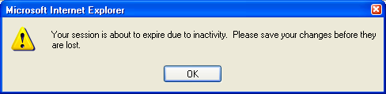

- System Features

The following features can be found throughout the IPRC system:

- Radio buttons
- Text boxes
- Check boxes
- Buttons to
  - Insert
  - Edit
  - Delete
  - Check Spelling
  - Save or
  - Reset
- Printer-friendly view
- Contact us
- Upload files

Radio buttons. You may choose only ONE response when using radio buttons. To select a radio button, click on it with your mouse. Once a radio button is selected, the only way to deselect it is to choose another radio button in that response.

Text boxes. Single-line text boxes are usually limited to the size of the displayed box. Multi-line text boxes do not have a character limit; however, we encourage you to be brief, concise and to the point when entering text. When referencing a Web address, include the entire address (including “http://”). (See Figure 8 for an example of radio buttons and text boxes.)

Figure 8. Radio buttons and text boxes

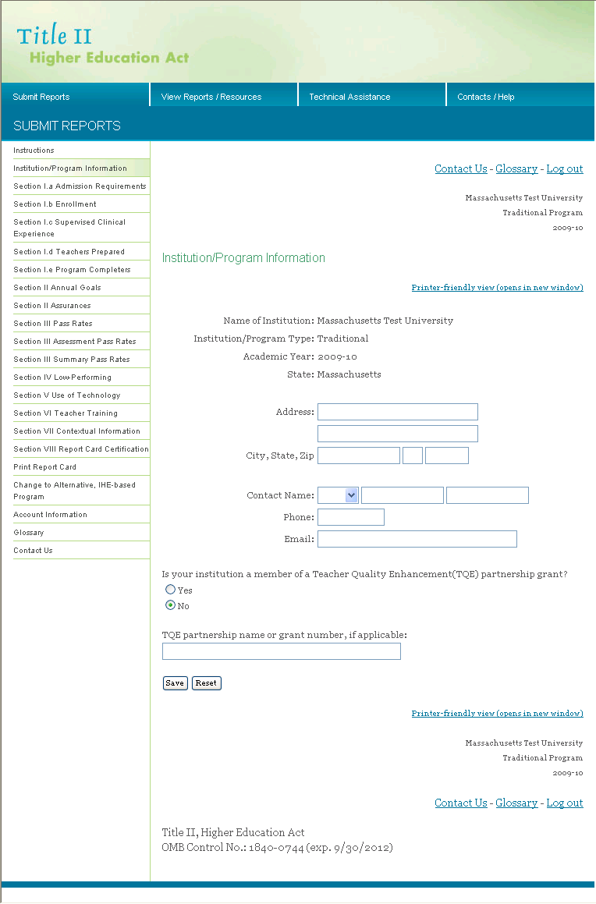
Radio buttons
Text boxes

Check boxes. You may choose more than one check box in a single response (see Figure 9). To select a check box, click your mouse in the box (or using the Tab key, tab to the box and press the space bar). To deselect a box, click your mouse in the box (or press the space bar) again.

Figure 9. Check boxes
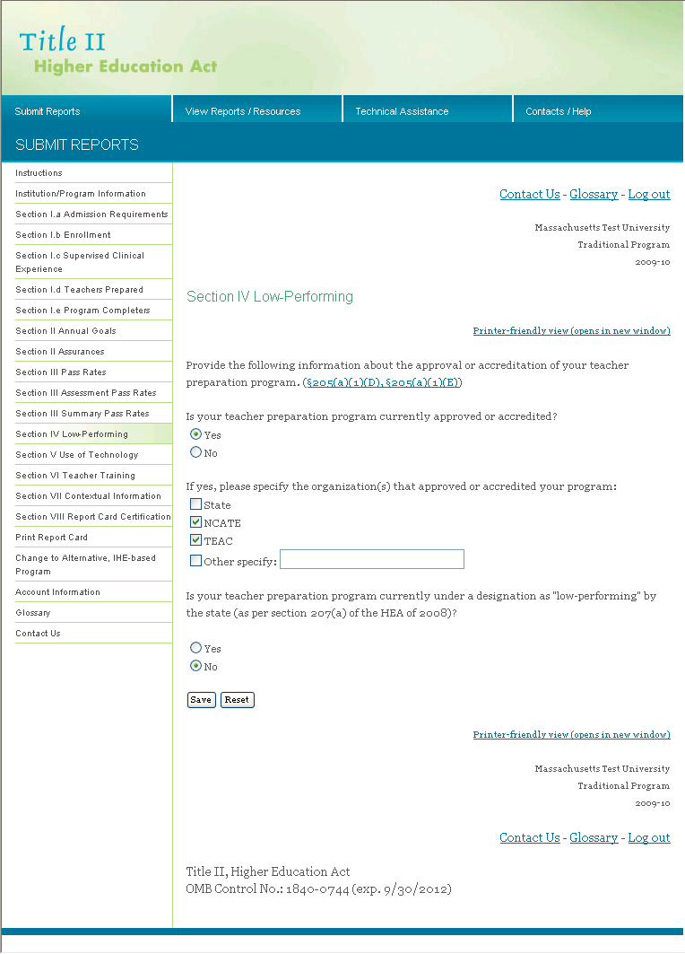
Check boxes

Insert/Edit/Delete. To add new entries, click Insert. To view or modify an existing entry, click Edit. To delete an entry, click Delete. You will see an alert box asking if you are sure you want to delete this item. Click on OK to delete the item, or click on Cancel if you do not want to delete the item. (see Figure 10).

Figure 10. Insert/edit/delete

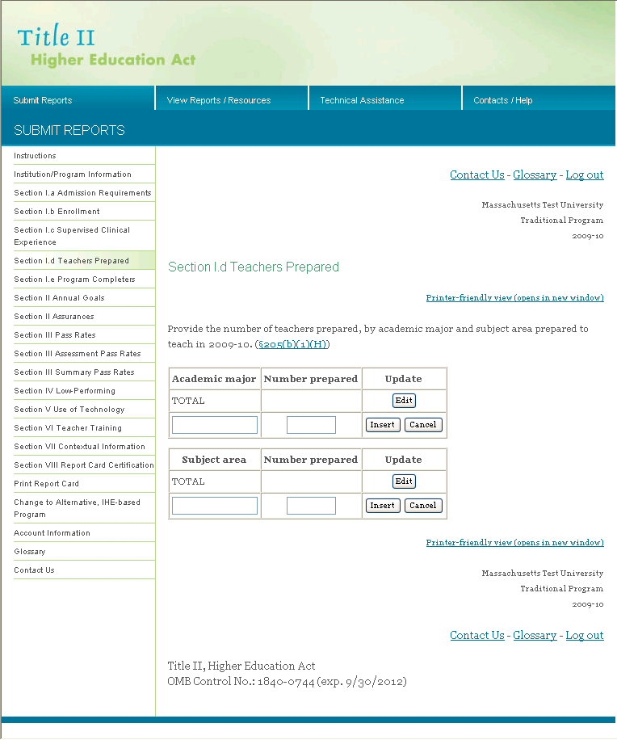
Some sections ask for a website. Enter the Web address, including “http://” (see Figure 11).

Figure 11. Web address

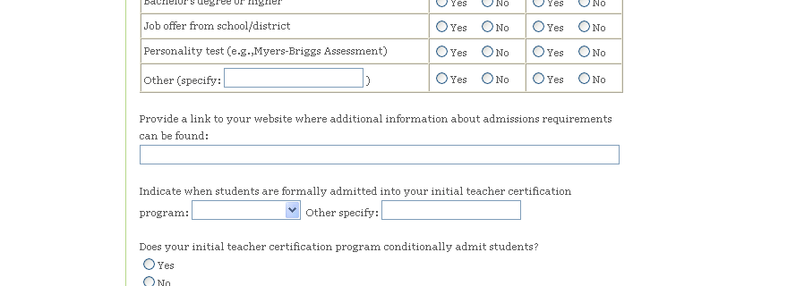

Buttons. One or more buttons are at the bottom of each survey section. Please make special note of the following two buttons: Save and Reset. A description of each is below.

Save: Selecting this button saves data in the section and keeps you in that section. If you will be working on the same section for a long time, we recommend that you save your data at least every 15 minutes (see Security). Use this button to save your data periodically as you work through a section.
Reset: This button will reset all fields in the section to their last saved value. For example, if you make changes to a saved section but do not want to save the changes, use the Reset button. The section will return to how it appeared the last time you saved it.

Check Spelling. If you want to check the spelling in a section, click on the button at the bottom of the page marked, "Check Spelling." A new window will open that lists spelling errors and suggests replacements. This feature is similar to those used in word processing programs. In order for the spell-check feature to work properly, your browser must allow pop-up windows. Please disable any pop-up blockers to use this feature.

Glossary. If you want to check the definition of a word listed in the glossary, click on the Glossary link at the top or bottom of the page. A new window will open with the glossary.

Printer-Friendly View. To print the current section of the report, click on the printer-friendly view link at the top or bottom of the page. A new window will open with the report section that is formatted for printing. To print the section, use your browser print function. You cannot enter data in printer-friendly view; you can only view the questions and data that have been entered. The feature is helpful for printing a section after you complete it so that you can review your work.

Contact Us. If you need technical assistance with this Website, click the Contact Us link. A new window will open with email and telephone contact information. Contact your state Title II coordinator with questions about your responses.

Upload Files. Some sections allow you to upload files. You will first need to select the file that you want to upload and then click the upload button.

- Report Navigation

Once you log into the IPRC, you will be able to access all sections of the report (see Figure 12). You can access any section of the survey by clicking the links on the left side of the page. You can also access other information, such as the instructions and glossary. Questions included in the report come from the reporting requirements in Title II. Each reporting section contains a reference to the specific section of the law requiring the question(s) (e.g., (§205(a)(1)(C)(i))) and a link to the law for your reference.

Figure 12. Main menu

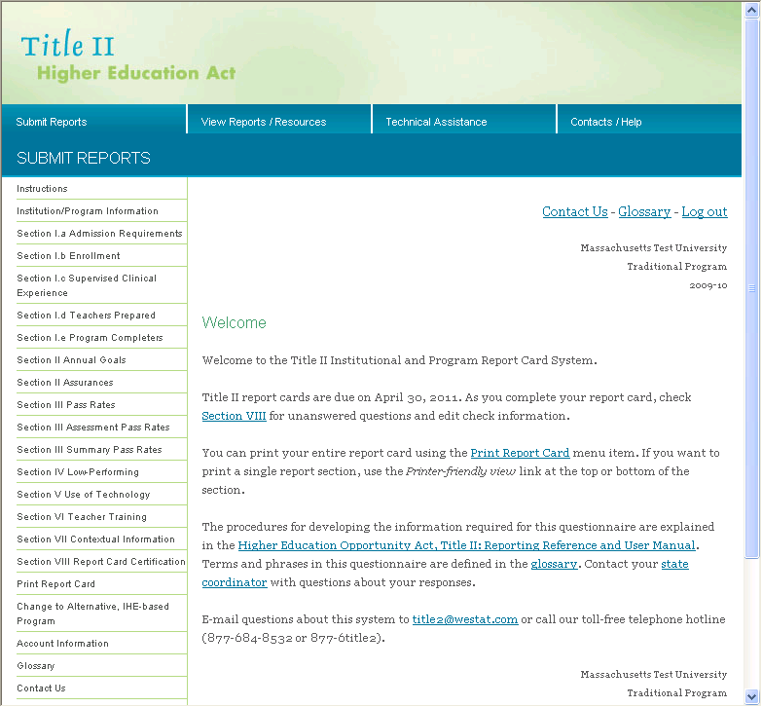

Change Program

IHEs that need to complete both a traditional and an alternative route report can select which report to complete after logging into the IPRC system. (see Figure 13). Select the report you would like to complete by clicking the Traditional or Alternative, IHE based link.You can toggle between the two reports by clicking Change to Traditional Report or Change to Alternative, IHE based Report on the left side menu. You will be brought to the Welcome screen each time you switch between the two reports. IHEs that need to complete only one type of report will not have access to both report types. At the top and bottom of each page is an indication of what report you are completing. The name of your IHE is shown, along with the type of report (traditional or alternative) and the academic year that is considered to be the “current” academic year that you are reporting on. Be sure that you are in the correct report before you enter data.

Figure 13. Change program

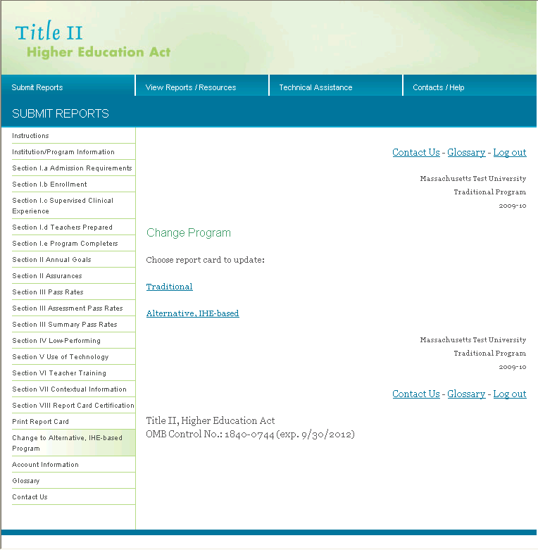

Instructions

From the left side of the page, click on the link for Instructions. This page provides basic information about the Title II reporting and the IPRC system and also provides links to other resources (see Figure 14). You will find links to the User Manual here.

Figure 14. Instructions

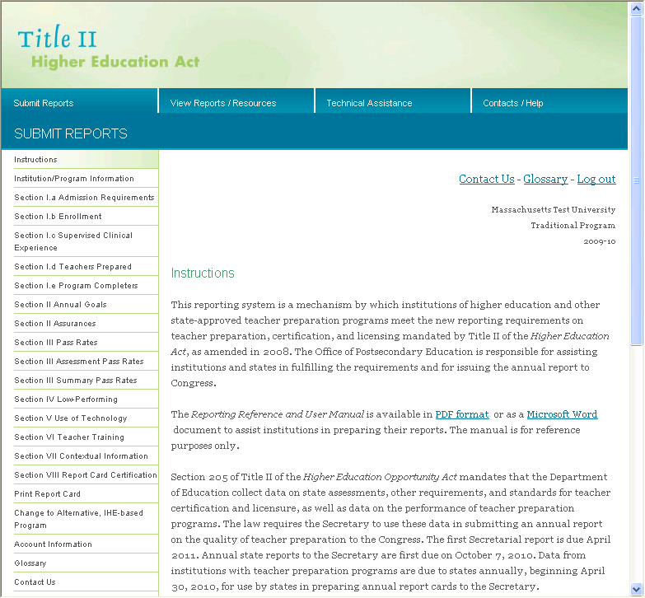

Institution/Program Information

The individual listed on the Institution/Program Information page (see Figure 15) will be shown in the report card as the contact person for members of the public who would like more information. Review the contact information each year and update as necessary. If your institution is a member of a Teacher Quality Enhancement (TQE) partnership grant, click the Yes radio button and enter the TQE partnership name or grant number. If your institution is not part of a TQE partnership grant, click the No radio button and do not enter anything into the TQE partnership name or grant number box. Once you have entered information in this section, choose the appropriate button (Save, Reset) at the bottom of the page.

Figure 15. Institution/program information

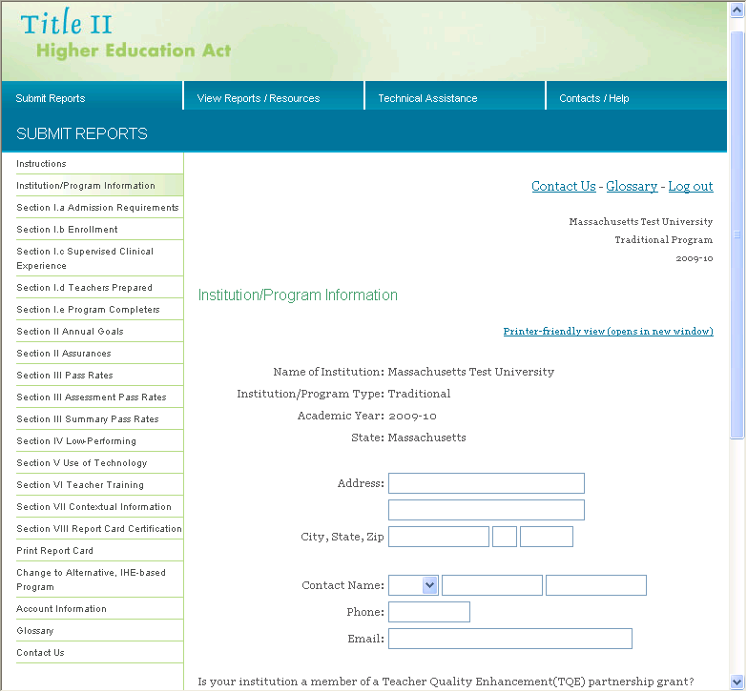
Section III: Completing the Title II Report

Section I.a. Admissions Requirements

Click on the link on the left side menu for Section I.a Admissions Requirements. Yes/no questions require you to choose either “yes” or “no” as your response. Click the radio button next to your response. To change your response, click the radio button for the other response.

Indicate whether each element is required for admission into any of your initial teacher certification program(s) at either the undergraduate or postgraduate level (see Figure 16). If all of the requirements are applicable, you can select Check all Yes, or you can select Check all No if none of the requirements are applicable. These selections can be found under the heading for both undergraduate and postgraduate column headings. If all of the requirements are applicable but one or two, you can click Check all Yes and then click No on the one or two elements that are not required. If there are no initial teacher certification programs at either the undergraduate level or postgraduate level, click the appropriate box at the top of the page. This will make the corresponding column inactive.

Figure 16. Section I.a Admissions Requirements

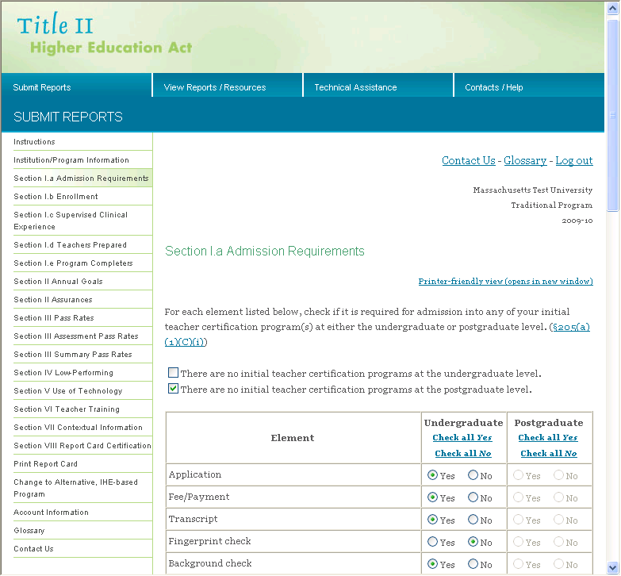
In this section, provide additional information about admissions requirements, including your institution/program Website, timeframe when students are formally admitted into the program and whether your institution conditionally admits students. If you feel there is a need to enter any additional narrative regarding your admissions process, enter this information into the contextual box, as seen in Figure 17. This text box does not have a character limit; however, we encourage you to be brief, concise and to the point when entering text. Once you have entered information in the Admissions Requirements section, save your data using the Save button at the bottom of the page.

Figure 17. Section 1.a Admissions Requirements

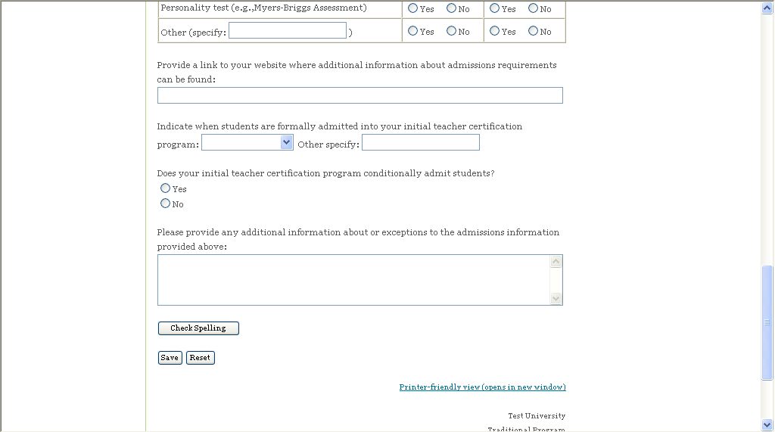

You can enter data on a rolling basis, so you do not necessarily need to complete Section I.a before moving on to the next section. You can respond to one or two questions in this section, save your data and then navigate to another section of the report. However, if this section is not complete when you click the Save button, you will get a pop-up reminder with a list of questions that still need to be answered. The data you have entered have been saved, but additional questions may need to be answered before you complete and submit your report. This reminder is generated in real time, so each time you respond to a question, the question will be removed from the list.
Section I.b. Enrollment

On the left side of the page, click on the link for Section I.b Enrollment.

In this section, provide the number of students enrolled in the teacher preparation program by category (see Figure 18). Do not report on the total number of students enrolled in your entire institution, only include students enrolled in the initial teacher preparation program. Do not include currently licensed teachers who are earning additional licenses or endorsements, or individuals preparing for school-based careers other than classroom teachers (e.g., administrators, guidance counselors). For purposes of Title II reporting, the definition of an enrolled student is a student who has been admitted to a teacher preparation program, but who has not yet completed the program.

The ethnicity category includes the number of Hispanic/Latino students of any race. The race category includes includes the number of students who are American Indian or Alaska Native, Asian, Black or African American, Native Hawaiian or Pacific Islander, White or Two or more races. Unknown, missing, other or other reporting categories are not permitted. Please note that you must report on the number of students by ethnicity and race separately. Individuals who are non-Hispanic/Latino will be reported in the race categories. Be sure to include non-resident aliens in the appropriate categories.

The following examples may be helpful in understanding how the reporting will work.

Example 1: An enrolled student self-identifies as Hispanic/Latino and as Asian. This individual is reported only in the Hispanic/Latino category.

Example 2: An enrolled student self-identifies as Hispanic/Latino and as Asian and Black or African American. This individual is reported only in the Hispanic/Latino category.

Example 3: An enrolled student self-identifies as non-Hispanic/Latino and as Native Hawaiian or Other Pacific Islander. This individual is reported in the Native Hawaiian or Other Pacific Islander category.

Example 4: An enrolled student self-identifies as non-Hispanic/Latino and as American Indian or Alaska Native and White. This individual is reported in the two or more races category.

It is understood that asking individuals to report on their race/ethnicity is optional in many places. Students should not be forced to report, and an ethnic/racial categorization should not be imposed or assumed. You will report on the race/ethnicity data that you have available, though the data may not be complete. Also, it is not expected that the sum of the enrolled students reported by race/ethnicity will equal the total number of students enrolled. For guidance from the U.S. Department of Education on the collection and reporting of racial and ethnic data, please see http://edocket.access.gpo.gov/2007/pdf/E7-20613.pdf.

Similarly, asking individuals to report on their gender is optional in some places. Students should not be forced to report, and gender categorization should not be imposed or assumed. You will report on the gender data that you have available, though the data may not be complete. Also, it is not expected that the sum of the enrolled students reported by gender will equal the total number of students enrolled.

Once you have entered information in the enrollment section, save your data using the Save button at the bottom of the page.

You will receive an error message in the following situations:
- The information entered is not a whole number.
- The value of any race and ethnicity category is higher than the count given for total enrollment.

If you get an error message, go back and update your data and click the Save button. You will be able to save your work; however, your report will not be eligible for certification until the errors are cleared.

You can enter data on a rolling basis, so you do not necessarily need to complete Section I.b before moving on to the next section. You can respond to one or two questions in this section save your data and then navigate to another section of the report. If this section is not complete when you click the Save button, you will get a pop-up reminder with a list of questions that still need to be answered. The data you have entered have been saved, but additional questions may need to be answered before you complete and submit your report. This reminder is generated in real time, so each time you respond to a question, the question will be removed from the list.

Figure 18. Section 1.b Enrollment

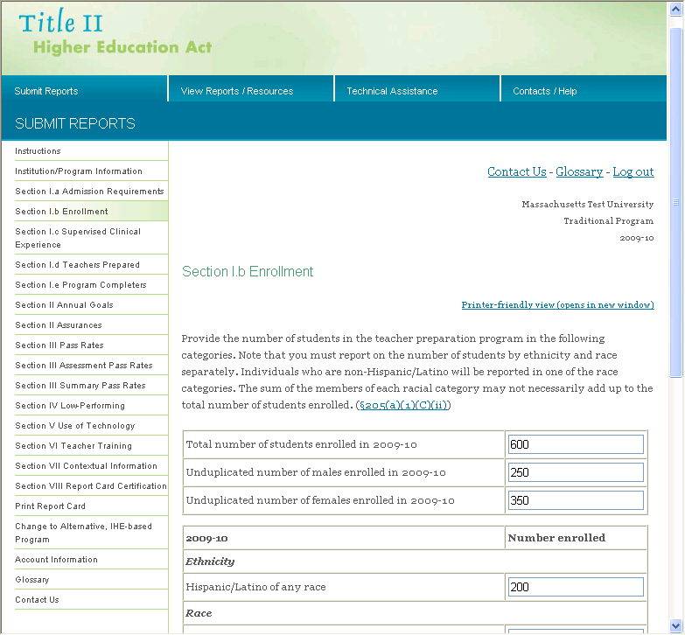

Section I.c. Supervised Clinical Experience

On the left side of the page, click on the link for Section I.c Supervised Clinical Experience.

In this section, provide information about supervised clinical experience. The activities that constitute supervised clinical experience will vary by state. If you are unsure about what to report in this section, please contact your state Title II coordinator.

If you feel there is a need to enter any additional narrative regarding supervised clinical experience, enter this information into the text box, as seen in Figure 19. This text box does not have a character limit; however, we encourage you to be brief, concise and to the point when entering text.

Once you have entered information in the supervised clinical experience section, save your data using the Save button at the bottom of the page.

You will receive an error message in the following situations:

- The information entered is not a number

If you get an error message, go back and update your data and click the Save button. You will be able to save your work; however, your report will not be eligible for certification until the errors are cleared.

You can enter data on a rolling basis, so you do not necessarily need to complete Section I.c before moving on to the next section. You can respond to one or two questions in this section save your data and then navigate to another section of the report. If this section is not complete when you click the Save button, you will get a pop-up reminder with a list of questions that still need to be answered. The data you have entered have been saved, but additional questions may need to be answered before you complete and submit your report. This reminder is generated in real time, so each time you respond to a question, the question will be removed from the list.

Figure 19. Section I.c Supervised clinical experience

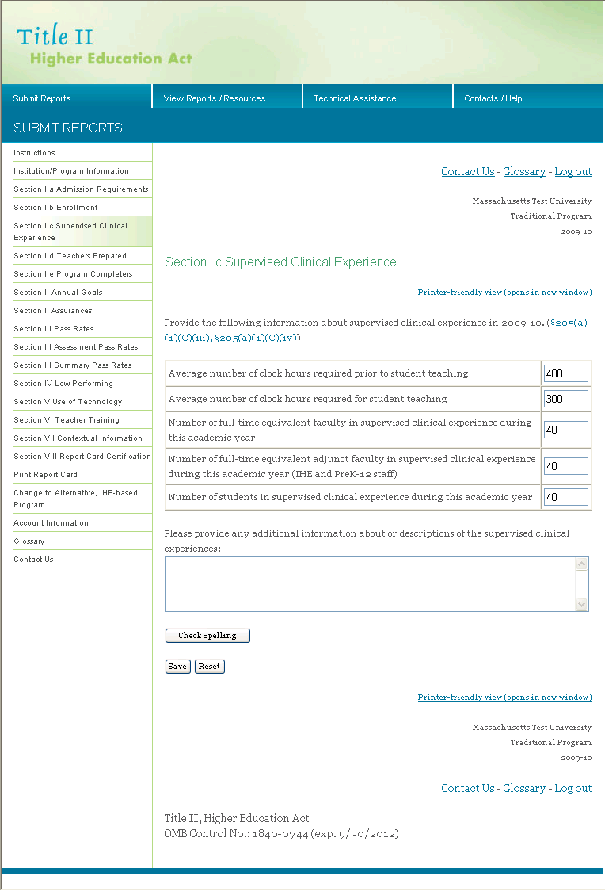

Section I.d. Teachers Prepared

On the left side of the page, click on the link for Section I.d Teachers Prepared.

In this section, provide the number of teachers prepared by academic major and subject area for academic year 2009-2010. For the purposes of this section, include students who are program completers. “Subject area” refers to the subject area individuals are able to teach. The data will vary depending on the subject area structure in each state and the academic majors offered. For example, in one IHE, the academic major and subject area may both be science. In another IHE, the academic major may be biology and the subject area may be science.

Users must first enter data in the Total row for both academic major and subject area. In order to do this, click the Edit button located in the Update column. Users will be given the option to enter data in the Number prepared column only. After data have been entered, users will click the Update button in order for the data to be saved (see Figure 20). You can click the Edit button in this row to make a change to the data you entered.

The Total is the total, unduplicated count of students who have been prepared by the teacher preparation program. It is not expected that the sum of the academic majors or subject areas would equal the Total, as some individuals may have double majors or may be prepared in more than one area.

Figure 20. Section I.d Teachers Prepared

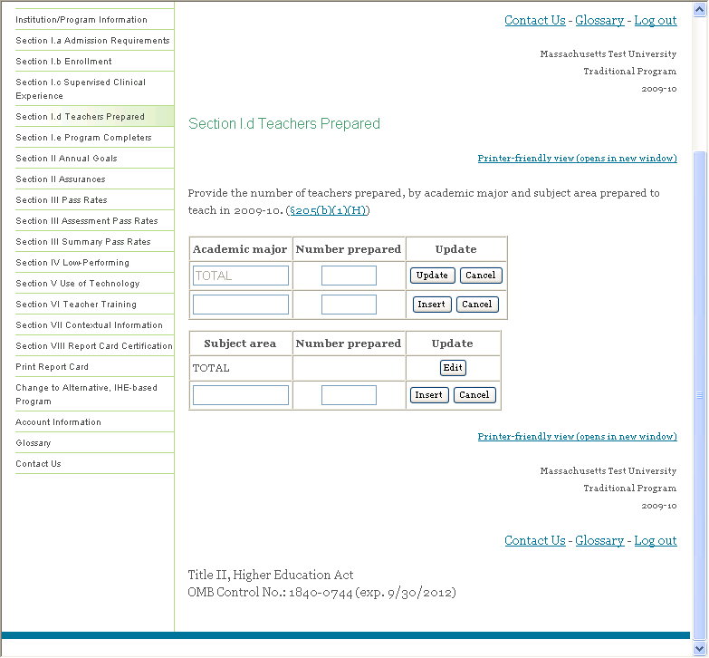

After entering the total number of students who have been prepared, you will be brought back to the main Teachers Prepared screen. Enter the name of an academic major or subject area on the next row and the number of students who have been prepared in this academic major or subject area. Click Insert to add this row to the table, click Cancel to delete this row and not add it to the table. You can click the Edit button in this row to make a change to the data you entered. Click Delete to delete this row (see Figure 21).

You do not need to enter every subject area in the state, only those that are applicable to your IHE and have students who have been prepared as teachers in those areas.

Figure 21. Section I.d Teachers prepared

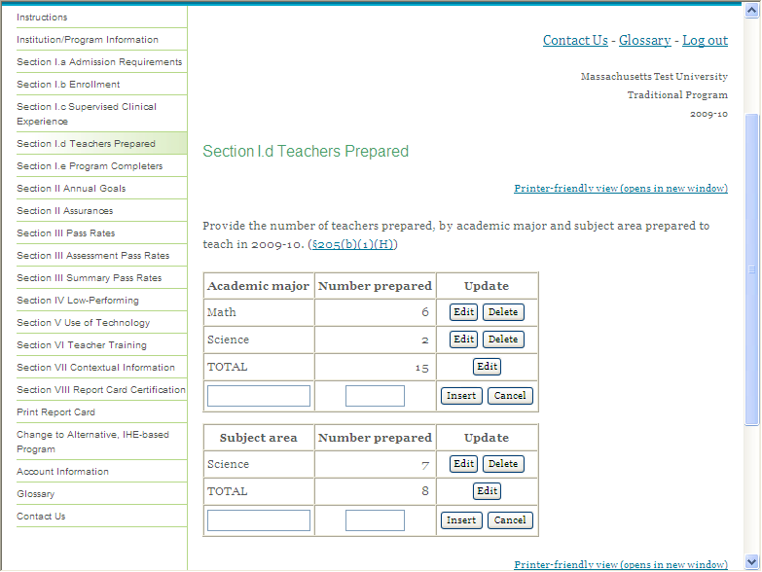

You will receive an error message in the following situations:

- The information entered for number prepared is not a whole number.
- Any row with a number prepared does not contain an academic major or subject area label.
- The number prepared in any row is greater than the total.
- Any row with an academic major or subject area label does not contain the number of students prepared.

If you get an error message, go back and update your data and click the Insert button. Use the Edit button to make any additional edits to the data in that row. You will be able to save your work; however, your report will not be eligible for certification until the errors are cleared.

You can enter data on a rolling basis, so you do not necessarily need to complete Section I.d before moving on to the next section. You can respond to one or two questions in this section save your data and then navigate to another section of the report. If a row is not complete when you click the Insert button, you will get a pop-up reminder with a list of questions that still need to be answered. The data you have entered have been saved, but additional questions may need to be answered before you complete and submit your report. This reminder is generated in real time, so each time you respond to a question, the question will be removed from the list.
Section 1.e. Program Completers

On the left side of the page, click on the link for Section I.e Program Completers.

In this section, report the number of program completers for the three academic years shown (see Figure 22). Program completer is defined as a person who has met all the requirements of a state-approved teacher preparation program. Program completers include all those who are documented as having met such requirements. Documentation may take the form of a degree, institutional certificate, program credential, transcript or other written proof of having met the program’s requirements. In applying this definition, the fact that an individual has or has not been recommended to the state for initial certification or licensure may not be used as a criterion for determining who is a program completer.

Once you have entered information in the program completer section, choose the appropriate button (Save, Reset) at the bottom of the page.

You will receive an error message in the following situations:

- The information entered is not a whole number.

If you get an error message, go back and update your data and click the Save button. You will be able to save your work; however, your report will not be eligible for certification until the errors are cleared.

You can enter data on a rolling basis, so you do not necessarily need to complete Section I.e before moving on to the next section. You can respond to one or two questions in this section save your data and then navigate to another section of the report. If this section is not complete when you click the Save button, you will get a pop-up reminder with a list of questions that still need to be answered. The data you have entered have been saved, but additional questions may need to be answered before you complete and submit your report. This reminder is generated in real time, so each time you respond to a question, the question will be removed from the list.

Figure 22. Section I.e Program completers

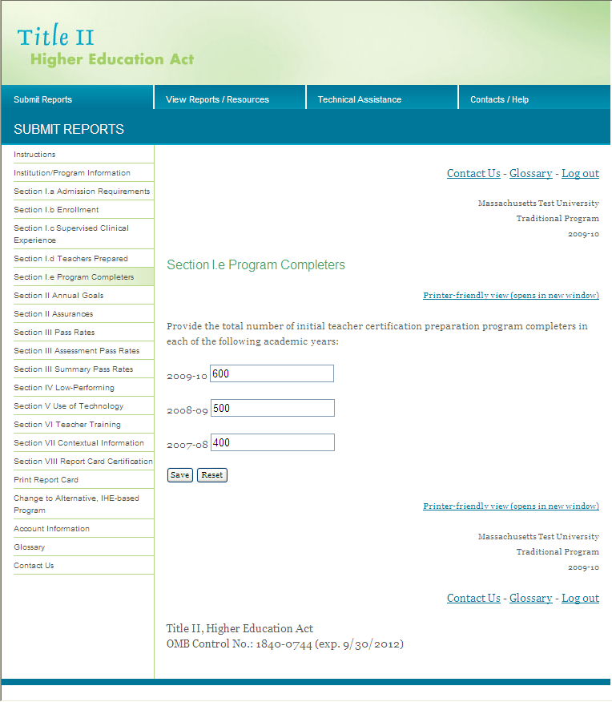
Section II. Annual Goals and Assurances

Section II is divided into two parts. The first part asks about annual goals; the second is about assurances. Select the link on the left to complete Section II. Annual Goals (see Figure 23) or Section II Assurances (see Figure 24).

When completing the Annual Goals section, be sure to provide the following information for each teacher shortage area:

- Enter the academic year in the correct format (e.g., 2008-09).
- Enter your numeric goal in the Goal box. The goal can be in the form of a number (e.g., 10) or a percent (e.g., 2%). IHEs that do not have a teacher preparation program in an area can enter NA for that area in the Goal box.
- Check Yes or No to indicate if the goal was met.
- Enter a description of the strategies used to achieve the goal.
- Enter a description of steps to improve your performance in meeting the goal or lessons learned in meeting the goal.

The Other shortage area row can be used when you have a shortage area other than the ones shown. Your state may have specified other shortage areas applicable to your state.

If you would like to enter any additional narrative regarding your annual goals, enter these data into the contextual box at the end of the section. This text box does not have a character limit; however, we encourage you to be brief, concise and to the point when entering text.

In the Assurances section, check Yes or No for each statement. In the text box, describe your institution’s most successful strategies in meeting the assurances. You can also use this box and the optional contextual information section (Section VII) to provide context for your responses.

As you enter information into each of these sections, choose the appropriate button (Save, Reset) at the bottom of the page.

You can enter data on a rolling basis, so you do not necessarily need to complete Section II before moving on to the next section. You can respond to one or two questions in this section save your data and then navigate to another section of the report. If the section is not complete when you click the Save button, you will get a pop-up reminder with a list of questions that still need to be answered. The data you have entered have been saved, but additional questions may need to be answered before you complete and submit your report. This reminder is generated in real time, so each time you respond to a question, the question will be removed from the list.

Figure 23. Section II Annual goals

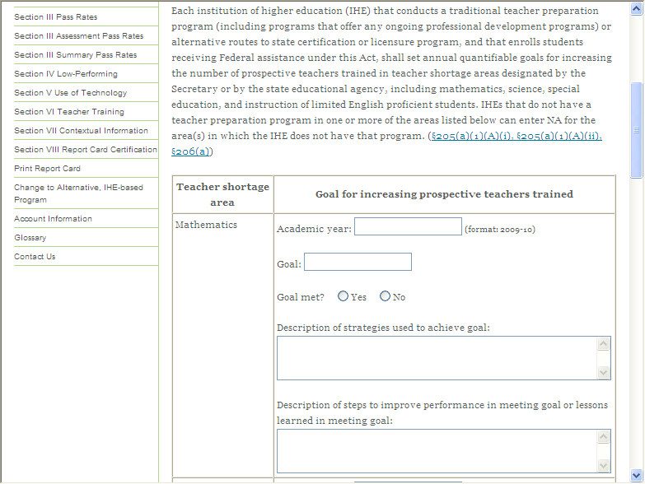

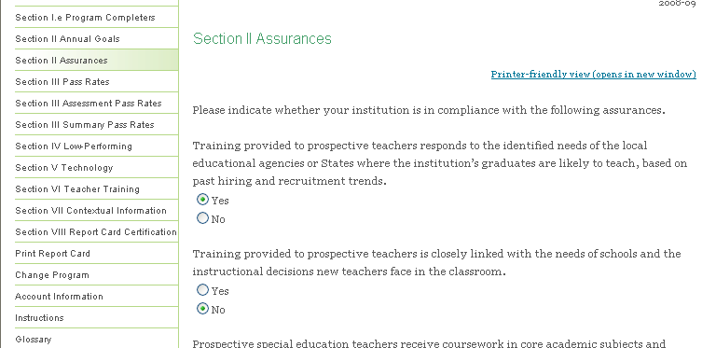
Figure 24. Section II Assurances
Section III. Pass Rates

This section allows users to provide the information on the performance of the students in their teacher preparation program on each initial teacher certification or licensure assessment used in the state.
The following points are important to remember when reporting these data:
- This information will be provided to you by the state or the testing company or companies.
- In cases where a student has taken a given assessment more than once, the highest score on that test must be used in the pass rate calculation.
- There must be at least 10 students in each group taking the same assessment in an academic year for data on that assessment to be reported; for summary data, there must also be at least 10 students (although not necessarily taking the same assessment) for data to be reported.
- In cases where there are less than 10 students taking the same assessment and the assessment pass rate is not reported, those students must be included in the summary data.
- Enrolled students are those students admitted to the teacher preparation program who have not yet completed the program.
- Not all groups of students will be applicable to every IHE. For example, if your IHE has interwoven clinical and nonclinical elements into every course so that there are no “nonclinical courses,” the “all enrolled students who have completed all nonclinical courses” group would not apply, and you would not report any data in this group.
- In the case of a teacher preparation program with fewer than 10 scores reported on any single initial teacher certification or licensure assessment during an academic year, the program shall collect and publish information with respect to an average pass rate and scaled score on each state certification or licensure assessment taken over a three-year period.

On the left side of the page, click on the link for Section III Pass Rates (see Figure 25).

Figure 25. Section III Pass rates
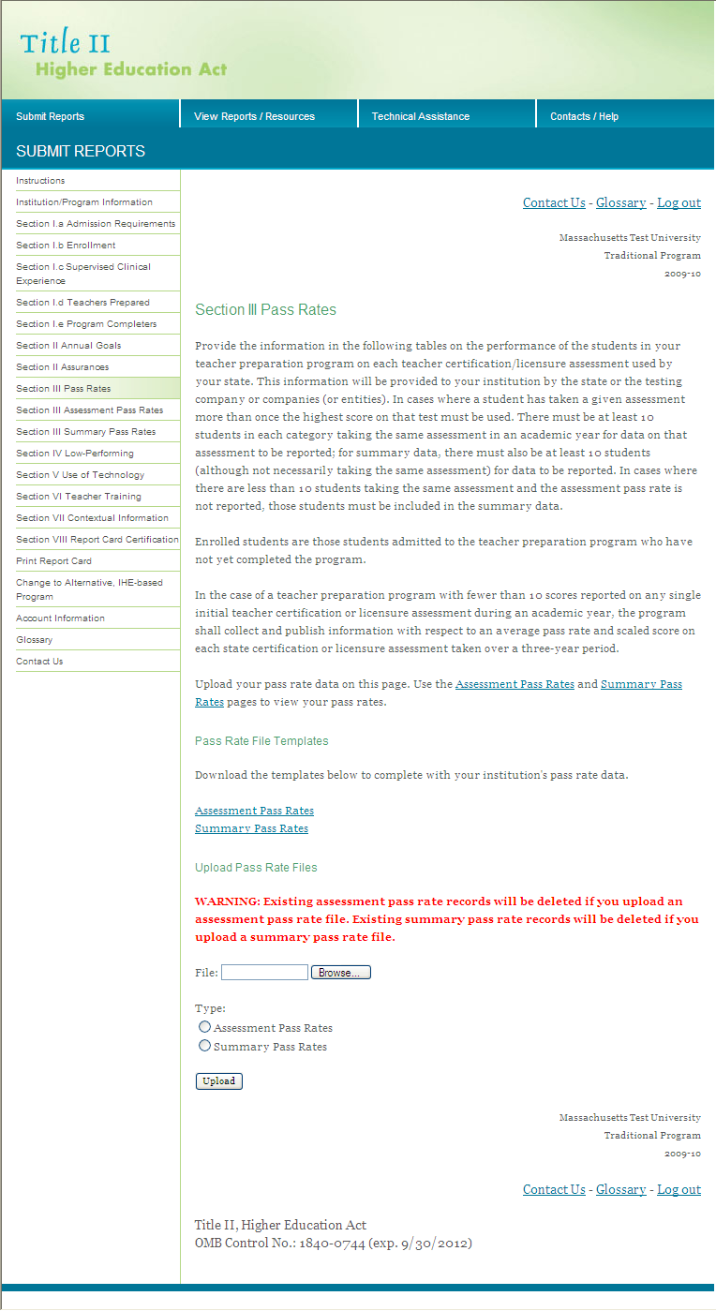

There are two ways to enter your data for this section: uploading the files from the state or testing company or downloading the templates.

It is recommended that you upload the data files that you received from the state or testing company. You should receive two files, one with the assessment-level data and one with summary data for the program completers. Summary pass rates will not be calculated for enrolled students. These files must be in Excel (.xls) format.

To upload the data files follow these steps:
- Scroll down to the bottom of the Section III Pass Rates page.
- Under the “Upload Pass Rate Files” heading, click on the Browse button.
- Navigate to the file you want to upload.
- Click on the file and click Open.
- Click the radio button for Assessment Pass Rate (see figure 26) or Summary Pass Rate (see figure 27), depending on which is applicable to the file you are uploading.
- Click the Upload button.

You can only upload one file at a time. Repeat this process to upload a second file. Section III Assessment Pass Rates and Section III Summary Pass Rates will be populated with the data from the files that have been uploaded.

The second mechanism for loading the data into the system is to download assessment and summary pass rate data templates. Click the link Assessment Pass Rates or Summary Pass Rates. An Excel worksheet will be produced; save the file to your computer. Enter the data in the spreadsheet. After you enter the data into the Excel spreadsheet, you will upload the file as instructed above. See Appendix A for tips on working with these spreadsheets.

To make a correction the pass rate data in your report, revise the data in the appropriate data file. Reupload the file using the steps above. All of the existing records in the Assessment Pass Rates or Summary Pass Rates section will be deleted and replaced with the data in the revised file. Be sure all of the pass rate data are included in the revised file, not just the data changes you made.

Figure 26. Assessment pass rates

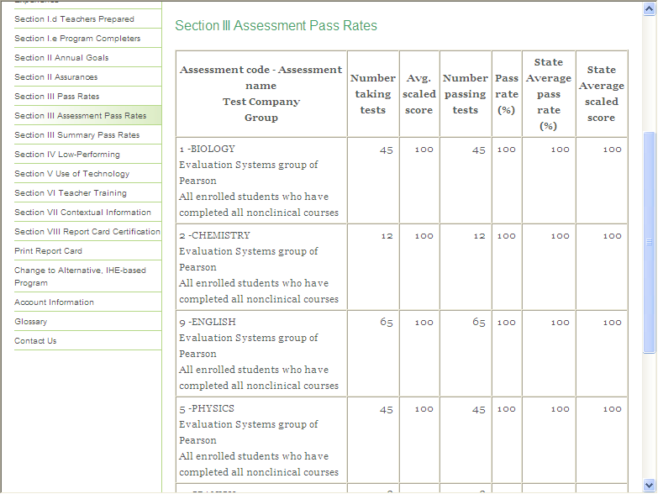

Figure 27. Summary pass rates

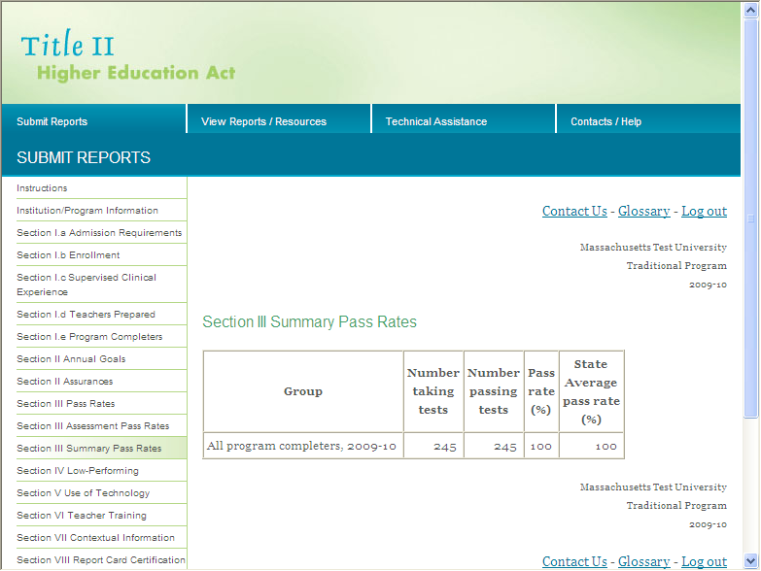

Section IV. Low-Performing

From the left side of the page, click on the link for Section IV Low-Performing (see Figure 28).

In this section, provide information about the approval or accreditation of your teacher preparation program.

Each state has its own state-specific definition of low performing. Confer with your state to determine if your program meets your state’s definition.

Yes/no questions require you to choose either “yes” or “no” as your response. Click the radio button next to your response. To change your response, click the radio button for the other response.

A question with a list of responses allows to you choose more than one response, as applicable. Click the box next to one or more of your responses. To change your response, click the box again. If you choose “other” as your response, you must provide more information in the “specify” box.

Once you have entered information in this section, choose the appropriate button (Save, Reset) at the bottom of the page.

You can enter data on a rolling basis, so you do not necessarily need to complete Section IV before moving on to the next section. You can respond to one or two questions in this section save your data and then navigate to another section of the report. If this section is not complete when you click the Save button, you will get a pop-up reminder with a list of questions that still need to be answered. The data you have entered have been saved, but additional questions may need to be answered before you complete and submit your report. This reminder is generated in real time, so each time you respond to a question, the question will be removed from the list.

Figure 28. Section IV Low-performing

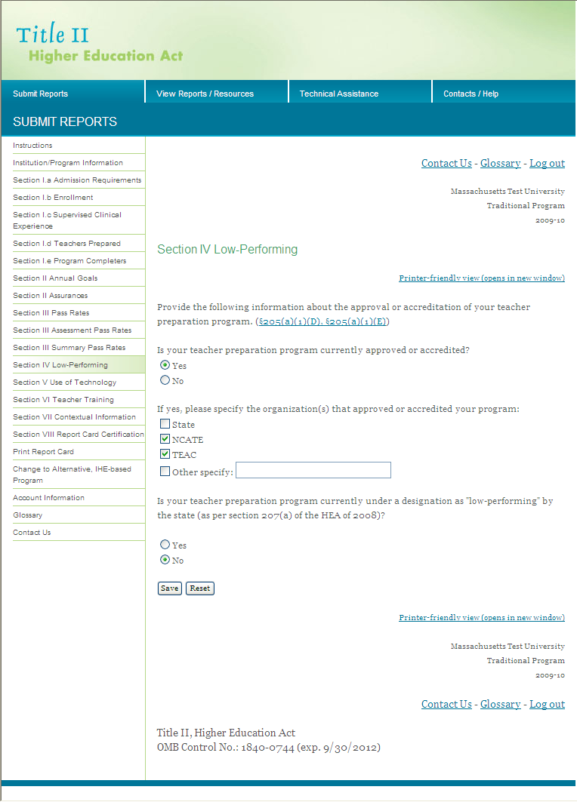

Section V. Use of Technology

From the left side of the page, click on the link for Section V Use of Technology (see Figure 29).

In this section, provide information about the use of technology in the teacher preparation program. Yes/no questions require you to choose either “yes” or “no” as your response. Click the radio button next to your response. To change your response, click the radio button for the other response. If any unit or department of the teacher preparation program would respond “yes” to an item, respond “yes” for the entire teacher preparation program and explain any exceptions in the text box.

The text box does not have a character limit; however, we encourage you to be brief, concise and to the point when entering text. Use the Check Spelling button to check your spelling in this section.

Once you have entered information in this section, choose the appropriate button (Save, Reset) at the bottom of the page.

You can enter data on a rolling basis, so you do not necessarily need to complete Section V before moving on to the next section. You can respond to one or two questions in this section save your data and then navigate to another section of the report. If this section is not complete when you click the Save button, you will get a pop-up reminder with a list of questions that still need to be answered. The data you have entered have been saved, but additional questions may need to be answered before you complete and submit your report. This reminder is generated in real time, so each time you respond to a question, the question will be removed from the list.

Figure 29. Section V Use of technology

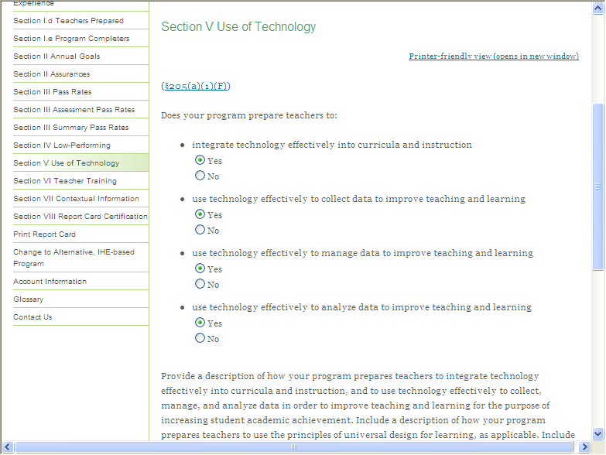

Section VI. Teacher Training

From the left side of the page, click on the link for Section VI Teacher Training (see Figure 30).

In this section, provide information about the preparation of both general and special education teachers. Be sure to scroll to the bottom of the page to respond to all items in this section.

Yes/no questions require you to choose either “yes” or “no” as your response. Click the radio button next to your response. To change your response, click the radio button for the other response. If any unit or department of the teacher preparation program would respond “yes” to an item, respond “yes” for the entire teacher preparation program and explain any exceptions in the text box. The special education items include a “Program does not prepare special education teachers” response. Use this response if your institution does not have a program to prepare special education teachers.

The text box does not have a character limit; however, we encourage you to be brief, concise and to the point when entering text. Use the Check Spelling button to check your spelling in this section.

Once you have entered information in this section, choose the appropriate button (Save, Reset) at the bottom of the page.

You can enter data on a rolling basis, so you do not necessarily need to complete Section VI before moving on to the next section. You can respond to one or two questions in this section save your data and then navigate to another section of the report. If this section is not complete when you click the Save button, you will get a pop-up reminder with a list of questions that still need to be answered. The data you have entered have been saved, but additional questions may need to be answered before you complete and submit your report. This reminder is generated in real time, so each time you respond to a question, the question will be removed from the list.

Figure 30. Section VI Teacher training

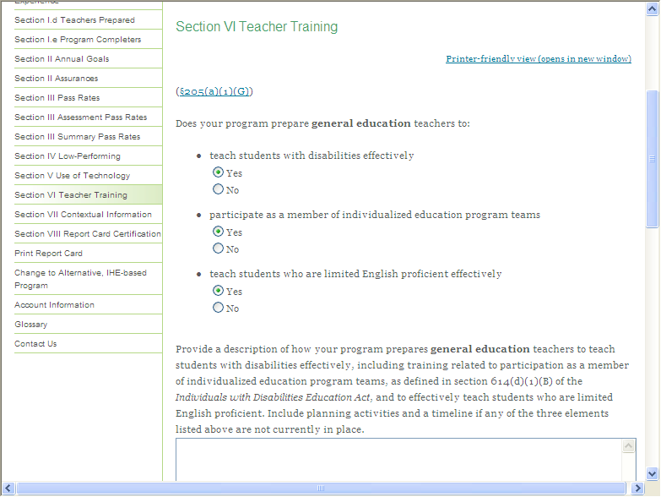

Section VII. Contextual Information (Optional)

From the left side of the page, click on the link for Section VII Contextual Information (see Figure 31).

This section is optional; it can be used to provide supplementary information. In this section, you can provide any additional information that describes your teacher preparation program(s) or gives context for the responses you provided throughout your report. Use the Check Spelling button to check your spelling in this section.

You may also attach information to this report card. If you do attach supplementary information, please note you can only upload Microsoft Word, Microsoft Excel or Adobe PDF documents.

When uploading a document, click the Browse button to navigate your computer and select a document. Once you have selected your document, click open. Click the Upload button to finish the upload process. In the Link Text box, provide a brief title or description of the document. The files you upload will be listed as links in your report card. Upload files in the order that you'd like them to appear.

Once you have entered information in this section, choose the appropriate button (Save, Reset) in the middle of the page.

Figure 31. Section VII Contextual information (Optional)

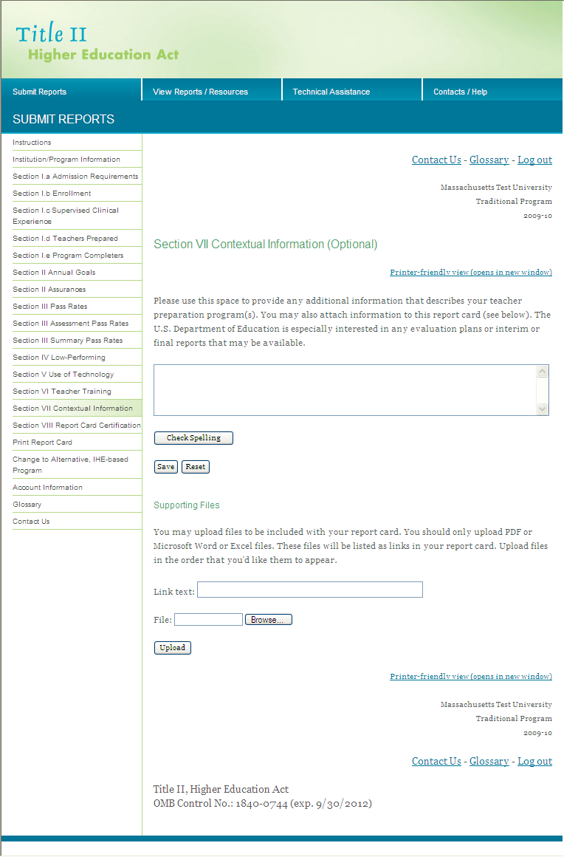

Section VIII. Certification

On the left side of the page, click on the link for Section VIII Certification (see Figure 32). Upon entering this section, the system will run a check to ensure the report is complete. If the report is not complete, the system will present a list of questions that have been left unanswered. You can click on the link to the section(s) listed to bring you directly to the page where there are unanswered questions. Data verification features have been implemented to assist you in ensuring the quality and accuracy of the information being reported. The data verification report, which provides edit check information, is generated in real time and is always available in Section VIII; you do not need to certify your report in order to view the edit check information.

When all sections of the report have been completed, and the report has been reviewed by the appropriate person (e.g., university president), you are ready to certify your report. Select the check box under Certification of submission. Enter your name and title. Select the check box under Certification of review of submission. Enter the name and title of the reviewer. Checking these boxes indicates that the report is complete and that the information in the report is accurate. Finally, click the Certify and Submit Report Card button. Do not click this button until you are ready to submit your completed report. You will no longer have access to your report in order to edit it, so be sure that the report is complete before it is certified.

When this section is complete, the system will automatically send you an email indicating that the certification process is complete. The state Title II coordinator will receive a copy of this email. In order for the e-mail verification of data certification to work properly, your browser must allow pop-up windows. Please disable any pop-up blockers to use this feature. Be sure to follow any other report certification procedures specified by your state.

Figure 32. Certification

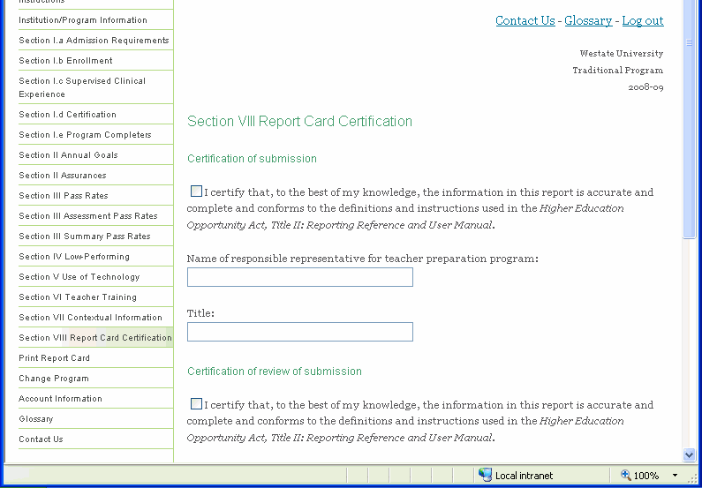
Printing Your Report

From the left side of the page, click on the Print Report Card link. From here (see Figure 33), you may print your complete report. To print the report, use your browser print function. For example, if you are using Internet Explorer, you should see a Print button at the top of your browser window. Click on this button to print the report or click on File from the menu at the top of the screen and then choose Print. You cannot enter data in this section, you can only view the questions and data that have been entered.

Depending on your window or browser settings, some sections (Section III, for example) will print better in landscape format. Also, many of the sections can be quite lengthy. Printing the entire report at once may take several minutes. You must wait for entire report to load on the screen before printing. It is recommended that you print a copy of your report after you complete it and keep it for your records. Alternatively, if you have access to a PDF program, you can create and save a PDF version of your report.

Figure 33. Print menu

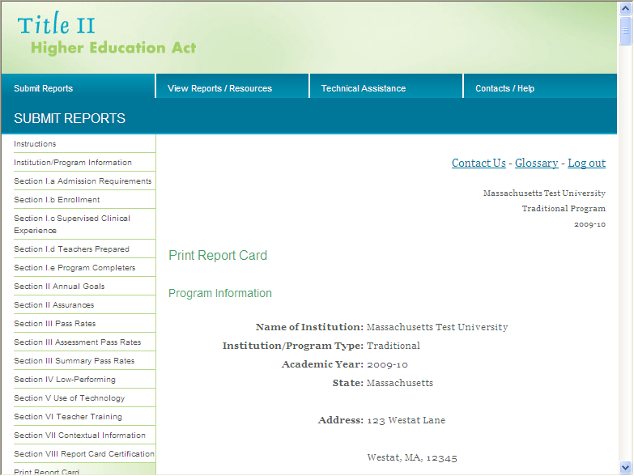

Updating User Account Information

From the left side of the page, click on the Account Information link. From here (see Figure 34), you may update your contact information, user name and password.

Once you have entered information in this section, choose the appropriate button (Save) at the bottom of the page.

Figure 34. User account information

Glossary

For your reference, the glossary can be found by clicking Glossary link on the left side menu or at the top or bottom of each page. (See Figure 35). A new window will open with the Glossary.

Figure 35. Glossary

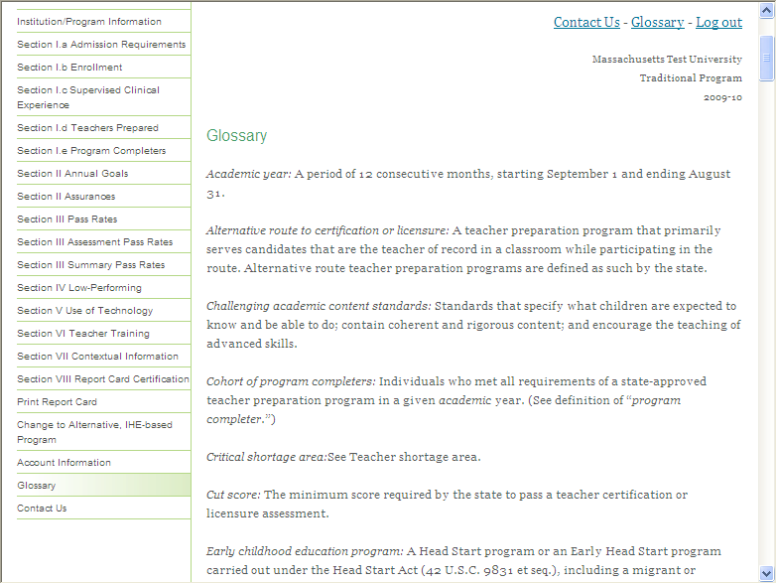

Contact Us

For your reference, contact information can be found by clicking Contact Us link on the left side menu. (See Figure 36). Contact Westat for technical assistance in using this system. Contact your state Title II coordinator with questions about your responses.

Figure 36. Contact us

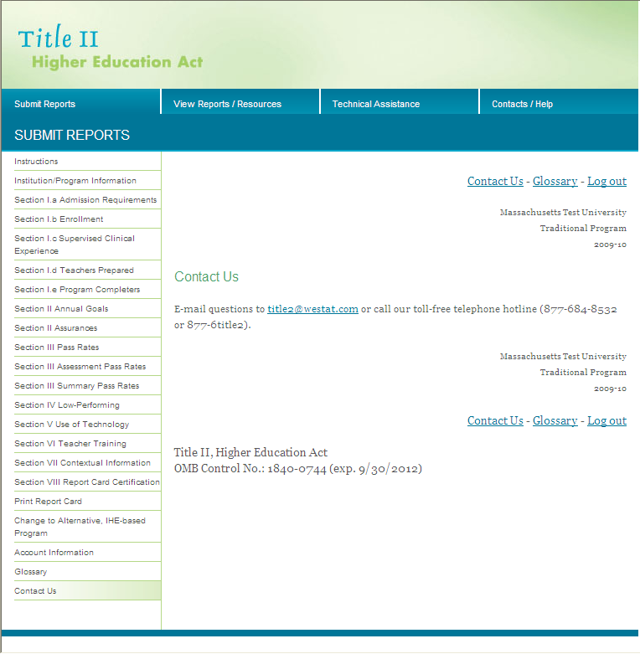

Appendix A

Title II Tips for Reporting

Pass Rate Templates

Section 205 of Title II of the Higher Education Act (as amended in 2008) requires teacher preparation programs to report data on the assessments used for teacher certification or licensure by the state. These data include the number of test takers, the number who passed, the pass rate, the average scaled score and the minimum passing score for each assessment. States must report these data for each IHE (traditional and alternative routes) and non-IHE-based alternative route. For Title II reporting, all traditional teacher preparation programs at a single IHE are to be considered a single program. Similarly, all alternative routes at a single IHE are to be considered a single program.

Pass rate data will be reported at the single assessment level and at the summary level. At the single assessment level, pass rate data for each assessment taken by each group of students will be aggregated into a state summary pass rate. At the summary level, the pass rate data for each completer group will be aggregated to present the percentage of students who passed all tests they took for their area of specialization among those who took one or more tests in their specialization areas. Summary pass rates will not be computed for the enrolled groups of students as it is expected that they will not have declared their area of specialization, and the number and types of tests required for their areas of specialization would be unknown. The pass rate data for the traditional routes will be reported separately from the pass rate data for the alternative routes.

Data templates are provided to report pass rates and related data. These templates are provided in Excel format (.xls) and are required to be used to report pass rate data. You can also download a data template from the institutional (IPRC) or state (STRC) reporting systems. Once you have downloaded and saved a file, you can work in that file without being logged into the reporting system.

Pass rate files will undergo rigorous system checks as they are uploaded. Any errors will be reported immediately to you in an error message. Some errors will prevent you from uploading the file(s). Some errors must be corrected after the file is uploaded. To avoid these errors, please review the checklist before submitting or uploading pass rate files.

Variables

GROUP | DESCRIPTION
1 | All enrolled students who have completed all nonclinical courses
2 | Other enrolled students
3 | All program completers, current year
4 | All program completers, prior year
5 | All program completers, two years prior
6 | All program completers, combined three years (summary pass rate files only)

TESTCOMPANY | DESCRIPTION
1 | Educational Testing Service (ETS)
2 | Evaluation Systems group of Pearson
3 | College Board
4 | American Board for Certification of Teacher Excellence (ABCTE)
5 | American Council on the Teaching of Foreign Languages (ACTFL)
98 | State
99 | Other

Table D1

Use for: single assessment pass rates for traditional teacher preparation programs within IHEs
Filename: TableD1.xls
Field Name | Description | Max Length | Field Type
INSTCODE | Unique code to identify the institution | 6 | Text
INSTNAME | Name of the institution | 100 | Text
ASSESSMENTCODE | Unique code to identify the assessment | 8 | Text
ASSESSMENTNAME | Name of the assessment | 50 | Text
TESTCOMPANY | Use code to identify test company | 8 | Numeric
LOWSCORE | Lowest possible score on assessment | 8 | Numeric
HIGHSCORE | Highest possible score on assessment | 8 | Numeric
CUTSCORE | Minimum passing score on assessment | 8 | Numeric
GROUP | Use code to identify status of students | 8 | Numeric
TAKERS | Number of test takers | 8 | Numeric
AVGSCALED | Average scaled score on assessment | 8 | Numeric
PASSERS | Of total test takers, number who passed | 8 | Numeric
PASSRATE | Percentage of test takers who passed | 8 | Numeric
STAVGPASSRATE | Statewide pass rate on assessment | 8 | Numeric
STAVGSCALED | Statewide average scaled score on assessment | 8 | Numeric

Variables continued

Table D2

Use for: summary pass rates for traditional teacher preparation programs within IHEs
Filename: TableD2.xls
Field Name | Description | Max Length | Field Type
INSTCODE | Unique code to identify the institution | 6 | Text
INSTNAME | Name of the institution | 100 | Text
GROUP | Use code to identify status of students | 8 | Numeric
TAKERS | Number of test takers | 8 | Numeric
PASSERS | Of total test takers, number who passed | 8 | Numeric
PASSRATE | Percentage of test takers who passed | 8 | Numeric
STAVGPASSRATE | Statewide summary pass rate | 8 | Numeric

Table D3

Use for: single assessment pass rates for alternative teacher preparation programs within IHEs
Filename: TableD3.xls
Field Name | Description | Max Length | Field Type
INSTCODE | Unique code to identify the institution | 6 | Text
INSTNAME | Name of the institution | 100 | Text
ASSESSMENTCODE | Unique code to identify the assessment | 8 | Text
ASSESSMENTNAME | Name of the assessment | 50 | Text
TESTCOMPANY | Use code to identify test company | 8 | Numeric
LOWSCORE | Lowest possible score on assessment | 8 | Numeric
HIGHSCORE | Highest possible score on assessment | 8 | Numeric
CUTSCORE | Minimum passing score on assessment | 8 | Numeric
GROUP | Use code to identify status of students | 8 | Numeric
TAKERS | Number of test takers | 8 | Numeric
AVGSCALED | Average scaled score on assessment | 8 | Numeric
PASSERS | Of total test takers, number who passed | 8 | Numeric
PASSRATE | Percentage of test takers who passed | 8 | Numeric
STAVGPASSRATE | Statewide pass rate on assessment | 8 | Numeric
STAVGSCALED | Statewide average scaled score on assessment | 8 | Numeric

Variables continued

Table D4

Use for: summary pass rates for alternative teacher preparation programs within IHEs
Filename: TableD4.xls
Field Name | Description | Max Length | Field Type
INSTCODE | Unique code to identify the institution | 6 | Text
INSTNAME | Name of the institution | 100 | Text
GROUP | Use code to identify status of students | 8 | Numeric
TAKERS | Number of test takers | 8 | Numeric
PASSERS | Of total test takers, number who passed | 8 | Numeric
PASSRATE | Percentage of test takers who passed | 8 | Numeric
STAVGPASSRATE | Statewide summary pass rate | 8 | Numeric

Table D5

Use for: single assessment pass rates for alternative teacher preparation programs outside of IHEs
Filename: TableD5.xls
Field Name | Description | Max Length | Field Type
INSTCODE | Unique code to identify the institution | 6 | Text
INSTNAME | Name of the institution | 100 | Text
ASSESSMENTCODE | Unique code to identify the assessment | 8 | Text
ASSESSMENTNAME | Name of the assessment | 50 | Text
TESTCOMPANY | Use code to identify test company | 8 | Numeric
LOWSCORE | Lowest possible score on assessment | 8 | Numeric
HIGHSCORE | Highest possible score on assessment | 8 | Numeric
CUTSCORE | Minimum passing score on assessment | 8 | Numeric
GROUP | Use code to identify status of students | 8 | Numeric
TAKERS | Number of test takers | 8 | Numeric
AVGSCALED | Average scaled score on assessment | 8 | Numeric
PASSERS | Of total test takers, number who passed | 8 | Numeric
PASSRATE | Percentage of test takers who passed | 8 | Numeric
STAVGPASSRATE | Statewide pass rate on assessment | 8 | Numeric
STAVGSCALED | Statewide average scaled score on assessment | 8 | Numeric

Variables continued

Table D6

Use for: summary pass rates for alternative teacher preparation programs outside of IHEs
Filename: TableD6.xls
Field Name | Description | Max Length | Field Type
INSTCODE | Unique code to identify the institution | 6 | Text
INSTNAME | Name of the institution | 100 | Text
GROUP | Use code to identify status of students | 8 | Numeric
TAKERS | Number of test takers | 8 | Numeric
PASSERS | Of total test takers, number who passed | 8 | Numeric
PASSRATE | Percentage of test takers who passed | 8 | Numeric
STAVGPASSRATE | Statewide summary pass rate | 8 | Numeric

✓ Troubleshooting Check List
  - The files CANNOT contain any commas. Make sure that the text fields do not contain commas.
  - An Institutional Code [INSTCODE] is required for each institution. Institutional Codes must be unique to each institution, but can be the same for a traditional and alternative route at the same institution. For example, the Institutional Code for the traditional route at Teachers College can be 100, and the Institutional Code for the alternative route at Teachers College can also be 100. However, the Institutional Code for the traditional route at Educators University cannot be 100, since this is the Institutional Code for Teachers College.
  - Institutional Codes should match the codes used in prior years.
  - An Institutional Name [INSTNAME] is required for each institution. Institutional Names must be unique to each institution, but can be the same for a traditional and alternative route at the same institution.
  - Please check the Institutional Name to ensure uniformity. Verify that the names are spelled correctly. If you use abbreviations, make sure they are used consistently.
  - The Assessment Code [ASSESSMENTCODE] and Assessment Name [ASSESSMENTNAME] must be unique to each test. They also should match the codes and names given by the testing companies and/or your state. Frequently we see incomplete names (for example, Biology rather than Biology Content Knowledge) or inconsistent Assessment Codes.
  - You cannot use the same Assessment Code for tests with two different names or the same Assessment Name for tests with two different Assessment Codes. If a test has been changed and given a different code, but the name was not changed, you must make an adjustment to the test name with the different code. For example, if test 151 was revised, and the code for the revised test is 251, add the word “Revised” to the end of the Assessment Name for the test with Assessment Code 251.
  - Assessment Names and Assessment Codes must be used uniformly throughout tables D1-D6. Assessment Code 100 cannot have the Assessment Name Mathematics in Table D3 if Assessment Code 100 has the Assessment Name Reading in Table D1.
  - Use the code (1-5, 98, 99) to identify the Test Company [TESTCOMPANY] for each assessment. If all of the tests in the file are from the same company, this variable will have the same value for each test.
  - The Low Score [LOWSCORE] is the lowest possible score that a test taker can get on the assessment. This is not the lowest score observed or achieved by the test takers. It is possible for many tests to have the same Low Score. This information should be available from the testing company.
  - The High Score [HIGHSCORE] is the highest possible score that a test taker can get on the assessment. This is not the highest score observed or achieved by the test takers. It is possible for many tests to have the same High Score. This information should be available from the testing company.
  - The Cut Score [CUTSCORE] is the minimum passing score on the assessment. It is possible for many tests to have the same Cut Score. This information should be available from the testing company.
✓ Troubleshooting Check List continued

  - Use the code (1-6) to identify the Group [GROUP] of students taking the assessments. Once a student becomes a program completer, he or she is no longer included in the enrolled student groups. It is possible for a student to be in the same cohort for more than one year. It is possible to have zero students in the “all enrolled students who have completed all nonclinical courses” group if clinical experiences are incorporated throughout the teacher preparation program. See the Glossary section of this document for the definition of enrolled student and program completer.
  - Group 6 will only be used in Tables D2, D4 or D6 when an institution as a whole is submitting fewer than 10 completers in two of the last three, or all three, years being reported. Group 6 will include the completers from all three years being reported.
- The number of test Takers [TAKERS] must be a number equal to or greater than zero, even if it is fewer than 10. If the record is left blank, it will not be loaded. Do not include tests in the file that had zero test takers.
  - The Average scaled score [AVGSCALED] must be a number equal to or greater than zero. See the Definitions section of this document for the definition of scaled score. The average scaled score should be blank if there are fewer than 10 test takers.
- The number Passing [PASSERS] should be blank if there are fewer than 10 test takers. It must also be less than or equal to the number of takers.
- The Pass rate [PASSRATE] should be blank if there are fewer than 10 test takers. It must be equal to the number of passers divided by the number of takers.
- Pass rate percentages will be reported to the nearest whole percent (i.e., 98 percent, not 98.2 percent or 98.23 percent). Rounding will use the third (thousandths) digit, and in some cases the next after that (fourth). As an example, 98.49 percent would become 98 percent; 98.50 would become 99 percent. Round percentages of 99.50 and above to 100 percent.

- The Statewide Pass Rate [STAVGPASSRATE] must be equal to the number of passers divided by the number of takers in the state. The statewide pass rate should be blank if there are fewer than 10 test takers in the state on the assessment (Tables D1, D3, D5) or fewer than 10 test takers in the state overall (Table D2, D4, D6).
- The Statewide Average Scaled Score [STAVGSCALED] must be a number equal to or greater than zero. The statewide average scaled score should be blank if there are fewer than 10 test takers in the state on the assessment (Tables D1, D3, D5) or fewer than 10 test takers in the state overall (Table D2, D4, D6).
- There must be a Table D2 record for every school listed in D1. Table D1 collects single assessment information at the IHE level, and D2 collects this IHE information at the summary level. All schools with assessment information in D1 must be aggregated and listed in D2. This is also the case with Table D4 and D3 and Tables D6 and D5. Summary pass rates must aggregate pass rate data from all testing companies used in the state.
- There must be a statewide record for each assessment in D1, D3 and D5.
- There must be a summary statewide record in D2, D4 and D6. Summary pass rates must aggregate pass rate data from all testing companies used in the state.
- The statewide summary records must use the IHE or Program Code 9999. State summary records must be named Statename Summary (Alabama Summary, for example).

Some traditional teacher preparation programs may lead to a teaching credential but not a degree. A traditional teacher preparation program in the outlying areas may lead to an associate’s degree.

