

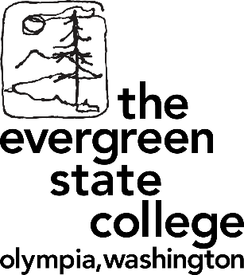

**Master in Teaching Program**

**Information Events Winter 2017**

**Learn how to become a Teacher**

* **Wednesday January 11 3-5 pm**, Information Workshop at Seminar II E 3123, Evergreen Olympia
* **Tuesday January 17 2-3 pm**, Information Workshop Room 218 Evergreen Tacoma,

1210 6th Ave, Tacoma

* **Thursday January 26 6-7 pm**, Information Workshop at Olympia Timberland Regional Library Community Meeting Room, 313 8th Ave SE, Olympia
* **Monday January 30 6-7 pm**, Information Workshop Room 104 Evergreen Tacoma,

1210 6th Ave, Evergreen Tacoma

* **Saturday February 4 11:30 am-3 pm**, Documentary “Most Likely to Succeed“ at noon followed by community discussion, Evergreen Tacoma, 1210 6th Ave, Tacoma
* **Wednesday February 8 3-5 pm**, Information Workshop at Seminar II E 3123, Evergreen Olympia
* **Monday February 13 6-7 pm**, Information Workshop Room 104 Evergreen Tacoma,

1210 6th Ave, Tacoma

* **Tuesday February 21 2-3 pm**, Information Workshop Room 104 Evergreen Tacoma,

1210 6th Ave, Tacoma

* **Thursday March 2 6-7 pm**, Information Workshop at Olympia Timberland Regional Library Community Meeting Room, 313 8th Ave SE, Olympia
* **Tuesday March 7 2-7 pm**, advising appointments Room 114 Evergreen Tacoma,

1210 6th Ave, Tacoma. Email [foranm@evergreen.edu](mailto:foranm@evergreen.edu) to reserve half hour slot

* **Wednesday March 8 4-6 pm**, Information at MiT table at Academic Fair, Costantino Recreation Center, Evergreen Olympia
* **Monday March 13 6-7 pm**, Information Workshop Room 104 Evergreen Tacoma,

1210 6th Ave, Tacoma

**Further information @ www.evergreen.edu/mit**