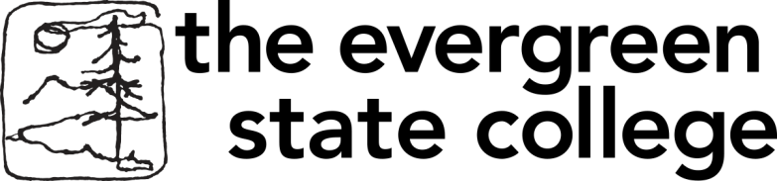 

**Master in Teaching**

**(MiT) Program**

**Summer 2016 Events**

July 30-31, Noon - 7 pm

MiT Information Table @

Ethnic Fest, Wright Park, Tacoma

August 22, 3 - 5 pm

MiT Information Workshop

Sem 2 E 3120 Olympia Campus

September 22, 6 - 7 pm

MiT Information Workshop at Olympia Timberland Regional Library Community Meeting Room 313 8th Ave. Olympia

[foranm@evergreen.edu](mailto:foranm@evergreen.edu) or 360.867.6559

 **Be Someone’s Hero**

**Become a Teacher!**

[www.evergreen.edu/mit](http://www.evergreen.edu/mit)