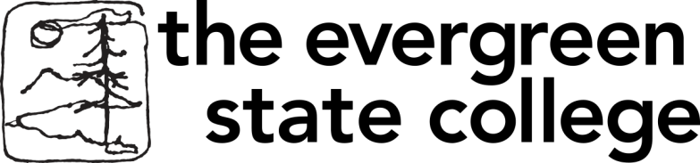 

**Master in Teaching**

**(MiT) Program**

**Early Fall Events**

September 22, 6 - 7 pm

MiT Information Workshop at Olympia Timberland Regional Library Community Meeting Room 313 8th Ave. Olympia

Oct. 3, 2-3:30 pm

Mit Information Workshop at Room 104

Evergreen Tacoma, 1210 6th Ave. E. Tacoma

Oct. 5, 3-5 pm

Information Workshop Seminar II E 3120, Olympia



**Be Someone’s Hero**

**Become a Teacher!**

[www.evergreen.edu/mit](http://www.evergreen.edu/mit)

[foranm@evergreen.edu](mailto:foranm@evergreen.edu) 360.867.6559