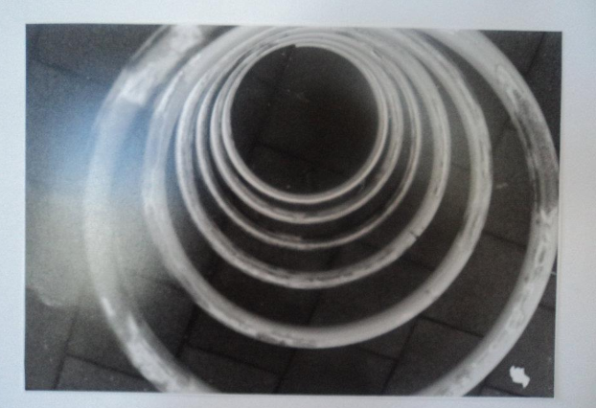Childs’ Play.1

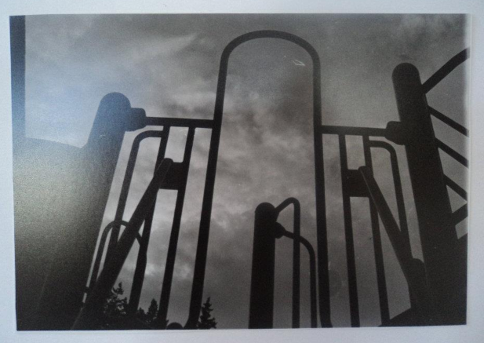 Childs’ Play.2

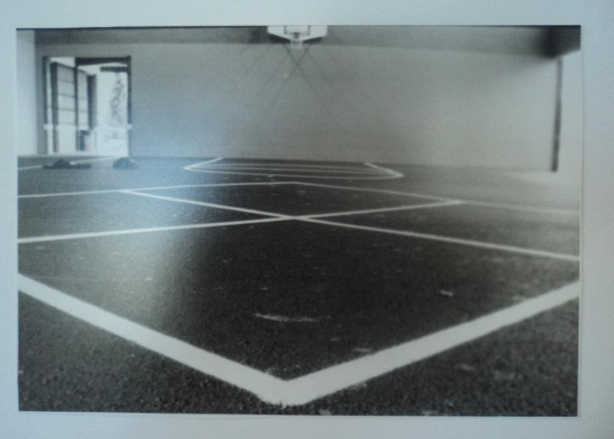 Childs’ Play.3

During the planning and conceptualization focus of the Childs’ Play series; I wanted to capture how the use of traditional black and white photography affects the tone of a piece. My intended audience was adults; I hoped to trigger a childhood memory of perception of child’s play on the playground. Perspective played a major role in the development of these pieces. I intended for the photos to be familiar to the viewer as if they were a child again. The angles and perspective in which these photos were shot suggest the viewer is short; the point of view of a child. The used of black and white rather than color was deliberate as well. The monochromatic tone sets a dark setting for the otherwise joyful experience of recess. The fact children are not present running and jump off the toys in conjunction to the black in white color scheme, were deliberate in the contextual development of the piece. The feelings and values I am expressing through the creation of this piece were the experience of missing my childhood, the loss of innocence that comes with becoming an adult. This is an emotion often expressed by my viewers as well. They often question why are there no children, or why do these pictures make them sad. And the answer is often because that’s what our playground now look.

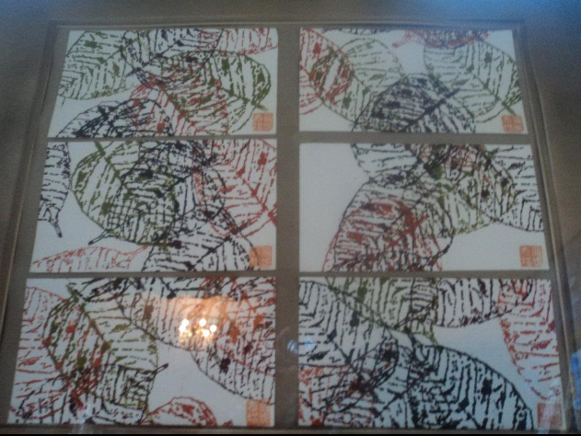Seasons of Life

The planning and conceptualization of this piece I believe developed long after the piece was actually created. I think as an artist ideas of the intention of a piece can change in the process of it being created; or the development and value it takes on after it’s completed. This print was produced while I was studying abroad in China. The print was is a versatile design that I thought was esthetically pleasing to anyone. I used a traditional screen printing technique’s new to me but familiar to the Chinese, a vacuum exposure unit was used to expose my screen. This allowed for a high level of detail within the print. I chose colors that reflected the seasons of the environment. The value I expressed by this piece came upon my return to the United States’, travelling aboard made me a different person, I had changed, I was more seasoned. The piece communicated to me how things change so much but often remains the same in only form or another. The name of the piece often invokes this thought provoking idea this with viewers of my piece.

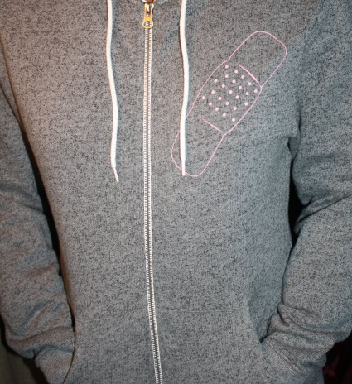**Front 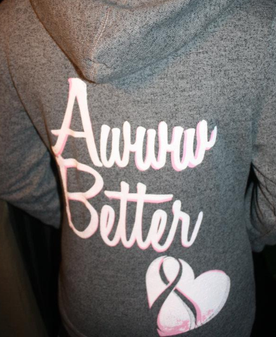Back**

My mother is a breast cancer survivor and like most of my other works my family/ personal life have motivated me to complete this work. Memories of my childhood remind me that band aids made everything feel better. The screen-printed shirts I created were intended for those affected by cancer. The band aid on the chest of the shirt is over the wound, (the breast cancer) and the back reads “Awww Better” which is a statement made by most attempting to comfort a child in distress. The plastisol ink is an ink pigment with elastic type properties which foster a short drying time at high temperatures. This insures long wear time on the clothing. Feeling and values expressed by this piece is often pride and motivation to fight the disease. Almost all of my viewers have expressed this as well.