April 17, 2013

Sara Nadine Beith **STUDENT ID: A00238866**

726 Adams St SE Apt 4

Olympia, WA 98501

Dear Sara,

Congratulations! I am pleased to offer you **conditional** **acceptance** to the Master in Teaching (MiT) Program at The Evergreen State College, starting September 30, 2013. We are delighted that you want to become a teacher and serve your community. You have been accepted as a candidate seeking an endorsement in **Middle Level Humanities**.

Based on the decision of the admissions committee, your admission is **conditional pending completion** of the following requirements:

* **2 credits of geography**
* **Official passing WEST B scores**
* **Official passing WEST E scores for Middle Level Humanities**

If you have questions about these conditional requirements, please contact Maggie Foran, the MiT Certification and Advising Officer, at foranm@evergreen.edu or (360) 867-6559.

The rest of this lengthy letter contains detailed information you will need to read carefully, act upon, and save for future reference.

To hold your place in the MiT class beginning September 2013, you will need to do the following **within 30 days** **of the date of this letter**.

1. Inform the Office of Admissions, in writing, of your decision to accept or decline this offer of admission at: Admissions Office, The Evergreen State College, Olympia, WA 98505-0002
2. Submit a non-refundable $100 tuition deposit either through your my.evergreen.edu account or along with the enclosed tuition deposit form. Your deposit will be applied toward tuition for Fall Quarter, 2013. If your deposit is not received within 30 days of the date of this letter, this offer of admission expires and your place in the MiT program may be given to another applicant.

Please note you must have the official WEST B and WEST E scores into the Office of Admissions by September 13, 2013. All additional conditional requirements listed above must be completed by August 22, 2014.

To document any coursework you take between the time you applied to the program and the start of the program, you must send an official transcript(s) to the Office of Admissions by November 1, 2013. Finally, if you take coursework during summer 2014 at an institution other than Evergreen, you must send an official transcript to the Office of Admissions documenting that coursework by November 1, 2014.

A required orientation session will be held, tentatively on Saturday, September 21, 9 am – 4 pm at Evergreen’s Olympia campus, and the program begins September 30, 2013. Please make arrangements in your life to have sufficient time to complete all assigned readings, papers and projects for the full 16 graduate level credits each quarter. All credits must be earned each quarter to advance in the program - incompletes or partial credit is grounds for not being allowed to continue.

State education codes require that teacher candidates must have fingerprint and Washington State Patrol and FBI background check clearance before we can place you in schools. Therefore, make plans to be fingerprinted in August or early September 2013 and bring proof of current fingerprints (receipt from where fingerprints were done) to orientation. The most convenient, fastest, and reliable way to be fingerprinted is at one of the state’s Educational Service District offices with the two closest locations to Olympia at ESD 113 in Tumwater and ESD 121 in Renton. See <http://www.evergreen.edu/mit/forms.htm> for details. Fingerprints are valid for two years and must be current at all times in MiT. If you already have current fingerprints on file with the Office of the Superintendent of Public Instruction, please contact MiT field placement officer Loren Petty at [pettyl@evergreen.edu](mailto:pettyl@evergreen.edu) so he can verify.

Please also complete and bring to orientation all required forms found at: <http://www.evergreen.edu/mit/forms.htm>, especially the Character and Fitness supplement form 4020B. If you have any yes answers in Section II questions 3-11, Section III or Section IV, please contact MiT field placement officer Loren Petty at [pettyl@evergreen.edu](mailto:pettyl@evergreen.edu) in August to discuss how to obtain a clearance letter.

If you are interested in applying for financial aid and scholarships, you are encouraged to do so as soon as possible. Information about how to apply for financial aid can be found at: <http://www.evergreen.edu/mit/financialaid.htm>

Over the coming months you will be receiving information about orientation and registration by email. Please set up your Evergreen email and my.evergreen.edu account by July 1 so you do not miss any correspondence from college offices. In addition, make plans now to ensure you have reliable transportation you can use to attend field placements and student teaching sites in a timely manner wherever you are assigned within a 40 mile radius of our campus.

Finally, the state of Washington has passed legislation that requires people entering teacher education programs take and pass the Washington Teacher Performance Assessment (edTPA) during student teaching in order to be recommended for certification. The anticipated fee is $300.

Again, my sincere and warmest congratulations on your acceptance into the Evergreen MiT program. We look forward to meeting and working with you.

Sincerely,

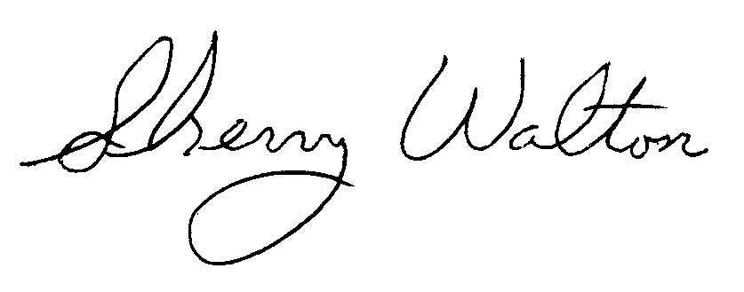

Dr. Sherry Walton, Director

Master in Teaching Program