May 1, 2014

Ms. Martha Preston
2900 Limited Lane Apt C101
Olympia, WA 98502

Dear Ms. Preston,

Thank you for your application to the Master in Teaching (MiT) Program at The Evergreen State College. After careful consideration of your application materials, the admissions committee has had to make the difficult decision to not admit you to the MiT program.

The MiT Admissions Committee did appreciate your desire to become an educator, and encourage you to consider strengthening your writing skills, complete more endorsement credits, and retake your admissions tests as you consider whether to reapply in the future.

Sincerely,
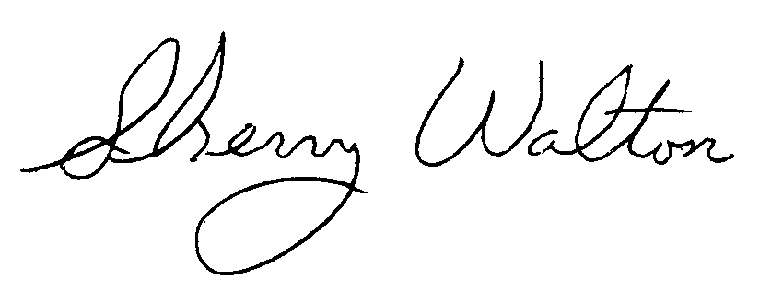
Dr. Sherry Walton, Director
Teacher Education Programs
The Evergreen State College

