May 1, 2014

Ms. Nichole Koehler
778 Elma McCleary Rd Apt 62
McCleary, WA 98557

Dear Ms. Koehler,

Thank you for your application to the Master in Teaching (MiT) Program at The Evergreen State College. After careful consideration of your application materials, the admissions committee has had to make the difficult decision to not admit you to the MiT program.

On behalf of the MiT Admissions Committee I wish you the best in your future endeavors.

Sincerely,
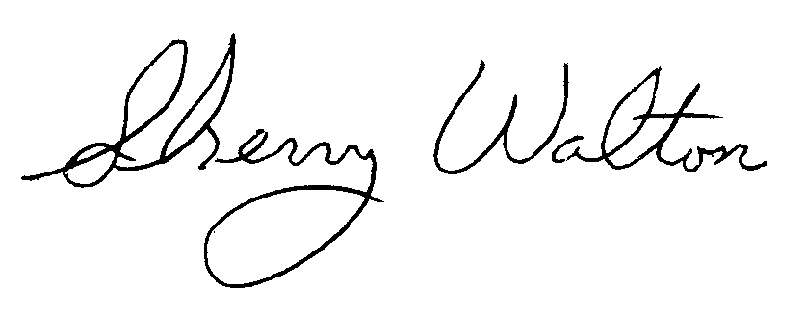
Dr. Sherry Walton, Director
Teacher Education Programs
The Evergreen State College

