May 1, 2014

Mr. Sean Chandler

24652 SE 216th St

Maple Valley, WA 98038

Dear Mr. Chandler,

Thank you for your application to the Master in Teaching (MiT) Program at The Evergreen State College. After careful consideration of your application materials, the admissions committee has had to make the difficult decision to not admit you to the MiT program.

On behalf of the MiT Admissions Committee I wish you the best in your future endeavors.

Sincerely,

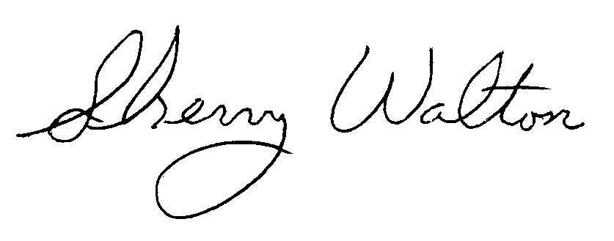

Dr. Sherry Walton, Director

Teacher Education Programs

The Evergreen State College