July 30, 2026

Rebecca L Reisbick STUDENT ID: A00169802
10415 Stardust Ln SE
Olympia, WA 98501

Dear Rebecca,

Congratulations! I am pleased to offer you provisional acceptance to the Master in Teaching (MiT) Program at The Evergreen State College, starting September 26, 2011. You have been accepted as a candidate seeking an endorsement in English Language Arts.

Your acceptance is provisional pending completion of your bachelor’s degree.

The Admissions Committee also recommends you strengthen your multicultural (American ethnic) literature background.

If you have any questions about this requirement, please contact Maggie Foran, the MiT Certification and Advising Officer, at foranm@evergreen.edu or (360) 867-6559.

To hold your place in the MiT class beginning September 2011, you will need to do the following within 30 days of the date of this letter.
- Inform the Office of Admissions, in writing, of your decision to accept or decline this offer of admission at: Admissions Office, The Evergreen State College, Olympia, WA 98505-0002
- Submit a non-refundable $100 tuition deposit along with the enclosed tuition deposit form. Your deposit will be applied toward tuition for Fall Quarter, 2011. If your deposit is not received within 30 days of the date of this letter, this offer of admission expires and your place in the MiT program may be given to another applicant.

Please note that you must complete your bachelor’s degree by September 09, 2011 and proof of degree on an official transcript must be received in the Office of Admissions no later than September 12, 2011 in order to start our graduate program and to qualify for financial aid.

A required orientation session will be held, tentatively on Saturday, September 17, 9 am – 4 pm, and the program begins September 26, 2011.

State education codes require that teacher candidates must have fingerprint and background check clearance before they begin working in schools. Therefore, please make plans to be fingerprinted in early to mid-September 2011 and bring proof of current fingerprints (receipt from where fingerprints were done) to orientation. The most convenient, fastest, and most

reliable way to be fingerprinted is at one of the state’s Educational Service District Offices with their electronic machines. The closest one to Evergreen is ESD 113 in west Olympia. See handout on Fingerprinting at ESD 113 about fees, payment methods, hours of operations, etc. at: http://www.evergreen.edu/mit/forms.htm
Fingerprints are valid for two years and must be current at all times in MiT.

Please also complete and bring to orientation all required forms found at: http://www.evergreen.edu/mit/forms.htm, especially the Character and Fitness supplement form 4020b. If you have any yes answers in Section II questions 3-11, Section III or Section IV, please contact MiT field placement officer Loren Petty at pettyl@evergreen.edu to bring your form in with accompanying documentation prior to orientation to begin the process of obtaining a clearance letter.

If you are interested in applying for financial aid and scholarships, you are encouraged to do so as soon as possible. Information about how to apply for financial aid can be found at: http://www.evergreen.edu/mit/financialaid.htm

Over the coming months you will be receiving information about orientation and registration by email. Please set up your Evergreen email and my.evergreen.edu account by mid-summer so you do not miss any correspondence from college offices. In addition, make plans now to ensure you have reliable transportation you can use to attend field placements and student teaching sites in a timely manner wherever you are assigned within a 40 mile radius of our campus during your time in the MIT program. This requirement is on p. 9 of our catalog.

Again, my sincere and warmest congratulations on your acceptance into the Evergreen MiT program.

Sincerely,
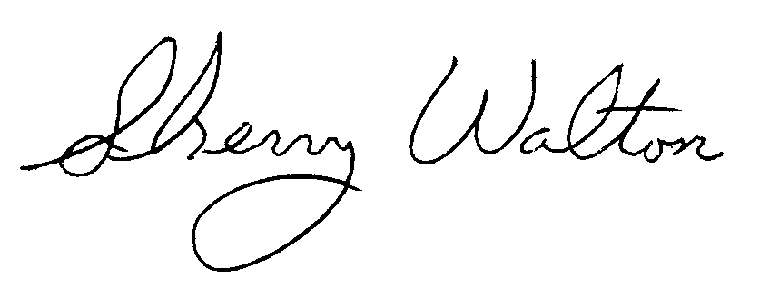
Dr. Sherry Walton, Director
Master in Teaching Program

