July 31, 2026

Krystle Denise Reeds STUDENT ID: A00145805
10214 Lakeview Ave SW Apt 47
Lakewood, WA 98499

Dear Krystel,

Congratulations! I am pleased to offer you provisional acceptance to the Master in Teaching (MIT) Program at The Evergreen State College, starting September 27, 2010. You have been accepted as a candidate seeking an endorsement in Elementary Education.

Your acceptance is provisional until official Evergreen transcript showing bachelor’s degree awarded has been received by Evergreen’s Office of Admissions.

Based on the decision of the admission committee, your admission is also conditional pending completion of the following requirements:

Passing WEST-E scores Elementary Education endorsements subtests one and two by 9/27/10
One or more credits in economics
One or more credits in world history
Two credits in Pacific Northwest history
One or more credits in a type of earth/space science (astronomy, meteorology, geology or oceanography
One or more credits in a type of physical science (chemistry, physics or environmental science)

If you have questions about these conditional requirements, please contact Maggie Foran, the MIT Certification and Advising Officer, at foranm@evergreen.edu or (360) 867-6559.

To hold your place in the MIT class beginning September 2010, you will need to do the following
by September 1:

- Inform the Office of Admissions, in writing, of your decision to accept or decline this offer of admission at: Admissions Office, The Evergreen State College, Olympia, WA 98505-0002
- Submit a non-refundable $100 tuition deposit along with the enclosed tuition deposit form. Your deposit will be applied toward tuition for Fall Quarter, 2010. If your deposit is not received within 30 days of the date of this letter, this offer of admission expires and your place in the MIT program may be given to another applicant.

Please note that you must have submitted an official transcript with proof of bachelor’s degree by September 1, 2010. Evergreen must have received your official passing WEST E scores by September 27, 2010. Also, you must have completed all of the requirements listed above by August 19, 2011. For the coursework taken during summer 2011, you must send a transcript to the Admissions Office documenting that coursework; that transcript must be received by November 1, 2011.

A required orientation session will be held, tentatively on Saturday, September 18, 9 am – 4 pm, and the program begins September 27, 2010. State education codes require that teacher candidates must have fingerprint and background check clearance before they begin working in schools. Therefore, please make sure to bring proof of current fingerprints (receipt from where fingerprints were done) and a complete Character and Fitness form. Go to the Office of the Superintendent of Public Instruction’s website at: http://www.k12.wa.us/certification/certapp/4031.pdf Please download and read pages 3 and 4 of the application instructions for information and locations on being fingerprinted – ESD 113 in west Olympia is the closest location to Evergreen. Also download the Character and Fitness Supplement (pages 7-10 of the above packet) and fill out. If you have any yes answers in Section II questions 3-11, Section III or Section IV, please contact MiT field placement officer Loren Petty at pettyl@evergreen.edu to bring your form in with accompanying documentation prior to orientation so the process of obtaining a clearance letter can be instigated.

Over the coming months you will be receiving information about orientation and registration. If you are interested in applying for financial aid and scholarships, you are encouraged to do so as soon as possible. Information about how to apply for financial aid can be found at: http://www.evergreen.edu/mit/financialaid.htm.

Please also make plans to ensure you have reliable transportation you can use to attend field placements and student teaching sites in a timely manner wherever you are assigned within a 40 mile radius of our campus during your time in the MIT program. This requirement is on p. 9 of our catalog.

Again, my sincere and warmest congratulations on your acceptance into the Evergreen MIT program.

Sincerely,
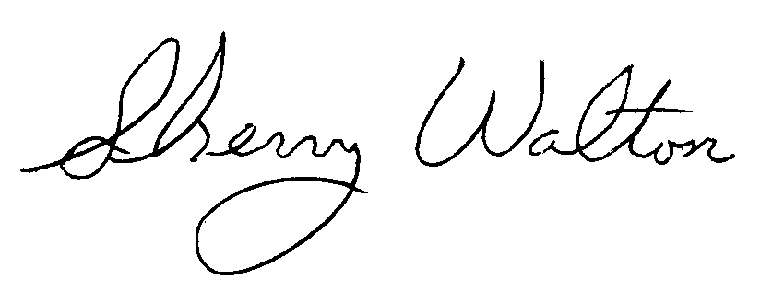
Dr. Sherry Walton, Director
Master in Teaching Program

