July 29, 2026

Kayla Elianna Lehman NEW STUDENT ID: A00266709
PO Box 88995
Steilacoom, WA 98388

Dear Kayla,

Congratulations! I am pleased to offer you provisional acceptance to the Master in Teaching (MIT) Program at The Evergreen State College, starting September 27, 2010. You have been accepted as a candidate seeking endorsements in English Language Arts and Theatre.

Your acceptance is provisional pending completion of your bachelor’s degree.

Based on the decision of the admission committee, your admission is conditional pending completion of the following requirements:

College level math course
Adolescent literature course
Verification of experience with diverse students in public high school English classroom setting

If you have questions about these conditional requirements, please contact Maggie Foran, the MIT Certification and Advising Officer, at foranm@evergreen.edu or (360) 867-6559.

To hold your place in the MIT class beginning September 2010, you will need to do the following within 30 days of the date of this letter.

- Inform the Office of Admissions, in writing, of your decision to accept or decline this offer of admission at: Admissions Office, The Evergreen State College, Olympia, WA 98505-0002
- Submit a non-refundable $100 tuition deposit along with the enclosed tuition deposit form. Your deposit will be applied toward tuition for Fall Quarter, 2010. If your deposit is not received within 30 days of the date of this letter, this offer of admission expires and your place in the MIT program may be given to another applicant.

Please note that you must complete your bachelor’s degree, the prerequisite math course and verify your experience with diverse high school by September 11, 2010. Also, you must have completed all of the requirements listed above by August 19, 2011.

Also note, you must send an official transcript(s) to the Office of Admissions that document(s) any coursework you take between the time you applied to the program and the start of the program. The transcript(s) must be received by November 1, 2010. Finally, if you take course work during summer 2011 to fulfill your requirements, you must send a transcript to the Admissions Office documenting that coursework; that transcript must be received by November 1, 2011.

A required orientation session will be held, tentatively on Saturday, September 18, 9 am – 4 pm, and the program begins September 27, 2010. Over the coming months you will be receiving information about orientation and registration. If you are interested in applying for financial aid and scholarships, you are encouraged to do so as soon as possible. Information about how to apply for financial aid can be found at: http://www.evergreen.edu/mit/financialaid.htm.

Please also make plans to ensure you have reliable transportation you can use to attend field placements and student teaching sites in a timely manner wherever you are assigned within a 40 mile radius of our campus during your time in the MIT program. This requirement is on p. 9 of our catalog.

Again, my sincere and warmest congratulations on your acceptance into the Evergreen MIT program.

Sincerely,
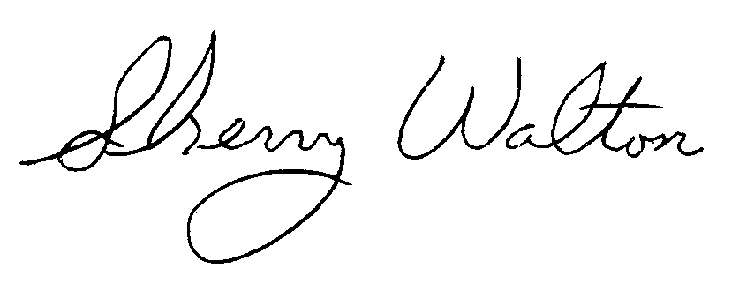
Dr. Sherry Walton, Director
Master in Teaching Program

