July 29, 2026

Julie A Dodson NEW STUDENT ID: A00271042
219 E Garfield St Apt 201
Seattle, WA 98102

Dear Julie,

Congratulations! I am pleased to offer you conditional acceptance to the Master in Teaching (MIT) Program at The Evergreen State College, starting September 27, 2010. You have been accepted as a candidate seeking endorsements in Biology and Science.

Based on the decision of the admission committee, your admission is conditional pending completion of the following requirement:

Receipt of third letter of recommendation from Mr. Peter Newstead or other appropriate reference

If you have questions about this conditional requirement, please contact Maggie Foran, the MIT Certification and Advising Officer, at foranm@evergreen.edu or (360) 867-6559.

To hold your place in the MIT class beginning September 2010, you will need to do the following within 30 days of the date of this letter.

- Inform the Office of Admissions, in writing, of your decision to accept or decline this offer of admission at: Admissions Office, The Evergreen State College, Olympia, WA 98505-0002
- Submit a non-refundable $100 tuition deposit along with the enclosed tuition deposit form. Your deposit will be applied toward tuition for Fall Quarter, 2010. If your deposit is not received within 30 days of the date of this letter, this offer of admission expires and your place in the MIT program may be given to another applicant.

Please note you must send an official transcript(s) to the Office of Admissions that document(s) any coursework you take between the time you applied to the program and the start of the program. The transcript(s) must be received by November 1, 2010.

A required orientation session will be held, tentatively on Saturday, September 18, 9 am – 4 pm, and the program begins September 27, 2010. Over the coming months you will be receiving information about orientation and registration. If you are interested in applying for financial aid and scholarships, you are encouraged to do so as soon as possible. Information about how to apply for financial aid can be found at: http://www.evergreen.edu/mit/financialaid.htm

Again, my sincere and warmest congratulations on your acceptance into the Evergreen MIT program.

Sincerely,
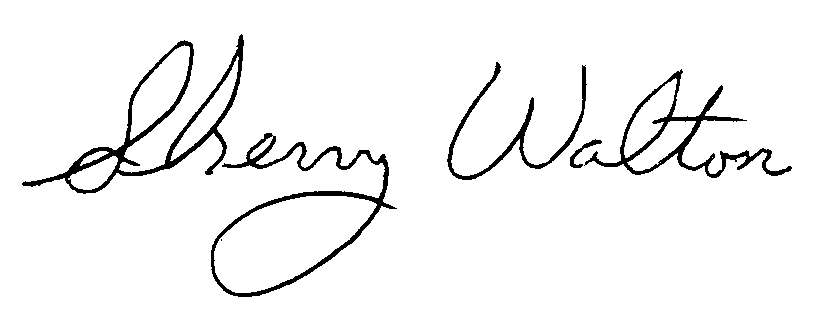
Dr. Sherry Walton, Director
Master in Teaching Program

