July 29, 2026

Bridget Elizabeth Kameen NEW STUDENT ID: A00255026
600 Black Lake Blvd Apt 104
Olympia, WA 98502

Dear Bridget,

Congratulations! I am pleased to offer you conditional acceptance to the Master in Teaching (MIT) Program at The Evergreen State College, starting September 27, 2010. You have been accepted as a candidate seeking endorsements in Elementary Education and Visual Arts.

Based on the decision of the admission committee, your admission is conditional pending completion of the following requirements:

Official passing WEST-E in Visual Arts
Passing review of art portfolio
Some credit in biology
Some credit in Pacific Northwest history
4 credits children’s and adolescent literature
Documentation of observation experience in a public high school art classroom

If you have questions about these conditional requirements, please contact Maggie Foran, the MIT Certification and Advising Officer, at foranm@evergreen.edu or (360) 867-6559.

To hold your place in the MIT class beginning September 2010, you will need to do the following within 30 days of the date of this letter.
- Inform the Office of Admissions, in writing, of your decision to accept or decline this offer of admission at: Admissions Office, The Evergreen State College, Olympia, WA 98505-0002
- Submit a non-refundable $100 tuition deposit along with the enclosed tuition deposit form. Your deposit will be applied toward tuition for Fall Quarter, 2010. If your deposit is not received within 30 days of the date of this letter, this offer of admission expires and your place in the MIT program may be given to another applicant.

Please note documentation of observations in a public high school art classroom and official passing WEST-E must be received by the Office of Admissions and the art portfolio reviewed passed by September 11, 2010. Also, you must have completed all of the requirements listed above by August 19, 2011.

Also note, you must send an official transcript(s) to the Office of Admissions that document(s) any coursework you take between the time you applied to the program and the start of the program. The transcript(s) must be received by November 1, 2010. Finally, if you take course work during summer 2011, you must send a transcript to the Admissions Office documenting that coursework; that transcript must be received by November 1, 2011.

A required orientation session will be held, tentatively on Saturday, September 18, 9 am – 4 pm, and the program begins September 27, 2010. State education codes require that teacher candidates must have fingerprint and background check clearance before they begin working in schools. Therefore, please make sure to bring proof of current fingerprints (receipt from where fingerprints were done) and a complete Character and Fitness form. Go to the Office of the Superintendent of Public Instruction’s website at: http://www.k12.wa.us/certification/certapp/4031.pdf Please download and read pages 3 and 4 of the application instructions for information and locations on being fingerprinted – ESD 113 in west Olympia is the closest location to Evergreen. Also download the Character and Fitness Supplement (pages 7-10 of the above packet) and fill out. If you have any yes answers in Section II questions 3-11, Section III or Section IV, please contact MIT field placement officer Loren Petty at pettyl@evergreen.edu to bring your form in with accompanying documentation prior to orientation so the process of obtaining a clearance letter can be instigated.

Over the coming months you will be receiving information about orientation and registration. If you are interested in applying for financial aid and scholarships, you are encouraged to do so as soon as possible. Information about how to apply for financial aid can be found at: http://www.evergreen.edu/mit/financialaid.htm.

Please also make plans to ensure you have reliable transportation you can use to attend field placements and student teaching sites in a timely manner wherever you are assigned within a 40 mile radius of our campus during your time in the MIT program. This requirement is on p. 9 of our catalog.

Again, my sincere and warmest congratulations on your acceptance into the Evergreen MIT program.

Sincerely,
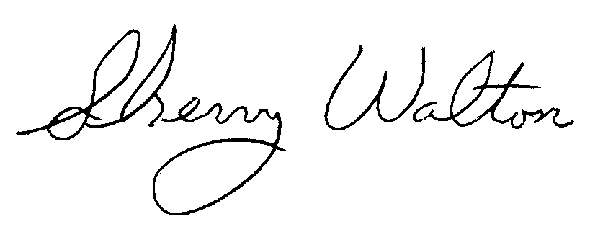
Dr. Sherry Walton, Director
Master in Teaching Program

