July 29, 2026

Douglas Gerald Richert Sr STUDENT ID: A00270418
206 W Colorado
Shelton, WA 98584

Dear Douglas,

Congratulations! I am pleased to offer you provisional acceptance to the Master in Teaching (MIT) Program at The Evergreen State College, starting September 28, 2009. You have been accepted as a candidate seeking an endorsement in Elementary Education.

Your acceptance is provisional pending completion of your bachelor’s degree.

Based on the decision of the admission committee, your admission is also conditional pending completion of the following requirement:

1 credit in health

If you have questions about these conditional requirements, please contact Maggie Foran, the MIT Certification and Advising Officer, at foranm@evergreen.edu or (360) 867-6559.

To hold your place in the MIT class beginning September 2009, you will need to do the following within 30 days of the date of this letter.

- Inform the Office of Admissions, in writing, of your decision to accept or decline this offer of admission at: Admissions Office, The Evergreen State College, Olympia, WA 98505-0002
- Submit a non-refundable $100 tuition deposit along with the enclosed tuition deposit form. Your deposit will be applied toward tuition for Fall Quarter, 2009. If your deposit is not received within 30 days of the date of this letter, this offer of admission expires and your place in the MIT program may be given to another applicant.

Please note that you must complete your bachelor’s degree by September 12, 2009. Also, you must have completed all of the requirements listed above by August 20, 2010.

Also note, you must send an official transcript(s) to the Office of Admissions that documents any coursework you take between the time you applied to the program and the start of the program. This transcript(s) with bachelor’s degree posted must be received by September 18, 2009. Finally, if you take course work during summer 2010 to fulfill your requirements, you must send a transcript to the Admissions Office documenting that coursework; that transcript must be received by November 1, 2010.

A required orientation session will be held, tentatively on Saturday, September 19, 9 am – 4 pm, and the program begins September 28, 2009. Over the coming months you will be receiving information about orientation and registration. If you are interested in applying for financial aid and scholarships, you are encouraged to do so as soon as possible. Information about how to apply for financial aid can be found at: http://www.evergreen.edu/mit/finance/financialaid.htm

Again, my sincere and warmest congratulations on your acceptance into the Evergreen MIT program.

Sincerely,
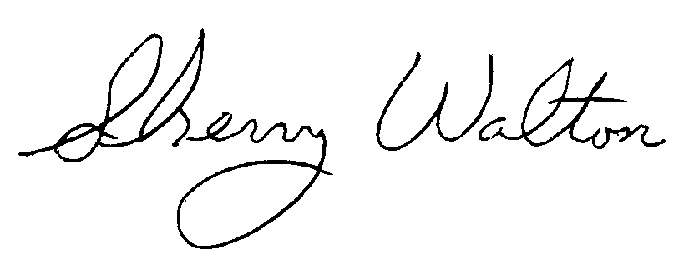
Dr. Sherry Walton, Director
Master in Teaching Program

