July 31, 2026

Jennifer Lauren Chaney STUDENT ID: A00267247
5448 2nd Ave SW
Olympia, WA 98512

Dear Jennifer,

Congratulations! I am pleased to offer you provisional acceptance to the Master in Teaching (MIT) Program at The Evergreen State College, starting September 29, 2008. You have been accepted as a candidate seeking an endorsement in Elementary Education.

Your acceptance is provisional pending completion of your bachelor’s degree.

Based on the decision of the admission committee, your admission is also conditional pending completion of the following requirements:

Some credit in earth and space science
Some credit in US history
Some credit in civics
Some credit in economics

If you have questions about these conditional requirements, please contact Maggie Foran, the MIT Certification and Advising Officer, at foranm@evergreen.edu or (360) 867-6559.

To hold your place in the MIT class beginning September 2008, you will need to do the following within 30 days of the date of this letter.

- Inform the Office of Admissions, in writing, of your decision to accept or decline this offer of admission at: Admissions Office, The Evergreen State College, Olympia, WA 98505-0002
- Submit a non-refundable $100 tuition deposit along with the enclosed tuition deposit form. Your deposit will be applied towards tuition for Fall Quarter, 2008. If your deposit is not received within 30 days of the date of this letter this offer of admission expires and your place in the MIT program may be given to another applicant.

Please note that you must complete your bachelor’s degree and be within 8 credits of completing the requirements listed above by September 12, 2008. Also, you must have completed all of the requirements listed above by August 21, 2009.

Also note, you must send an official transcript(s) to the Office of Admissions that documents any coursework you take between the time you applied to the program and the start of the program. This transcript(s) must be received by November 1, 2008. Finally, if you take course work during summer 2009 to fulfill your requirements, you must send a transcript to the Admissions Office documenting that coursework; that transcript must be received by November 1, 2009.

A required orientation session will be held, tentatively on Saturday, September 20, 9 am – 4 pm, and the program begins September 29, 2008. Over the coming months you will be receiving information about orientation and registration. If you are interested in applying for financial aid and scholarships, you are encouraged to do so as soon as possible. Information about how to apply for financial aid can be found at: http://www.evergreen.edu/mit/finance/financialaid.htm

Again, my sincere and warmest congratulations on your acceptance into the Evergreen MIT program.

Sincerely,
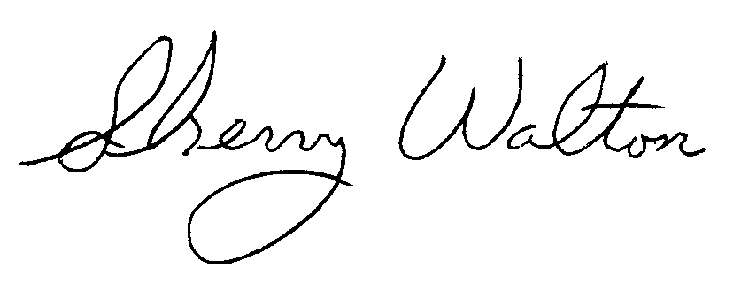
Dr. Sherry Walton, Director
Master in Teaching Program

